SUPPLEMENTARY MATERIALS

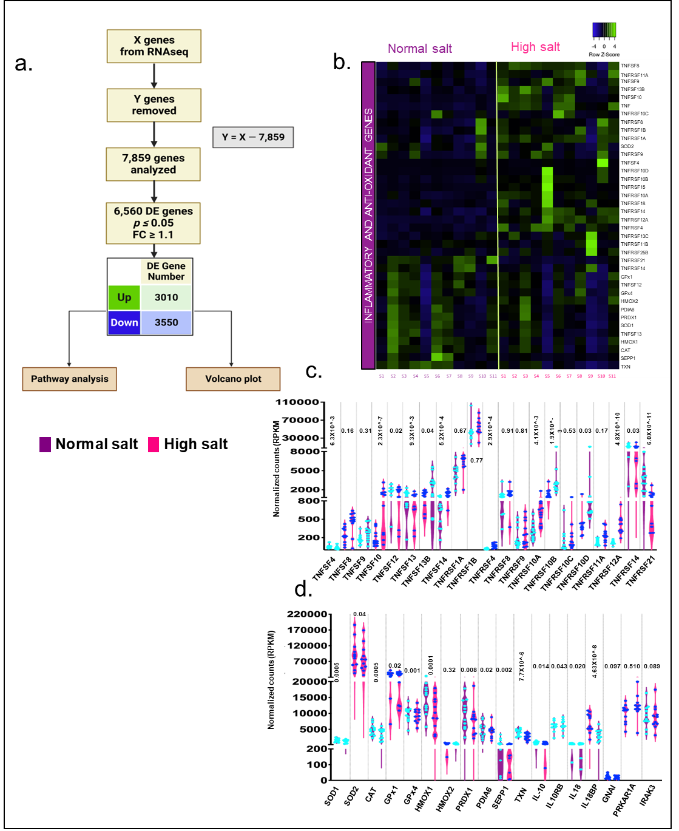
Fig. S1. High salt modulates JAK/STAT and downstream regulatory genes in human monocytes. a, Workflow analysis for bulk-RNA-Seq. b, Heatmap showing the differences in the gene expression of inflammatory and antioxidant genes. c, bar graphs showing RPKM values for inflammatory genes, and d, showing antioxidant and anti-inflammatory genes. DE indicates differentially expressed; RPKM, reads per kilobase of transcript per million reads mapped; TNFSF, tumor necrosis factor superfamily; SOD, superoxide dismutase; TNFRSF, tumor necrosis factor receptor superfamily; GPx, Glutathione Peroxidase; HMOX, Heme Oxygenase; PDIA6, Protein Disulfide Isomerase Family A Member 6; PRDX1, Peroxiredoxin 1; CAT, catalase; SEPP1, Selenoprotein P; TRXN, Thioredoxin.

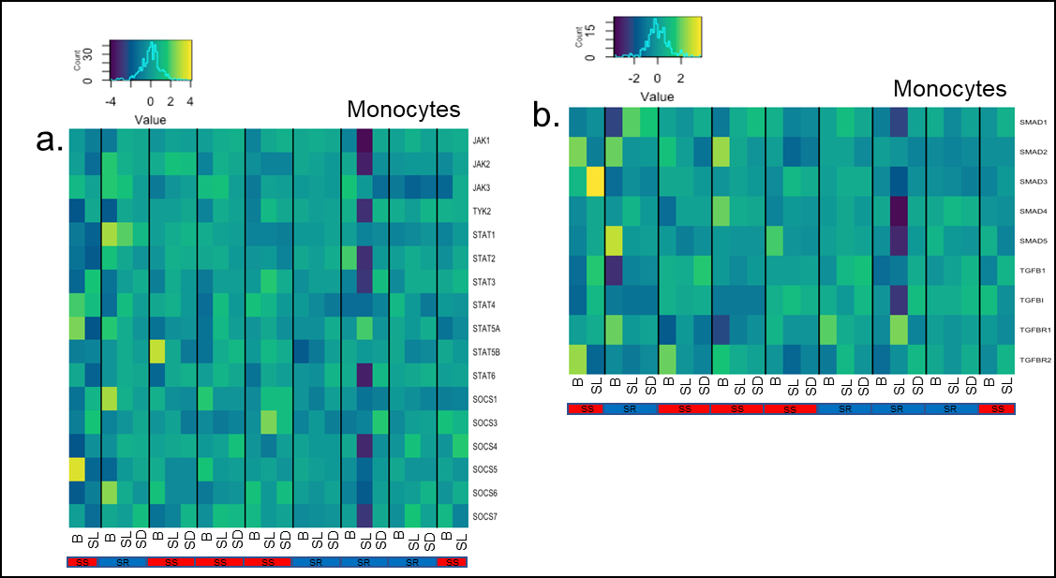
Figure S2. Cite-Seq data exhibits changes in the blood pressure mirror the changes in JAK2/STAT3/SMAD3 transcripts expression after salt-load and depletion in hypertensive patients. a, b, Heatmap hierarchical clustering of JAK/STAT/SOCS/SMAD gene expression in monocytes in SS and SR patients. B indicates baseline; SL, salt load; SD, salt depletion; DCs, dendritic cells; JAK, Janus kinase; STAT, signal transducer and activator of transcription; SOCS, suppressor of cytokine signaling; TGFB1, Transforming Growth Factor Beta 1; TGFBI, transforming growth factor beta-induced; TGFBR, transforming growth factor beta receptor 1; TYK2, tyrosine kinase 2.
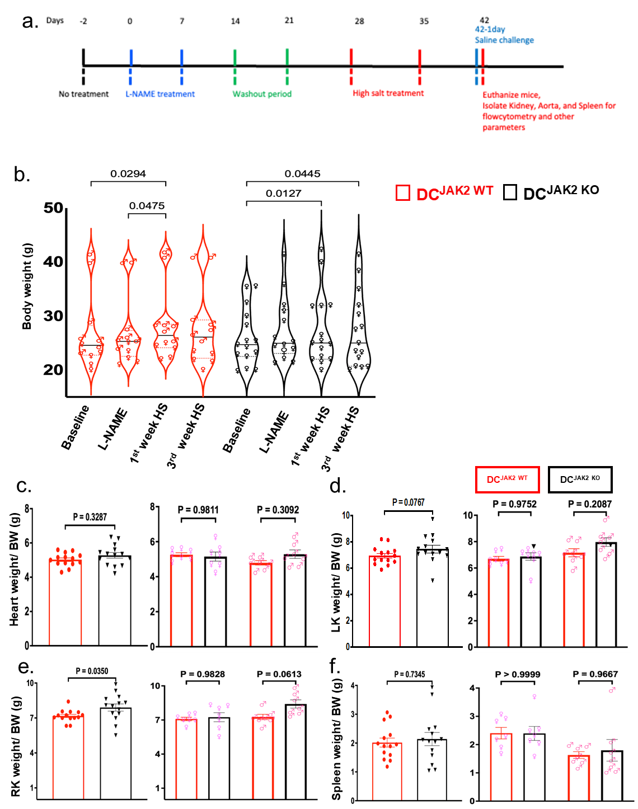
Figure S3. Experimental design, body weight over time, and organ weight after L-NAME/HS regimen. a, Experimental setup of L-NAME treatment, washout, high salt treatment, and saline challenge. b, Bar graph showing the body weight of DC^{JAK2WT} and DC^{JAK2KO} mice during the experimental design described in (a). c, Heart weight/body weight ratio, d, LK weight/body weight ratio, e, RK weight/body weight ratio and f, Spleen weight/body weight ratio of DC^{JAK2WT} and DC^{JAK2KO} mice. All data are expressed as mean ±SEM; n=12-13, male 6, female 7. Statistical analysis performed using paired two-way ANOVA with Bonferonni repeated measures post hoc test. HS indicates high salt; L-NAME, L-NG-Nitro arginine methyl ester; BW, body weight; LK, left kidney; RK, right kidney.
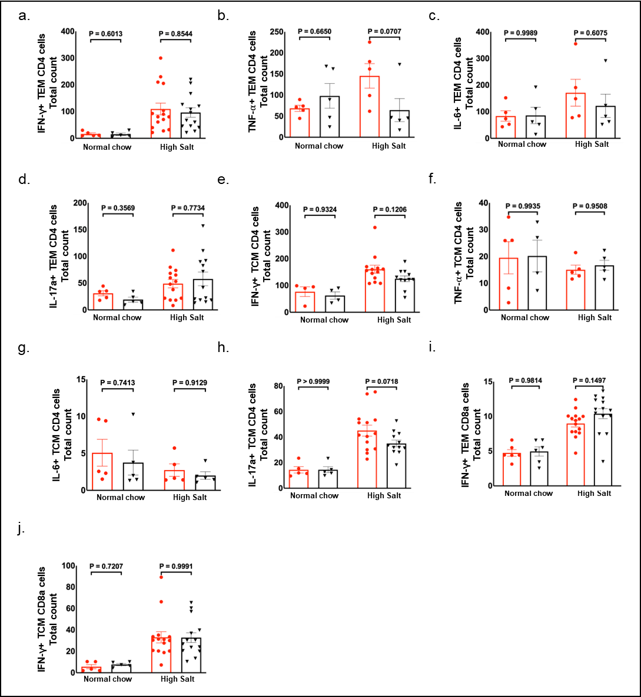

Figure S4. Loss of JAK2 in myeloid dendritic cells does not affect ENaC-γ expression in T-lymphocytes in the kidney. a-c, Bar graphs showing IFN-γ, TNF-⍺, and IL-6 expression in CD4+ effector memory (T_{EM}) and central memory (TCM) T-cells. Likewise, d-f, Bar graphs showing IFN-γ, TNF-⍺, and IL-6 expression in CD4+ central memory (T_{CM}) T-cells. i, j, Bar graphs showing IFN-γ expression in CD8a+ effector memory (T_{EM}) and central memory (T_{CM}) cells. n= 4-5 for the normal chow group, 5-13 for L-NAME/HS group. We used two-ANOVA 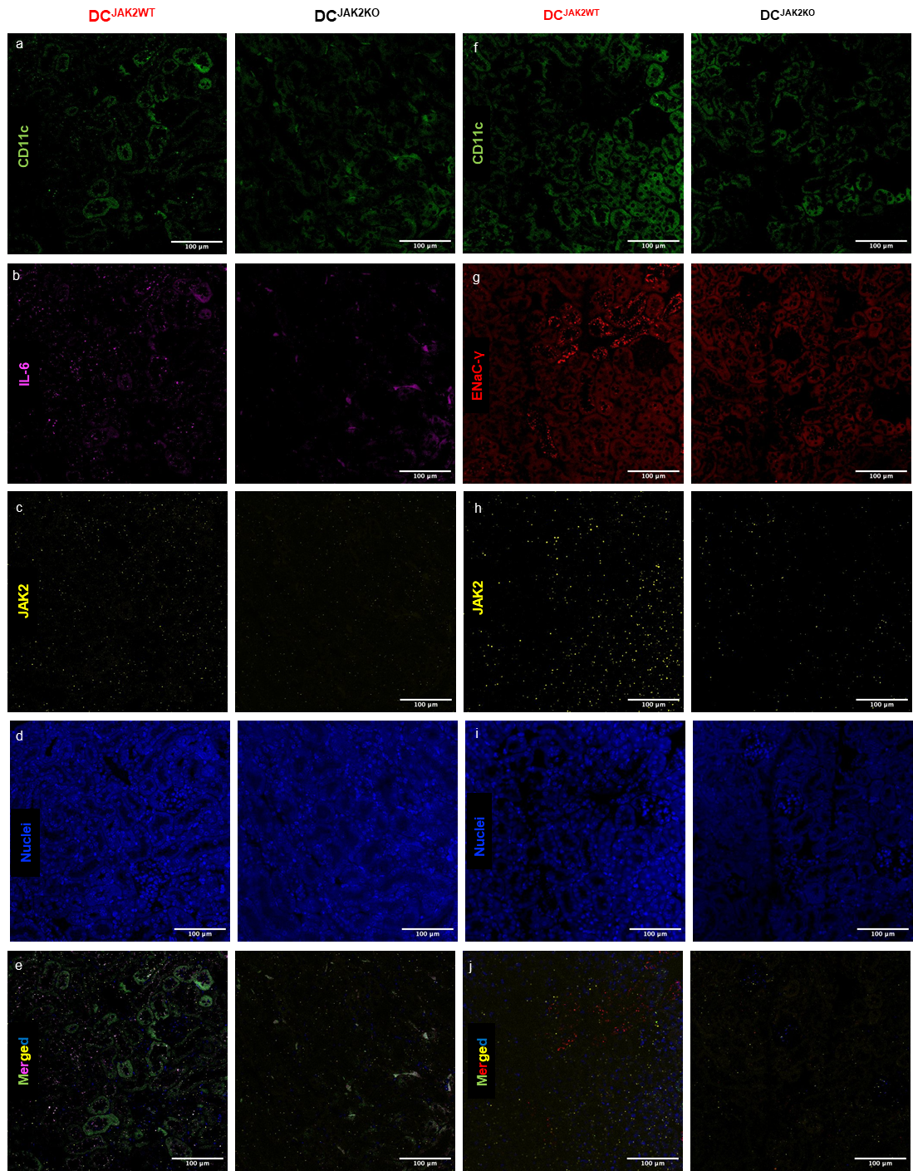

Figure S5. Loss of JAK2 in myeloid dendritic cells prevents salt-induced IL-6 and ENaC-γ expression in the kidney. We performed Fluorescence In-Situ Hybridization (FISH) in paraffin-embedded kidneys isolated from mice treated with L-NAME/HS regimen. Green fluorescence represents CD11c+ mRNA expression; magenta IL-6 mRNA expression; red ENaC-γ expression; and yellow represents JAK2 mRNA expression; blue, nuclei. a, Representative microscopy images of CD11c expression, b, IL-6 expression, c, JAK2 expression, d, nuclei, and e, merged. Similarly, f, representative microscopy images of CD11c expression, g, ENaC-γ expression, h, JAK2 expression, i, nuclei, and j, merged. We were limited to the number of channels in the microscope, so, we needed to stain two sets of slides for four different markers. n=2, scale bar, 100 µm. The original magnification was 20x. JAK indicates Janus kinase; IL-6, interleukin-6; ENaC, epithelial sodium channel.
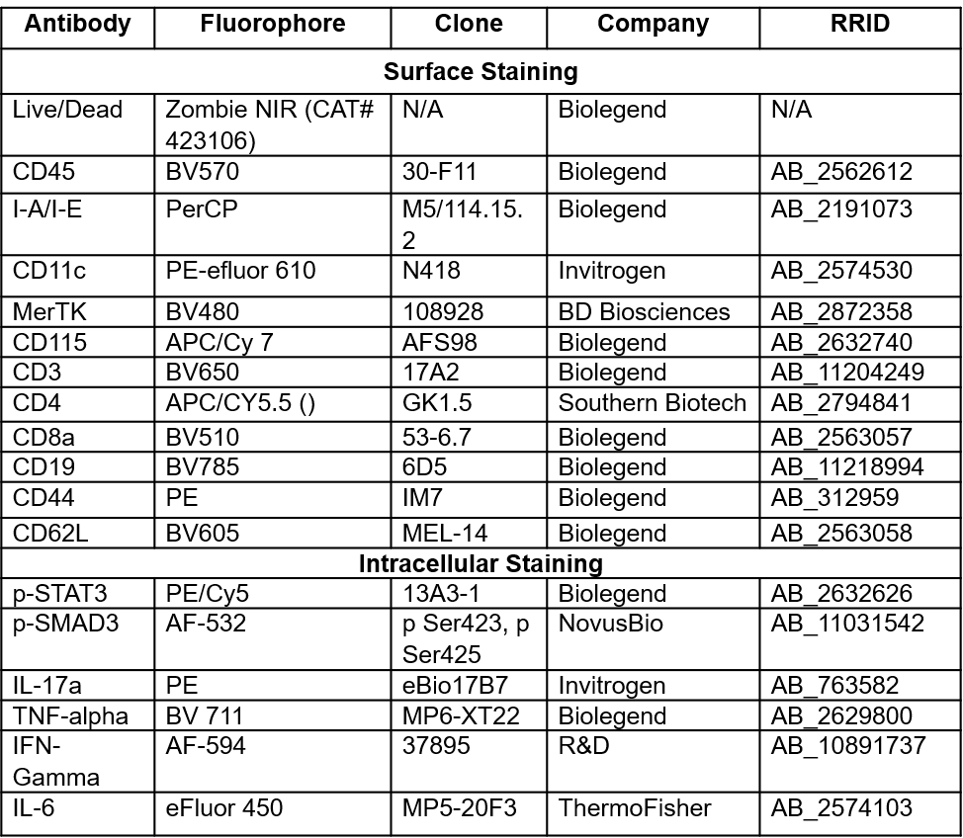
Table S1: List of antibodies used for surface and intracellular staining

