Case scenarios - CT images listed down were recruited during study enrollment, all CT images are printed out, dated and labelled by each lady name for more confidence of our research honest.

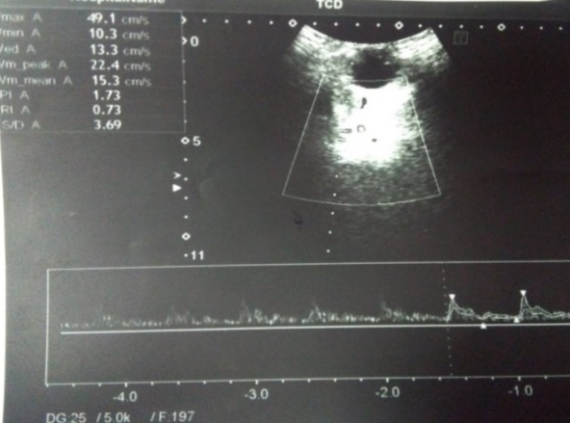
Figure (1a) real time transcranial doppler of left middle cerebral artery.

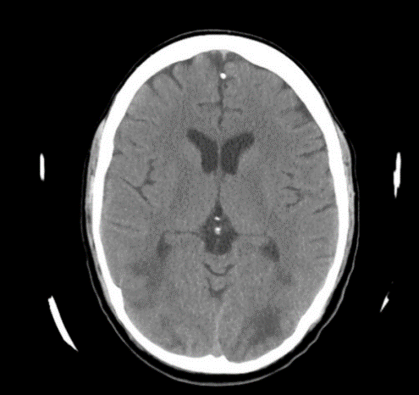
Figure (1b) CT brain showing posterior reversible ischemic encephalopathy OF control group

A 24 years old multigravida in (C) group. Figure (1a) showing 12 hs post-operative brain CT with posterior reversible encephalopathy syndrome.
Figure (1b) showing MCA Doppler of the same patient 6 hs post operative with PI=1.7 and RI=0.73.

