Appendix for
Stabilization and solidification of metal and organotin contaminated sediment after electrochemical pretreatment
Anna Norén^{a,}*, Ann-Margret Strömvallª, Sebastien Rauchª, Yvonne Andersson-Sköld^{c,d}, Oskar Modinª, Karin Karlfeldt Fedje^{a,b}

Addresses
ª Department of Architecture and Civil Engineering, Division of Water Environment Technology, Chalmers University of Technology, SE-412 96 Gothenburg, Sweden
^{b} Recovery and Management, Renova AB, Box 156, SE-401 22 Gothenburg, Sweden
^{c} Swedish National Road and Transport Research Institute (VTI), Box 8072, SE-402 78 Gothenburg, Sweden
^{d} Department of Architecture and Civil Engineering, Division of Geology and geotechnics, Chalmers University of Technology, SE-412 96 Gothenburg, Sweden
* Corresponding author, anna.noren@chalmers.se

Table A.1 Typical chemical composition range of Ecocem GGBS (Ecocem, n.d.)
Compound | Composition range (%)
SiO₂ | 34.15-37.9
Al₂O₃ | 10.4-13.1
Fe₂O₃ | 0.64-0.7
CaO | 37.6-43
MgO | 7-8.1
MnO | 0.4
TiO₂ | 0.5-0.7
SO | 0.01-0.20
Cl | 0.01-0.03
S²⁻ | 0.7-1.02
Na₂O_{eqv} | 0.51-0.53

Table A.2 Average content of compounds in Byggcement Std PK Skövde (Cementa, 2021)
Compound | Composition (%)
CaO | 61.2
SiO₂ | 18.2
Al₂O₃ | 5
Fe₂O₃ | 2.9
MgO | 1.2
Na₂O | 0.16
K₂O | 1.2
SO₃ | 3.6
Cl | 0.03

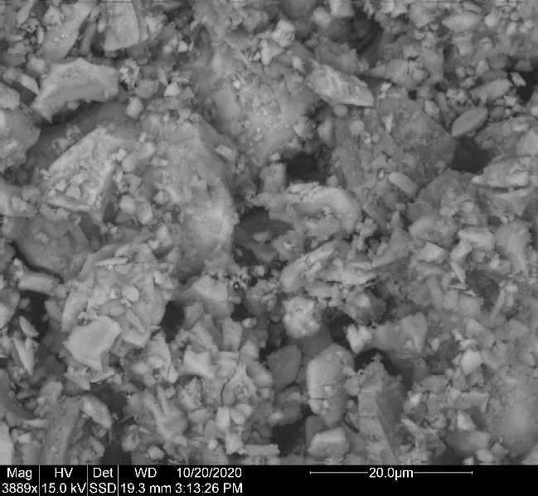 | 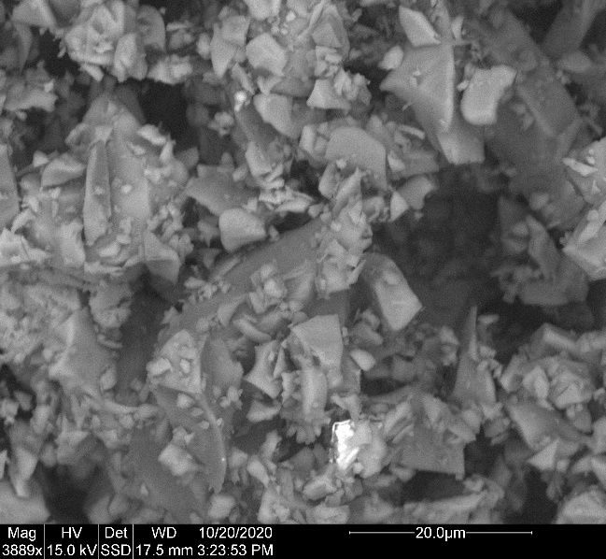
Cement | GGBS
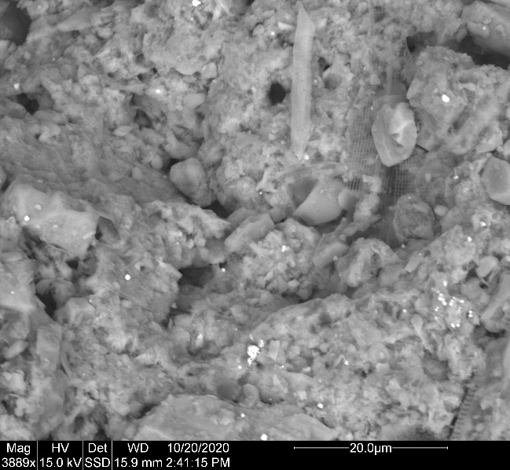 | 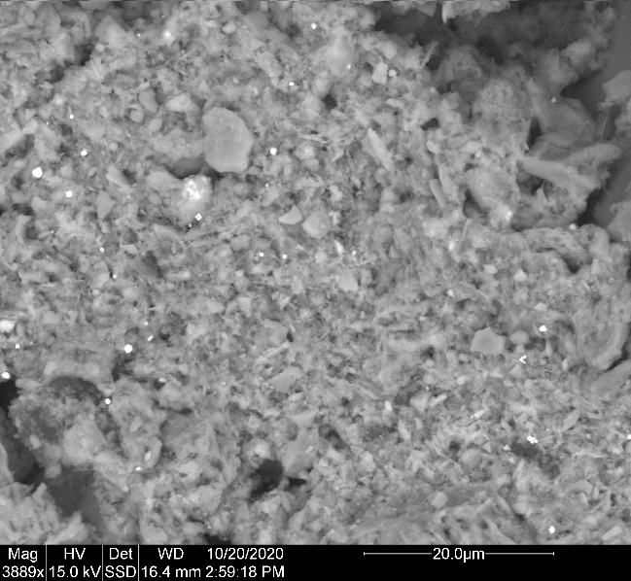
Original sediment | Electro sediment
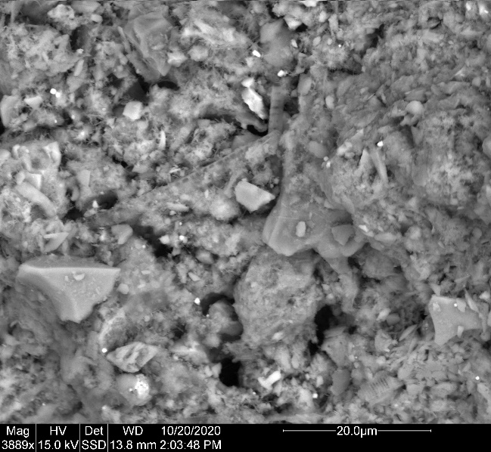 | 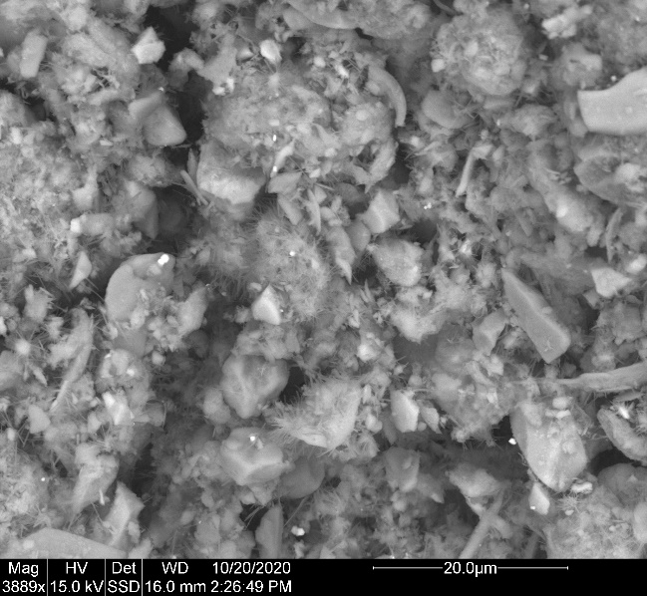
Original S/S | Electro S/S
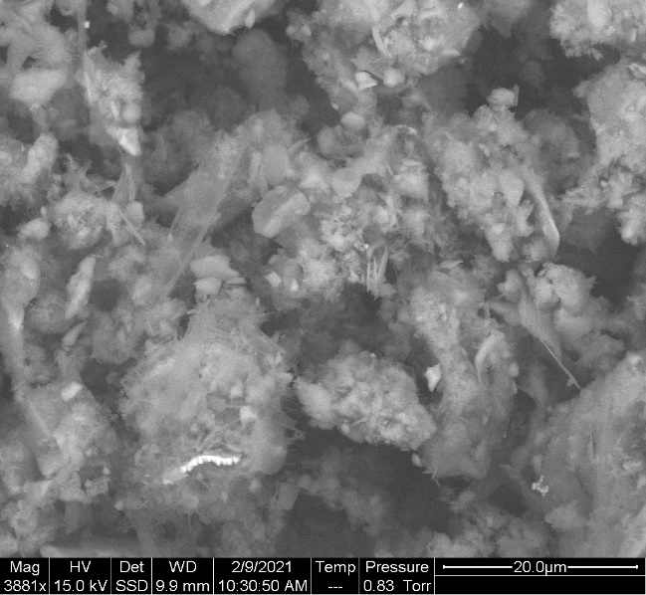 | 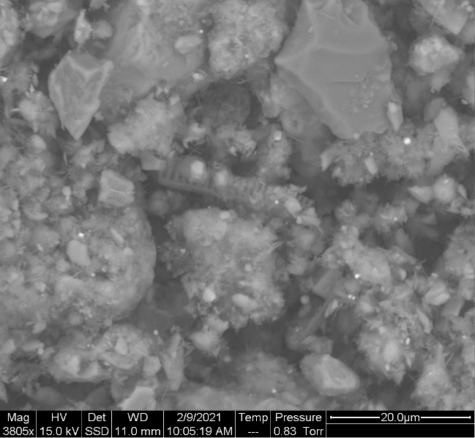
Original S/S 28 U-P | Electro S/S 28 U-P
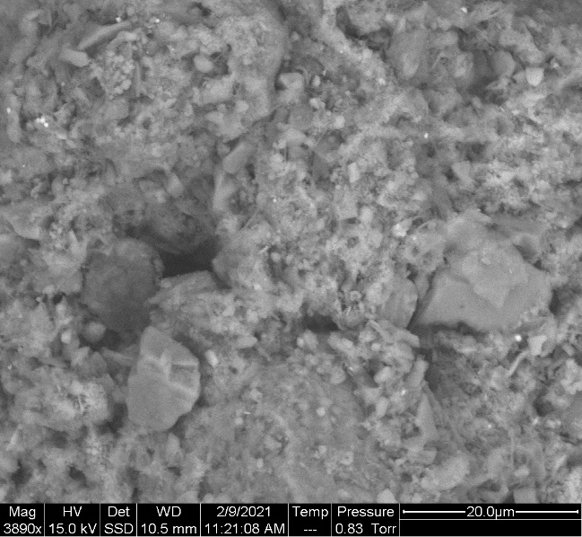 | 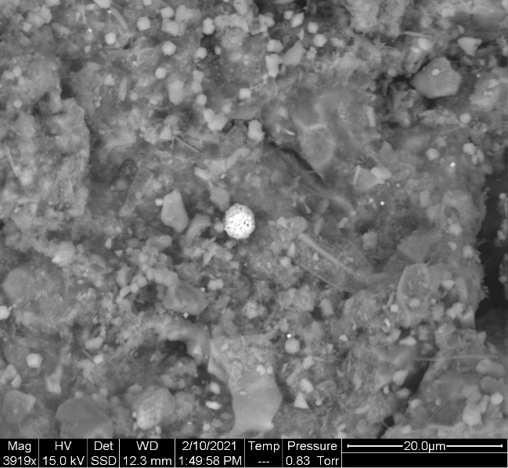
Original S/S 28 NaCl | Electro S/S 28 NaCl
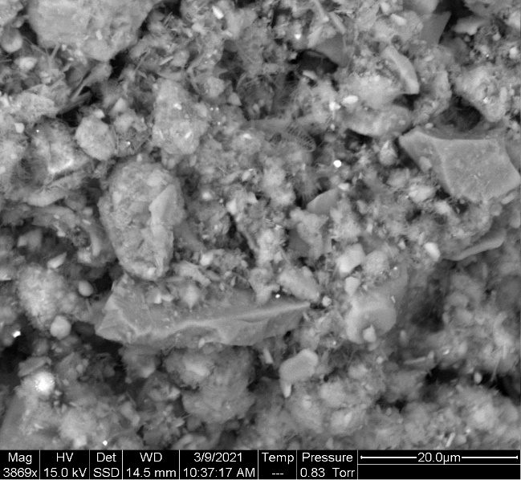 | 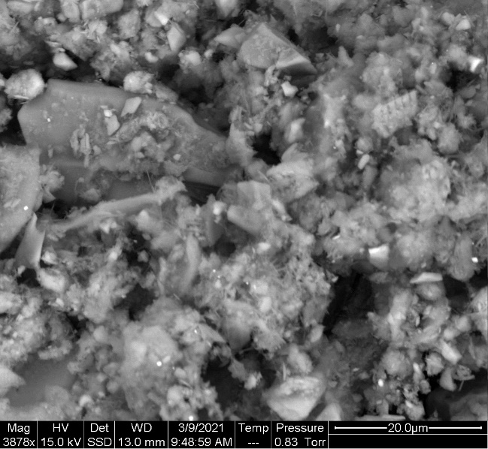
Original S/S 56 U-P | Electro S/S 56 U-P
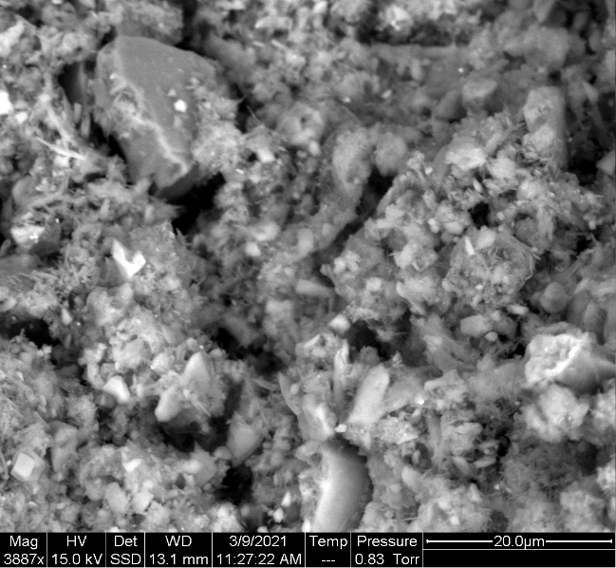 | 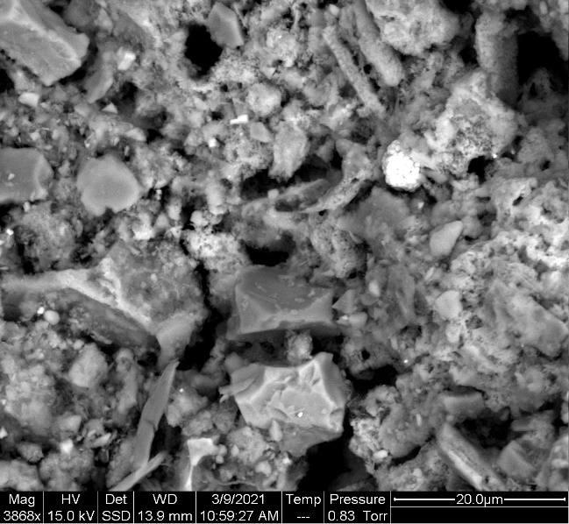
Original S/S 56 NaCl | Electro S/S 56 NaCl
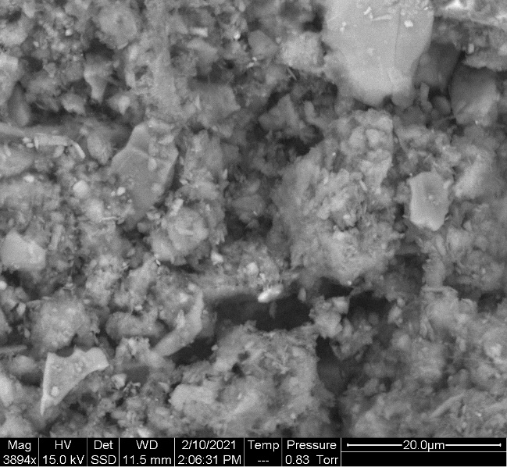
Original S/S 90 U-P | Electro S/S 90 U-P
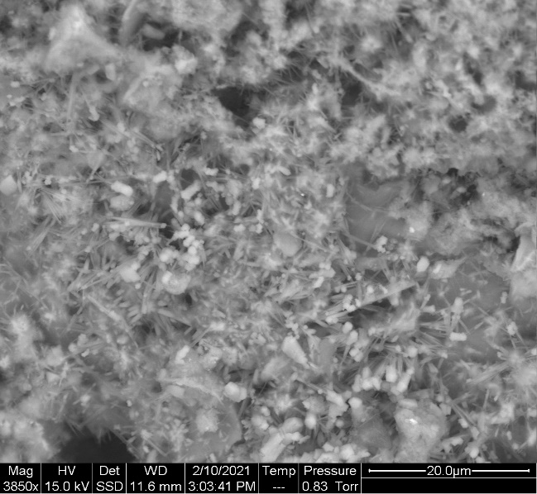 | 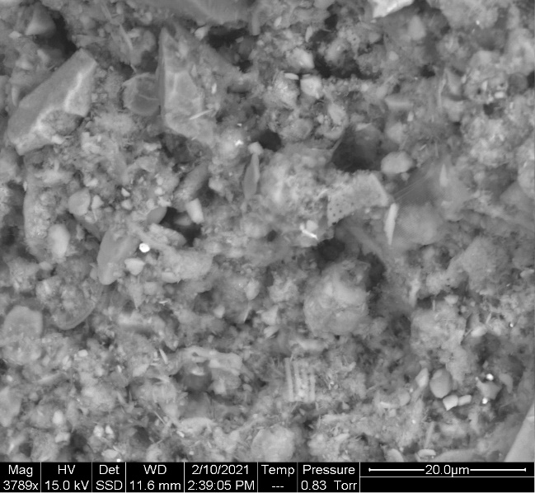
Original S/S 90 NaCl | Electro S/S 90 NaCl
Fig. A.1 ESEM images of cement, ground granulated blast-furnace slag (GGBS), untreated (original) sediment, electrochemically pretreated (electro) sediment, stabilized original samples (original S/S), and stabilized electrochemically pretreated sediment (electro S/S). The number in the stabilized samples’ image name identifies the time in days after the casting. The curing conditions for the stabilized sediments were either in ultra-pure (U-P) or saline (NaCl) water
Table A.3 Results from the compression tests for electrochemically pretreated stabilized sediment (electro S/S) and untreated stabilized sediment (original S/S) cured in ultra-pure (U-P) or saline (NaCl) water
 | Electro S/S U-P | Original S/S U-P | Electro S/S NaCl | Original S/S NaCl
Day | kPa | kPa | kPa | kPa
28 | 1343 | 444 | 973 | 630
28 | 873 | 965 | 1280 | 800
28 | 1160 | 913 | 1342 | 751
56 | 1295 | 1643 | 1215 | 1696
56 | 1411 | 1681 | 1232 | 1693
56 | 1355 | 1712 | 1243 | 1720
56 | 1042 | 1677 | - | -
90 | 442 | 2282 | 1359 | 2557
90 | 345 | 2153 | 1308 | 2485
90 | 226 | 2012 | 1280 | 2514
90 | 351 | 2436 | - | -

Electro stabilized sample in ultra-pure water | Original stabilized sample in ultra-pure water
Electro stabilized sample in saline water | Original stabilized sample in saline water
Electro stabilized sample in saline water with DOC
Fig. A.2 DBT leaching from untreated (i.e., original) and electrochemically pretreated (i.e., electro) stabilized sample cured in ultra-pure water, saline water, as well as saline water with dissolved organic carbon (DOC) in the NEN7375 surface diffusion leaching test. e*(n) displays the measured cumulative leaching and e(n) displays the derived cumulative leaching. The slope 0.5 is marked as a reference for identifying diffusion-controlled leaching (see Method and (Environment Agency, 2005))

Electro stabilized sample in ultra-pure water | Original stabilized sample in ultra-pure water
Electro stabilized sample in saline water | Original stabilized sample in saline water
Electro stabilized sample in saline water with DOC
Fig. A.3 MBT leaching from untreated (i.e., original) and electrochemically pretreated (i.e., electro) stabilized sample cured in ultra-pure water, saline water, as well as saline water with dissolved organic carbon (DOC) in the NEN7375 surface diffusion leaching test. e*(n) displays the measured cumulative leaching and e(n) displays the derived cumulative leaching. The slope 0.5 is marked as a reference for identifying diffusion controlled leaching (see Method and (Environment Agency, 2005))

Treated stabilized sample in ultra-pure water | Original stabilized sample in ultra-pure water
Treated stabilized samples in saline water | Original stabilized sample in saline water
Fig. A.4 Al leaching from untreated (original) and electrochemically pretreated (electro) stabilized sample cured in ultra-pure water and saline water in the NEN7375 surface diffusion leaching test. e*(n) displays the measured cumulative leaching and e(n) displays the derived cumulative leaching. The slope 0.5 is marked as a reference for identifying diffusion-controlled leaching (see Method and (Environment Agency, 2005))

Fig. A.5 Metals released (µg/kg DW) during the granular waste compliance L/S10 leaching test, leached in either ultra-pure water or saline water. Each uniquely colored bar is corresponding to either untreated (i.e., original) or electrochemically pretreated (electro) stabilized samples cured in ultra-pure water (U-P) or saline water (NaCl). The number on the horizontal axis denotes the number of days the samples have been curing when the leaching test was conducted

References
Cementa, 2021. Typanalys 2020.
Ecocem, n.d. GGBS - Technical data sheet.
Environment Agency, 2005. EA NEN 7375:2004 Leaching characteristics of moulded or monolitic building and waste material. Determination of leaching of inorganic components with diffusion test. "The tank test".

