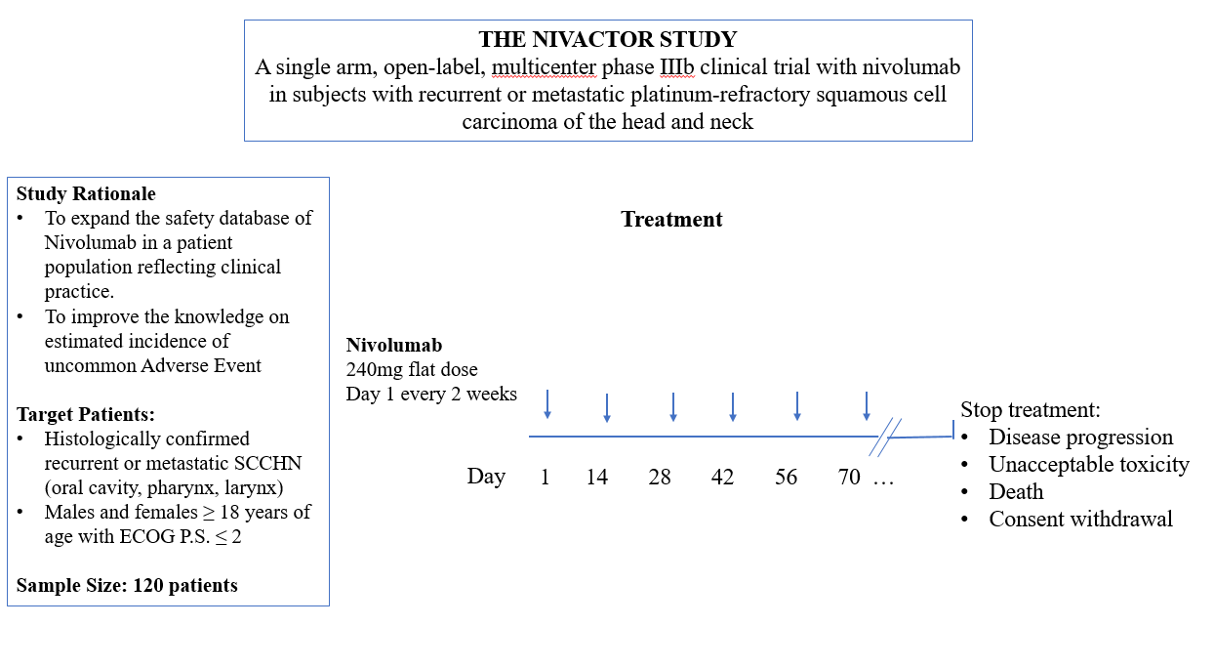

Fig S1. Representation of study design of NIVACTOR trials.
Fig S2. Kaplan Meier curves for PFS (left) and OS (right) for patient’s population.

Area Under the Curve

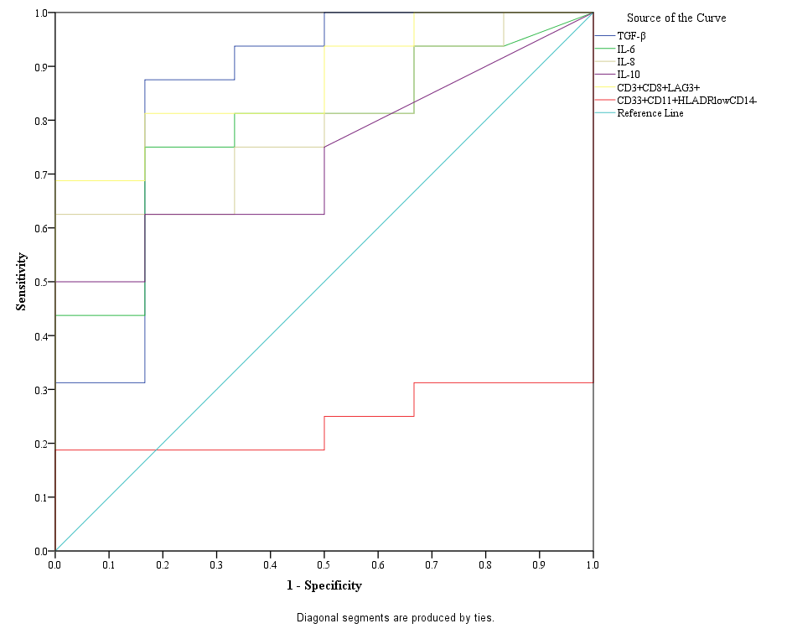

Test Result Variable(s) | Area | Std. Errorª | Asymptotic Sig.^{b} | Asymptotic 95% Confidence Interval
 |  |  |  | Lower Bound | Upper Bound
TGF-β | .854 | .108 | .012 | .642 | 1.000
IL-6 | .786 | .103 | .043 | .585 | .988
IL-8 | .792 | .097 | .039 | .602 | .981
IL-10 | .729 | .108 | .105 | .518 | .941
CD3+CD8+LAG3+ | .875 | .075 | .008 | .728 | 1.000
CD33+CD11+HLADRlowCD14- | .240 | .102 | .065 | .040 | .439
a. Under the nonparametric assumption
b. Null hypothesis: true area = 0.5

Fig S3. ROC curve and table of variables specific to identify Group 1 from Group 2.

Fig S4. Distribution of TGF-β, IL-6, IL-8 and CD3⁺CD8⁺LAG3⁺ between Group1 and Group2. * p<0.05, ** p<0.01.

Table S2. representation how patients of group 3 are distributed for each of four variables cut-off.
Group 3 Patients ID | cut-off IL-6 | cut-off IL-10 | cut-off TGF-β | cut-off CD3⁺CD8⁺LAG3⁺
NIVCN2 | above | below | below | below
NIVCN3 | below | below | below | below
NIVCN7 | below | below | below | below
NIVCN13 | below | below | below | below
NIVCA9 | below | below | below | below
NIVCA10 | below | above | above | above
Legend: IL, interleukins.

a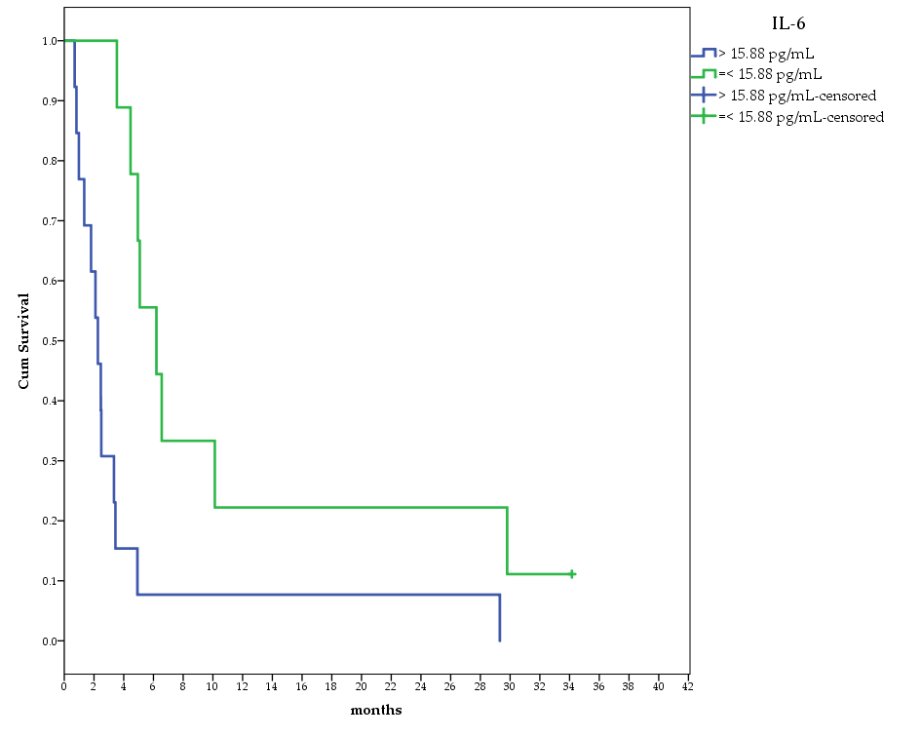b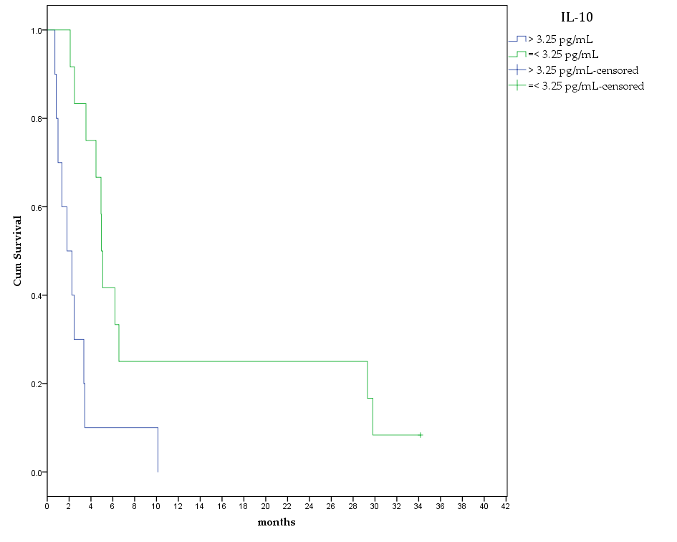
c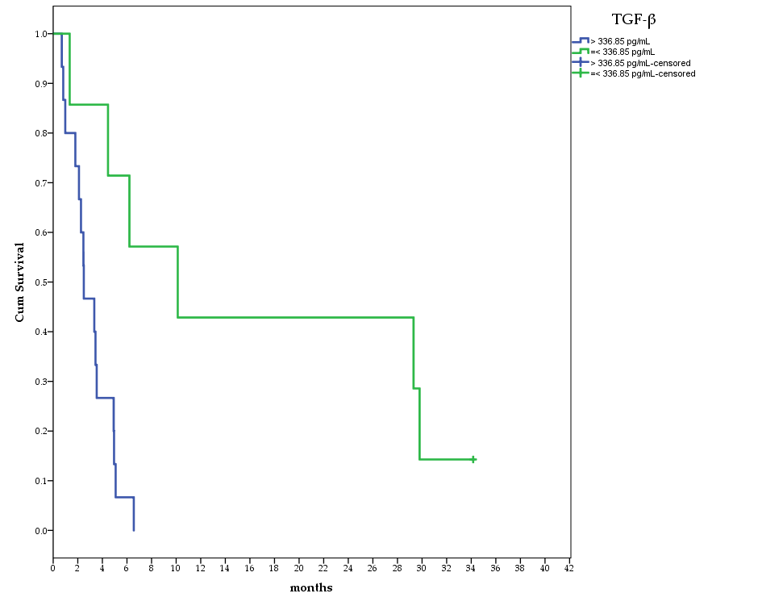d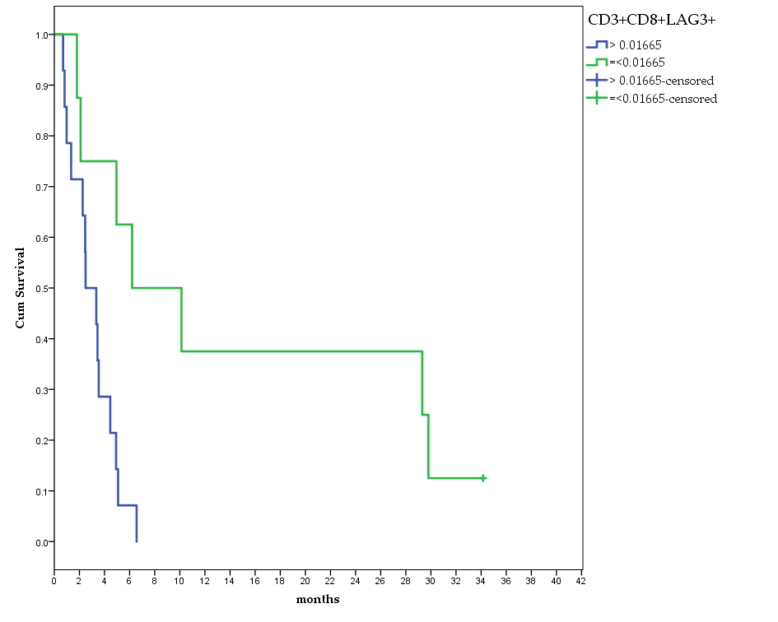

Fig S5.Kaplan Meier for a) IL-6, b) IL-10, c), TGF-β and d) CD3⁺CD8⁺LAG3⁺.

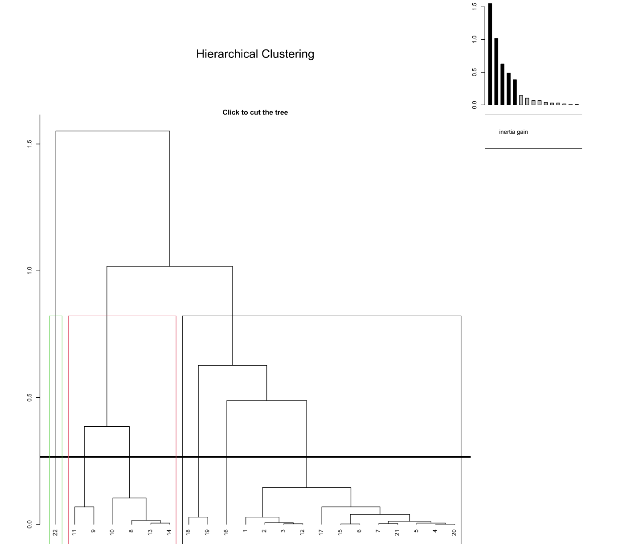
Fig S6. HCPC clustering with dendrogram selecting 3 clusters.

Table S3. OS for patients in cluster 1 and in cluster 2.
Cluster 1 | OS (months) | Cluster 2 | OS (months)
NIVCN1 | 4.5 | NIVCN8 | 3.4
NIVCN2 | 29.3 | NIVCN9 | 2.3
NIVCN3 | 6.2 | NIVCN10 | 1.3
NIVCN4 | 3.5 | NIVCN11 | 0.8
NIVCN5 | 4.9 | NIVCN14 | 0.7
NIVCN6 | 5.1 | NIVCN15 | 2.4
NIVCN7 | 29.8
NIVCN13 | 34.1
NIVCA1 | 4.9
NIVCA2 | 2.5
NIVCA6 | 3.3
NIVCA7 | 1.0
NIVCA8 | 2.1
NIVCA9 | 10.1
NIVCA10 | 6.6

Table S4. Multivariate Cox analysis for Cluster belonging, smoking status, site, sex and age.

Categorical Variable Codings^{a,c,d,e}
 |  | Frequency | (1)^{f}
AGE_group^{b} | 0==< median age | 10 | 1
AGE_group^{b} | 1=> median age | 11 | 0
smoking^{b} | 0=no, <10 p/y, passed | 8 | 1
smoking^{b} | 1=> 10 p/y | 13 | 0
Cluster^{b} | 1 | 15 | 1
Cluster^{b} | 2 | 6 | 0
sex^{b} | 0=female | 8 | 1
sex^{b} | 1=male | 13 | 0
a. Category variable: AGE_group
b. Indicator Parameter Coding
c. Category variable: smoking
d. Category variable: Cluster
e. Category variable: sex
f. The (0,1) variable has been recoded, so its coefficients will not be the same as for indicator (0,1) coding.

Variables in the Equation
 | B | SE | Wald | df | Sig. | Exp(B) | 95.0% CI for Exp(B)
 |  |  |  |  |  |  | Lower | Upper
Cluster | -2.492 | .744 | 11.211 | 1 | .001 | .083 | .019 | .356
smoking | 1.133 | .649 | 3.047 | 1 | .081 | 3.106 | .870 | 11.090
AGE_group | 1.617 | .734 | 4.855 | 1 | .028 | 5.037 | 1.196 | 21.219
sex | .234 | .682 | .118 | 1 | .731 | 1.264 | .332 | 4.814

