Supplementary Figures
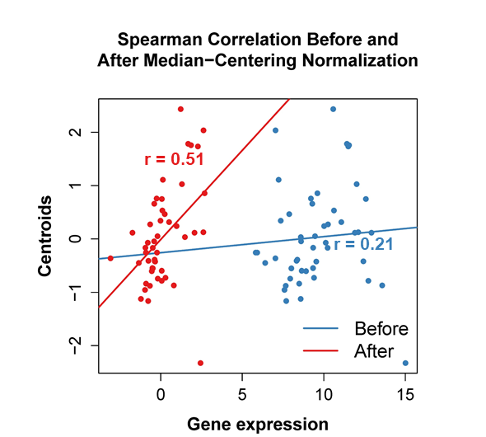
Supplementary Figure 1. Subtype prediction was changed from Luminal A to Normal-like.
The Spearman correlation coefficient was changed from 0.21 to 0.51 for centroids of Normal-like subtype after data normalization with more linearity, and it was the highest among the 5 coefficients for 5 intrinsic subtype centroids. This sample was changed from original Luminal A to Normal-like subtypes. Sample ID: TCGA-4H-AAAK-01A

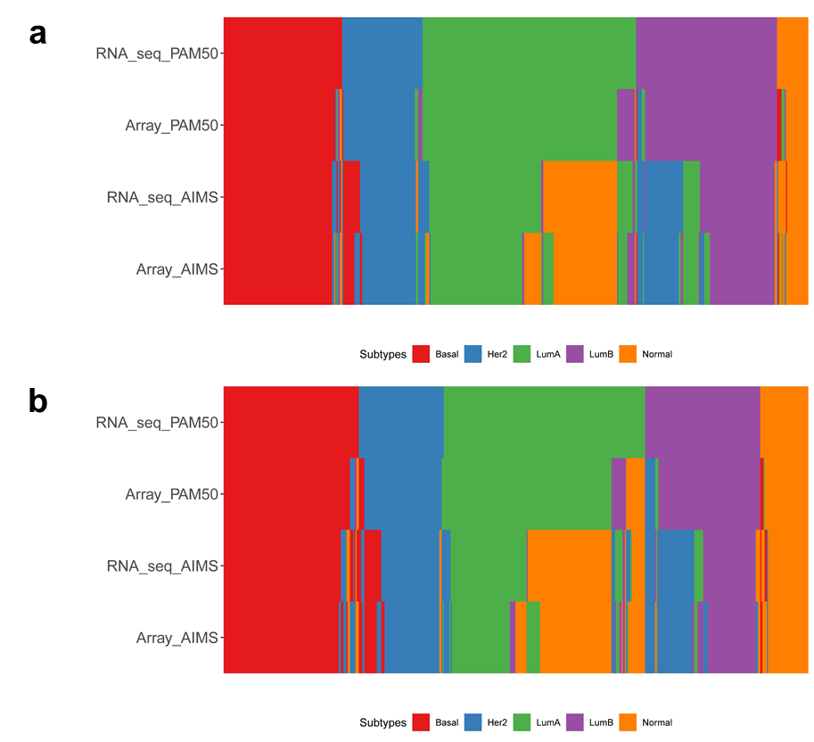
Supplementary Figure 2. Consistent Predictions after data normalization across genes within prediction models. a) Mean-centering; b) Median-centering.

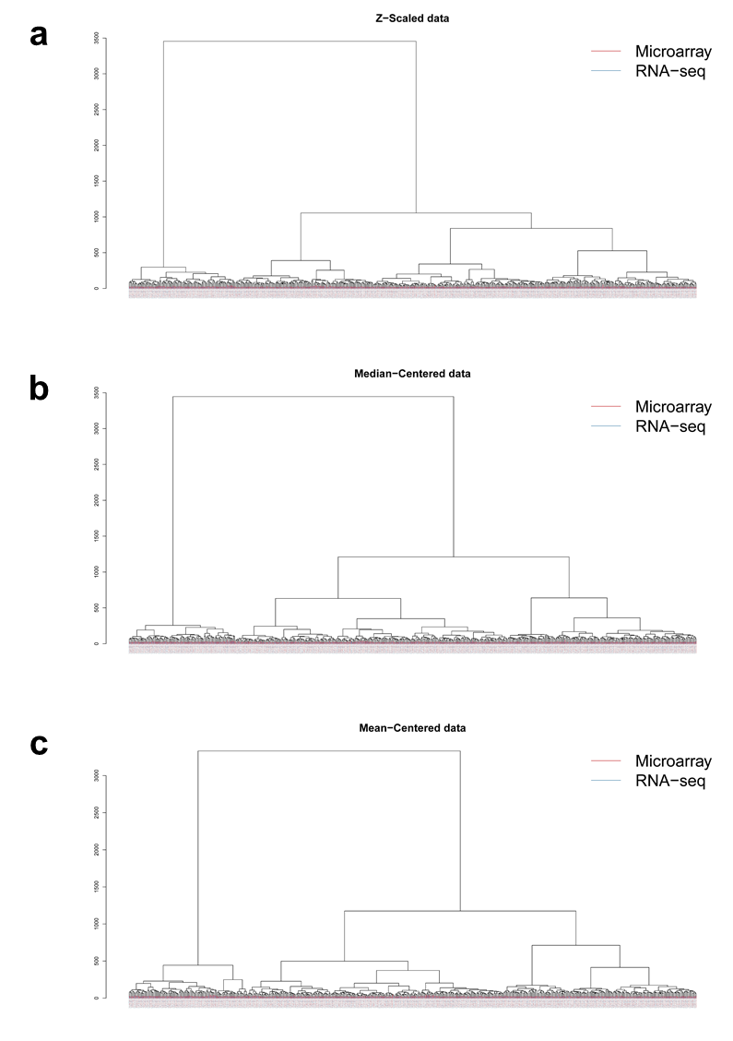
Supplementary Figure 3. Majority of the Microarray and RNA-seq data from the same samples clustered together by sample in hierarchical clustering analysis of gene-level normalized data. a) Z-Score normalization; b) Mean-centering; c) Median-centering.
Supplementary Figure 4. Batch effects between data of SEQC samples from two sites. HCA of gene expression exhibits large differences between data of SEQC samples from two sites (vendor-prepared libraries were excluded). Data of SEQC samples are from two sites: BGI (Beijing Genomics Institute) and CNL (Weill Cornell Medical College). Although the data of samples A, B, C, and D clustered together, the data from BGI and CNL clustered separately.

