  - SUPPORTING INFORMATION
Characterization and properties of a new insensitive explosive co-crystal composed of trinitrotoluene and pyrene

Nilgün Şen*^{1,2}, Nazife Aslan³, Bayram Yüksel⁴, Irem Teciman¹

¹Turkish National Police Academy, Institute of Forensic Sciences, Ankara, Turkey
²Centre for Defence Chemistry, Cranfield University, Defence Academy of the United Kingdom, Shrivenham, SN6 8LA, UK
³Department of Chemistry, Polatlı Science and Arts Faculty, Ankara Hacı Bayram Veli University, Ankara, Turkey
⁴Department of Property Protection and Security, Giresun University, Giresun, Turkey

Contents
Figure S1. Total free space in the unit cell of a) TNT and b) TNT: PYRN
Figure S2. Shock adiabat and expansion isentrope of a) TNT and b) TNT: PYRN

Figure S1. Total free space in the unit cell of a) TNT and b) TNT: PYRN
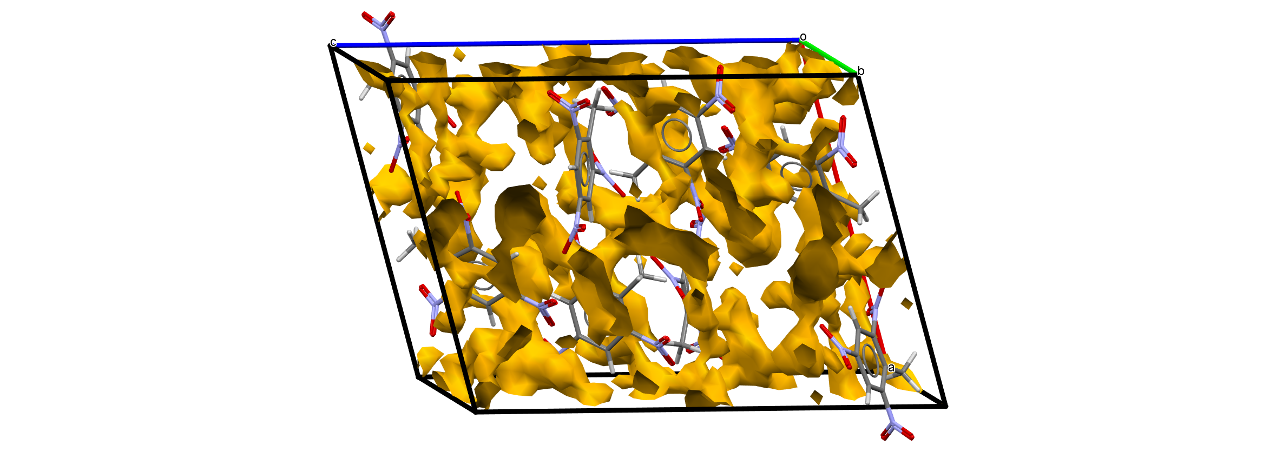
a

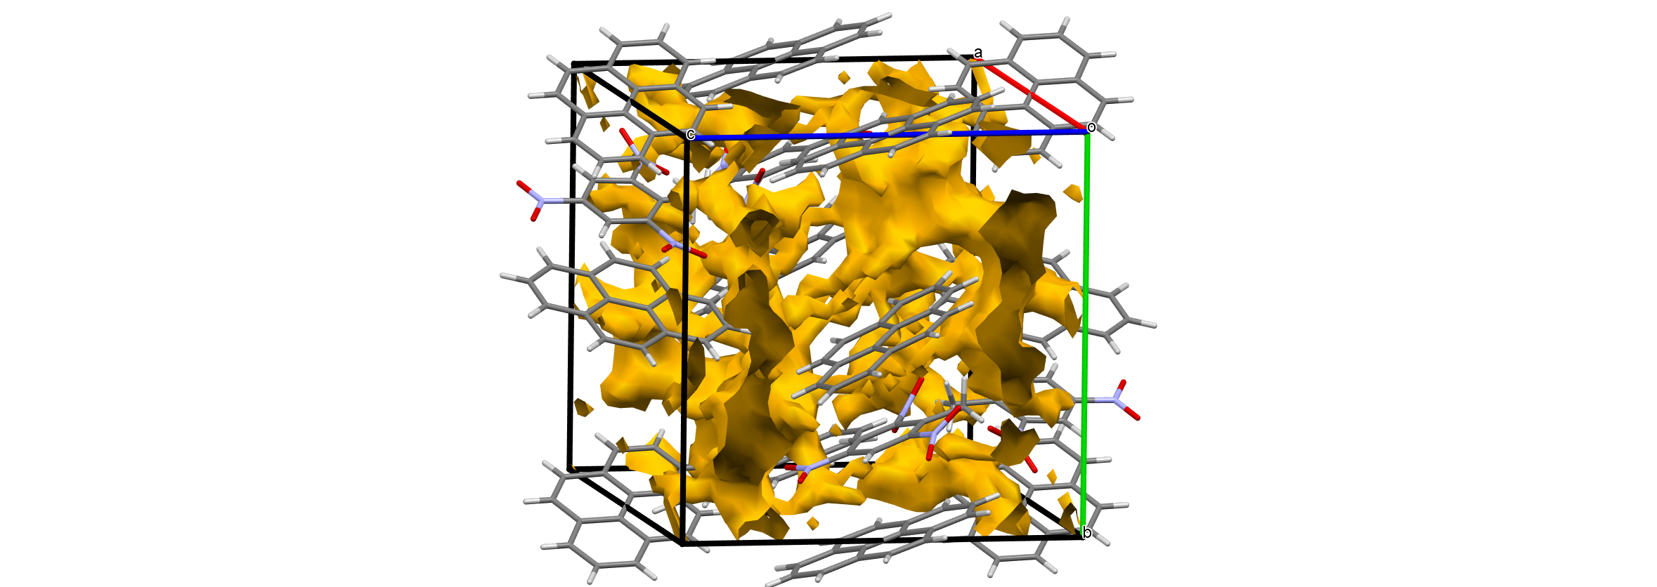

b

Figure S2. Shock adiabat and expansion isentrope of a) TNT and b) TNT:PYRN

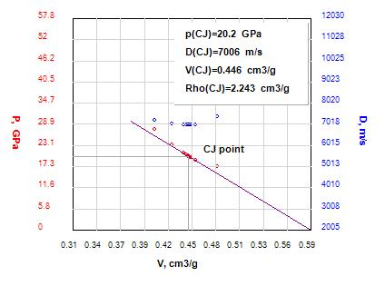

a

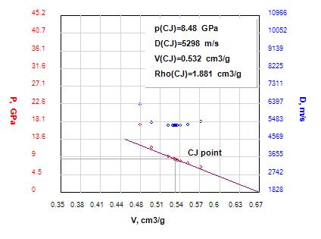
b

