Supplementary Figure
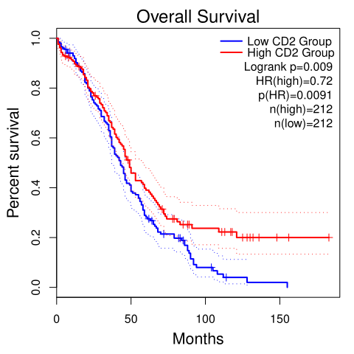A CD2 | 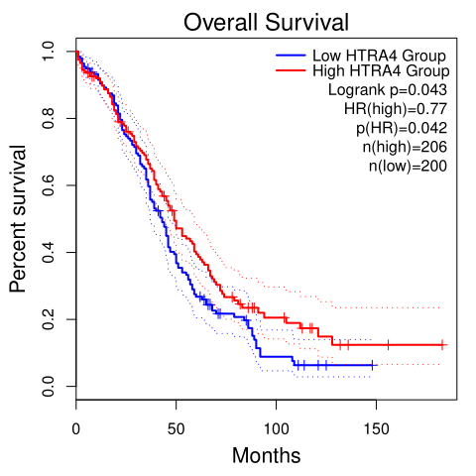  B HTRA4
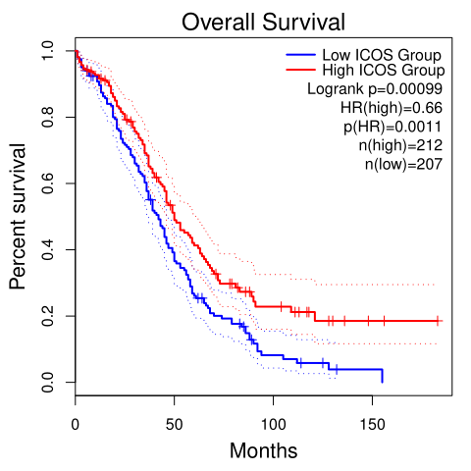  C ICOS | 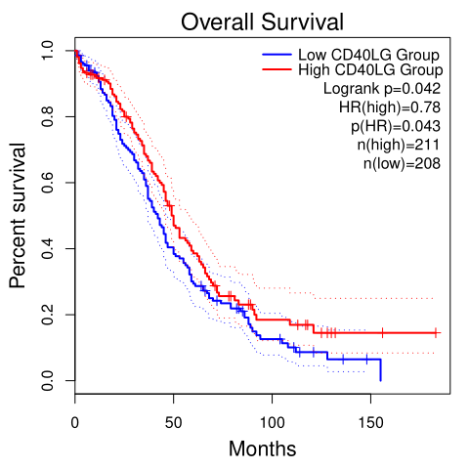  D CD40LG
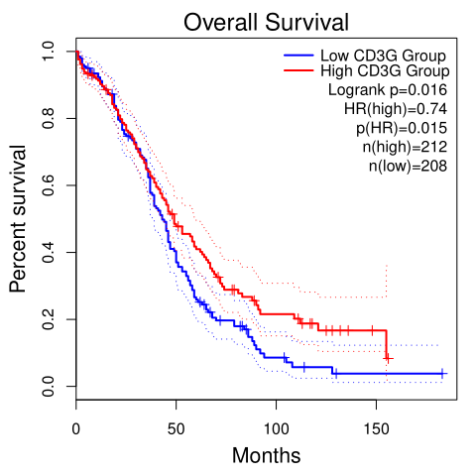
E CD3G
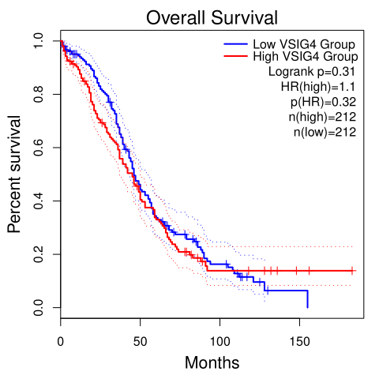  F VSIG4 | 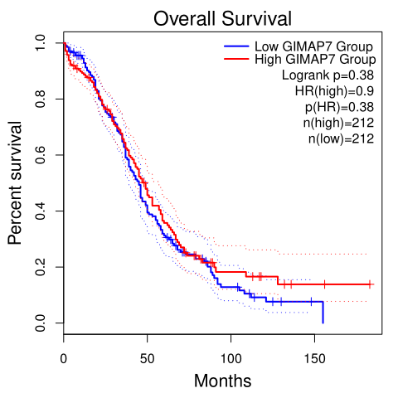  G GIMAP7
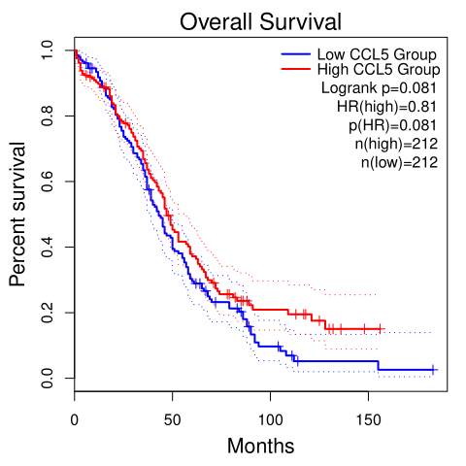  H CCL5 | 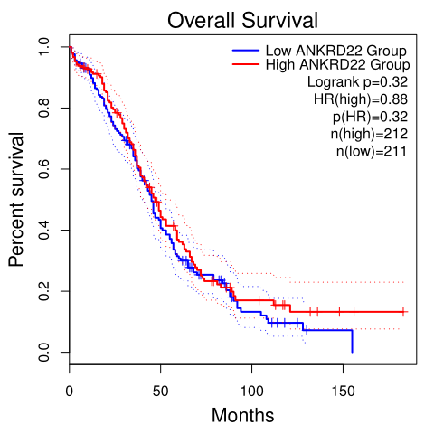  I ANKRD22
Figure S1.Kaplan-Meier curve analysis of 9 genes with OS in OC patients of TCGA cohorts.

Supplementary Table
Software Title | Software Version | Software Function
Survminer | V0.4.9 | visualization of survival analysis
Survival ROC Curve | V1.0.3 | ROC visualization
org.Hs.eg.db | V3.14.0 | gene enrichment database
limma | V3.50.0 | differential analysis
ggpubr | V0.4.0 | mapping software
ggplot2 | V3.3.5 | mapping software
estimate | V1.0.13 | analysis of immune score
clusterProfiler | V4.2.0 | GSEA
Table S1. The list of software used in the essay

