Supporting Information
Hydrolysis and condensation behavior of tetraethoxysilane, hexaethoxydisiloxane, and octaethoxytrisiloxane
Yohei Sato¹*, Asahi Sugimoto¹, Tatsuya Iwashina¹, Ryohei Hayami¹, Kazuki Yamamoto¹, Takahiro Gunji^{1,2}*
¹Department of Pure and Applied Chemistry, Faculty of Science and Technology, Tokyo University of Science, 2641 Yamazaki, Noda, Chiba 278-8510, Japan.
²Research Group for Advanced Energy Conversion, Research Institute for Science and Technology (RIST), Tokyo University of Science, 2641 Yamazaki, Noda, Chiba 278-8510, Japan
Corresponding authors: 7221702@ed.tus.ac.jp (Y. Sato), gunji@rs.tus.ac.jp (T. Gunji)

GC trace of reaction solution of HEDITS for 8 h

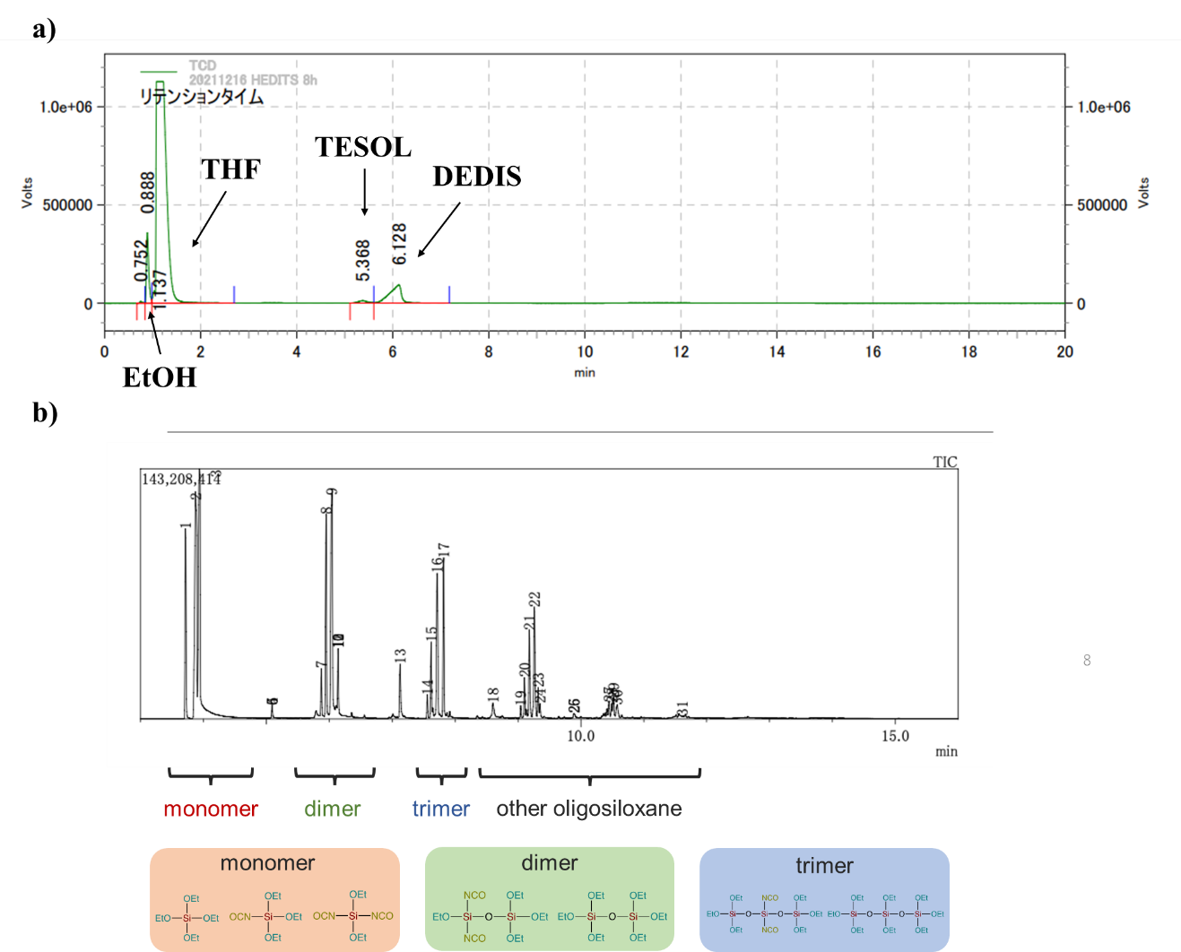
Figure S1. GC trace of reaction solution of HEDITS for 8 h on a) GC analysis, b) GC/MS analysis .

Estimated Structure for HPs on MS spectra
Table S1. Estimated Structure for ethoxysilane–TMS
M_{W} | structure | TEOS–TMS | HEDS–TMS | OETS–TMS
365 | Si₂O(OEt)₆ |  | ○
409 | Si₂O(OEt)₅(OSiMe₃) |  | ○
453 | Si₂O(OEt)₄(OSiMe₃)₂ |  | ○
497 | Si₂O(OEt)₃(OSiMe₃)₃ |  | ○
499 | Si₃O₂(OEt)₈ |  | ○ | ○
543 | Si₃O₂(OEt)₇(OSiMe₃)₁ | ○ | ○ | ○
587 | Si₃O₂(OEt)₆(OSiMe₃)₂ | ○ | ○ | ○
603 | Si₄O₄(OEt)₇(OSiMe₃)₁ | ○
631 | Si₃O₂(OEt)₅(OSiMe₃)₃ | ○ | ○ | ○
633 | Si₄O₃(OEt)₁₀ | ○ | ○ | ○
647 | Si₄O₄(OEt)₆(OSiMe₃)₂ | ○ | ○
675 | Si₃O₂(OEt)₄(OSiMe₃)₄ | ○ |  | ○
677 | Si₄O₃(OEt)₉(OSiMe₃)₁ | ○ | ○ | ○
691 | Si₄O₄(OEt)₅(OSiMe₃)₃ | ○ | ○
693 | Si₅O₅(OEt)₁₀ |  | ○
721 | Si₄O₃(OEt)₈(OSiMe₃)₂ | ○ | ○ | ○
737 | Si₅O₅(OEt)₉(OSiMe₃)₁ | ○ | ○
765 | Si₄O₃(OEt)₇(OSiMe₃)₃ | ○ | ○ | ○
767 | Si₅O₄(OEt)₁₂ | ○ |  | ○
781 | Si₅O₅(OEt)₈(OSiMe₃)₂ | ○ | ○ | ○
809 | Si₄O₃(OEt)₆(OSiMe₃)₄ | ○ | ○
811 | Si₅O₄(OEt)₁₁(OSiMe₃)₁ | ○ |  | ○
825 | Si₅O₅(OEt)₇(OSiMe₃)₃ | ○ |  | ○
853 | Si₄O₃(OEt)₅(OSiMe₃)₅ | ○
855 | Si₅O₄(OEt)₁₀(OSiMe₃)₂ | ○ | ○ | ○
869 | Si₅O₅(OEt)₆(OSiMe₃)₄ | ○
871 | Si₆O₆(OEt)₁₁(OSiMe₃)₁ |  |  | ○
899 | Si₅O₄(OEt)₉(OSiMe₃)₃ | ○ | ○ | ○
901 | Si₆O₅(OEt)₁₄ | ○ |  | ○
913 | Si₅O₅(OEt)₅(OSiMe₃)₅ | ○
915 | Si₆O₆(OEt)₁₀(OSiMe₃)₂ | ○ |  | ○
917 | Si₇O₁₀(OEt)₈(OSiMe₃)₂ |  |  | ○
931 | Si₇O₈(OEt)₁₁(OSiMe₃)₁ | ○
943 | Si₅O₄(OEt)₈(OSiMe₃)₄ | ○ |  | ○
945 | Si₆O₅(OEt)₁₃(OSiMe₃)₁ | ○ |  | ○
959 | Si₆O₆(OEt)₉(OSiMe₃)₃ | ○ | ○ | ○
961 | Si₇O₇(OEt)₁₄ | ○ |  | ○
975 | Si₇O₈(OEt)₁₀(OSiMe₃)₂ | ○ | ○
987 | Si₅O₄(OEt)₇(OSiMe₃)₅ | ○
989 | Si₆O₅(OEt)₁₂(OSiMe₃)₂ | ○ | ○ | ○
1003 | Si₆O₆(OEt)₈(OSiMe₃)₄ | ○
1005 | Si₇O₇(OEt)₁₃(OSiMe₃)₁ | ○
1031 | Si₅O₄(OEt)₆(OSiMe₃)₆ | ○
1033 | Si₆O₅(OEt)₁₁(OSiMe₃)₃ | ○ | ○ | ○
1047 | Si₆O₆(OEt)₇(OSiMe₃)₅ | ○ | ○
1049 | Si₇O₇(OEt)₁₂(OSiMe₃)₂ | ○ | ○
1077 | Si₆O₅(OEt)₁₀(OSiMe₃)₄ | ○ | ○ | ○
1079 | Si₇O₆(OEt)₁₅(OSiMe₃)₁ | ○ | ○ | ○
1093 | Si₇O₇(OEt)₁₁(OSiMe₃)₃ | ○ | ○
1121 | Si₆O₅(OEt)₉(OSiMe₃)₅ | ○ | ○
1137 | Si₇O₇(OEt)₁₀(OSiMe₃)₄ | ○
1167 | Si₇O₆(OEt)₁₃(OSiMe₃)₃ | ○ | ○
1211 | Si₇O₆(OEt)₁₂(OSiMe₃)₄ | ○ | ○
1255 | Si₇O₆(OEt)₁₁(OSiMe₃)₅ | ○
1257 | Si₈O₇(OEt)₁₆(OSiMe₃)₂ | ○ | ○
1299 | Si₇O₆(OEt)₁₀(OSiMe₃)₆ | ○
1301 | Si₈O₇(OEt)₁₅(OSiMe₃)₃ | ○
1345 | Si₈O₇(OEt)₁₄(OSiMe₃)₄ | ○

FT-IR spectra of ethoxysilane–TMSs
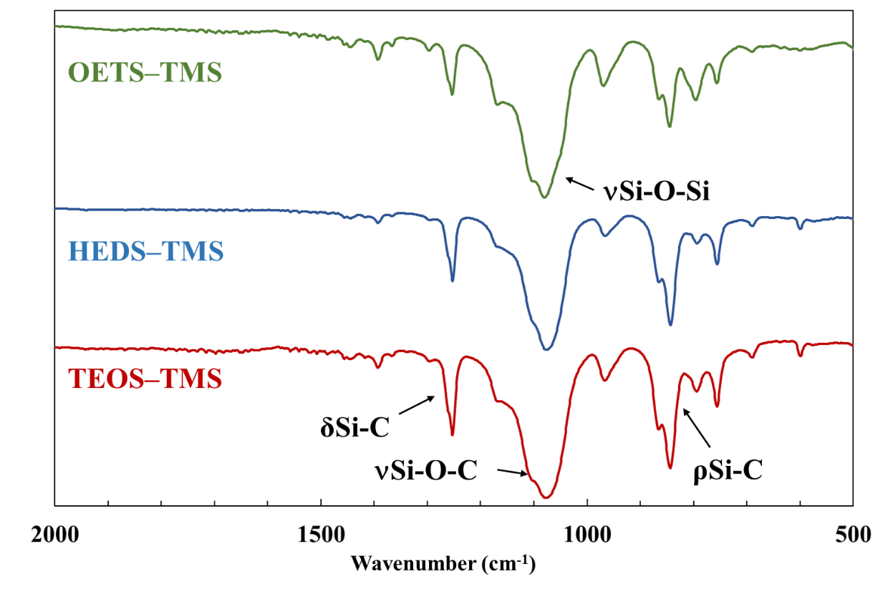
Figure S2 FT-IR spectra of top) OETS–TMS, middle) HEDS–TMS, and bottom) TEOS–TMS (neat method).

GPC of oligomers
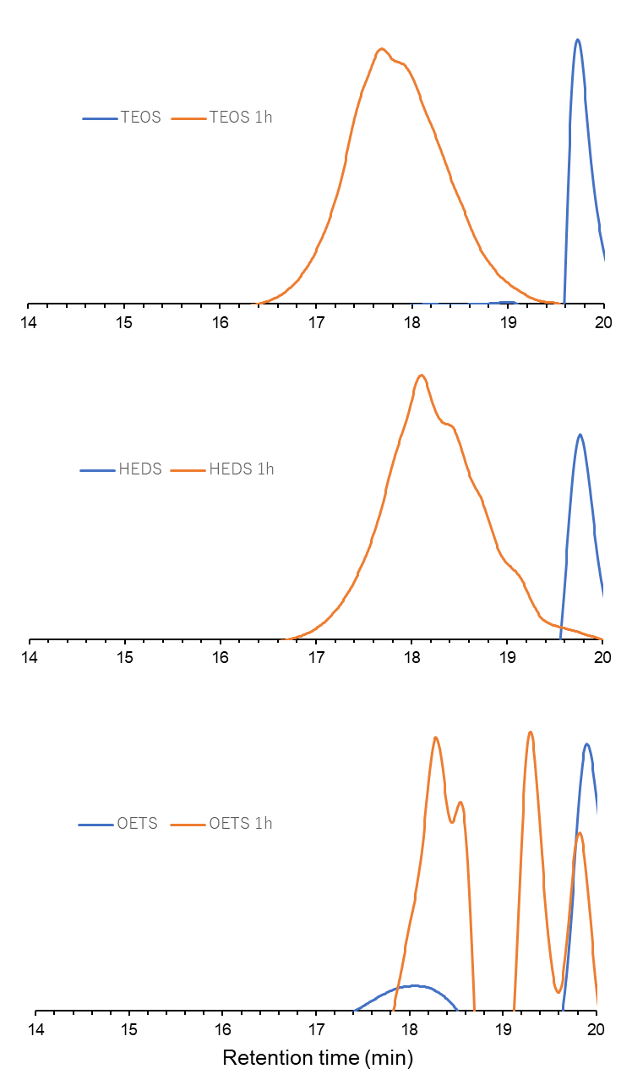
Figure S3. GPC chart of monomers and oligomers for 1 h
Synthesis of Diethoxydiicocyanatosilane (DEDIS)
According to a previous procedure [1]. A mixture of ethanol (9.2 g, 0.2 mol) and diethylether (40 ml) was added dropwise to a mixture of tetraisocyanatosilane (19.62 g, 0.1 mol) and diethylether (160 ml) at 0 °C. Then, a mixture was stirred at ca. 23 °C for ten min followed by stirring at 40 °C for o.n.. After the reaction, the solvent was evaporated. DEDIS was obtained as colorless liquid (18.4 g, 91%) by distillation (77.2–78.1℃, 23 mmHg).

¹H NMR (400 MHz, CDCl₃ / ppm): δ 3.88 (q, J = 6.0 Hz, CH₂, 4H), 1.25 (t, J = 6.0 Hz, CH₃, 6H).
²⁹Si NMR (80 MHz, CDCl₃ / ppm): δ −93.2.

Synthesis of chloro(triethoxy)silane (CTES)
According to a previous procedure [2,3]. A mixture of SOCl₂ (23.9 g, 0.2 mol) and DMF (0.1 mL) was then cooled in an ice bath, and TEOS (20.5 g, 0.1 mol) was slowly added dropwise to a mixture and stirred for 1 h in the ice bath and then for o. n. at ca. 23 °C. Subsequently, the volatiles were evaporated under reduced pressure, followed by distillation under reduced pressure (67.0–68.8 °C, 76 mmHg) to give 89.3 g (92% yield) of CTES as a colorless liquid.
¹H NMR (400 MHz, CDCl₃ / ppm): δ 3.90 (q, 6H, J = 6.0 Hz, CH₂), 1.26 (t, 9H, J = 6.0 Hz, CH₃).
²⁹Si NMR (80 MHz, CDCl₃ / ppm): δ −70.1.

Synthesis of triethoxysilanol (TESOL)
According to a previous procedure [2,3]. CTES (9.98 g, 0.05 mol) dissolved in THF (100 mL) was added dropwise to a mixture of THF as received (250 mL), (NH₄)₂CO₃ (24.22 g, 0.25 mol), and water (0.90 g, 0.05 mol) in an ice bath. The mixture was then stirred for 1 h at ca. 23 °C. After filtration, the volatiles were removed under reduced pressure, followed by vacuum distillation (b.p. 56.3–61.2 °C, 3.1 mmHg) to give 6.8 g (76% yield) of TESOL as a colorless liquid.
¹H NMR (400 MHz, CDCl₃): δ (ppm) 4.50 (s, 1H, OH), 3.83 (q, 6H, J = 6.0 Hz, CH₂), 1.21 (t, 9H, J = 6.0 Hz, CH₃).
¹³C NMR (125 MHz, CDCl₃): δ (ppm) 18.0 (CH₃), 59.4 (CH₂).
²⁹Si NMR (100 MHz, CDCl₃): δ (ppm) −78.7.
FT-IR (neat, cm⁻¹): 3403 (νO-H), 2976, 2929, 2895 (νC-H), 1170 (ρCH₃), 1103 (νSi-O-C), 966 (νC-C), 905 (νSi-O-H).

References
[1] Abe Y, Motoyama K, Kobayashi T, Iwasaki S, Gunji T (1996) Syntheses of Alkoxyisocyanatosilanes from Tri- and Tetraisocyanatosilane. NIPPON KAGAKU KAISHI 1996:969–974. https://doi.org/10.1246/nikkashi.1996.969
[2] Kazakova VV, Gorbatsevich OB, Skvortsova SA, Demchenko NV, Muzafarov AM (2005) Synthesis of triethoxysilanol. Russ. Chem. Bull. 54:1350–1351. https://doi.org/10.1007/s11172-005-0409-y
[3] Yamamoto K, Shimoda T, Sato Y, Nakaya T, Ohshita J, Gunji T (2022) Preparation and film properties of polysiloxanes consisting of di- and quadra-functional hybrid units. J. Sol-Gel Sci. Technol. 104:724–734. https://doi.org/10.1007/s10971-022-05806-zK

