Supporting Information

In Silico Screening of Laccases with Universality based on Structural Analysis

Yunxin Zheng ^{a, 1}, Chang Liu ^{a, 1}, Chengyu Zhang ª, Zixin qi ª, Shengping You^{*, a, d}, Wei Qi ^{a, b, c, d}, Rongxin Su ^{a, b, c, d}
* Corresponding author.
¹ Two authors contributed equally to the work.

Address:
ª Chemical Engineering Research Center, School of Chemical Engineering and Technology, Tianjin University, Tianjin 300072, PR China
^{b} State Key Laboratory of Chemical Engineering, Tianjin University, Tianjin 300072, PR China
^{c} Collaborative Innovation Center of Chemical Science and Engineering (Tianjin), Tianjin 300072, P. R. China.
^{d} Tianjin Key Laboratory of Membrane Science and Desalination Technology, Tianjin University, Tianjin 300072, PR China
Tel: +86 22 27407799
Fax: +86 22 27407599
E-mail address: ysp@tju.edu.cn;

Four different sources of laccases was analyzed based on sequence and crystal structure, including maize laccase (6KLI), T.versicolor-derived laccase (1KYA), E.coli-derived laccase (3PAV) and CotA (4Q8B). Their amino acid sequences are highly divergent (Fig. S1). However, their amino acid residues that interact with copper ions share high similarity.
In the three-dimensional structure of laccase, different domains are close to each other by hydrophobic forces, and the disulfide bonds between the domains also contributes to the compactness of the structure (Fig. S2). Although these four laccases are highly conserved in the amino acid sequences that interact with copper ions, their exposed area of surface copper (T1 copper) varies greatly (Fig. S3). T1 copper is located in the recess of the catalytic active center and receives electrons from the substrate. Its exposure area reflects the size of the active pocket. The exposure degree of T1 copper and the type and spacing of amino acids interacting with T1 copper in the active pocket are closely related to its oxidation ability. The distance between T1 copper and its coordinated cysteine residue was 2.2 Å for all four laccases (Fig. S4).
In order to compare the catalytic properties of the four laccases, eight substances were selected as ligands (Table S1). The specific binding position of the ligand and the interaction force between the ligand and amino acid residues in the active pocket were further analyzed (Fig. S5). The active pocket of 4Q8B can accommodate large ligand molecules. All the ligands are close to the bottom of active pocket, which shows a broader extent for substrates. And representative data were selected to further analyze the relevance of the data (Table S3).
Therefore, CotA (4Q8B) was selected for broad-spectrum catalytic applications in view of its strong substrate universality, short fermentation cycle and high tolerability. The CotA gene was introduced into the plasmid by double enzyme digestion technique, and the primer information is listed in Table S2. Finally, the CotA obtained through screening has been further applied in our group, and shows excellent catalytic performance (Table S4). It's an eco-friendly tool for disease treatment, biological detection, contaminant degradation, biomass conversion, and protein cross-linking.

Fig. S1 Amino acid sequence homology analysis of four laccases. Copper-binding domains (≡) were labeled below the sequence, the red region shows the amino acid residues that interact with copper ions.

Fig. S2 Comparison of disulfide bonds in laccases from different sources.

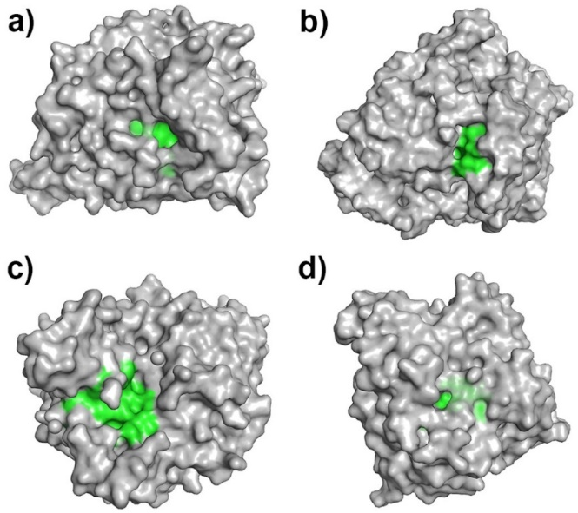
Fig. S3 The T1 copper exposure diagrams for laccases (a) 6KLI, (b)1KYA, (c) 4Q8B and (d) 3PAV.

Fig. S4 The key amino acid residues near the T1 copper of four laccases. (a) 6KLI, (b) 1KYA, (c) 4Q8B, (d) 3PAV.

Fig. S5 The binding diagrams of 8 ligands and four laccases. A-H represent the binding diagrams of four laccases with ABTS, SA, GU, CA, HBT, TEMPO, AMP and TET, respectively; a1-h1 represent the docking diagrams of the active pockets for four laccases and ABTS, SA, GU, CA, HBT, TEMPO, AMP, TET, respectively; a2-h2 represent the docking diagram details of the active pockets of four laccases with ABTS, SA, GU, CA, HBT, TEMPO, AMP, TET, respectively; a3-h3 represent the interaction in the docking complex formed by four laccases and 8 ligands (ABTS, SA, GU, CA, HBT, TEMPO, AMP, and TET).

Table S1 The information of ligands for enzymes
Num | Abbreviation | Structure | Molecular Weight | CAS
1 | ABTS |  | 548.68 | 30931-67-0
2 | SA |  | 210.23 | 537-33-7
3 | GU |  | 124.14 | 90-05-1
4 | CA |  | 180.20 | 458-35-5
5 | HBT |  | 227.28 | 3411-95-8
6 | TEMPO |  | 156.25 | 2564-83-2
7 | AMP |  | 403.45 | 7177-48-2
8 | TET |  | 444.44 | 60-54-8

Table S2 Pcrimers for CotA
Name | Sequence
Laccase-F | 5´-CGCGGATCCATGACACTTGAAAAATTTGTGGATGCTCTC
Laccase-R | 5´-CCGCTCGAGCTAGTGGTGGTGGTGGTGGTGTTTATGGGGATCAGTT ATATCC

Table S3 Representative data were selected for correlation analysis
 | 6KLI | 1KYA | 4Q8B |  | 3PAV
ABTS | -13.75 | -13.45 | -11.58 | 1.12
SA | -11.22 | -10.64 | -11.81 | -3.36
GU | -19.08 | -15.53 | -17.76 | -8.50
CA | -15.53 | -13.02 | -16.18 | -4.72
HBT | -9.37 | -8.84 | -8.92 | -2.38
TEMPO | -5.73 | -5.32 | -8.79 | -3.10
AMP | -19.32 | -16.48 | -22.95 | -10.49
TET | -3.17 | -4.57 | -19.58 | -1.90
T1 | 84.96 | 95.55 | 186.3 | 51.03
pocket | 786.45 | 399.73 | 1095.54 | 132.48
charge | 46 | 59 | 29 | 29
pI | 5.88 | 4.51 | 6.38 | 6.55

Table S4 The applications of B. subtilis-derived laccase (CotA) in our group.
Field | Substrate | Reaction system | Results | Reference
Disease treatment | Quercetin (QU) | Activate prodrug QU to produce toxic oxide quercetin. | The enzymatic activity of CotA to QU was up to 0.5 U/mg. | Zhou et al., 2022b
Biological detection | Direct bilirubin (DB) and Total bilirubin (TB) | Oxidized bilirubin | The pH selective oxidation of DB at pH 5.5 and TB at pH 7.5. | Zhang et al., 2021
Biomass conversion | 5-hydroxymethylfurfural (5-HMF) | Selectively convert 5-HMF to FFCA with TEMPO | FFCA yield reached 98.55% with high selectivity (98.65%). | Zhang et al., 2019a
Protein modification | Gallic acid (GA) | Catalyzed GA to bind to soy protein isolate (SPI) | The scavenging rates of DPPH and ABTS were almost 5- and 1.5-fold. | Wang et al., 2022
Contaminant degradation | Bisphenol A (BPA) | Biodegraded BPA | The removal rate of BPA was Nearly 100% after 4 h. | Zhang et al., 2020a
Contaminant degradation | Tetracycline (TE) and Ampicillin (AML) | Biodegraded TE and AML. | The degradation efficiency of TE and AML in some actual water was almost 100%. | Zhang et al., 2020b
Contaminant degradation | Ciprofloxacin (CIP) and Tetracycline-HCl (TCH) | Biodegraded CIP and TCH with TEMPO | The degradation efficiency of CIP and TCH were 95.42% and 98.73%, respectively. | Zhou et al., 2022a

