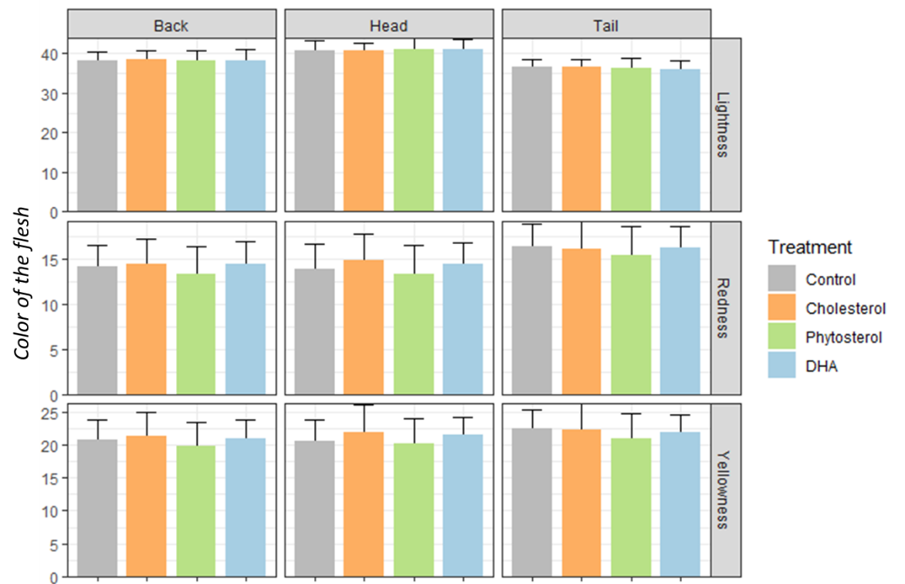
Supplementary Figure 1. Flesh color (Minolta) of the fish fed 4 different diets (n= 45 fish each dietary group).

