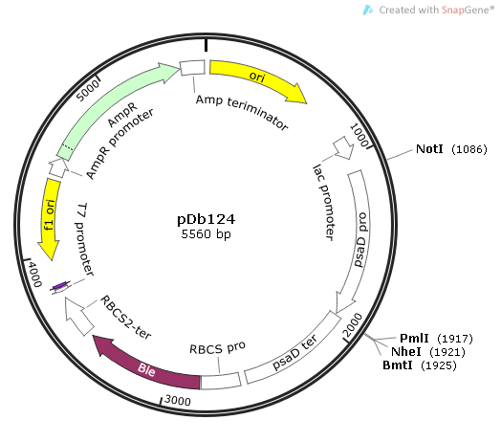
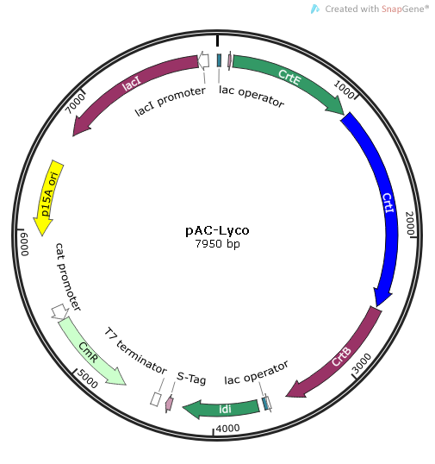

- (B)

Fig. S1 Schematic map of pAC-Lyco and pDb124 used in this study.

