Supporting Information for
Preparation and Enantiomeric Separation of L-Pro-L-Phe-L-Val-L-Leu Peptide Stationary Phases
Xinyuan Guo, Panpan Shang, Benben Wei, Wenrong Du, Yong Lan, Ligai Bai, Xiaoqiang Qiao, Zhengyue Ma*
College of Pharmaceutical Sciences, Key Laboratory of Pharmaceutical Quality Control of Hebei Province, Hebei University, Baoding, 071002, China

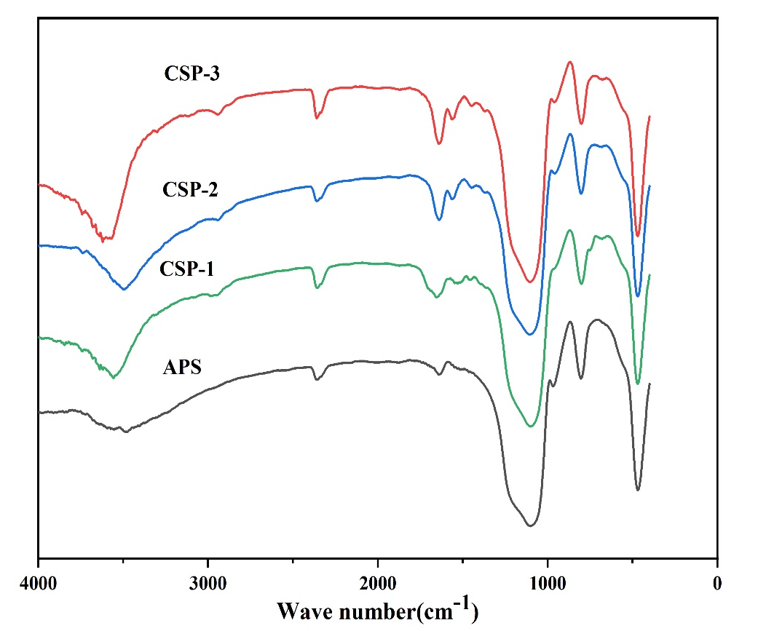
Fig. S1 FT-IR spectra of APS, CSP-1, CSP-2 and CSP-3.
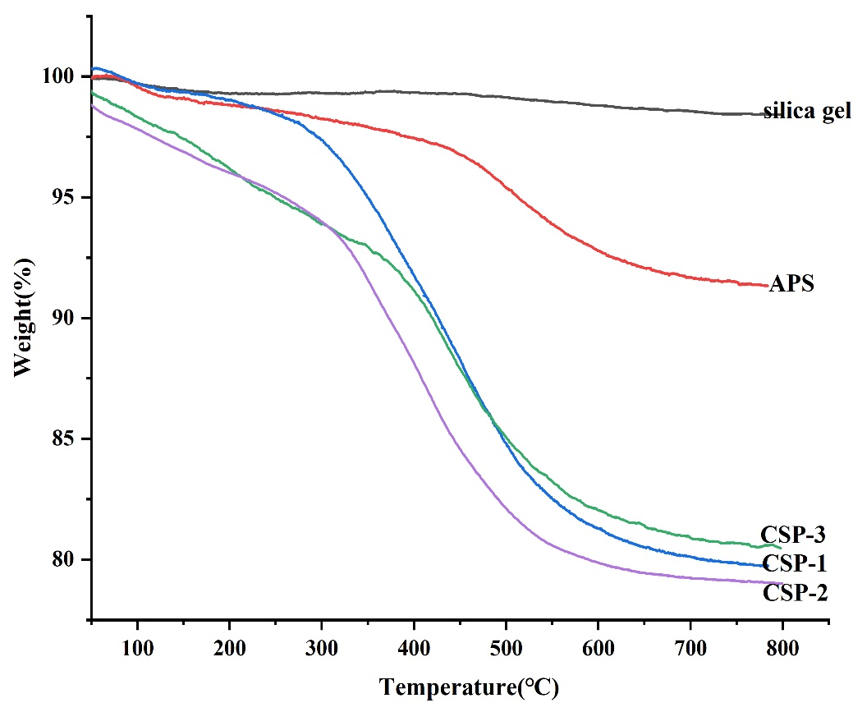
Fig. S2 TGA curves of Silica, APS, CSP-1, CSP-2, CSP-3.

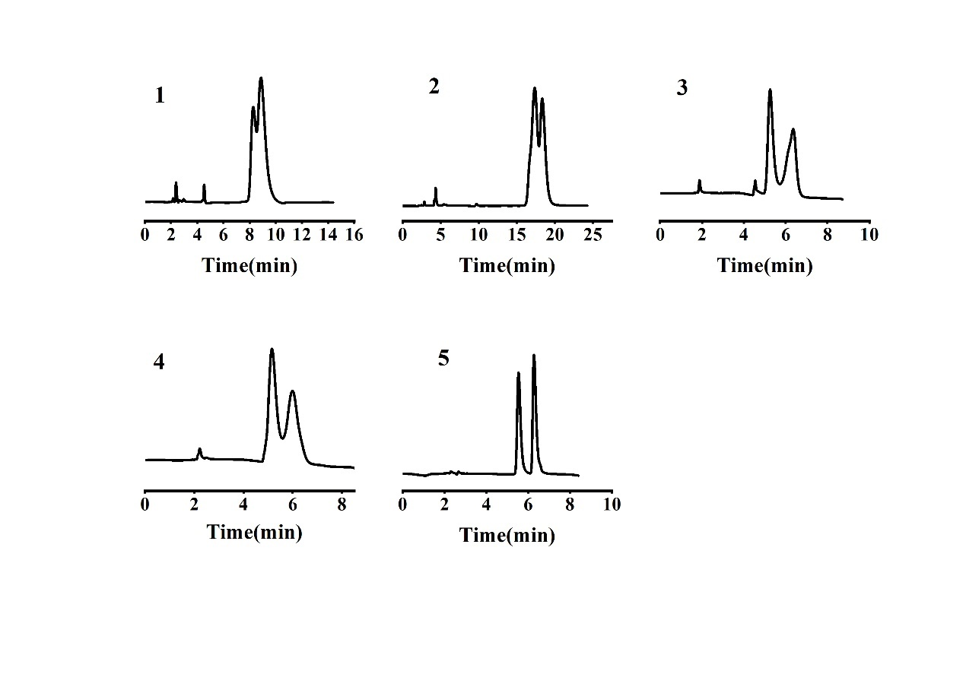
Fig. S3 Chromatograms for separation of racemic (1) benzoin, (2) 1,1-bi-2-naphthol, (3) flurbiprofen, (4) ketoprofen and (5) naproxen on the CSP-1. Other chromatographic conditions as shown in Table 2.

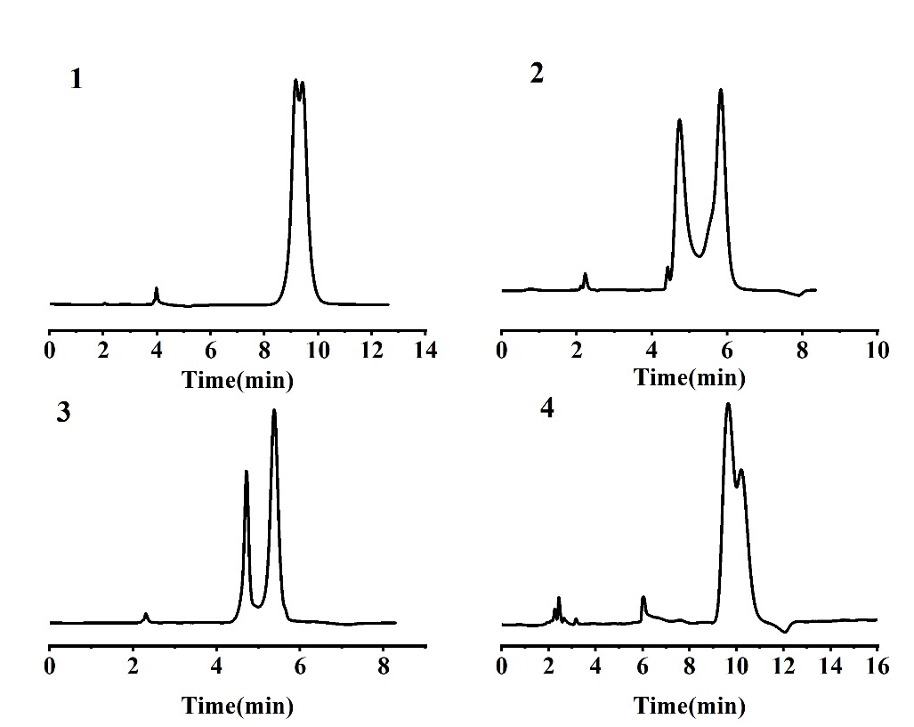
Fig. S4 Chromatograms for separation of racemic (1) 1,1-bi-2-naphthol, (2) flurbiprofen, (3) ketoprofen and (4) naproxen on the CSP-2. Other chromatographic conditions as shown in Table 2.
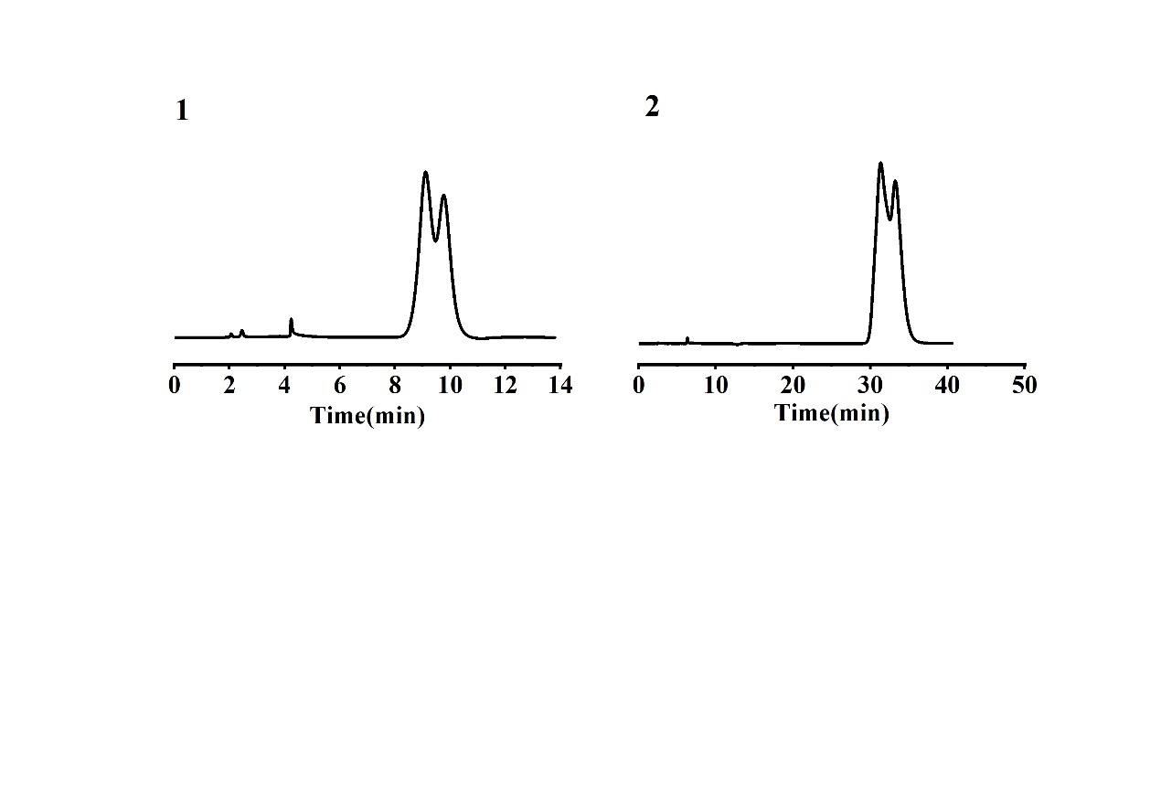
Fig. S5 Chromatograms for separation of racemic (1) flurbiprofen and (2) 1,1-bi-2-naphthol on the CSP-3. Other chromatographic conditions as shown in Table 2.
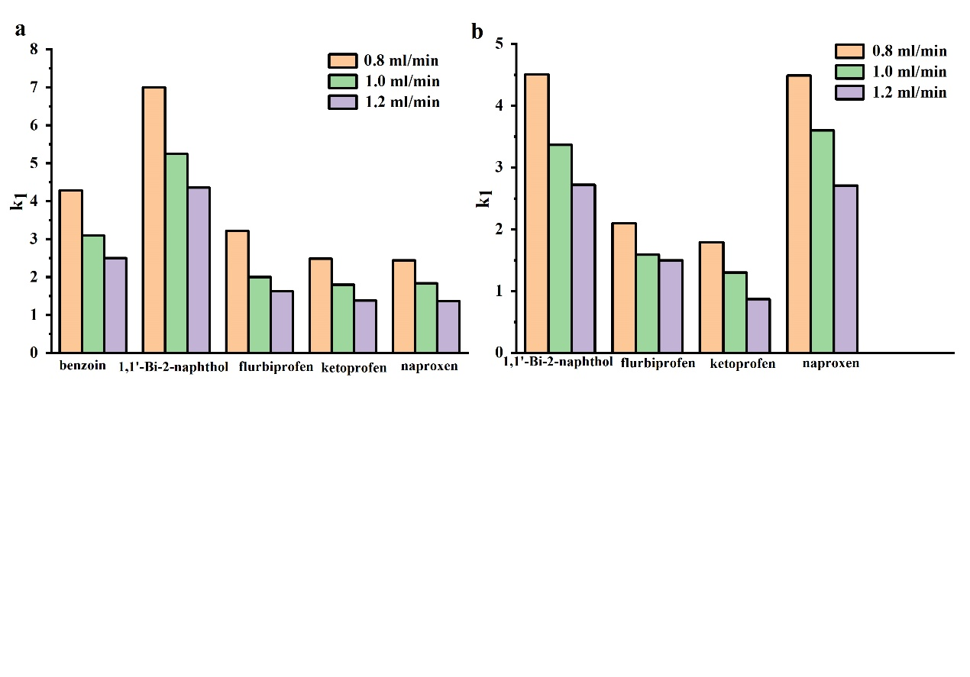
Fig. S6 Effect of flow rate on k₁ of chiral compounds on (a) CSP-1 and (b) CSP-2. Chromatographic conditions: injection volume, 5 μL; column temperature, 30 ℃; detection wavelength, 254 nm. Mobile phases conditions as shown in Table 2.
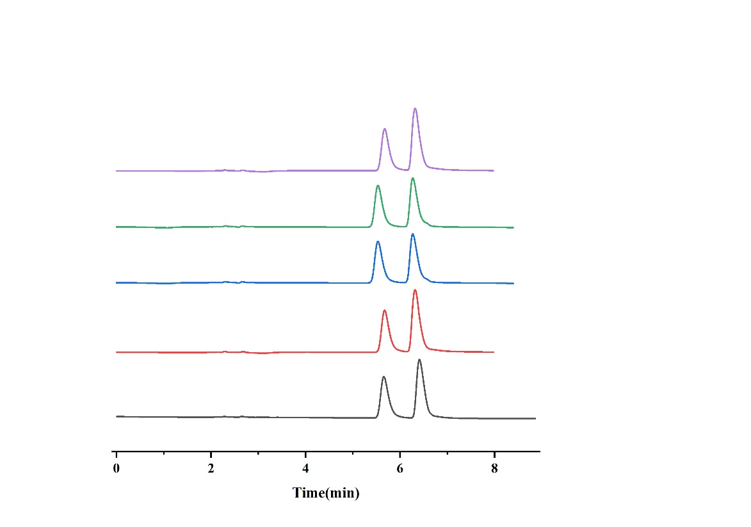
Fig. S7 Reproducibility testing of the CSP-1 column using naproxen.

*Corresponding author: E-mail address: mazhengy@126.com

