Supplementary Material

Supplementary Figures
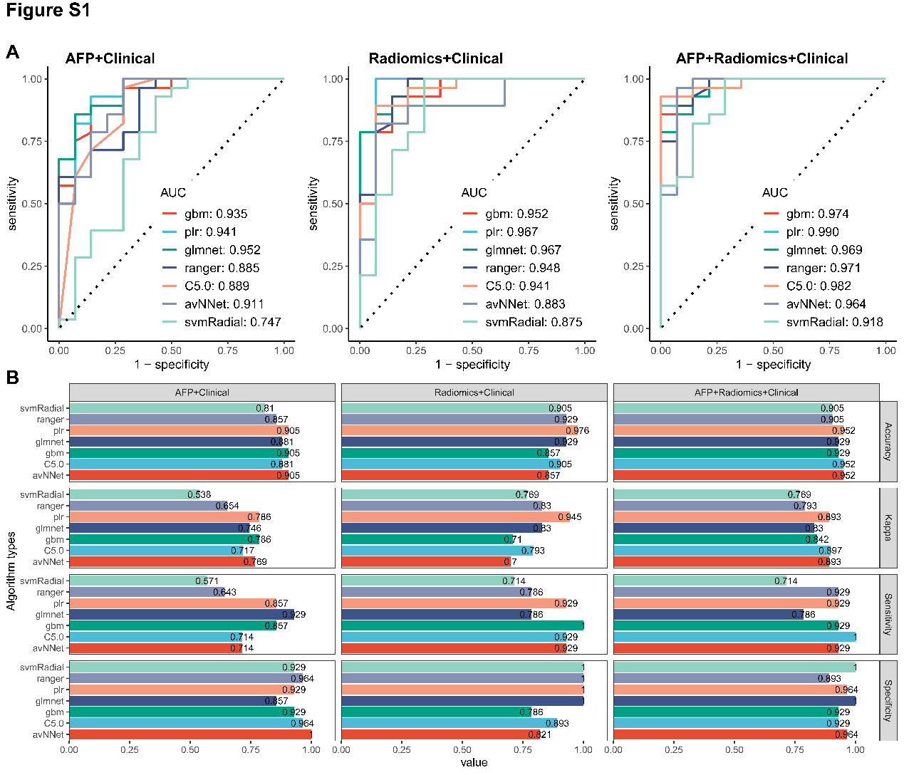
Supplementary Figure S1. Performance evaluation of HCC diagnosis model in validation set. AFP+clinical model, radiomic+clinical model and AFP+radiomic+clinical models were constructed based on 7 machine learning algorithms. The predictive performance of these models was evaluated through a variety of evaluation metrics. A) The receiver operating characteristic (ROC); B) Accuracy, Kappa, Sensitivity and Specificity.

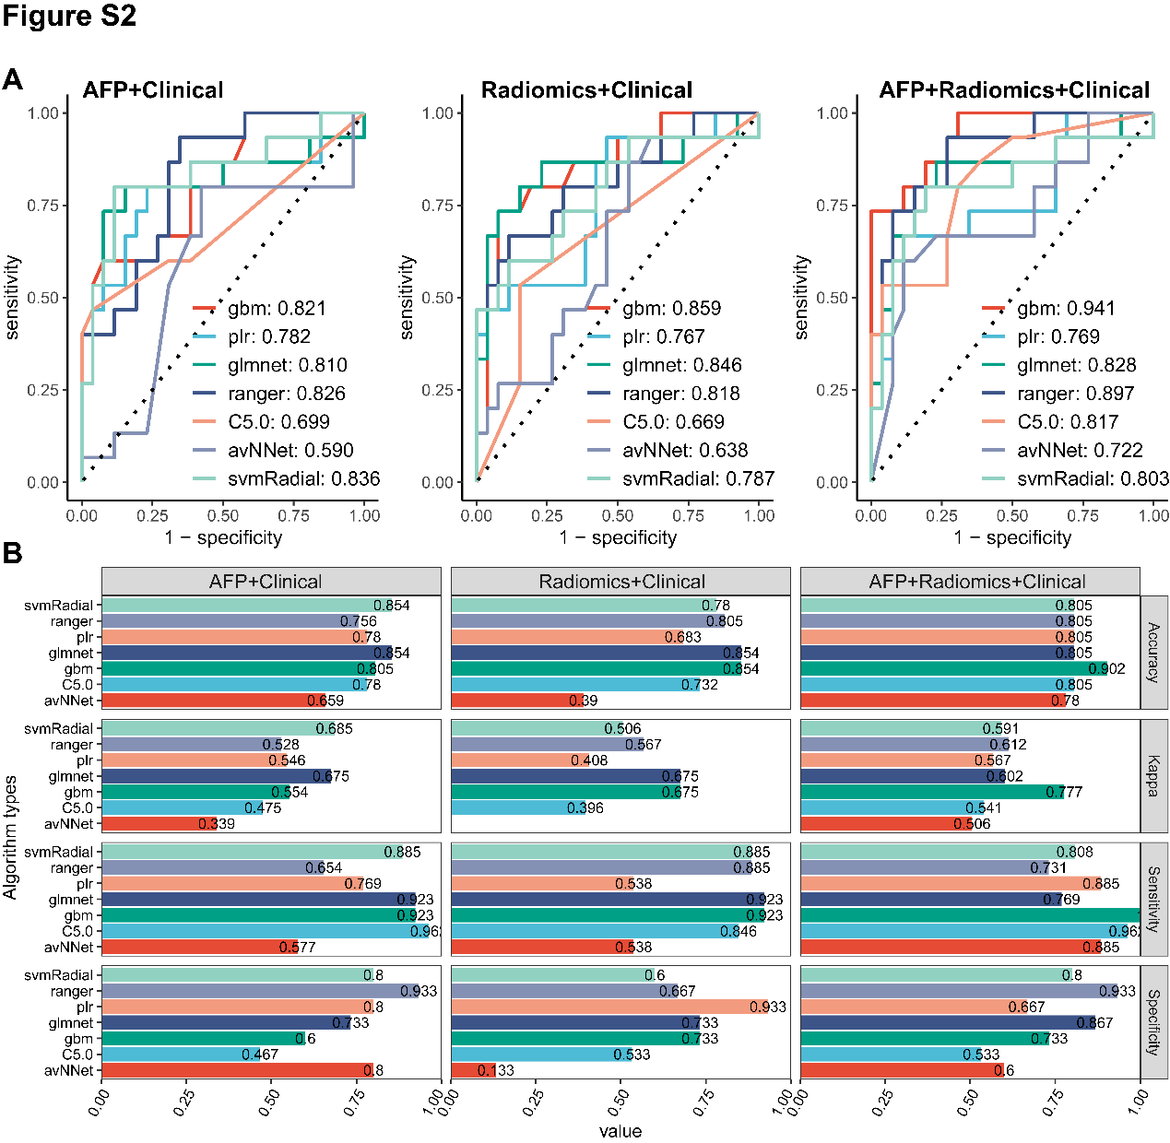
Supplementary Figure S2. Performance evaluation of ES grade prediction model in validation set. AFP+clinical model, radiomic+clinical model and AFP+radiomic+clinical models were constructed based on 7 machine learning algorithms. The prediction performance of these models was evaluated through a variety of evaluation metrics. A) The receiver operating characteristic (ROC); B) Accuracy, Kappa, Sensitivity and Specificity.

Supplementary Tables
Table S1. Characteristics of patients with different ES grade. The data set from Zhejiang Provincial People's Hospital is divided into two datasets based on ES grade. ES.I.II dataset contain patients with ES I or ES II grade. ES.III.IV contain patients with ES III or ES IV grade.
 | ES.I.II  (N=67) | ES.III.IV  (N=51) | P-value
Envelope
Complete | 18 (26.9%) | 12 (23.5%) | 0.104
Incompelte | 31 (46.3%) | 16 (31.4%)
No | 18 (26.9%) | 23 (45.1%)
Bile duct invasion
No | 65 (97.0%) | 47 (92.2%) | 0.539
Unknown | 1 (1.5%) | 1 (2.0%)
Yes | 1 (1.5%) | 3 (5.9%)
Microvascular invasion
No | 46 (68.7%) | 23 (45.1%) | 0.014
Yes | 21 (31.3%) | 28 (54.9%)
Lymph node metastasis
Not transferred | 2 (3.0%) | 4 (7.8%) | 0.41
Unknown | 65 (97.0%) | 47 (92.2%)
Adjacent organ invasion
No | 18 (26.9%) | 12 (23.5%) | 0.143
Unknown | 49 (73.1%) | 36 (70.6%)
Yes | 0 (0%) | 3 (5.9%)
Vascular tumor thrombus
No | 67 (100%) | 48 (94.1%) | 0.072
Yes | 0 (0%) | 3 (5.9%)
Perineural invasion
No | 66 (98.5%) | 48 (94.1%) | 0.317
Yes | 1 (1.5%) | 3 (5.9%)
Gender
Female | 12 (17.9%) | 11 (21.6%) | 0.652
Male | 55 (82.1%) | 40 (78.4%)
Age (years)
Mean (SD) | 63.4 (10.2) | 59.2 (12.4) | 0.0863
Median [Min, Max] | 64.0 [38.0, 86.0] | 60.0 [25.0, 86.0]
AFP (μg/L)
Mean (SD) | 771 (3610) | 4790 (15900) | <0.001
Median [Min, Max] | 6.00 [1.00, 28000] | 94.1 [1.30, 105000]

Table S2. Significant p value of AUC differences between the three HCC diagnostic models. The Delong's test method was used to calculate the significance p value of the difference in prediction performance between the three models. Compared with the other two models, the AFP+radiomics+clinical model has a significant difference in AFP negative dataset.
Dataset | AFP negative dataset | Validation dataset
AFP+Radiomics+Clinical vs AFP+Clinical | 0.001 | 0.219
AFP+Radiomics+Clinical vs Radiomics+Clinical | 0.276 | 0.393

Table S3. Significant p value of AUC differences between the three ES grad prediction models. The Delong's test method was used to calculate the significance p value of the difference in prediction performance between the three models. Compared with the other two models, the radiomics-AFP model has a significant difference in training set and TCGA-LIHC set.
Dataset | Training set | Validation set | TCGA-LIHC set
AFP+Radiomics+Clinical vs AFP+Clinical | 1.05e-04 | 0.04 | 0.0244
AFP+Radiomics+Clinical vs Radiomics+Clinical | 3.03e-04 | 0.16 | 0.157

