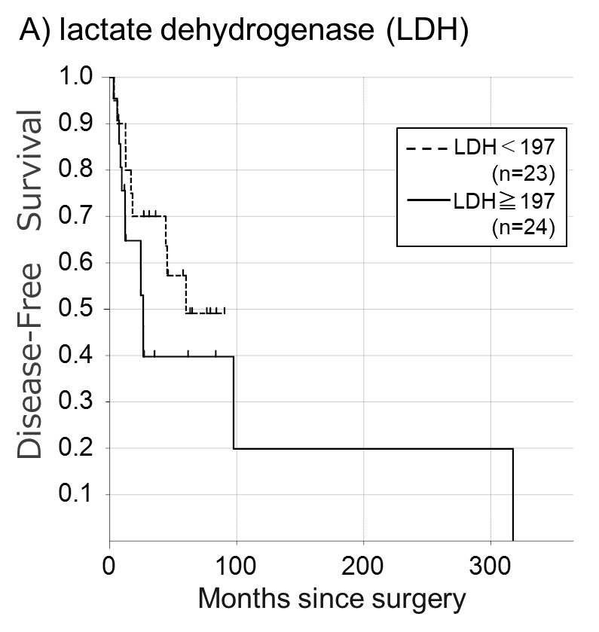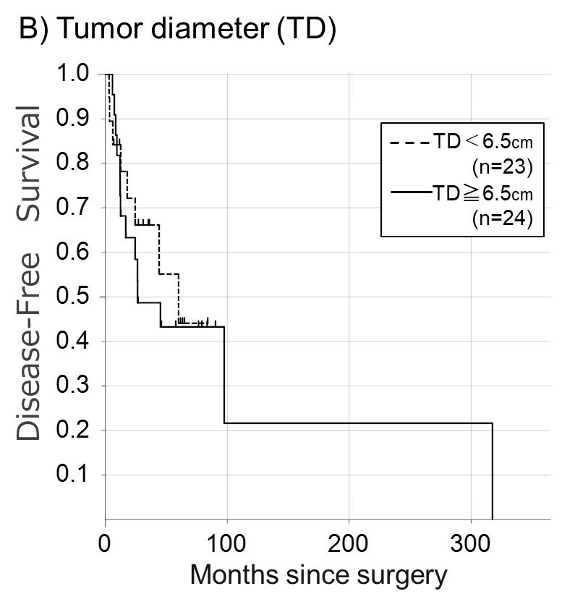
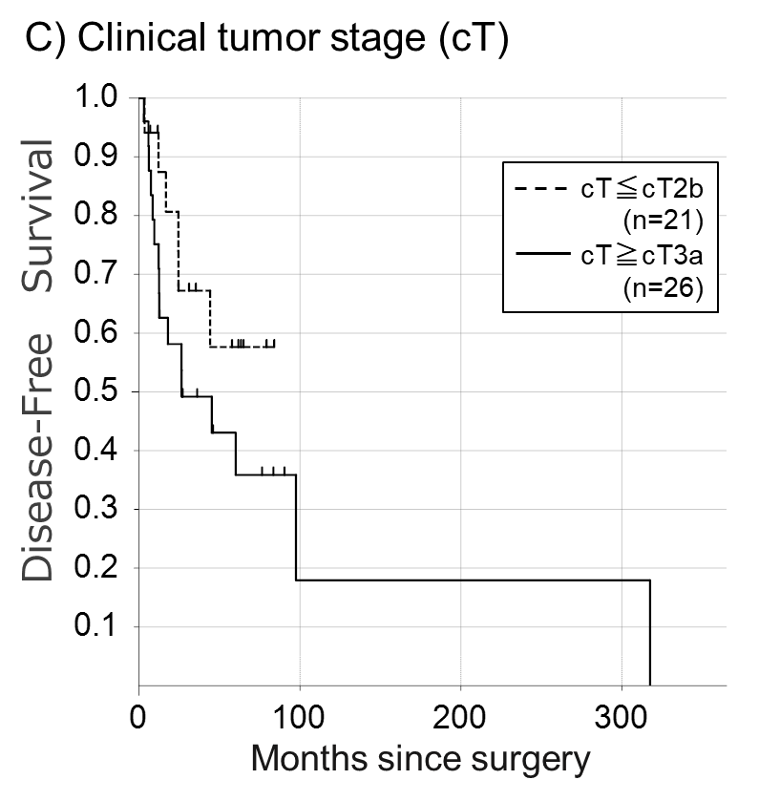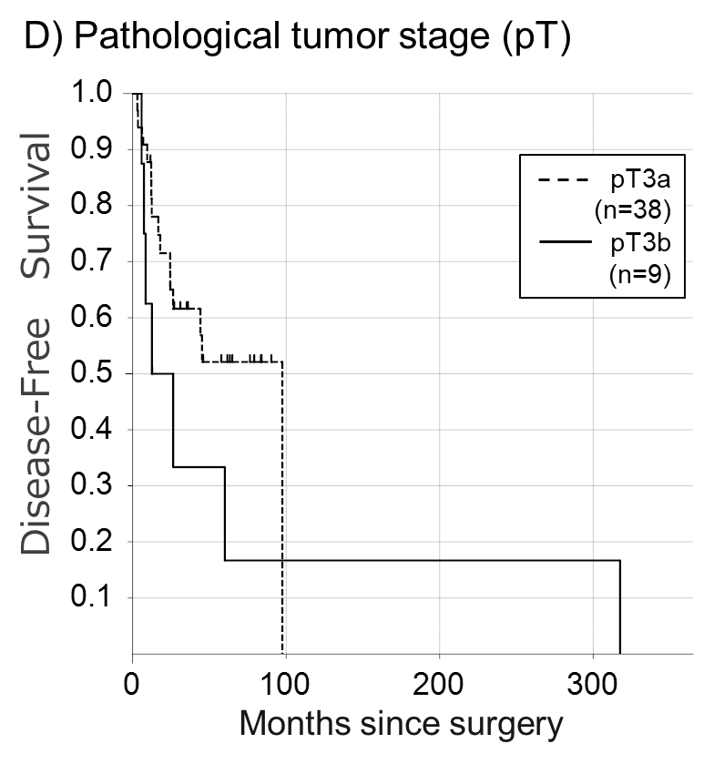
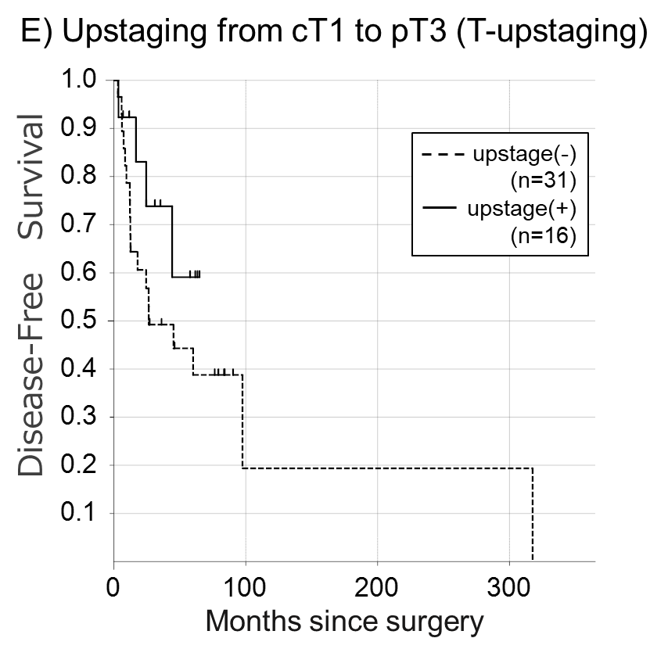
Supplementary Appendix 2. Median DFS: A) LDH < 197 IU/L versus LDH ≥ 197 IU/L; 60.04 months versus 26.39 months, P = 0.266. B) Tumor diameter < 6.5 cm versus Tumor diameter ≥ 6.5 cm; 60.04 months versus 26.50 months, P = 0.655. C) cT ≥ cT2b vs. cT ≤ cT3a; NR versus 26.50 months, P = 0.223. D) pT3a vs. pT3b; 97.54 months versus 12.54 months, P = 0.183. E) Upstaged (-) versus upstaged (+); 26.50 months versus NR: P = 0.236.

