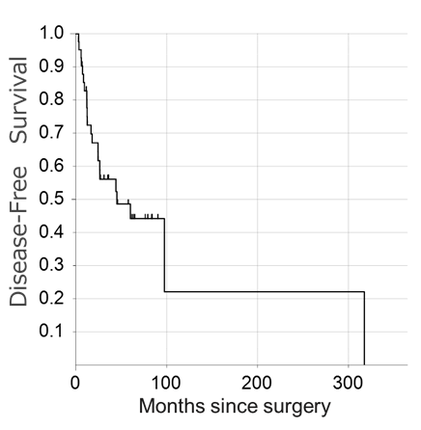
Supplementary Appendix 1. The median follow-up of the 47 study patients with pT3aN0M0 and ccRCC was 45.69 months (IQR:15.71–74.96). Of the 47 patients, 22 (46.8%) experienced recurrence and the median DFS was 45.18 months from surgery.

