Online Supplementary Materials to the Manuscript

Topographic Distribution of Inflammation Factors in a Healing Aneurysm

Basil E. Grüter^{1,2,3}, Gwendoline Boillat^{1,3}, Joshua Hägler^{1,3}, Jeannine Rey^{1,3}, Stefan Wanderer^{1,3}, Michael von Gunten^{3,4}, Jose Galvan⁵, Rainer Grobholz^{6, 7}, Hans-Rudolf Widmer³, Luca Remonda^{2,3}, Lukas Andereggen^{1,3}, and Serge Marbacher^{1,3}

¹ Department of Neurosurgery Kantonsspital Aarau, Aarau, Switzerland.
² Division of Neuroradiology, Department of Radiology, Kantonsspital Aarau, Aarau, Switzerland
³ Program for Regenerative Neuroscience, Department for BioMedical Research, University of Bern, Bern, Switzerland
⁴ Institute of Pathology Laenggasse, Ittigen, Switzerland
⁵ Translational Research Unit (TRU) Institute of Pathology University of Bern, Bern, Switzerland
⁶ Institute of Pathology, Kantonsspital Aarau, Aarau, Switzerland
⁷ Medical Faculty, University of Zurich, Zurich, Switzerland

Supplementary Online Resource 1

Sample size calculation
An a priori sample size calculation indicated an ideal group size of n=8. Power 80%, α=0.05, two tailed, β=0.2; Direct comparison between the two groups was calculated with an assumed difference of 30% and standard deviation of 21%.

$$k=\frac{n_{2}}{n_{1}}=1$$
$n_{1}$ = $\frac{({δ_{1}^{2}+ δ_{2}^{2}}/{K) {(z_{1-α/2}+ z_{1-β)}}^{2}}}{∆^{2}}$
$n_{1}$ = $\frac{({{2.1}^{2}+ {2.1}^{2}}/{1) ({1.96+0.84)}^{2}}}{3^{2}}$
$n_{1}$ = 8
$n_{2}$ = K * $n_{1}=8$

Supplementary Online Tables

Supplementary Table 1: Immunostainings for inflammation cells
Immunostainings for specified inflammation cells was performed according to the antibodies shown below.
Antibody | Targeted cell type
anti-CD3 | T-cells
anti-CD20 | B-cells
anti-HLA-DR | M1-macrophages
anti-CD163 | M2-macropahges
anti-CD 31 | endothelial cells
Actin, Smooth Muscle (1A4) Mouse Monoclonal Antibody | Smooth muscle cells, myofibroblasts
Monoclonal Mouse Anti-Human Von Willebrand Factor, Clone F8/86 | endothelial cells

Supplementary Table 2: Histopathological analysis

The following histopathological characteristics were assessed on conventional hematoxylin-eosin (HE), Masson-Goldner trichrome (MASA), and smooth muscle actin (SMA) staining, and scored with a previously published 4-tier system, according to Marbacher et al. Loss of mural cells leads to wall degeneration, aneurysm growth, and eventual rupture in a rat aneurysm model. Stroke; A Journal of Cerebral Circulation. 2014;45:248-254. doi: 10.1161/STROKEAHA.113.002745.

 | Criterion | Numeric |  | Criterion | Numeric
Neointima formation |  |  | Neutrophils in the thrombus
 | none | 0 |  | none | 0
 | organizing thrombus | 1 |  | mild | 1
 | organizing thrombus and neointima formation | 2 |  | moderate | 2
 | mature neointima | 3 |  | severe | 3
Aneurysm wall inflammation |  |  | Aneurysm wall cellularity
 | none | 0 |  | none | 0
 | few (1-3 spots) | 1 |  | few (1-3 spots) | 1
 | many (> 4 spots) | 2 |  | many (> 4 spots) | 2
 | ubiquitous | 3 |  | ubiquitous | 3
Periadventitial inflammation |  |  | Periadventitial fibrosis
 | none | 0 |  | none | 0
 | mild | 1 |  | mild | 1
 | moderate | 2 |  | moderate | 2
 | severe | 3 |  | severe | 3

Supplementary Online Figures

Supplementary Figure 1: Soluble factors rating
Chromatin stained in-situ hybridization of soluble factors (FGF23, MMP2, MMP9, Il6, TNF, VEGFA) were graded as: none (top left), mild (few spots, brown arrow, top right), moderate (> 5 spots, bottom left), or severe (ubiquitously, bottom right).
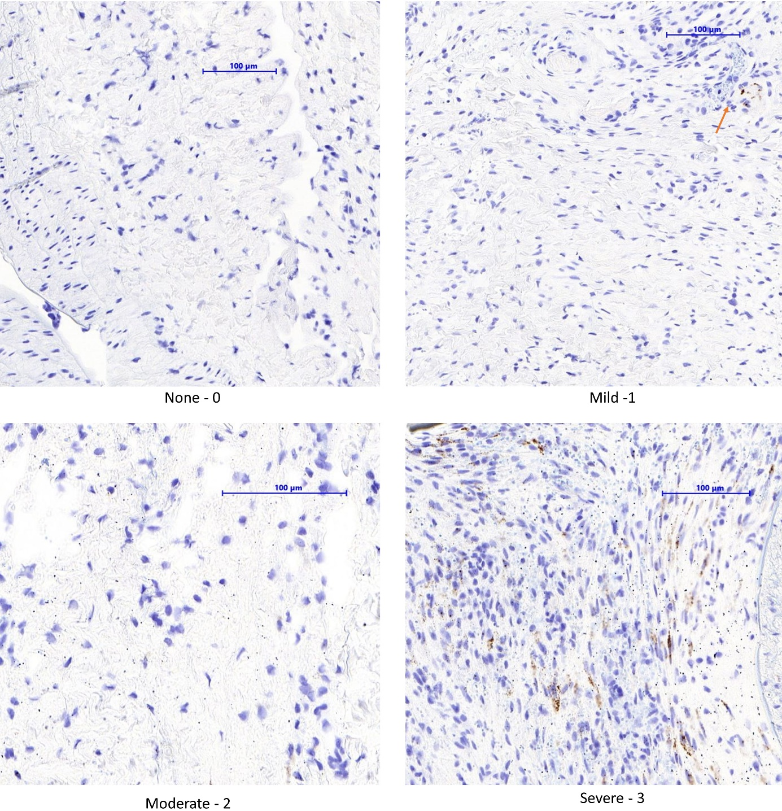

Supplementary Figure 2: Inflammation cells rating
Chromatin stained antigens characterizing immune-cells (CD-20, CD-163, CD-3, HLA-DR, anti-tryptase and CD-31) were graded as: none (top left), mild (few spots), moderate (localized, clustered spots, bottom left), or severe (ubiquitously, bottom right).
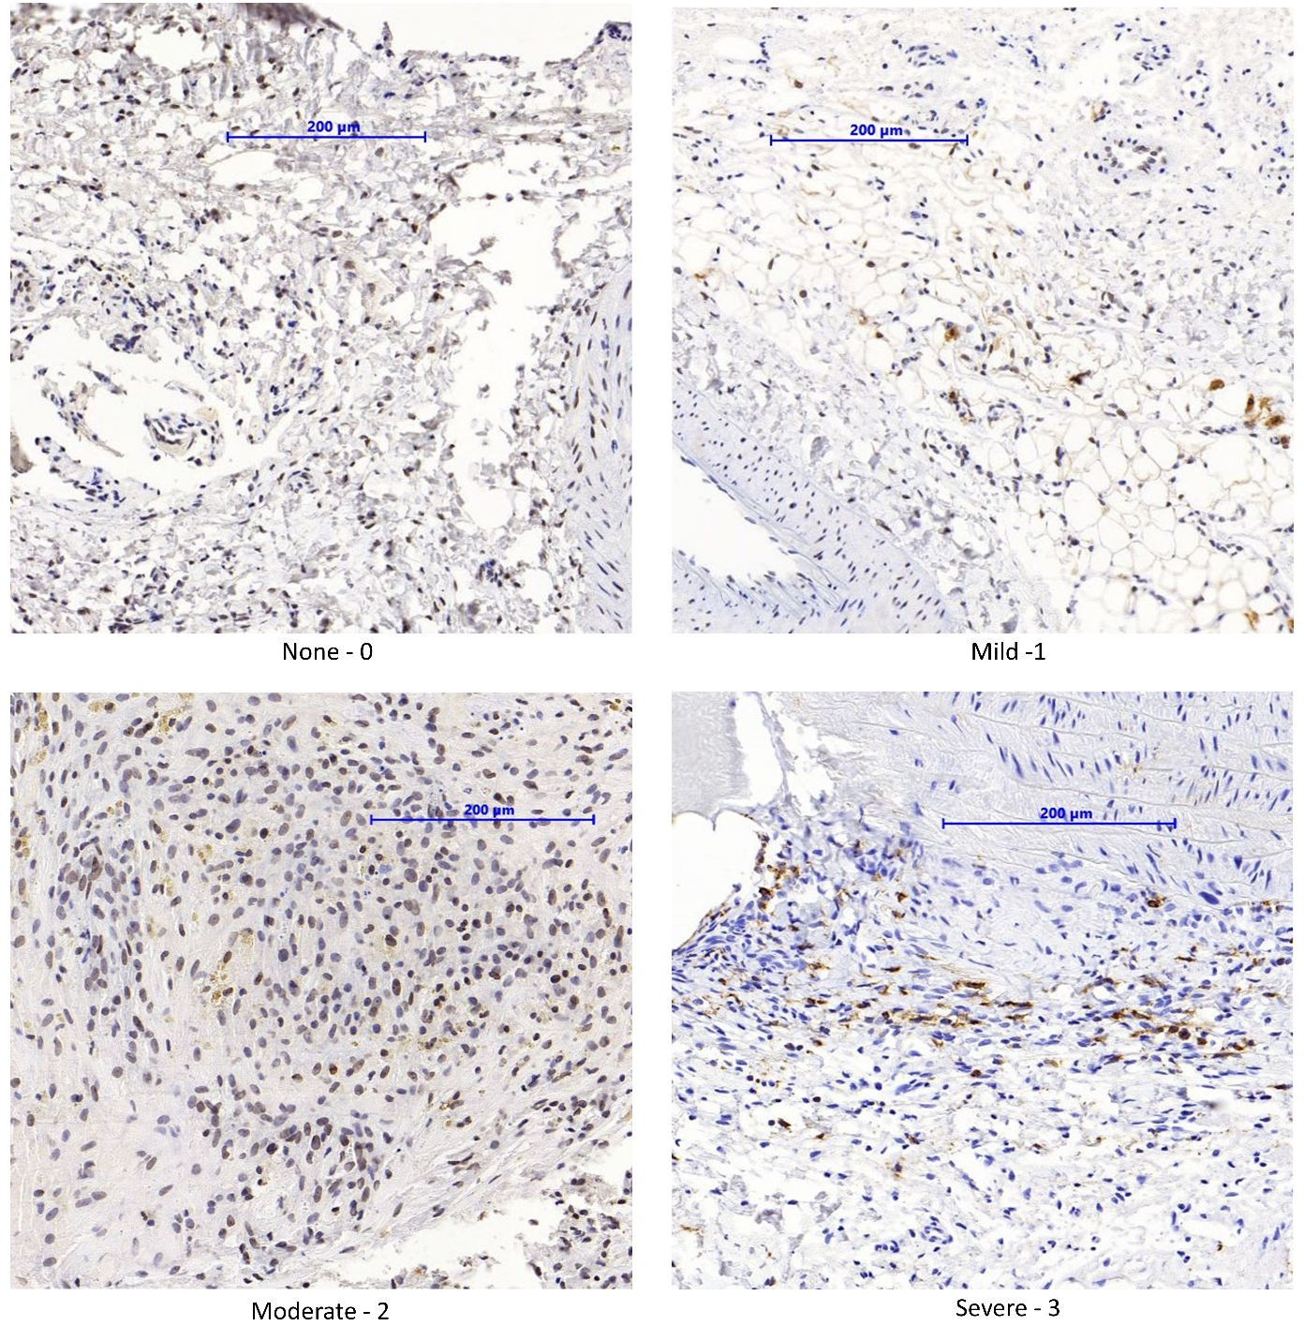

Supplementary Figure 3: Regions of interest (ROIs) in the aneurysm complex
The figure shows a schematic aneurysm with adjacent vessel (red), aneurysm neck (yellow), aneurysm dome (brown), thrombus (green) and neointima (blue).

Thrombus
Aneurysm dome
Neointima
Adjacent Vessel
Aneurysm
neck
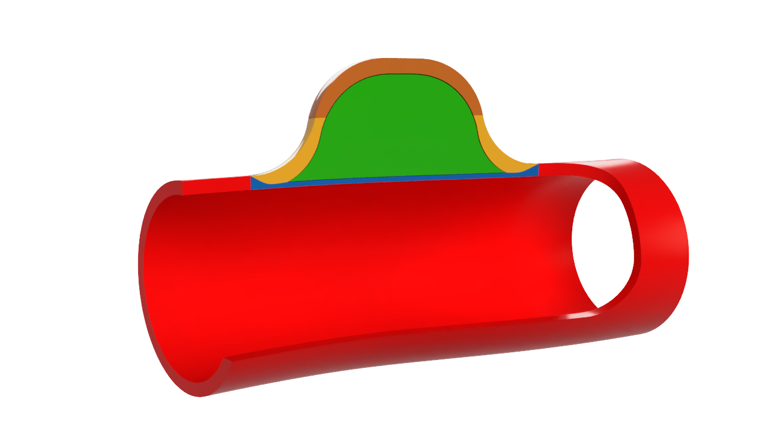
Supplementary Figure 4: Operative characteristics
Although animals allowed to heal naturally were slightly lighter (333 ±13g) than those with coil treatment (345±15g) (p=0.01), there was no significant difference in weight at follow-up. There were no relevant procedural differences between the two groups.
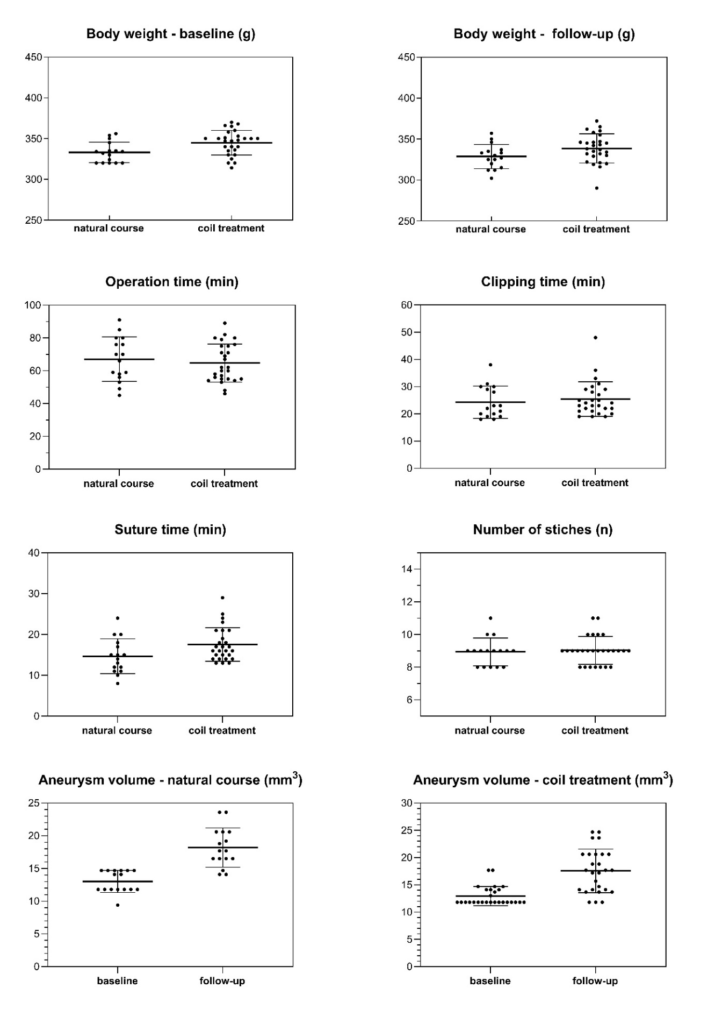
Supplementary Figure 5: Light microscopical findings of all experimental groups.
Untreated aneurysms showed more pronounced inflammation on Day 3 when compared to those with coil treatment. After 7 days, both groups were experiencing inflammation. Neointima formation was significantly stronger in coiled aneurysms as compared to untreated aneurysms at Day 7, which was confirmed in the replication cohort and in the long-term (Day 21) group. * p < 0.05
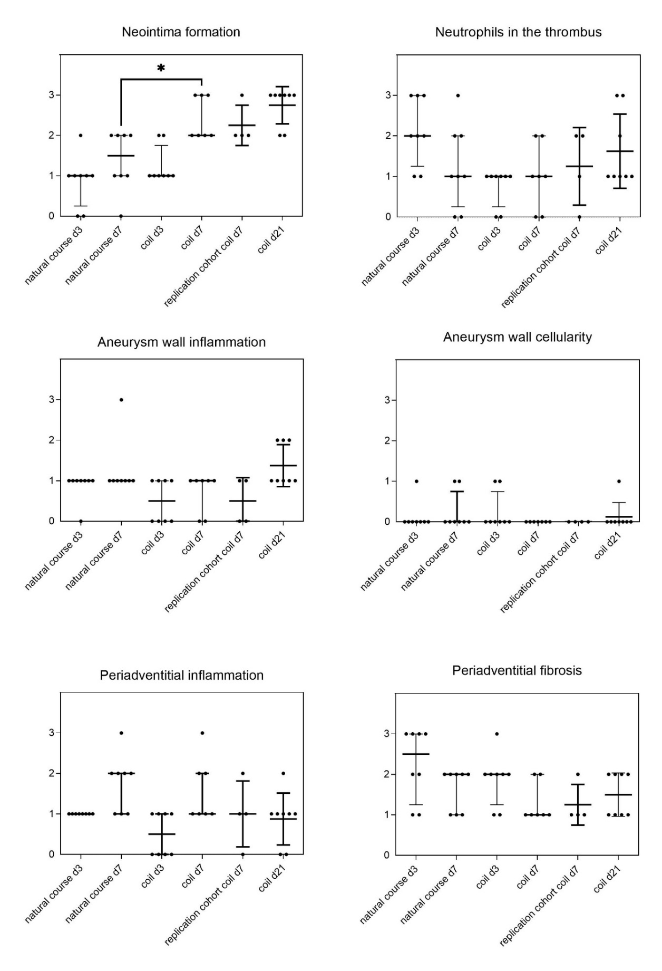
Supplementary Figure 6: Humoral inflammation at Day 7 in thrombus and neointima
The cytokines studied: TNF-α, Il-6, MMP-2, MMP-9, and FGF, were markedly increased in coiled aneurysms when compared to natural course at Day 7.
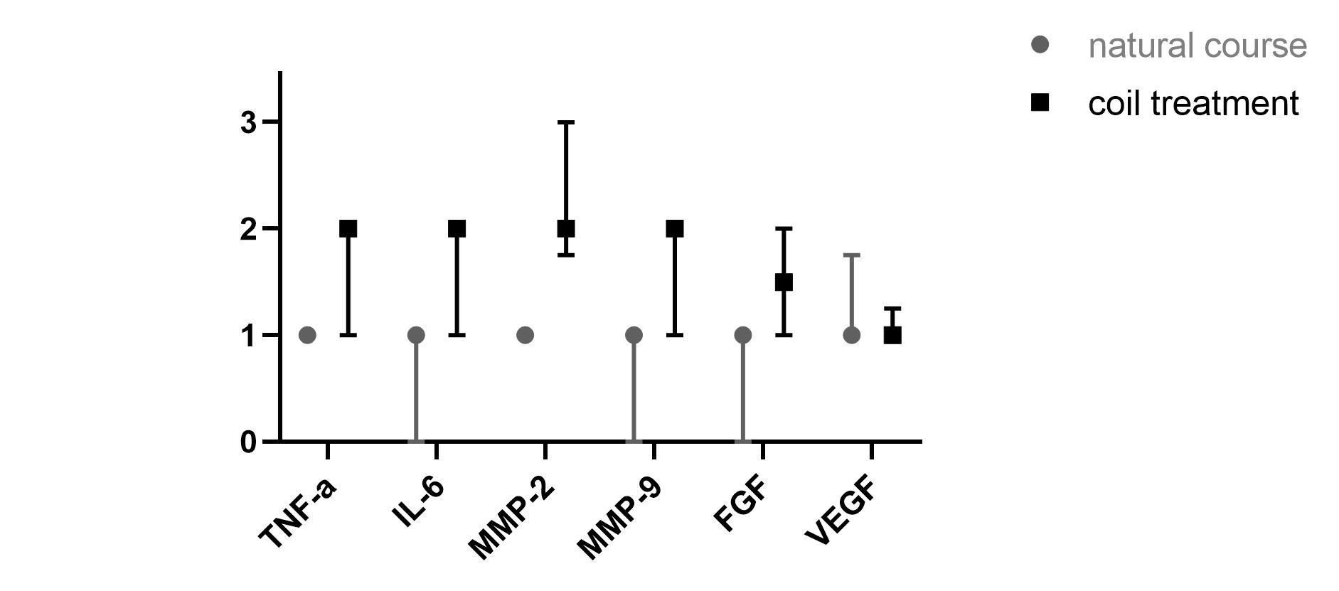

Supplementary Figure 7: Distribution of TNF-α
nc: natural course, coil: coil treatment. Follow-up in days (d)
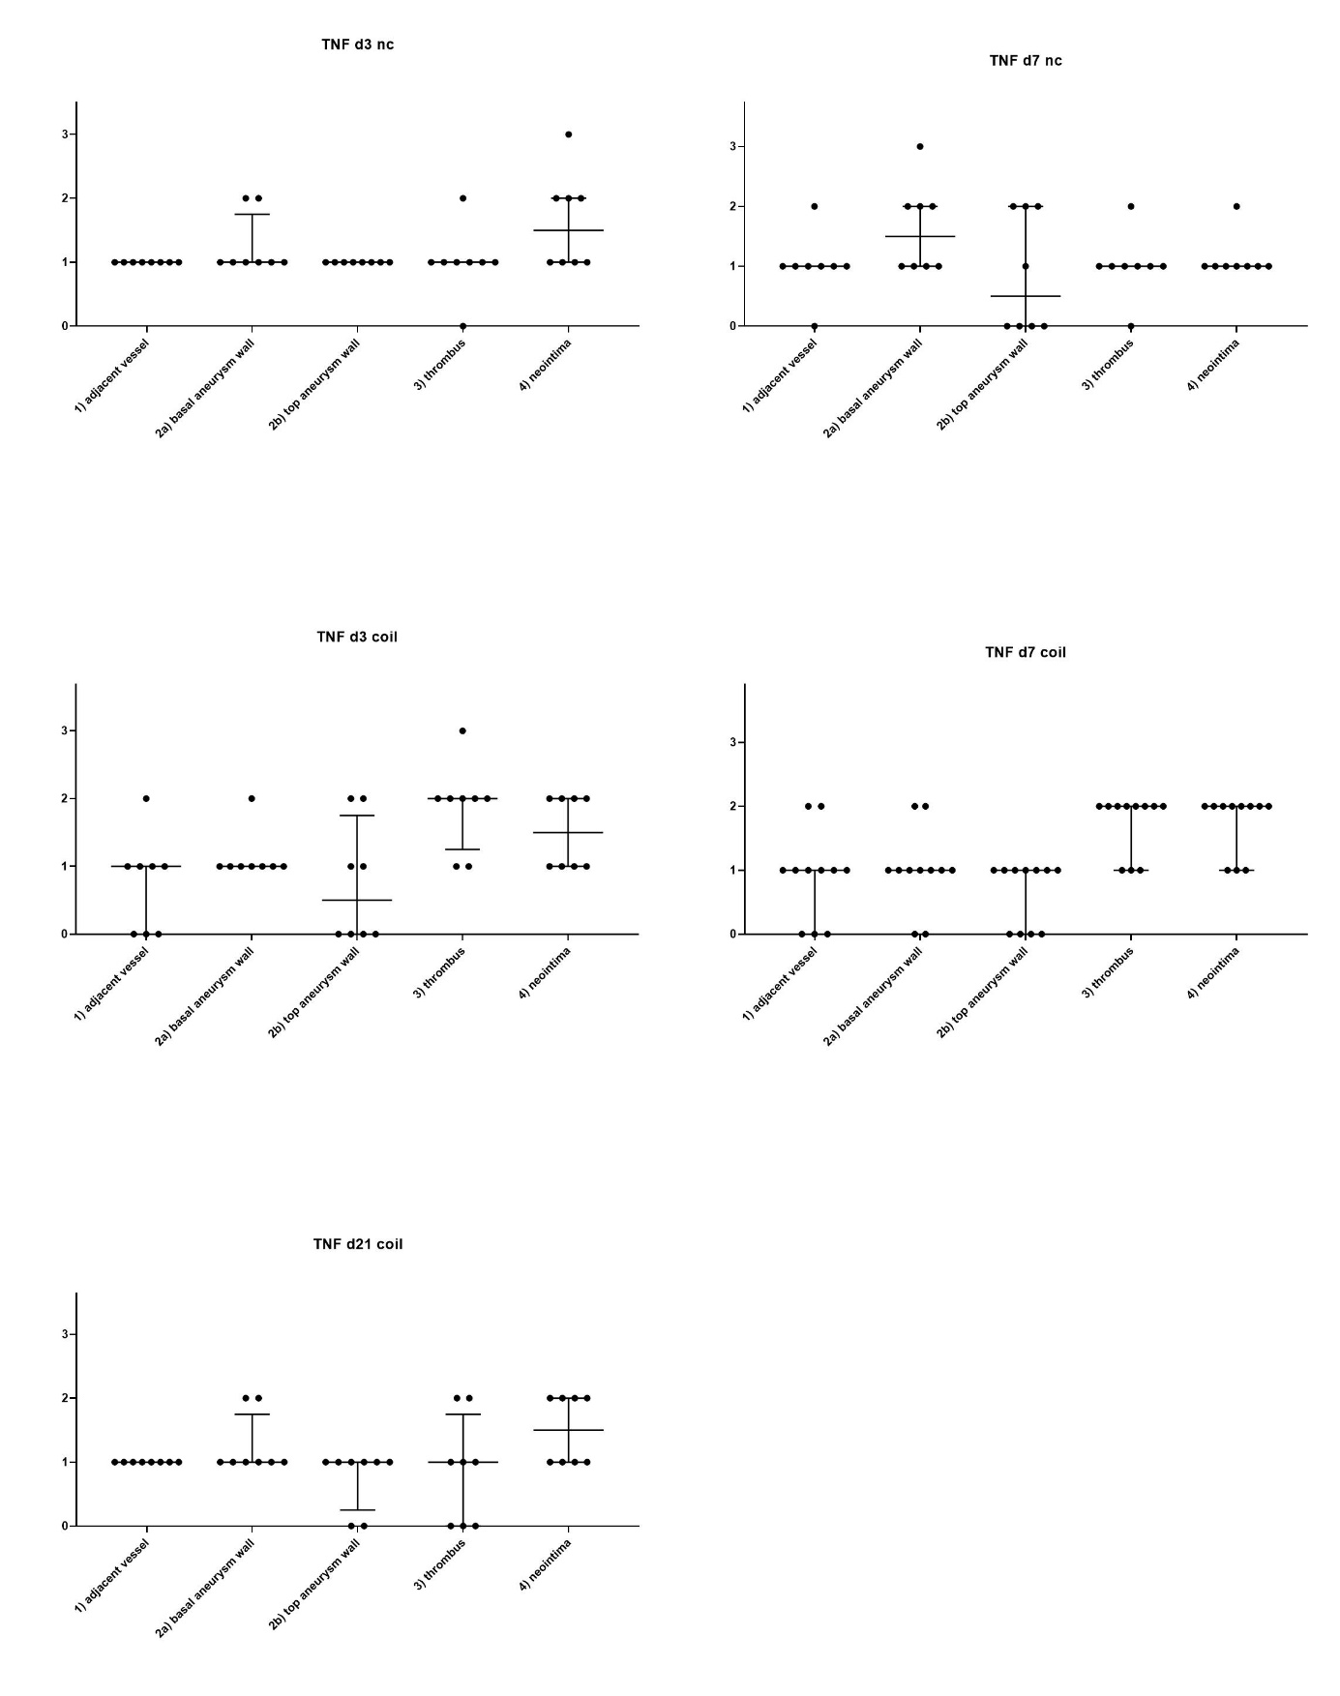

Supplementary Figure 8: Distribution of Il-6
nc: natural course, coil: coil treatment. Follow-up in days (d)

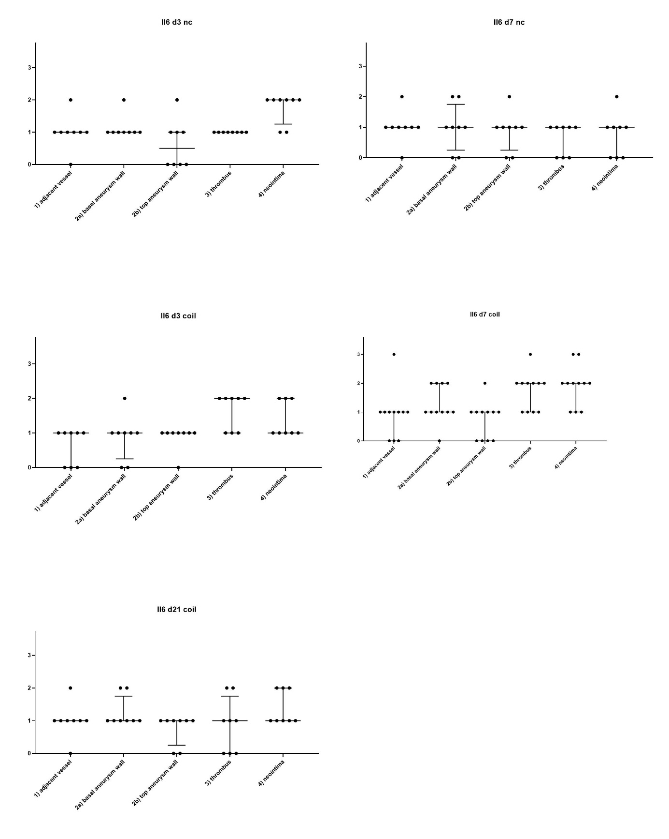

Supplementary Figure 9: Distribution of MMP-2
nc: natural course, coil: coil treatment. Follow-up in days (d)

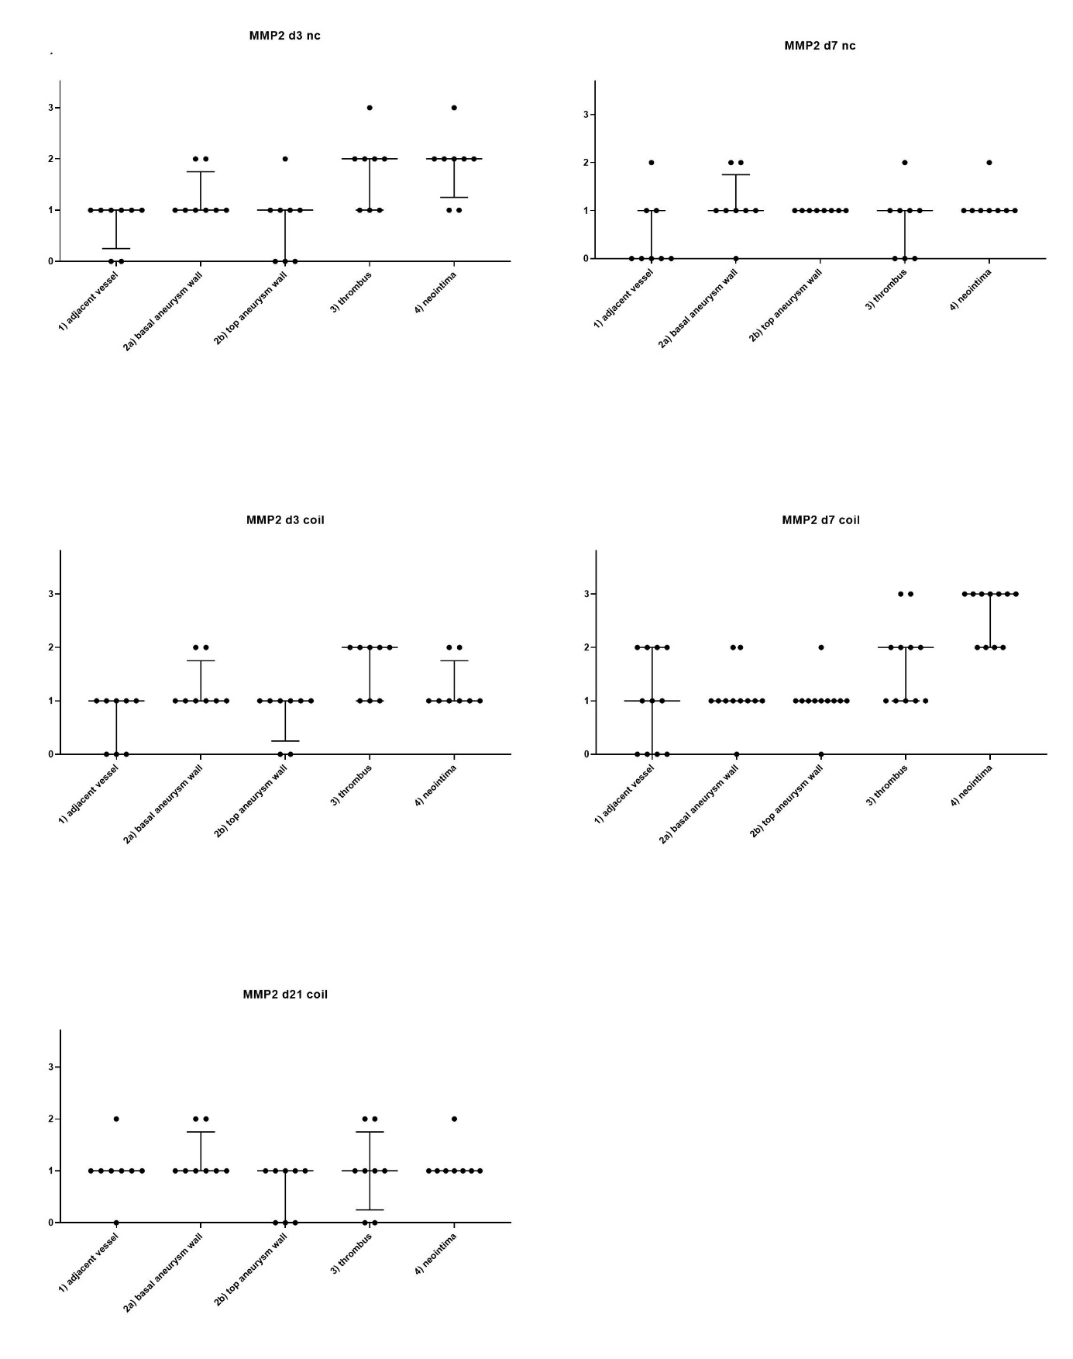

Supplementary Figure 10: Distribution of MMP-9
nc: natural course, coil: coil treatment. Follow-up in days (d)

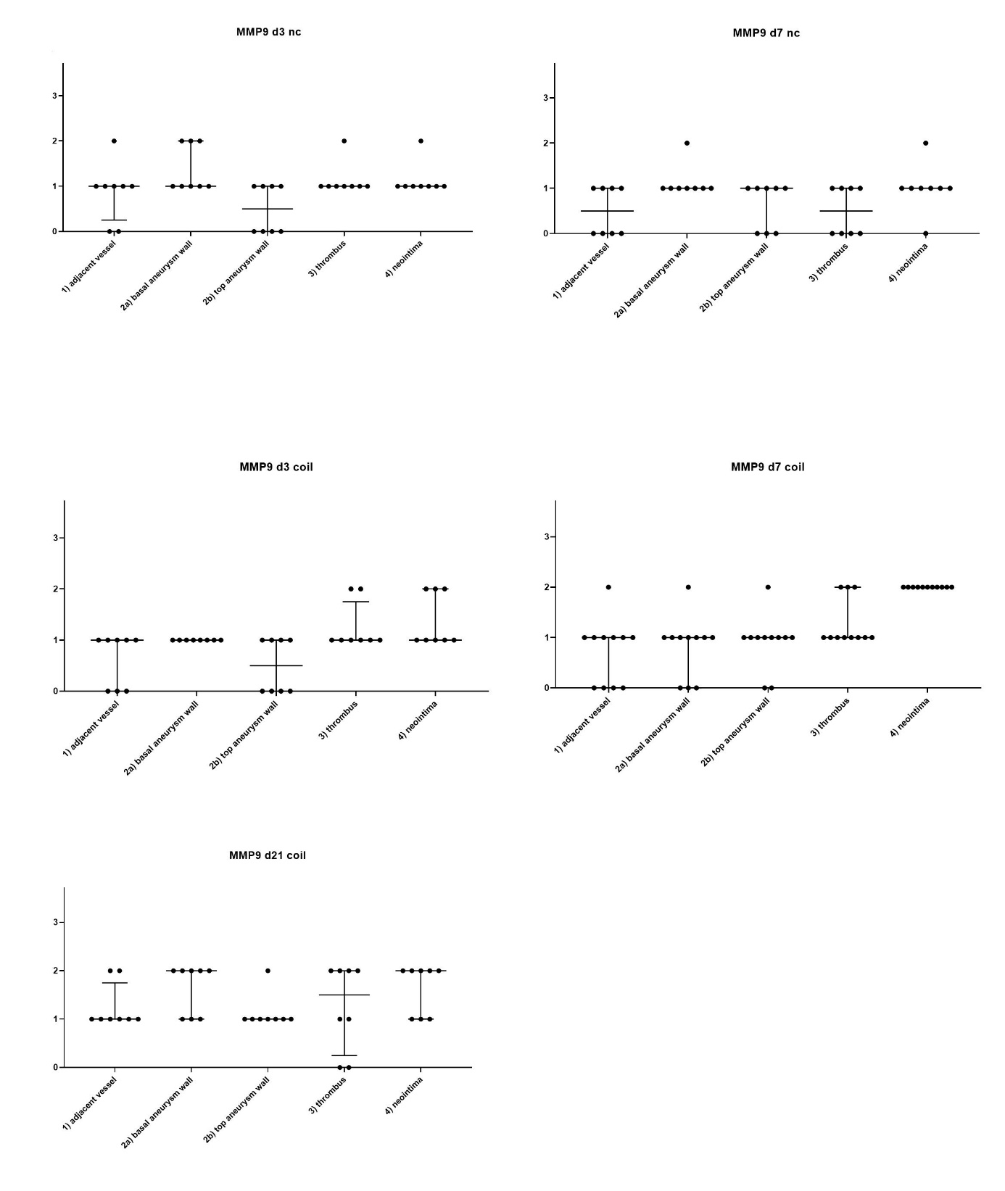

Supplementary Figure 11: Distribution of FGF
nc: natural course, coil: coil treatment. Follow-up in days (d)

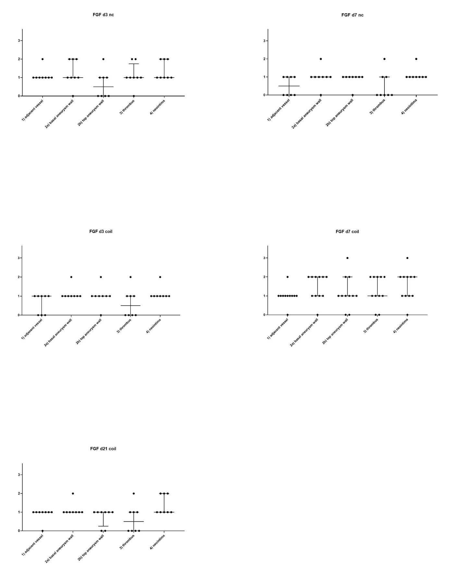

Supplementary Figure 12: Distribution of VEGF
nc: natural course, coil: coil treatment. Follow-up in days (d)

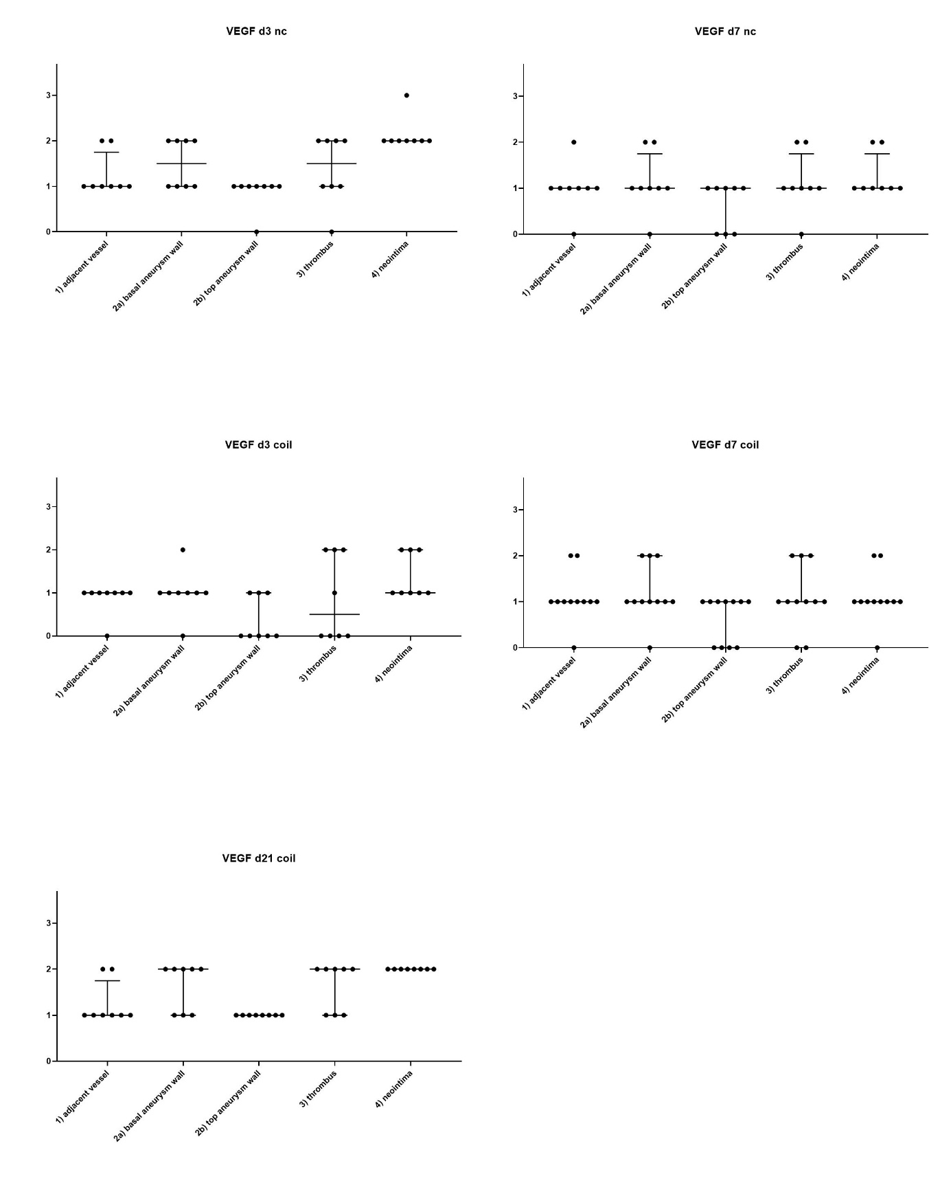

Supplementary Figure 13: Distribution of CD3+ cells
nc: natural course, coil: coil treatment. Follow-up in days (d)
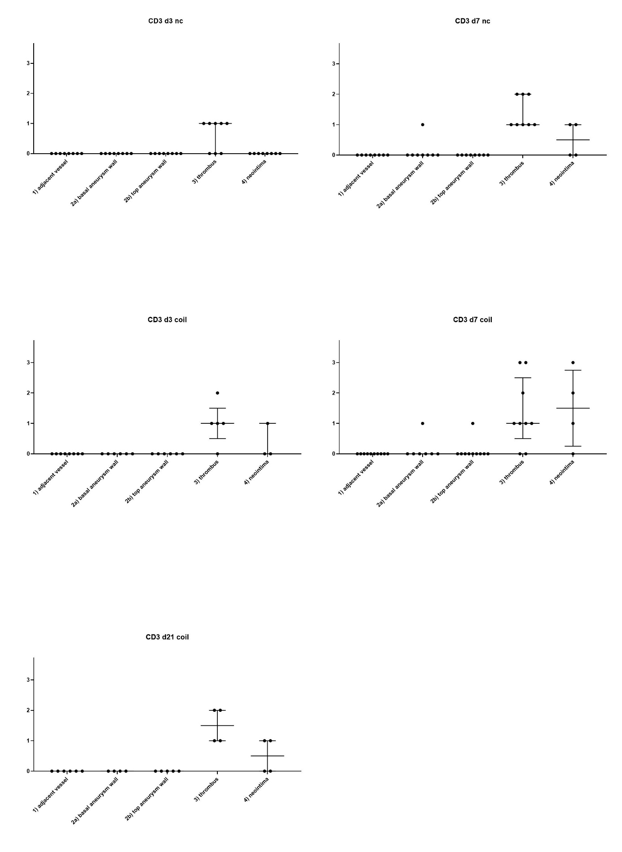
Supplementary Figure 14: Distribution of CD20+ cells
nc: natural course, coil: coil treatment. Follow-up in days (d)
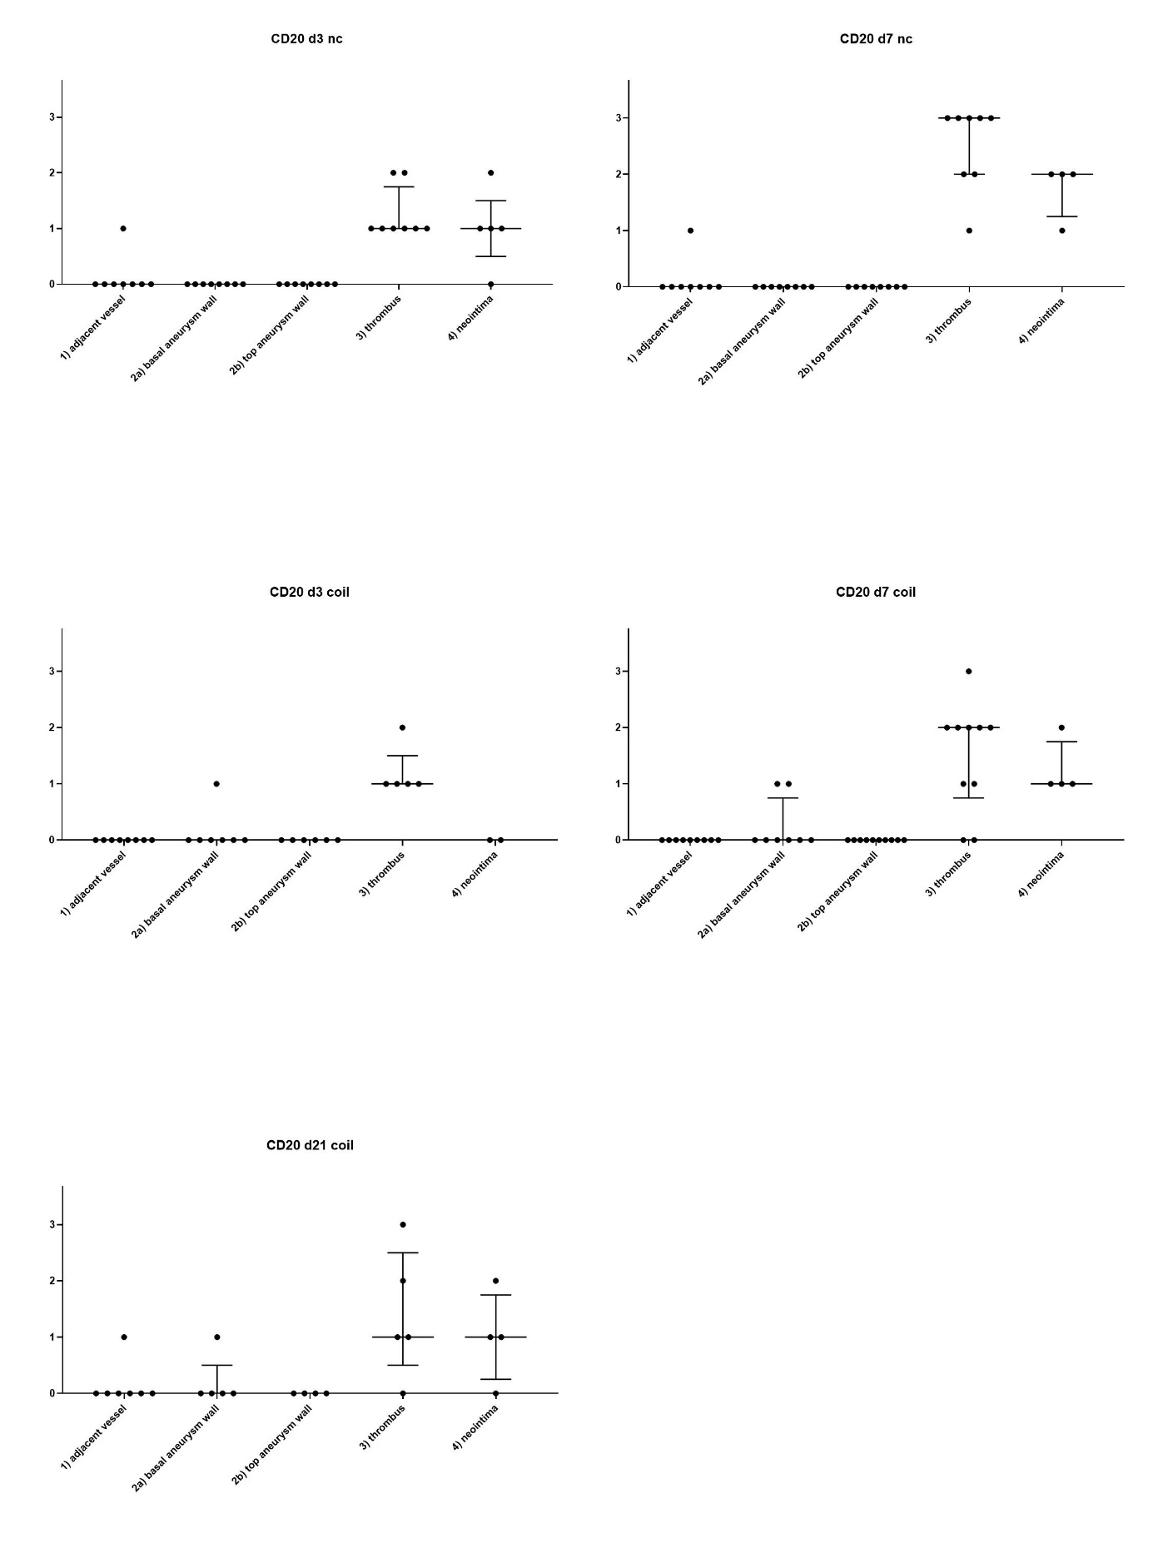
Supplementary Figure 15: Distribution of HLA DR
nc: natural course, coil: coil treatment. Follow-up in days (d)
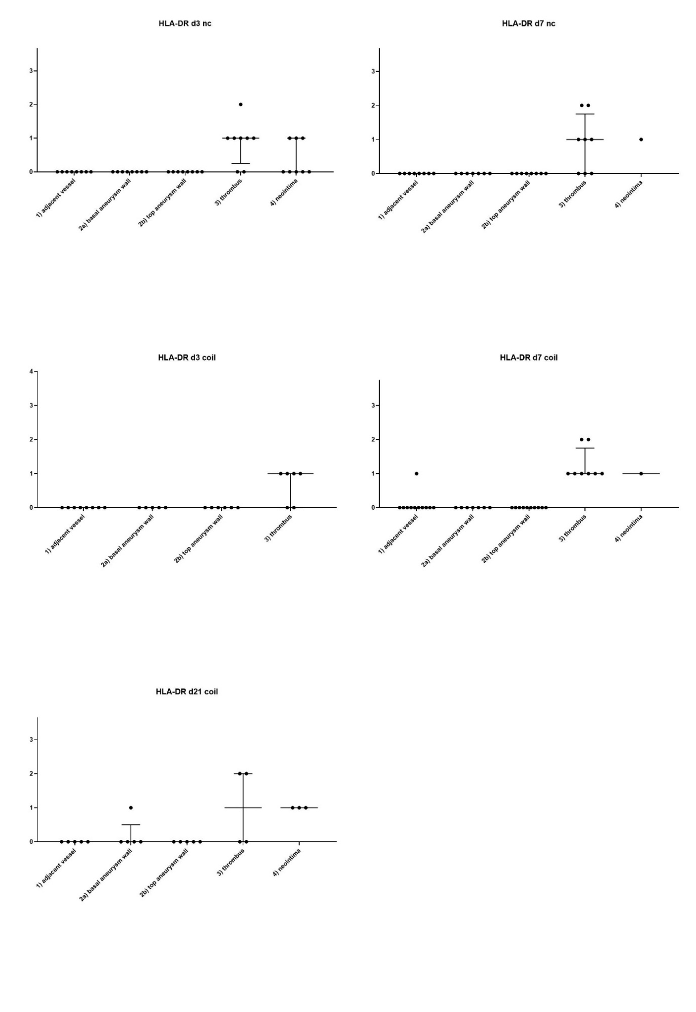

Supplementary Figure 16: Distribution of CD 163+ cells
nc: natural course, coil: coil treatment. Follow-up in days (d)
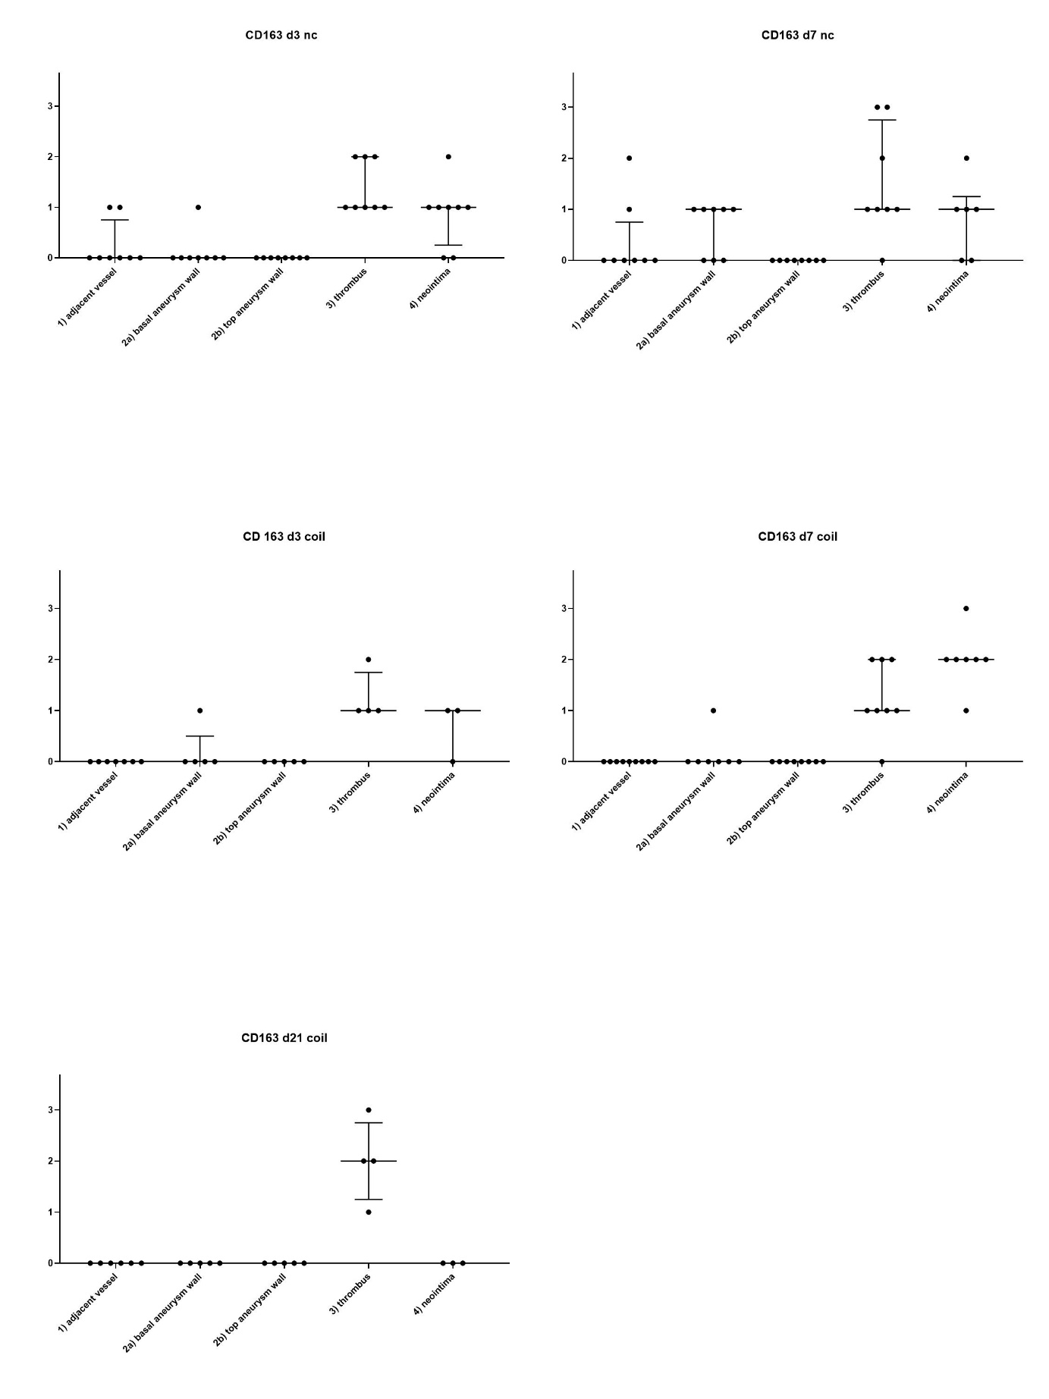

Supplementary Figure 17: Distribution of tryptase clone (MAST)
nc: natural course, coil: coil treatment. Follow-up in days (d)
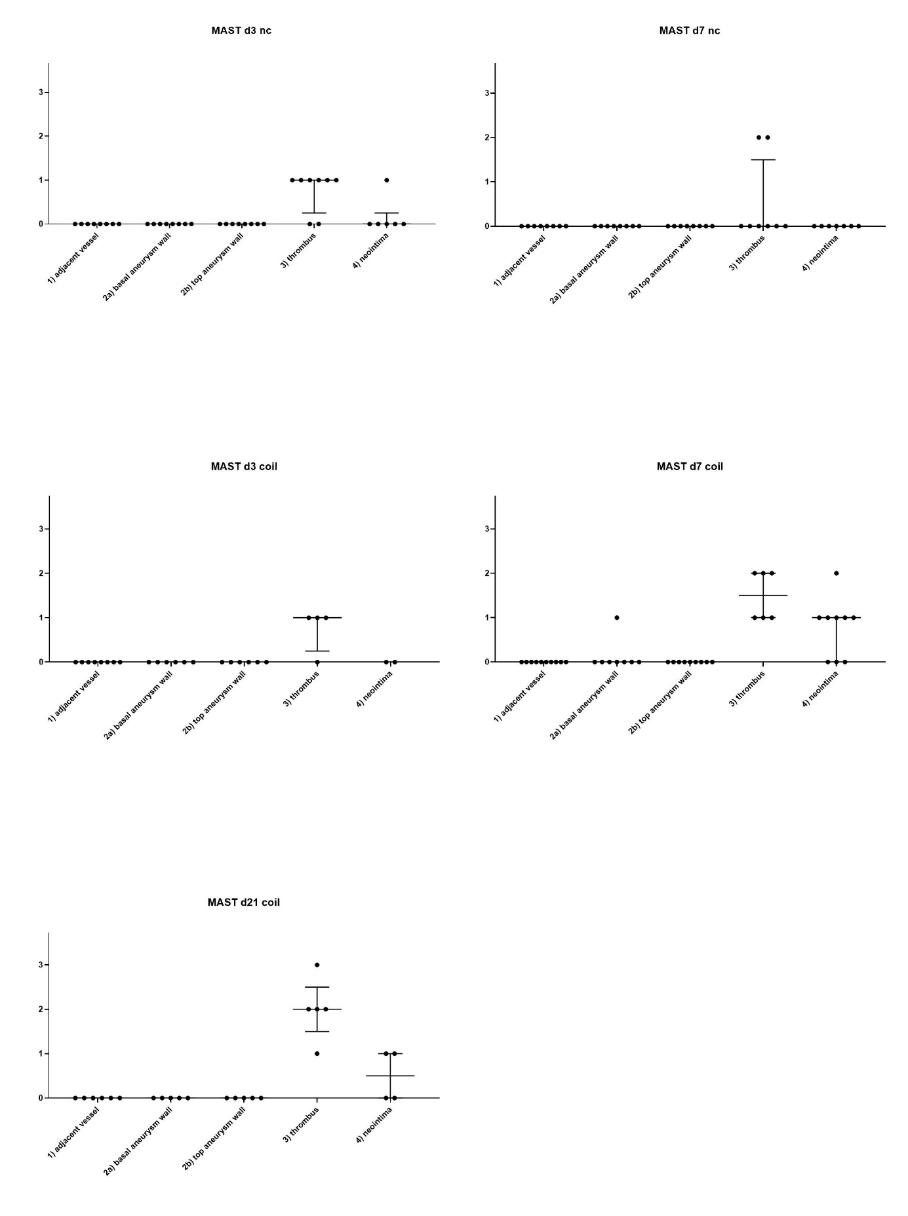
Supplementary Figure 18: Distribution of CD31+ cells
nc: natural course, coil: coil treatment. Follow-up in days (d)
