Integration of single-cell regulon atlas and multi-omics data for prognostic stratification and personalized treatment prediction in human lung adenocarcinoma

Yi Xiong^{1,2,3,*}, Yihao Zhang^{1,2,3,*}, Na Liu^{1,2,4}, Yueshuo Li^{1,2,4}, Hongwei Liu^{1,2}, Qi Yang^{1,2}, Yu Chen³, Zhizhi Xia⁵, Xin Chen^{6,#}, Siyi Wanggou^{1,2,#}, Xuejun Li^{1,2,#}

1 Department of Neurosurgery, Xiangya Hospital, Central South University, Changsha, Hunan, 410008, China
2 Hunan International Scientific and Technological Cooperation Base of Brain Tumor Research, Xiangya Hospital, Central South University, Changsha, Hunan, 410008, China
3 Xiangya School of Medicine, Central South University, 410013 Changsha, China
4 Postdoctoral Research Workstation, Xiangya Hospital, Central South University, Hunan, 410078, China
5 Department of Pharmacology & Toxicology, University of Toronto, Toronto, Ontario M5S 1A8, Canada
6 Songjiang Research Institute, Songjiang Hospital, Shanghai Jiao Tong University School of Medicine

* These authors contributed equally to this work.
# Author for correspondence:
Xuejun Li, lxjneuro@csu.edu.cn
Siyi Wanggou, zokygwong@gmail.com
Xin Chen, xinchen@shsmu.edu.cn

Supplementary Figures
Figure S1
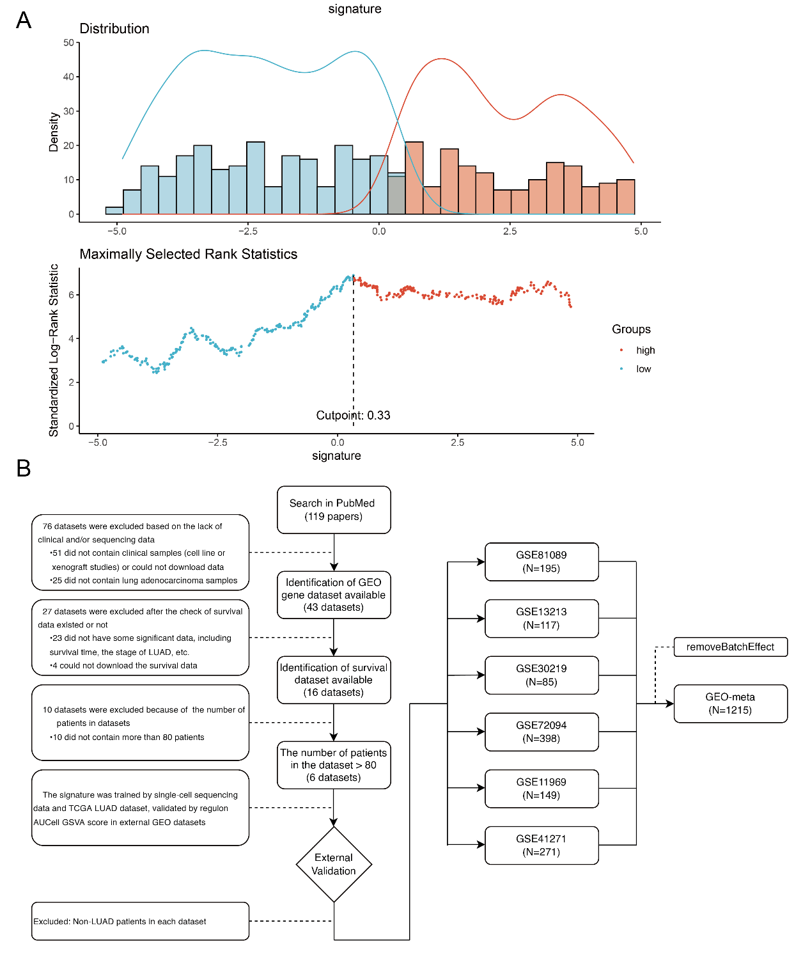
- The optimal cut-off value to divide LPRI as low and high subgroups in the TCGA-LUAD dataset.
- Flow diagram for data set selection in this study.

Figure S2
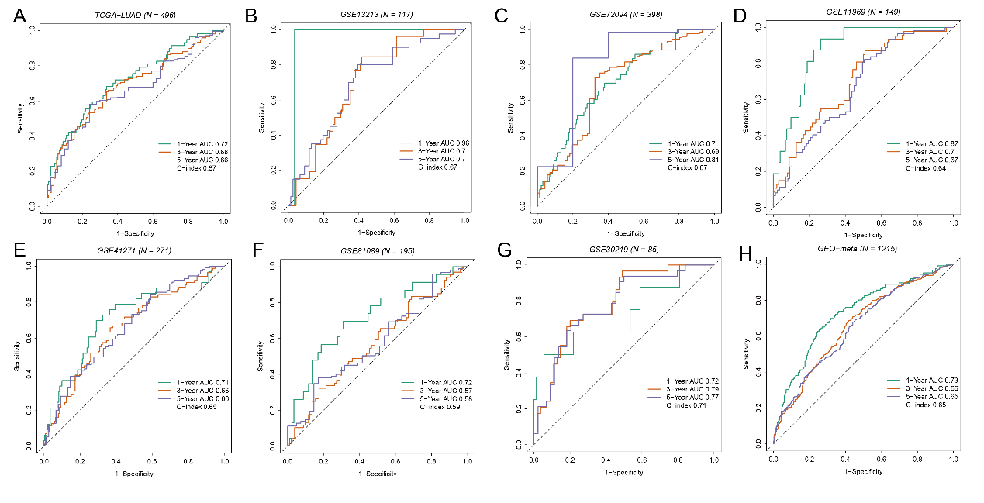
The time-dependent ROC curves for 1-, 3-, and 5-year overall survival in the training set and validation sets

Figure S3
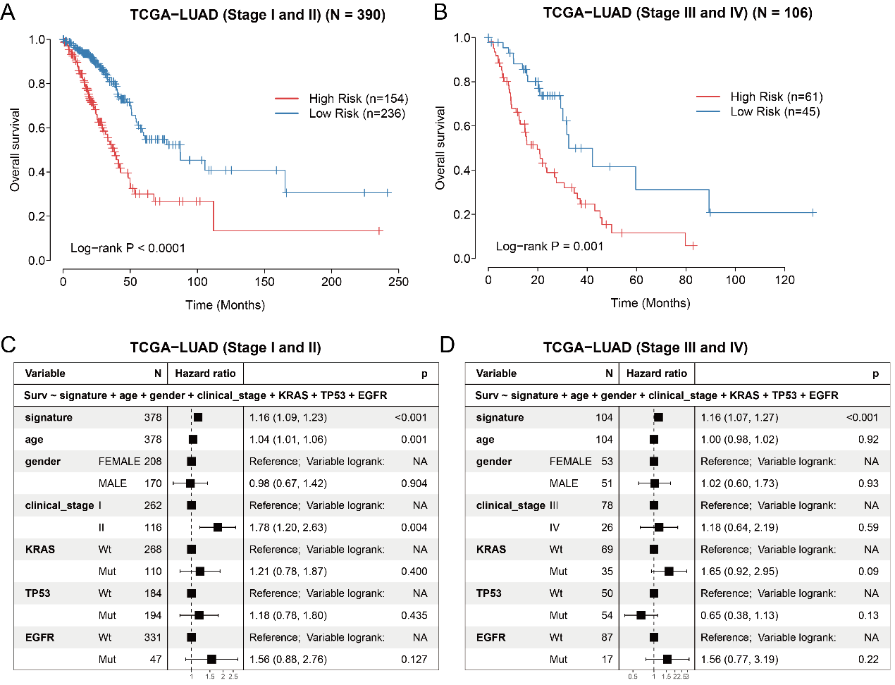
Kaplan-Meier survival curves show overall survival for patients grouped as high-and low-risk subgroups in the TCGA-LUAD dataset for the early stage (a) or advanced stage patients (b). Multivariate Cox regression analysis for overall survival in the TCGA-LUAD dataset for the early stage (c) or advanced stage patients(d).

Figure S4
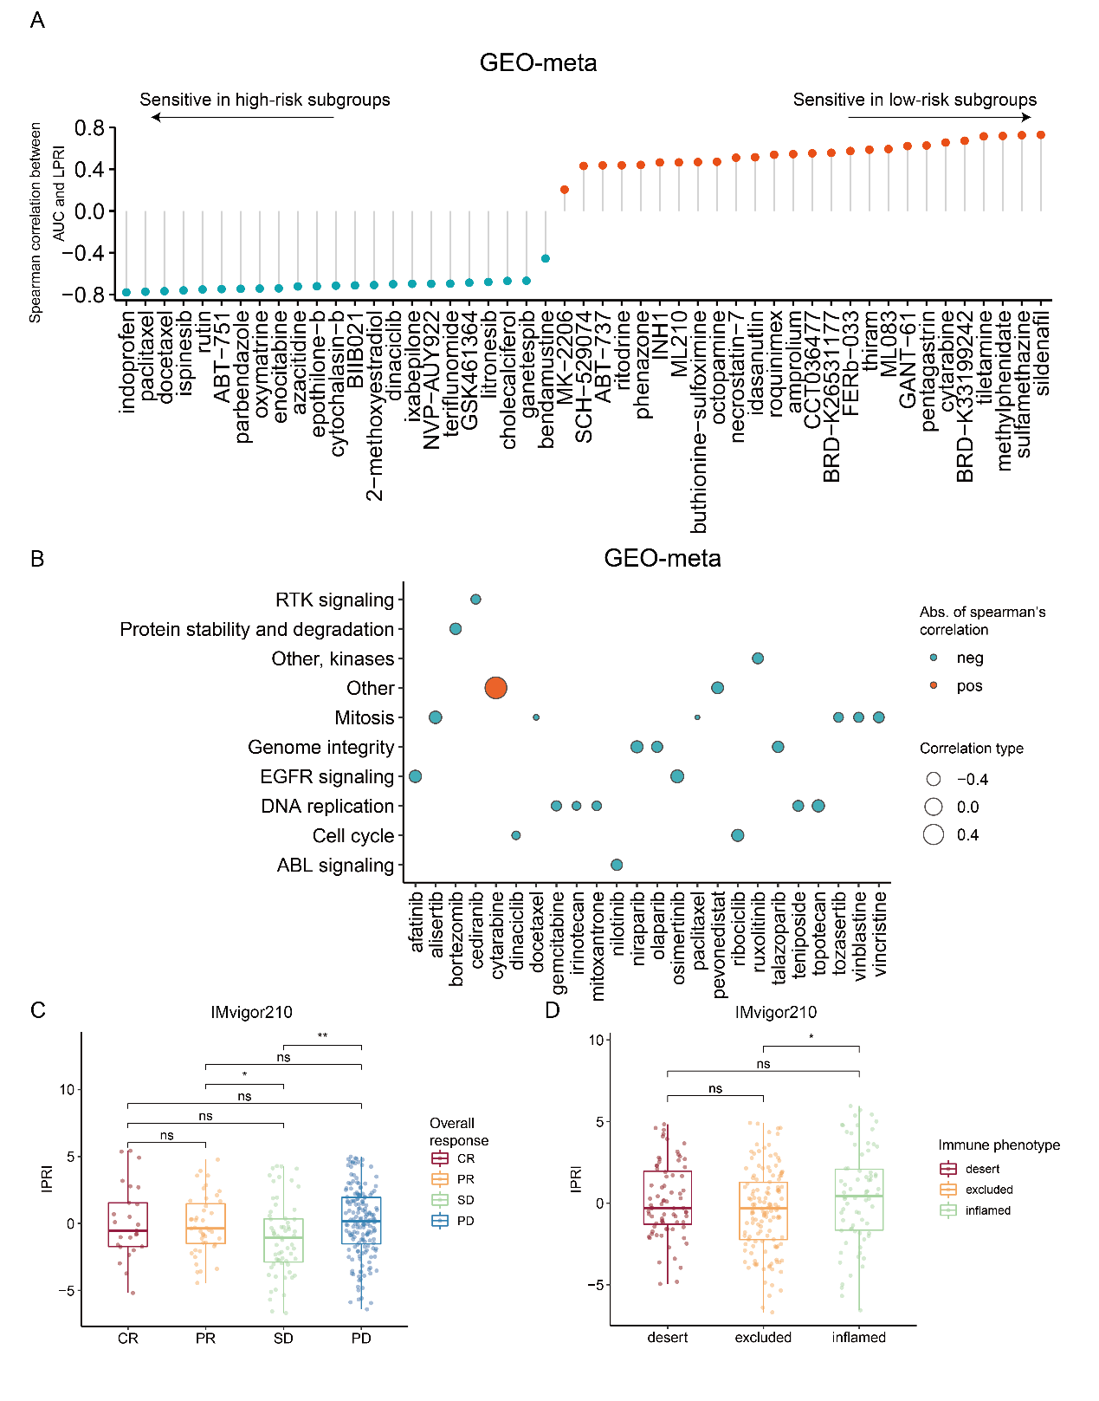

a) Spearman’s correlation between LPRI and predicted AUCs of drugs. b) Pathway annotation of potential sensitive drugs. c) Difference of LPRI among overall response groups in the IMvigor210 cohort. SD, stable disease; PD, progressive disease; CR, complete response; PR, partial response. d) Difference of LPRI among immune phenotype groups in the IMvigor210 cohort. ‘ns’ means no statistical significance, ∗ means P < 0.05, ∗∗ means P < 0.01, ∗∗∗ means P < 0.001 and ∗∗∗∗ means P < 0.0001.

Supplementary Tables
Table S1. Basic information of included datasets

Table S2. Identification of prognostic regulons

Table S3. LPRI of all included datasets

