Scheme 1. Synthesis of 4-phenylthiazol-2-yl-(phenylhydrazono)acetonitrile (PTPA) azo dye.
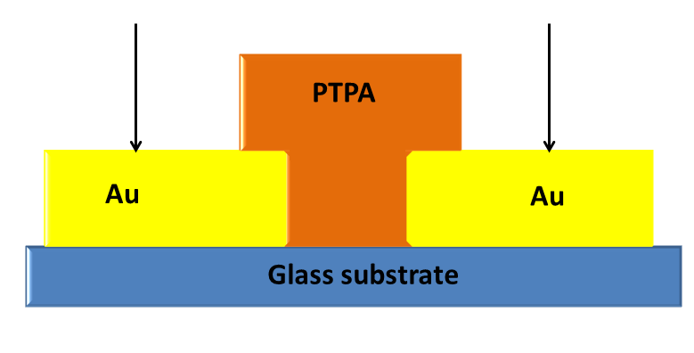
Scheme 2. Schematic illustration of the cross-section specimens' shape for electrical conductivity testing

Scheme 3. Azo-Hydrazone tautomerism of thiazole azo dye.

Scheme 4. The intra and intermolecular hydrogen bonds of the predominant Z- and E- hydrazone forms of PTPA dye. (*Numbering of carbons and protons will not be continuous and not follow numbering rules, where the thiazolylacetonitrile moiety has numbers from 1' to 9', on the other hand the substituted phenyl ring has numbers from 1 to 7.

