Supplementary Material
A Novel Organic Semiconductor 4-phenylthiazol-2-yl-(phenylhydrazono) acetonitrile (PTPA) Thin Films: Synthesis, Optical and Electrical properties

Amr Attia Abuelwafa^{a*}, Sahar Elnobi^{b}, M. A. Santos^{c}, H. M. Alsoghier^{b}
ª Nano & Thin Film Lab, Physics Department, Faculty of Science, South Valley University, Qena 83523, Egypt.
^{b} Chemistry Department, Faculty of Science, South Valley University, 83523 Qena, Egypt.
^{c} Centro de Química Estrutural, Instituto Superior Técnico, Universidade de Lisboa, Av. Rovisco Pais 1, 1049-001 Lisboa, Portugal
^{d} Physics Department, Faculty of Science, South Valley University, Qena 83523, Egypt.

*Corresponding author
*e-mail: Amr.abuelwafa@sci.svu.edu.eg (Amr Attia Abuelwafa)

Fig. S1: The ¹³C NMR spectrum of the 4-phenylthiazol-2-yl-(phenylhydrazono)acetonitrile (PTPA) azo dye in CDCl₃.

Fig. S2: The ¹³C DEPT-135 NMR spectrum of the dye (PTPA) in CDCl₃.
.
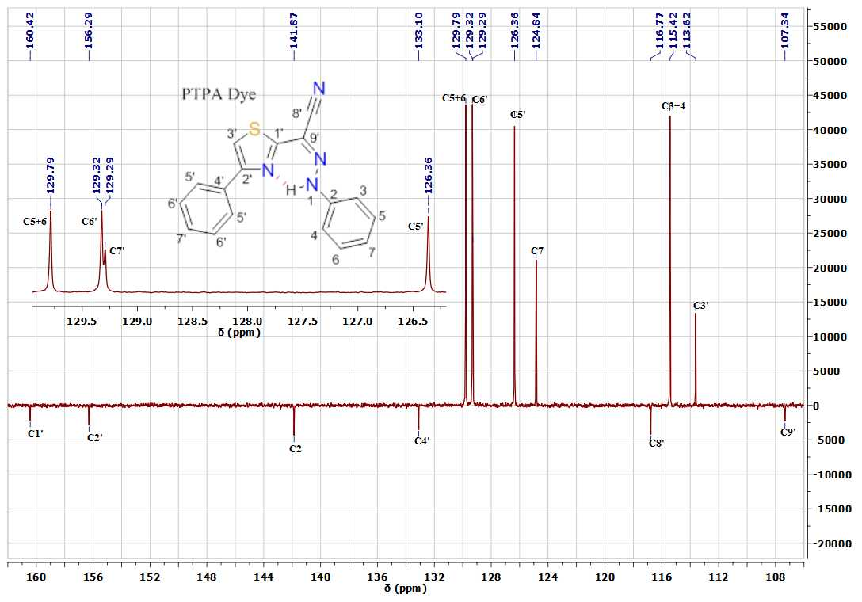
Fig. S3: The ¹³C APT NMR spectrum of the dye (BTPA) in CDCl₃.( *noted for accompanied tiny peaks)

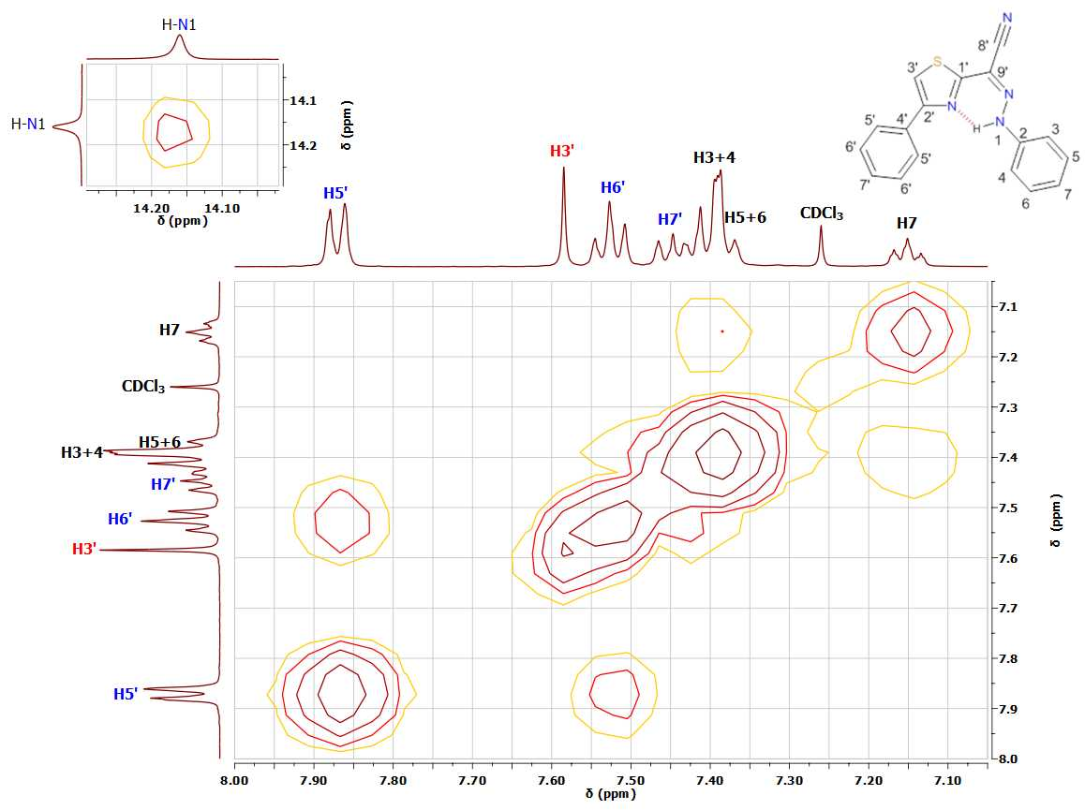
Fig. S4: The ¹H-¹H COSY NMR spectrum of the dye (PTPA) in CDCl₃.

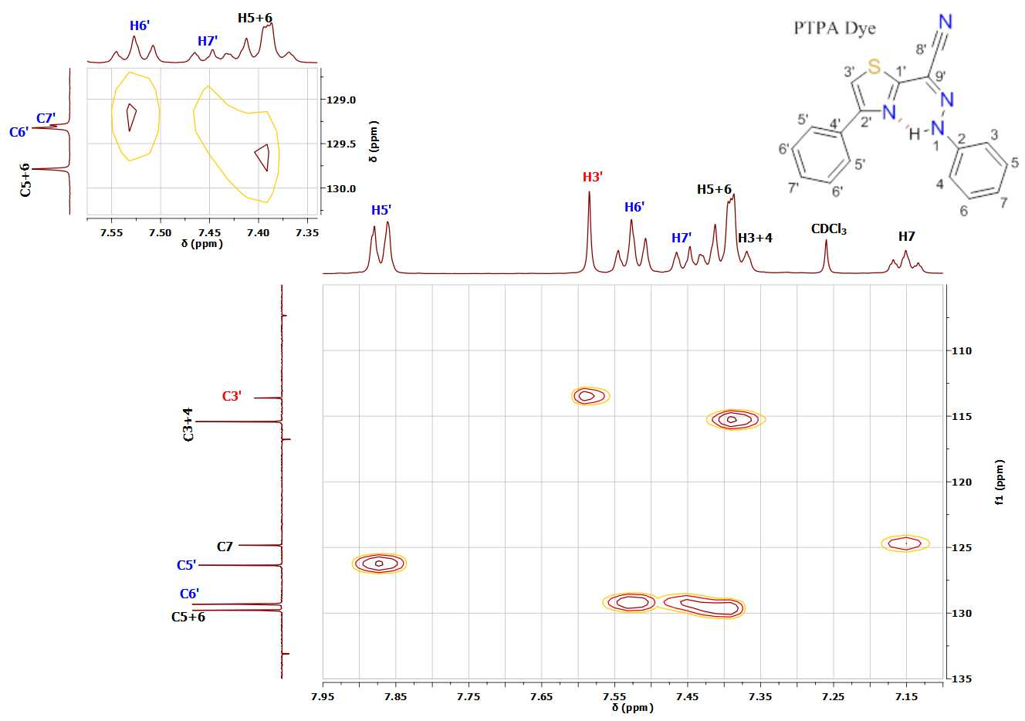

Fig. S5: The ¹H-¹³C HSQC NMR spectrum of the dye (PTPA) in CDCl₃.

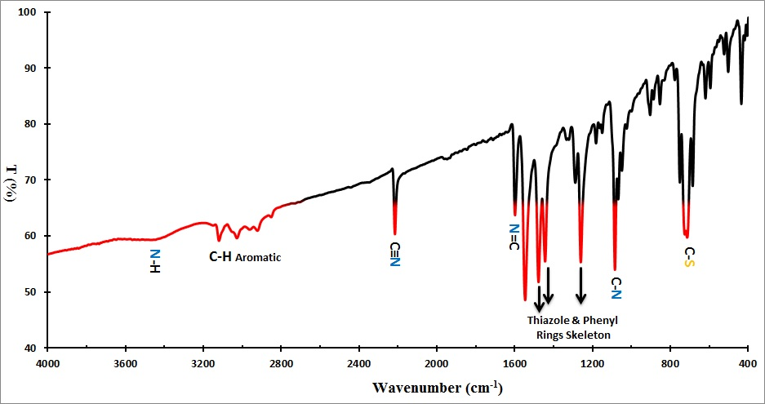

Fig. S6: FT-IR of the dye (PTPA).

Stock solution of 0.0033 gm of PTPA in 5mL MeOH + drop of DMF was prepared. 400 μL of the stock was added in 20mL Britton–Robinson buffer (BRB) solution at pH= 2.5. Versa STAT4 was utilized to perform all electrochemical experiments coupled with a cell of three-electrode system CPE 0.3 mm diameter as the working electrode, Ag/AgCl reference electrode, and Pt wire served as the counter electrode. The HOMO/LUMO computation was critical for adjusting device architectures to reach appropriate energy levels between emitting and conveying materials, hence avoiding interface emission and other device difficulties. This is also advantageous for improving device performance. PTPA's HOMO/LUMO energy levels were calculated using cyclic voltammetry (Figure 4). According to the equations below:
$E_{HOMO}=-(E_{ox}+4.4)eV$ (1)
$E_{LUMO}=-(E_{red}+4.4)eV$ (1)
where $E_{ox}$and $E_{red}$ are the onset oxidation and reduction potential.

Fig. S7: Cyclic voltammograms of PTPA

Table S1: ¹H and ¹³C chemical shifts (ppm) and protons coupling constants (J) of 4-phenylthiazol-2-yl-(phenylhydrazono)acetonitrile (PTPA) azo dye in CDCl₃.

H/C No. | PTPA
H/C No. | δ(¹H) | δ(¹³C)
1' | - | 160.43
2' | - | 156.30
3' | 7.58 (s, 1H) | 113.62
4' | - | 133.10
5' | 7.87 (d, J = 7.3 Hz, 2H) | 126.36
6' | 7.53 (t, J = 7.5 Hz, 2H) | 129.32
7' | 7.45 (t, J = 7.3 Hz, 1H), | 129.29
8' | - | 116.77
9' | - | 107.34
2 | - | 141.87
3,4 | 7.38 (d, J = 7.1 Hz, 2H) | 115.42
5,6 | 7.42 (d, J = 7.2 Hz, 2H) | 129.79
7 | 7.15 (t, J = 6.8 Hz, 1H) | 124.84
1N-H hydrazone | 14.16 (s, 1H) | -

