Supplementary Figure 1 Distribution of baseline platelet count in the study population

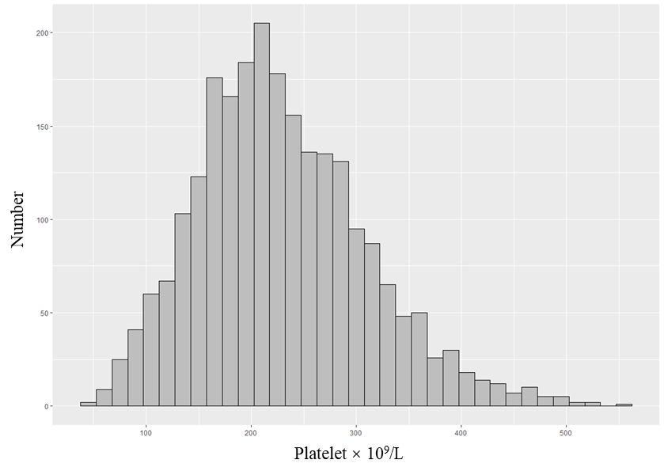

Supplementary Figure 2 Cumulative incidence function curve of PD-associated peritonitis using competing risk model analysis according to quartiles of platelet count at baseline
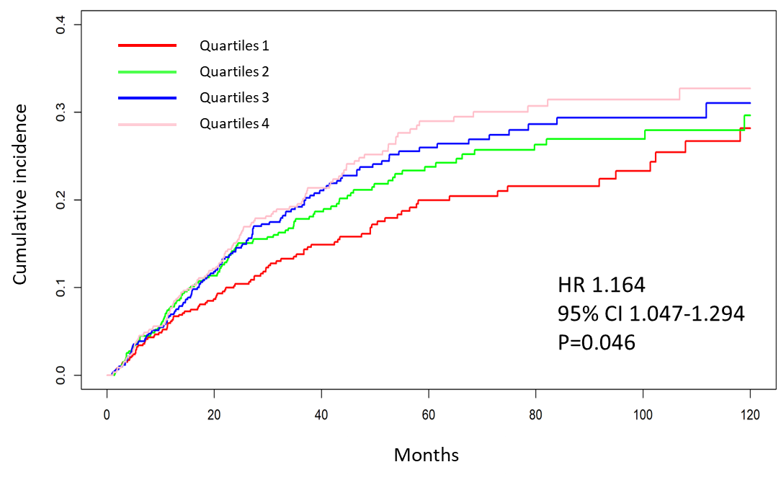

HR, hazard ratio; CI, confidence interval.
Adjusted for gender, age, BMI, cardiovascular disease, diabetes mellitus, white blood cell, N/L ratio, hemoglobin, albumin, potassium, anti-platelet agents use

