Supplementary material

Sound Absorption Polyimide Composite Aerogels for Ancient Architectures Protection

Xingyu Zhaoª, Yujia Hu^{b}, Xiuqi Xu^{c}, Mukun Li^{c}, Yixin Hanª*, Shan Huang^{b}*

ªShaanxi Key Laboratory of Macromolecular Science and Technology, School of Chemistry and Chemical Engineering, Northwestern Polytechnical University, Xi’an, 710072, People’s Republic of China.
^{b}School of Mechanics, Civil Engineering and Architectures, Northwestern Polytechnical University, Xi’an, 710072, People’s Republic of China.
^{c}Queen Mary University of London Engineering School, Northwestern Polytechnical University, Xi’an, Shaanxi, 710072, P. R. China.

* Corresponding authors: 18792580410@163.com (Y.X. Han), huangshan@nwpu.edu.cn (S. Huang).

S1.1 Main Materials
Diaminodiphenyl ether (ODA), pyromellitic dianhydride (PMDA), N, N-dimethylacetamide (DMAc), triethylamine (TEA) and calcium carbonate (CaCO₃) were all purchased from Shanghai Macklin Biochemical Technology Co., Ltd (Shanghai, China).
S1.2 Characterization
Heat resistances of the samples were tested by thermogravimetric analyzer (TGA, STA.449F3, NETZSCH Co., Germany) (Heating rate of 10ºC/min at argon atmosphere). Microscopic morphologies of the samples were tested by scanning electron microscope (SEM, VEGA 3, TESCAN Ltd., Czech Republic). Sound absorption coefficient of the samples in the frequency range of 100~6300 Hz was tested by SW422 and SW477 standing wave tube absorption test systems (BSWA Technology Co., Ltd., China). Thermal conductivity coefficient (λ) of the samples was measured by TPS2200 Hot Disk instrument (AB Corp., Sweden) according to ISO 22007-2:2008. Young’s modulus and fatigue resistances of the samples were tested by electronic universal testing machine (UTM210, Shenzhen Suns Instruments Corp., China) with compression rate of 10 mm/min.
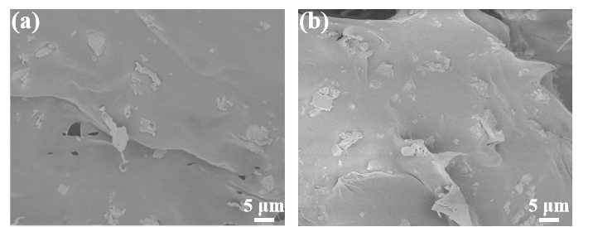
Fig. S1 SEM images of 2 wt% CaCO₃/PI (a) and 6 wt% CaCO₃/PI (b) composite aerogels
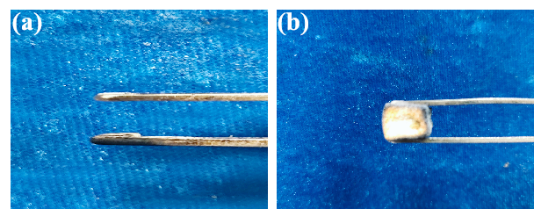
Fig. S2 Images of PS foams (a) and 4 wt% CaCO₃/PI composite aerogels (b) samples after 60 s combustion
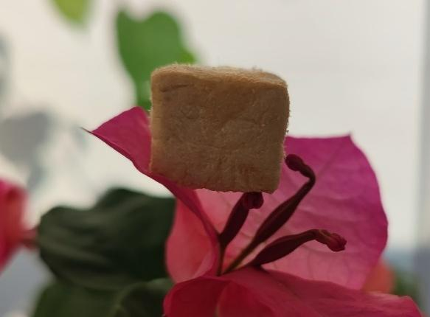
Fig. S3 Image of 4 wt% CaCO₃/PI composite aerogels placed on flower petal
Table S1 Component content of CaCO₃/PI composite aerogels
Samples | CaCO₃ (wt%) | PI (wt%)
PI | 0 | 100
2 wt% CaCO₃/PI | 2 | 98
4 wt% CaCO₃/PI | 4 | 96
6 wt% CaCO₃/PI | 6 | 94
Table S2 Thermal properties data of the CaCO₃/PI composite aerogels
Samples | Weight loss temperature (ºC) | T_{HRI} (ºC) | Residues (wt%)
 | T₅ T₃₀
PI | 521.8 596.1 | 277.5 | 52.4
2 wt% CaCO₃/PI | 558.9 735.8 | 325.9 | 53.1
4 wt% CaCO₃/PI | 577.3 751.4 | 334.1 | 54.0
6 wt% CaCO₃/PI | 675.2 773.3 | 359.7 | 57.5
T_{Heat-resistance index (HRI)}=0.49×(T₅+0.6×(T₃₀−T₅))

