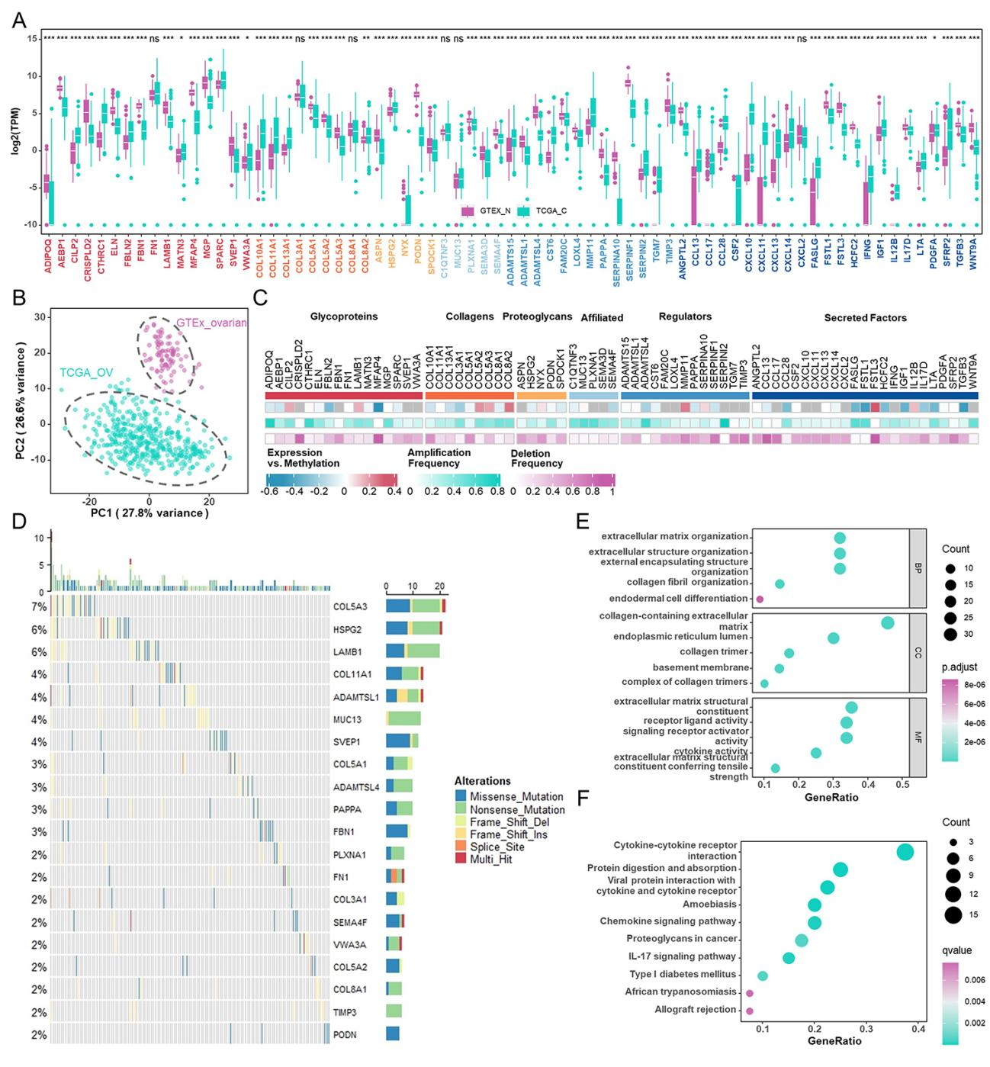
Figure S1: Selection of prognostic-related ECM genes in HGSOC patients.
(A) The expression of prognostic-related ECM genes in TCGA-OV and GTEx-ovarian tissues.
(B) Principal component analysis of prognostic-related ECM genes to distinguish ovarian cancer from normal ovarian tissues.
(C) Heatmap showing the correlation between the expression level and the methylation (upper), the amplification frequency (middle), and the deletion frequency (bottom) for prognostic-related ECM genes.
(D) Waterfall plot of prognostic-related ECM genes in TCGA-OV cohort.
(E) GO enrichment analyses based on the prognostic-related ECM genes.
(F) KEGG enrichment analyses based on the prognostic-related ECM genes.
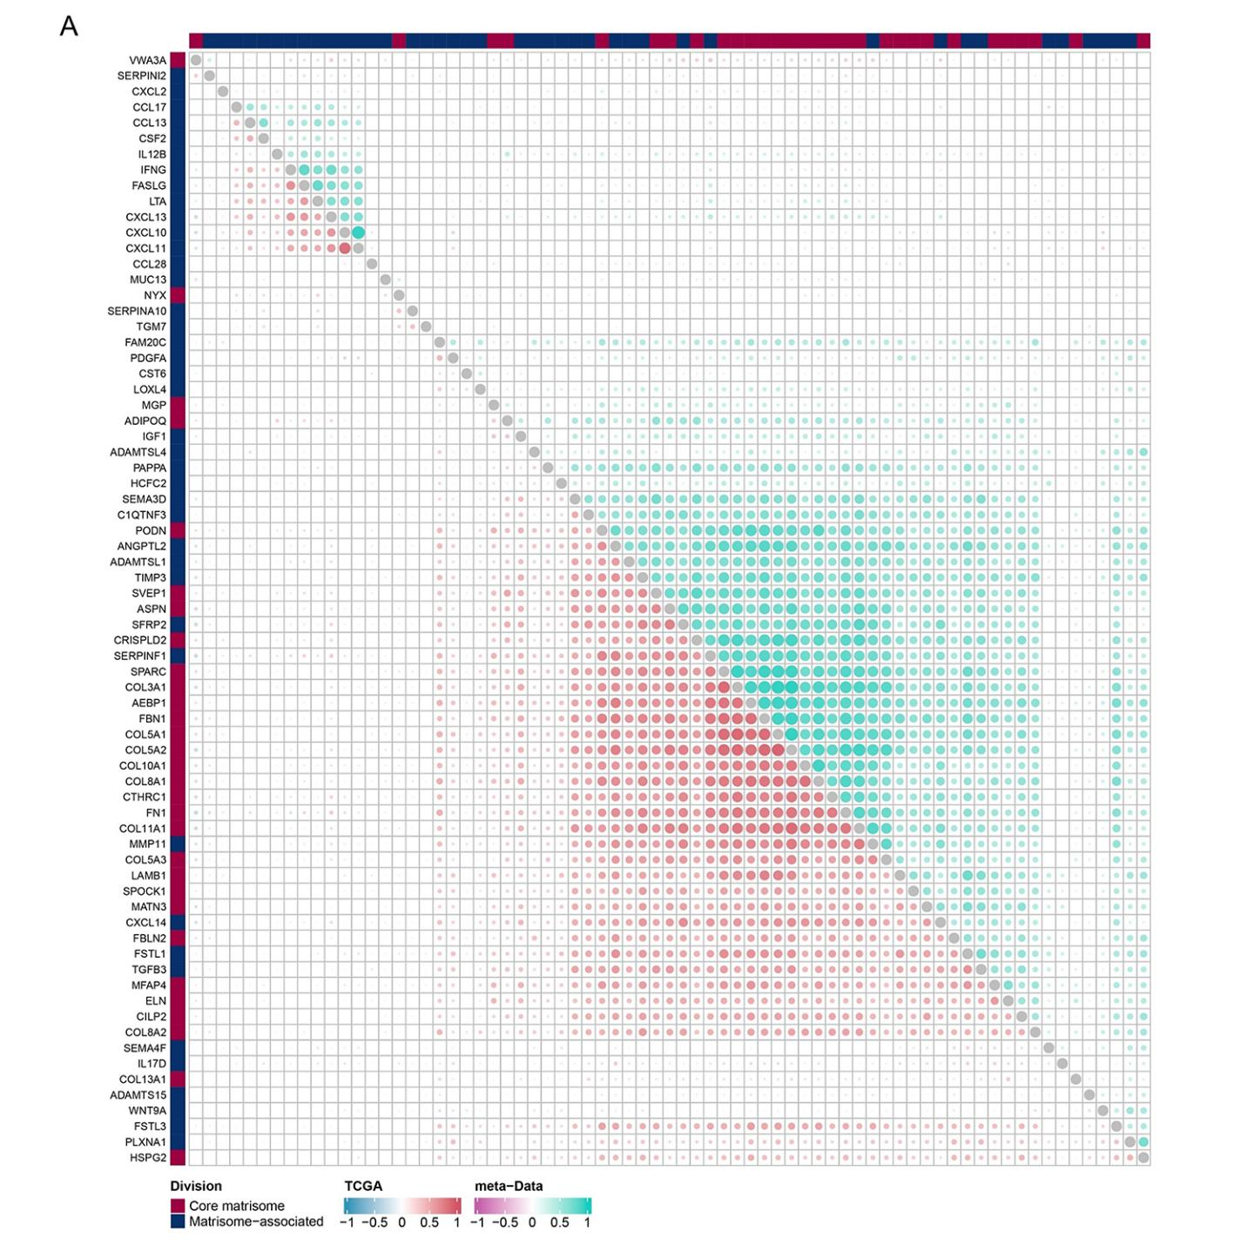
Figure S2: Correlation analysis between prognostic-related ECM genes in meta-data and TCGA-OV cohort.

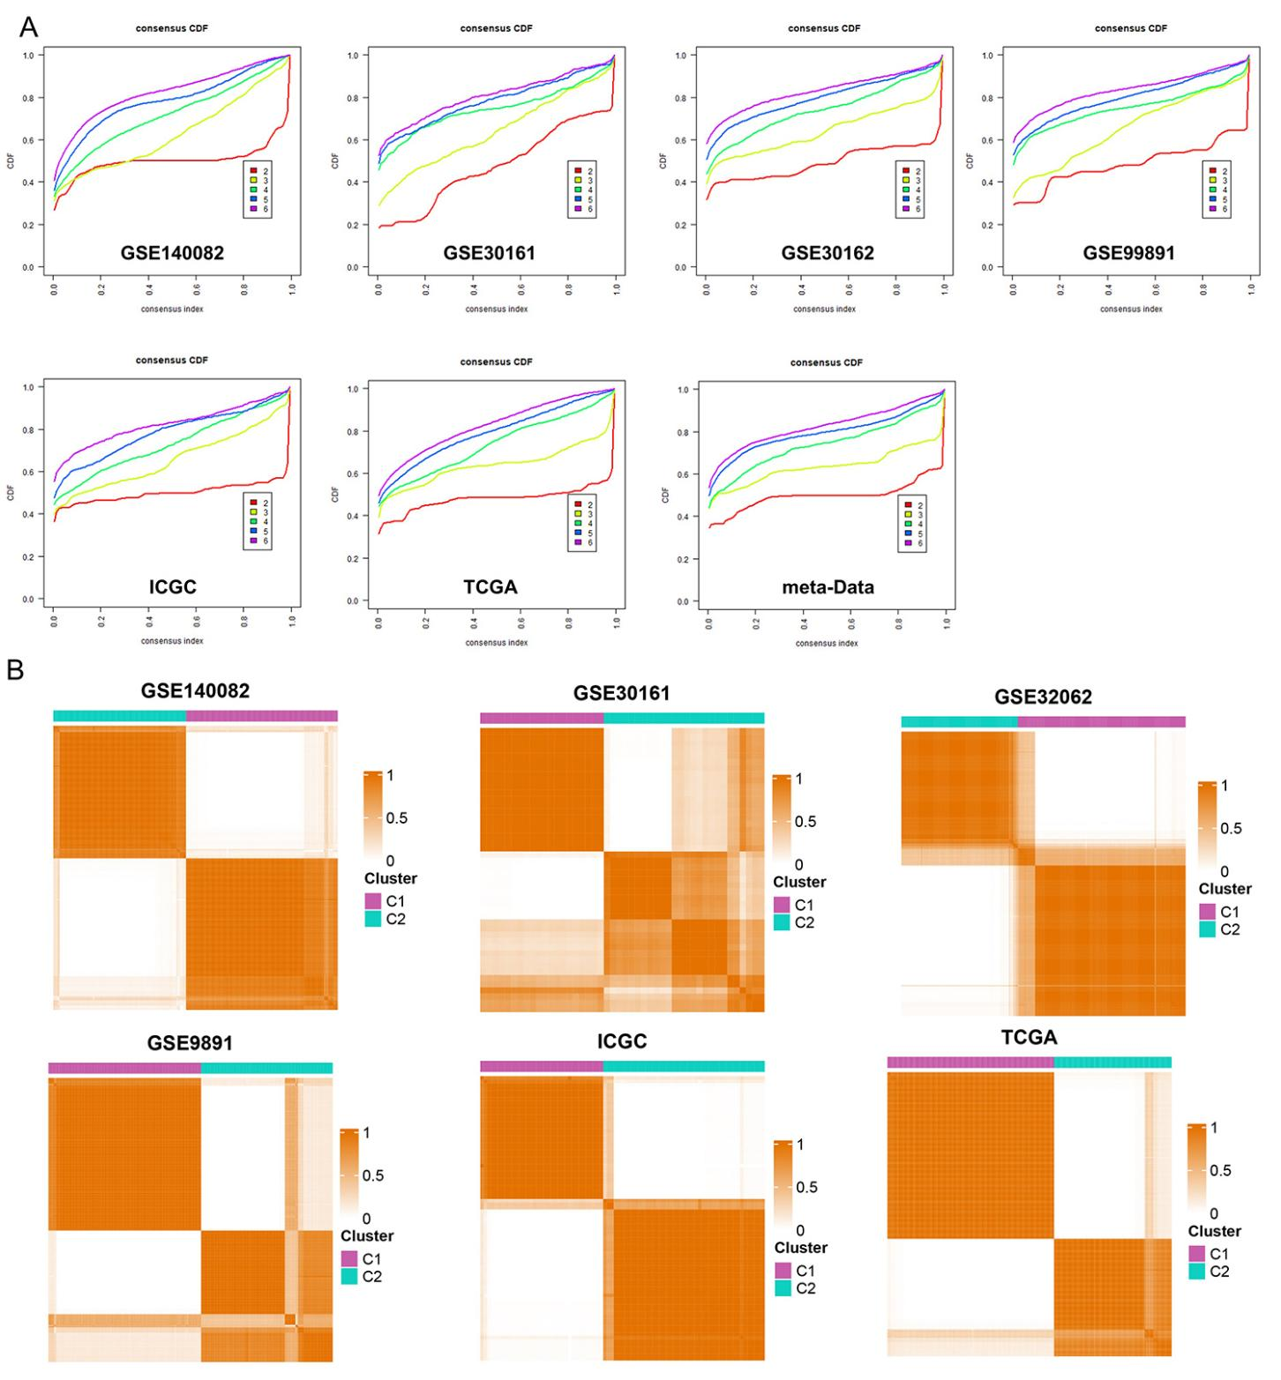
Figure S3: Identification of two ECM clusters in different cohorts.
(A) Cumulative distribution function curve displaying consensus distributions for each k value (from 2 to 6) in different cohorts.
(B) Consensus clustering cumulative distribution function for k = 2 in different cohorts.

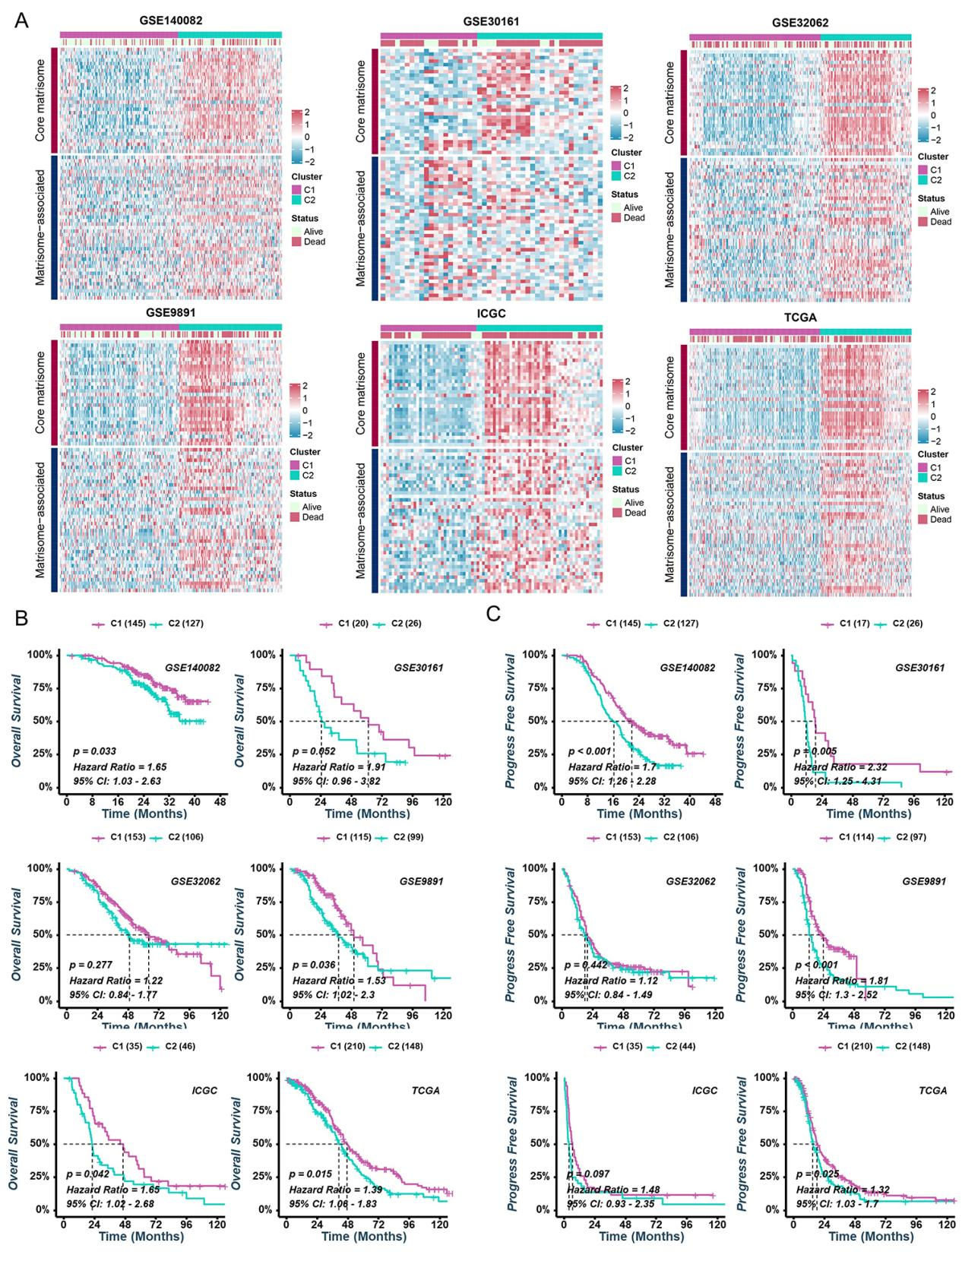
Figure S4: Unsupervised consensus clustering analyses identified two ECM clusters with heterogeneous prognosis.
(A) Heatmap displaying the transcriptome profiles of the prognostic-related ECM genes in different cohorts.
(B, C) Kaplan-Meier analyses estimating OS (B) and PFS (C) between cluster C1 and cluster C2 in different cohorts.
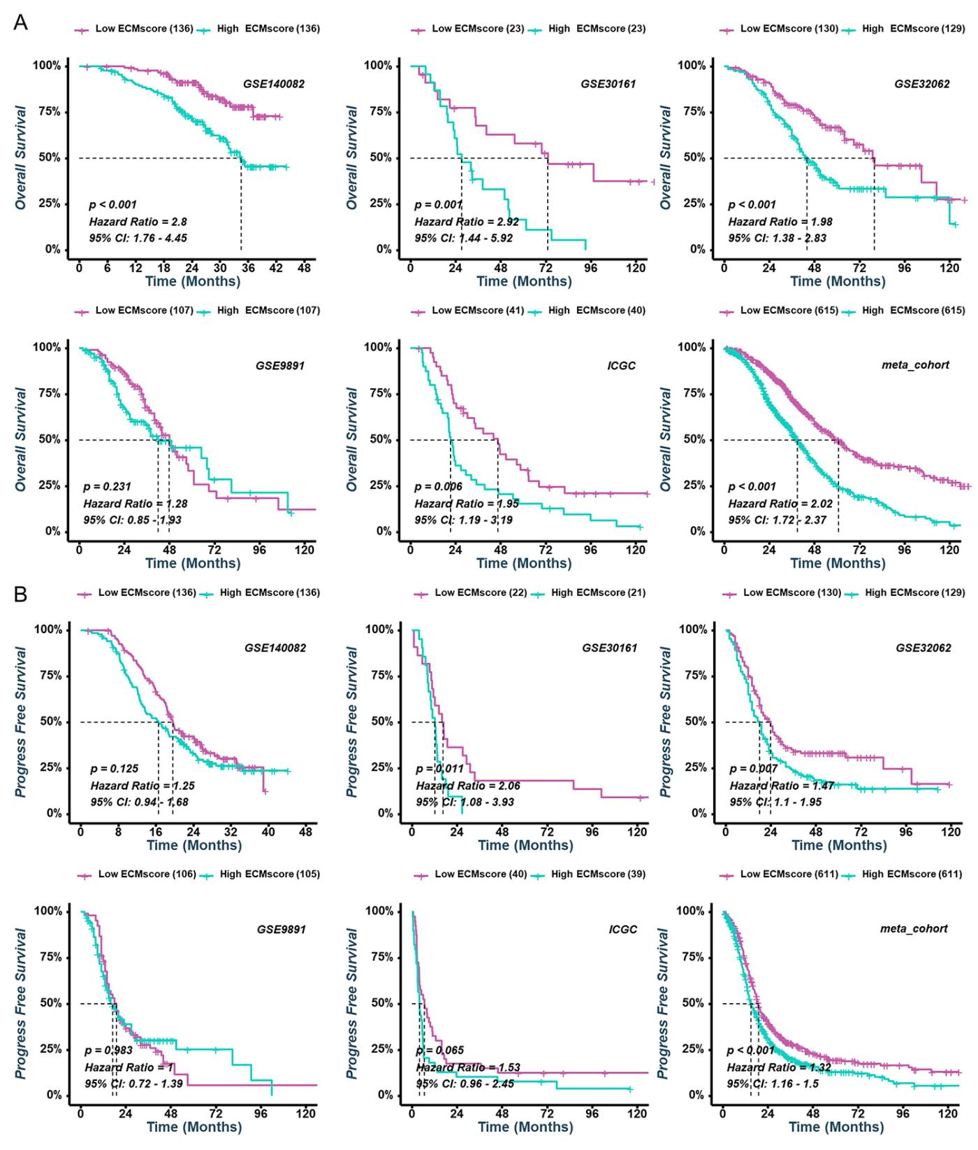
Figure S5: Validation of the ECMscore in six independent cohorts.
- Kaplan-Meier analyses estimating OS (A) and PFS (B) between low- and high- ECMscore groups in different cohorts.

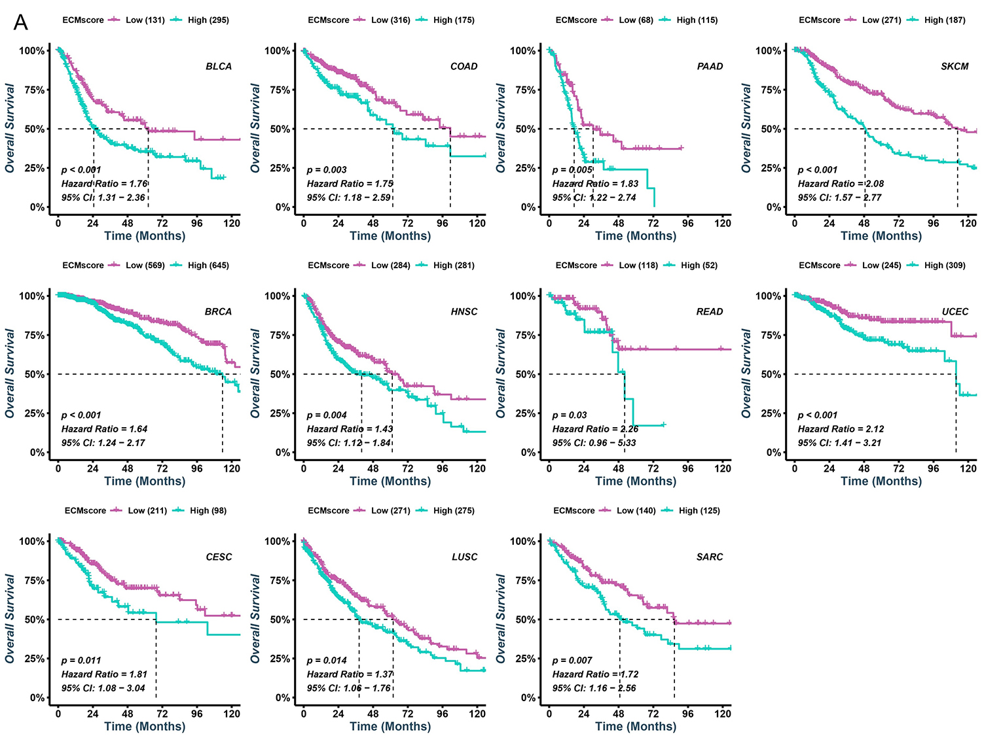
Figure S6: (A) The Kaplan-Meier analyses estimate OS between low- and high-ECMscore groups in pan-cancer cohorts.

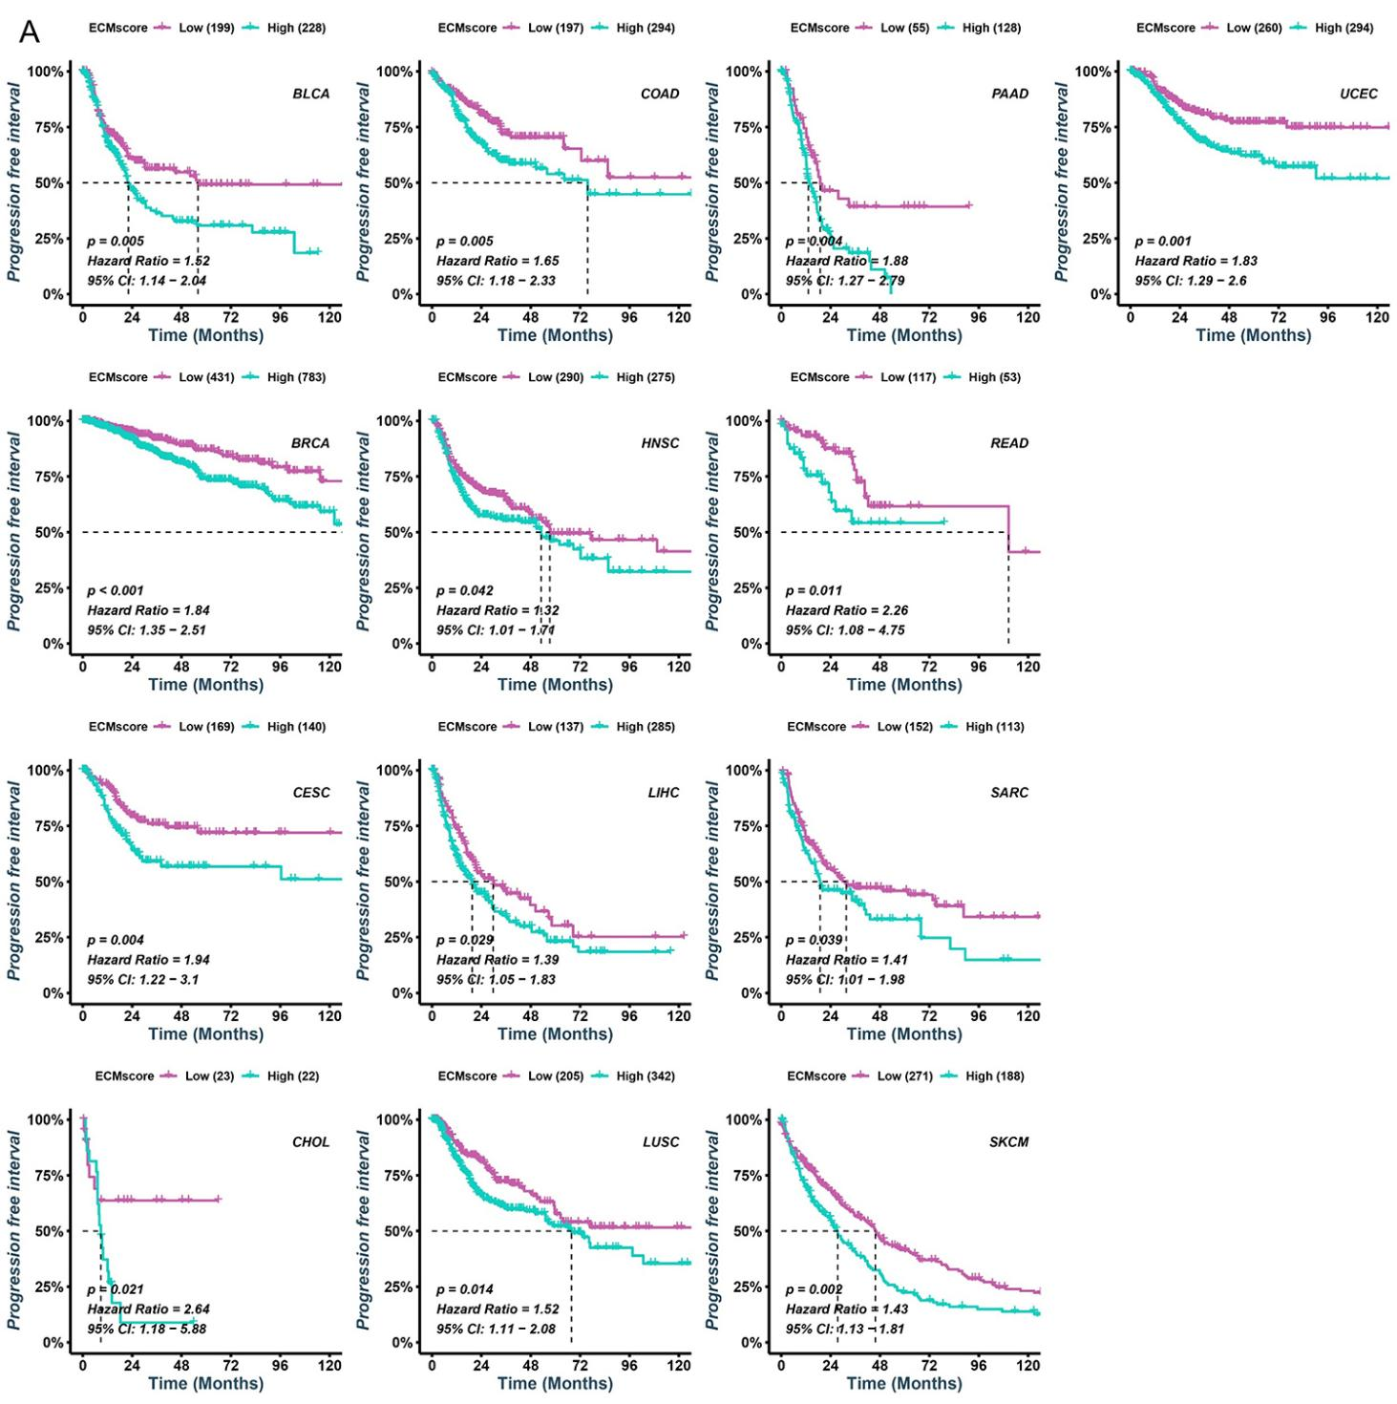
Figure S7: (A) The Kaplan-Meier analyses estimate PFS between low- and high-ECMscore groups in pan-cancer cohorts.

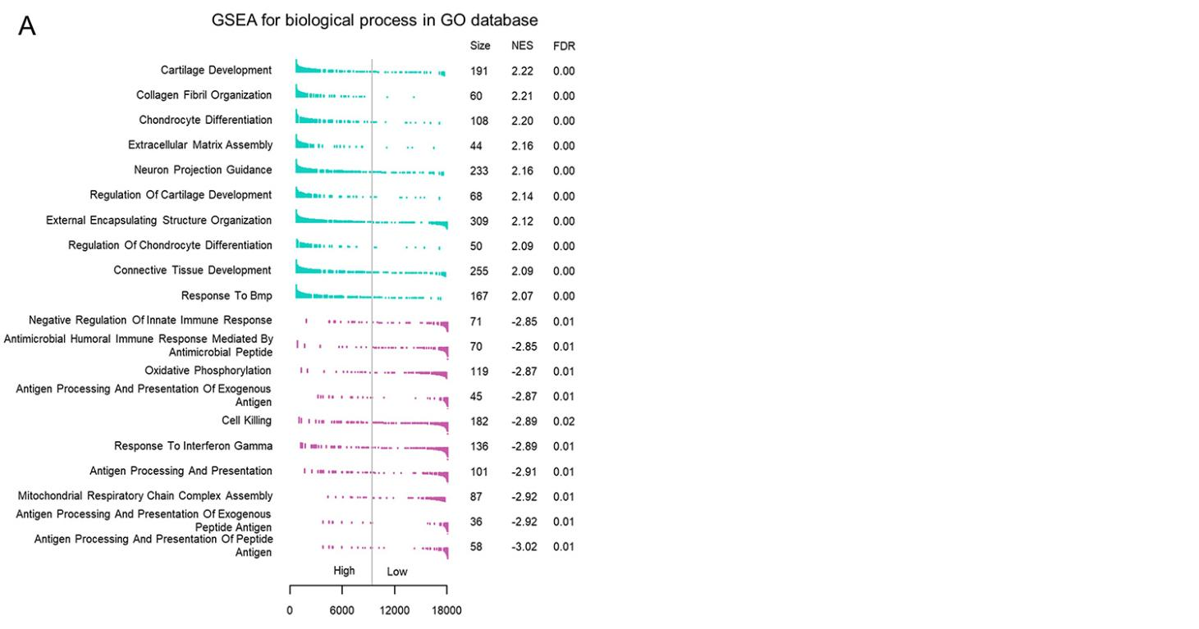
Figure S8: Underlying biological functions of different ECMscore groups.
- GSEA analyses of biological process gene sets from the GO database and the top 10 positively and negatively related pathways with ECMscore were presented.

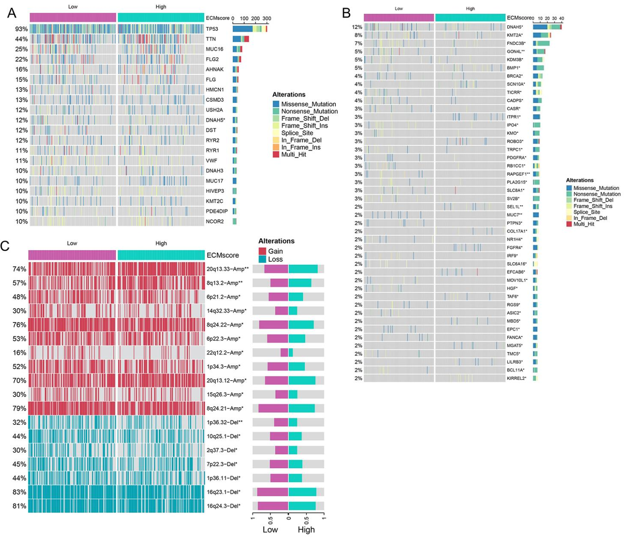
Figure S9: Genomic Features of different ECMscore groups.
(A) Waterfall plot of the top 20 most frequently mutated genes in the TCGA-OV cohort.
(B) Waterfall plot of genes with different frequencies mutated between the low- and high- ECMscore group.
(C) Heatmap (left) depicted the broad-level copy number alterations in the low- and high- ECMscore group. Bar chart (right) showed the frequency of amplifications or deletions in the low- and high- ECMscore groups.

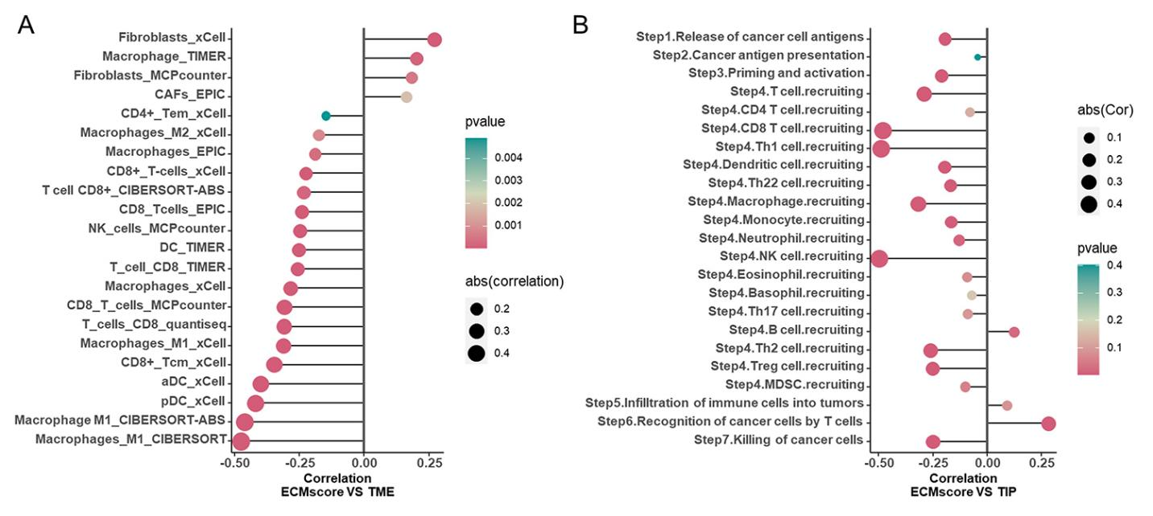
Figure S10: The association between the ECMscore and immune landscape.
(A) Correlation between ECMscore and several anticancer tumor-infiltrating immune cells using different algorithms.
(B) Correlation between ECMscore and cancer immunity cycle in TCGA-OV cohort.

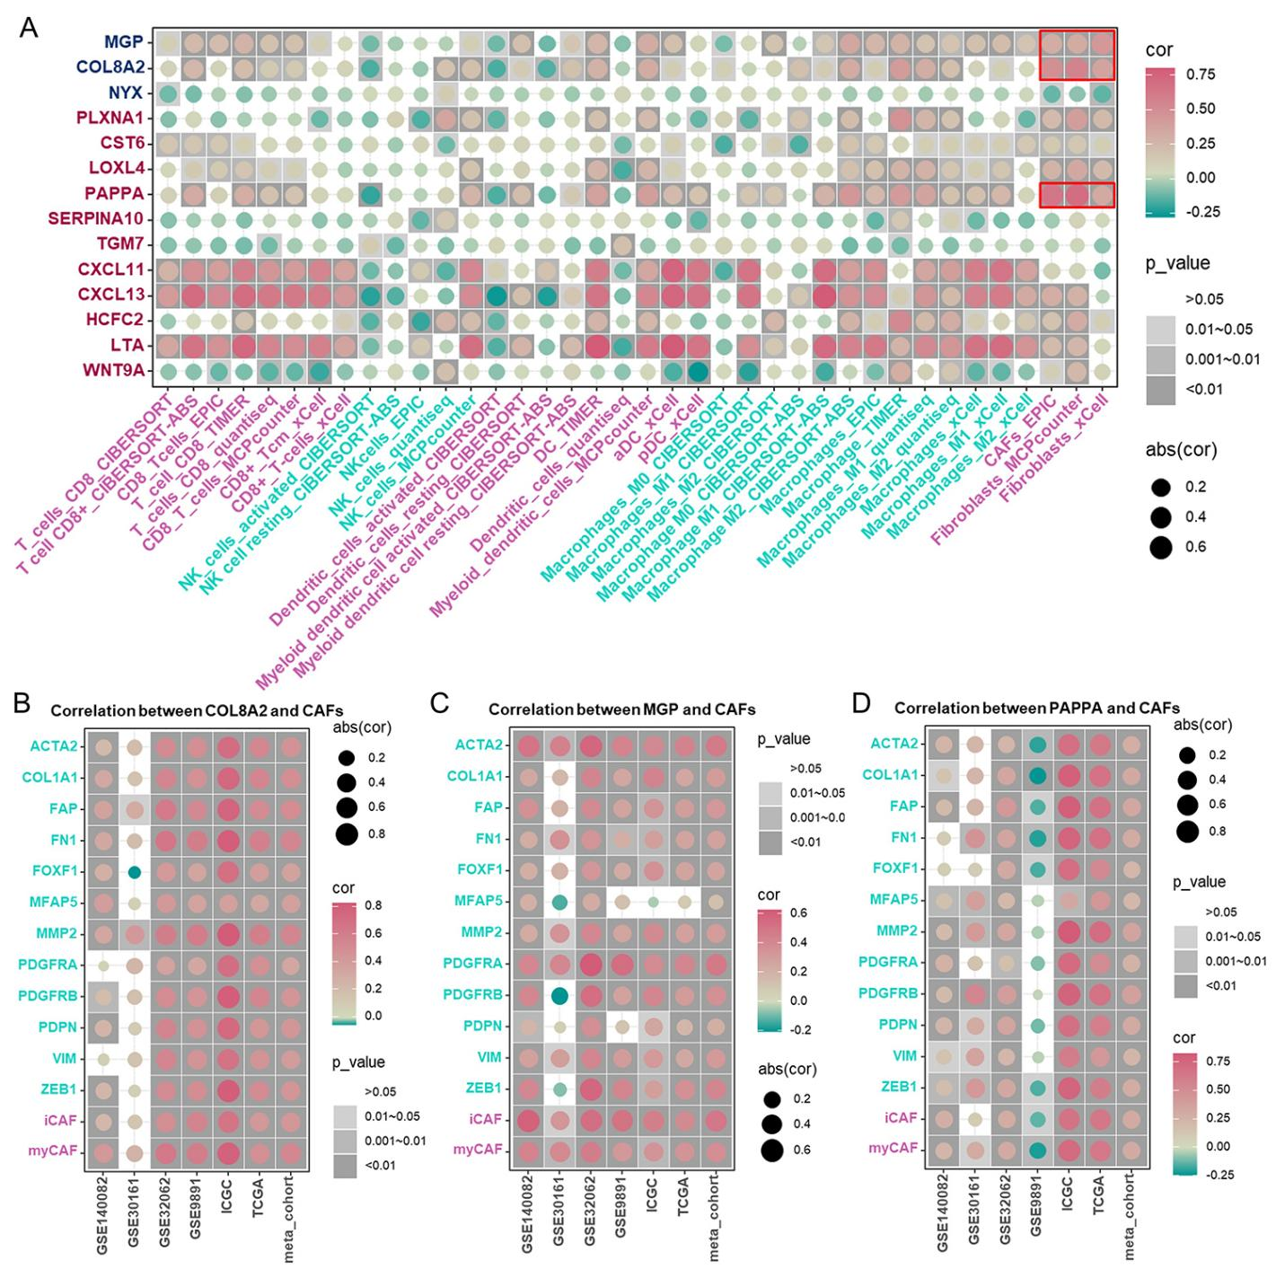
Figure S11: The association between the ECM genes and immune landscape.
(A) The correlation between the expression of 14 prognostic genes and several anticancer tumor-infiltrating immune cells. The color and size of the point reflect the correlation.
(B-D) The correlation between the expression of CAFs mark and COL8A2 (B), MGP (C), and PAPPA (D). The size and color of the point correspond to the correlation.

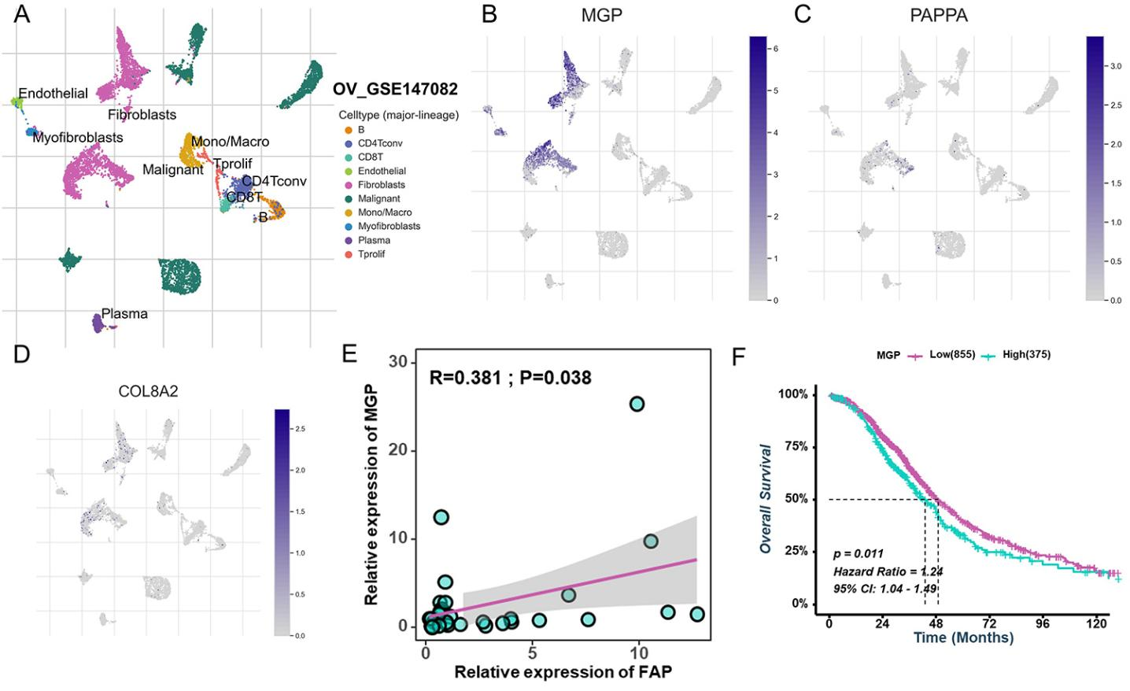
Figure S12: Validation of COL8A2, MGP, and PAPPA in single-cell RNA transcriptome data.
(A-D) Expression pattern of COL8A2, MGP, and PAPPA in various cells in GSE147082, the cells were clustered and annotated based on TISCH databases.
(E) The correlation between the MGP and FN1 was verified by qRT-PCR in the Xiangya cohort.
(F) Kaplan-Meier analysis estimating OS in low- and high- MGP groups in meta-data cohort.

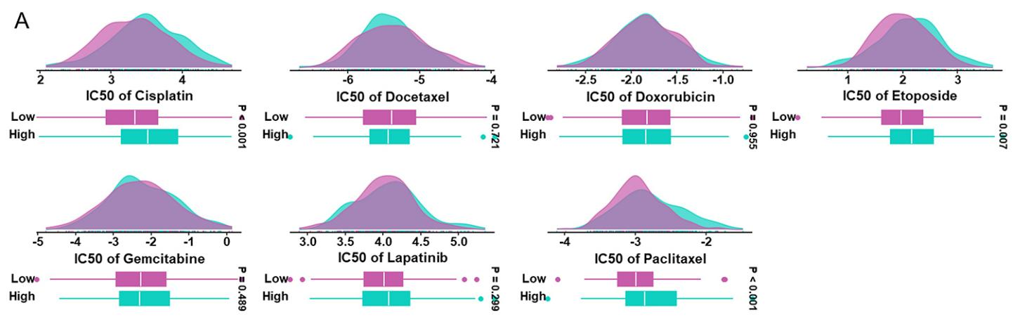
Figure S13: The IC50 values of several common chemotherapy drugs between low- and high- ECMscore groups in TCGA-OV cohort.

