In silico Analysis and Molecular Dynamic Modeling of Three-dimensional Structure of Glutelin type-B 5-like Proteins from Proso Millet: Effects of Temperature and Electric Field

Felix Akharume¹, Ashutosh Singh², Konstantin K. Korotkov³, Akinbode Adedeji^{1*}

¹Department of Biosystems and Agricultural Engineering, University of Kentucky, KY USA. 40546
²School of Engineering, University of Guelph, Guelph, Canada. N1G 2W1
³Department of Molecular and Cellular Biochemistry, University of Kentucky, Lexington, KY USA 40546.

*Corresponding author: e-mail: akinbode.adedeji@uky.edu; phone: 859-218-4355.
ORCID-0000-0002-3497-0166

Supplementary Material
Appendix 1. A summary of the glutelin type-B 5-like protein details used for the homology modeling
Protein type/ label | Length | Amino acid sequence | Ascension number
Glutelin type-B 5-like | 256 | MESSAANPRGRPPSGRGPAKSDEPRQHYAEHHVRARERERSENA  LLRETESQQRRQGNDRDYQQADGRGHSPDDQDQMCRMKVTMNLQ  ARPWHQRRPALPAEDEGHEPDRPQLPILNSLQVSVERGTLSQDV  AVPPLYYTAGAQSVVYAVRGSARLQLVDNIGAAVFDGELRRGQL  LVVPEFFVVLTEAGKDGVEYIAFRNDASPVTSRIAGPGSVLRGL  PVGVIAASYNVPAKDAMKLKDSGGGGGGGGTSESEL | RLM98351

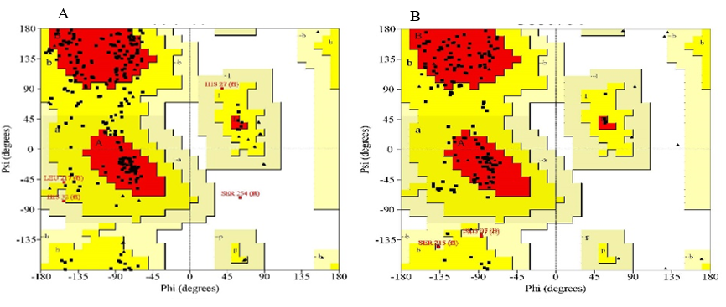
Appendix 2. Ramachandra plots of geometry minimalized glutelin type-B 5-like protein models (A) model from Swiss-Model server (B) model from the Robetta server.

