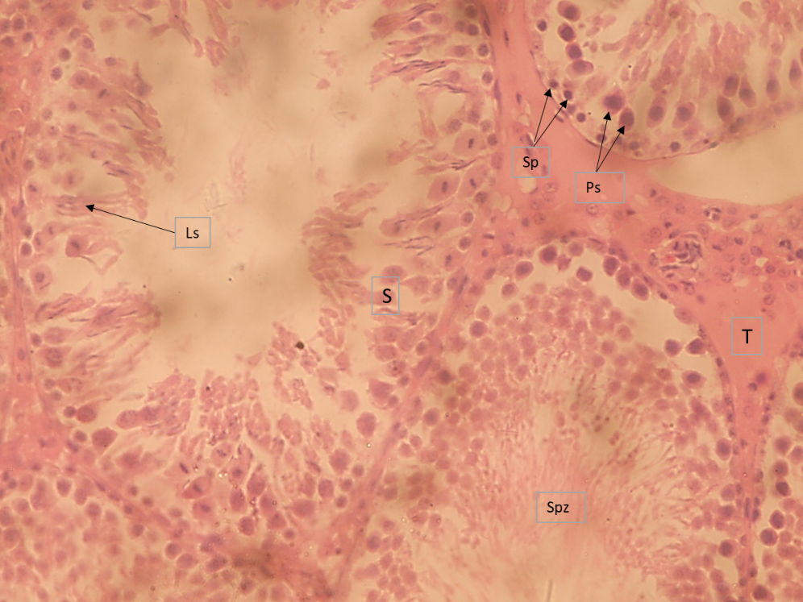
Plate 1. Histological appearance of testis of rat from group B given 125mg/kg of chloroform stem extract of P.oleracea, showing no obvious lesions. Note active seminiferous tubules (S) bearing spermatogonium (Sp), primary spermatocytes (Ps), late spermatids (Ls), Spermatozoa (Spz) and interstitium (T); Hematoxylin & Eosin (H&E) × 400.

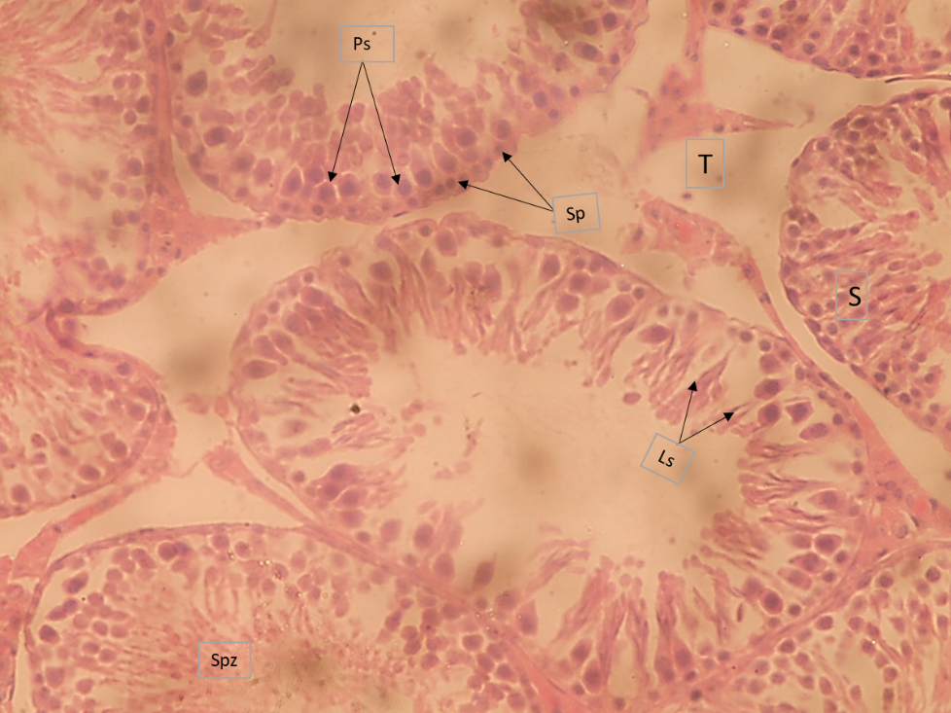
Plate 2. Histological appearance of testis of rat from group B given 250mg/kg of chloroform stem extract of P.oleracea, showing no obvious lesions. Note active seminiferous tubules (S) bearing spermatogonium (Sp), primary spermatocytes (Ps), late spermatids (Ls), Spermatozoa (Spz) and interstitium (T); Hematoxylin & Eosin (H&E) × 400

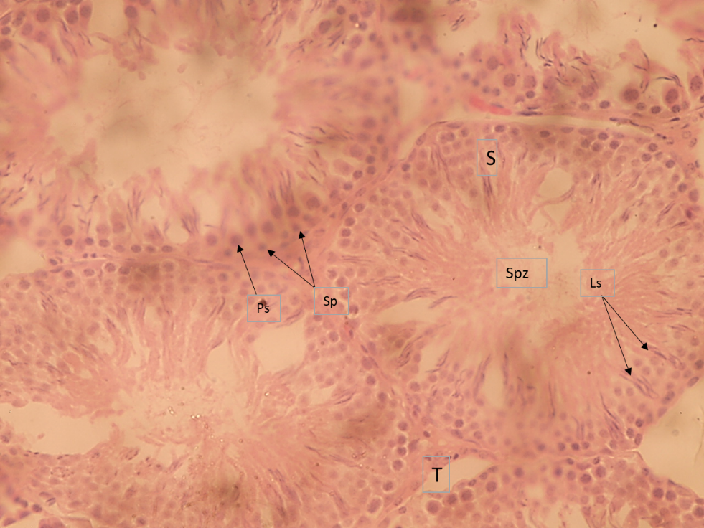
Plate 3. Histological appearance of testis of rat from group B given 500mg/kg of chloroform stem extract of P.oleracea, showing no obvious lesions. Note active seminiferous tubules (S) bearing spermatogonium (Sp), primary spermatocytes (Ps), late spermatids (Ls), Spermatozoa (Spz) and interstitium (T); Hematoxylin & Eosin (H&E) × 400.

