Table ( 3 ): GFR (Glomerular Filteration Rate) of the studied 45 SCD cases:
Variable | Value
GFR (CKD-EPI) in ml/min/1.73m2  Mean± SD  Range | 165.87±26.18  (98-245)

Table ( 4 ): Doppler parameters results among the studied 45 SCD patients
Variable | Value
Main Renal Artery Pulsatility index  Mean±SD  Range | 1.48±0.48  (0.88-3.54)
Main Renal Artery Resistance index  Mean±SD  Range | 0.69±0.06  (0.57-0.86)
Interlobar Artery Pulsatility index  Mean±SD  Range | 1.29±0.58  (0.71-1.87)
Interlobar Artery Resistance index  Mean±SD  Range | 0.63±0.06  (0.5-0.77)

Table ( 5 ): Comparison of the Renal doppler parameters of the studied SCD patients versus the control normal group (Cases versus Control group)
Variable | Cases group  (n=45) | Control group  (n=45) | Tests
Variable | Cases group  (n=45) | Control group  (n=45) | z/t | P
Main Renal Artery Pulsatility index  Mean±SD  Range | 1.48±0.48  (0.88-3.54) | 0.99±0.12  (0.85-1.21) | ^{-6.642(t)} | <0.001*
Main Renal Artery  Resistance index  Mean±SD  Range | 0.69±0.06  (0.57-0.86) | 0.60±0.03  (0.55-0.66) | ^{-6.374 (t)} | <0.001*
Interlobar Artery  Pulsatility index  Mean±SD  Median(IQR) | 1.29±0.58  1.21 (1.1-1.32) | 0.99±0.11  0.99 (0.89-1.10) | ^{-5.697(MW)} | <0.001*
Interlobar Artery  Resistance index  Mean±SD  Range | 0.63±0.06  (0.5-0.77) | 0.59±0.04  (0.52-0.64) | ^{-2.984 (t)} | 0.003*
(t) independent sample t test Mann Whitney test (MW)

Table ( 6 ): Multivariate regression analysis among the 45 SCD patients :
Factors | Mean Square | F | Sig.
Age in years | 15.548 | 3.243 | 0.014*
Age of start of illness | 0.928 | 0.656 | 0.836
Frequency of yearly transfusions | 20.573 | 1.470 | 0.234
HB (gm/dl) | 2.168 | 1.347 | 0.290
Reticulocytic count | 20.729 | 2.788 | 0.027*
Serum Ferritin Level (ng/ml) | 602473 | 0.976 | 0.546
LDH (U/L) | 3665193 | 95.429 | 0.000*
HB S % | 184.381 | 0.736 | 0.765
A/C (mg/g creat) | 860.510 | 3.297 | 0.013*

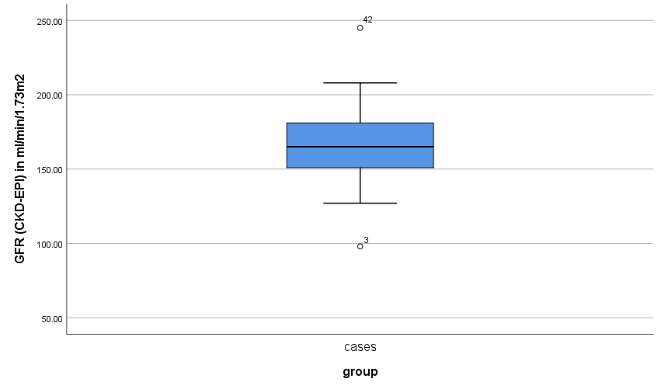
Figure (4) : Estimated GFR among studied 45 SCD patients via CKD-EPI

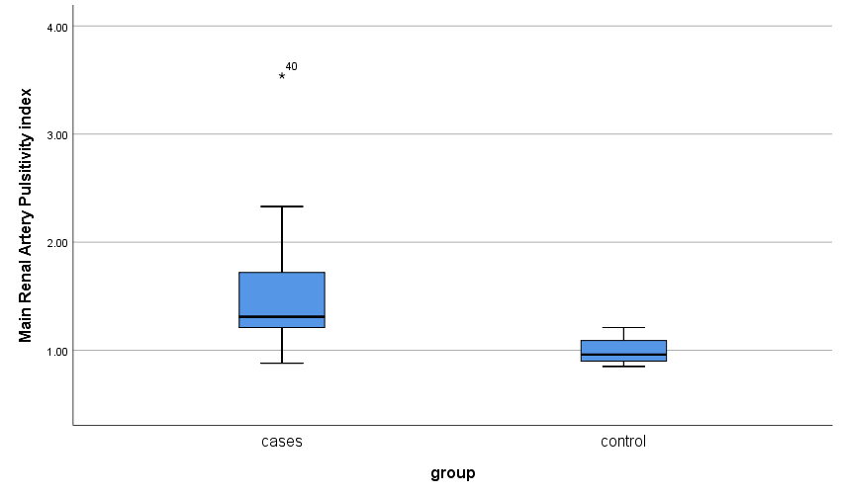
Figure (5) : Showing main renal artery pulsatility index among the 45 SCD patients versus control group .

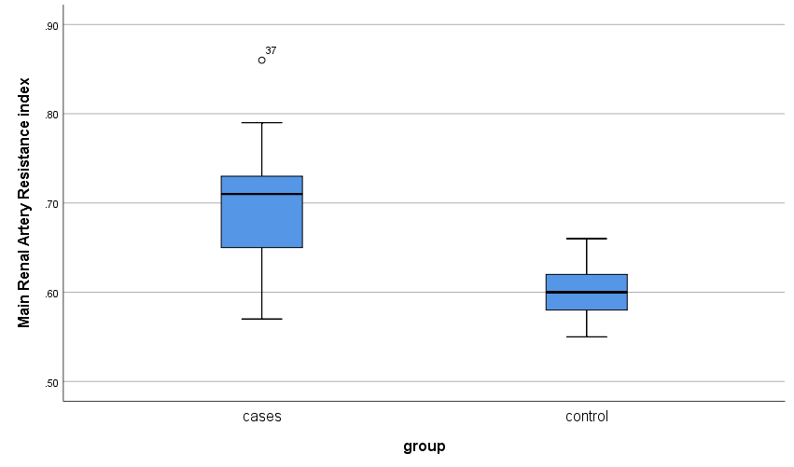
Figure (6) : Showing main renal artery resistance index among the 45 SCD patients versus control group

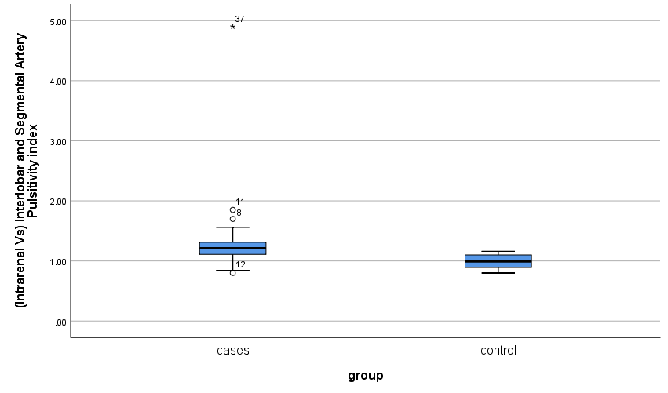
Figure (7) : Showing intrarenal vessel pulsatility index among the 45 SCD patients versus control group

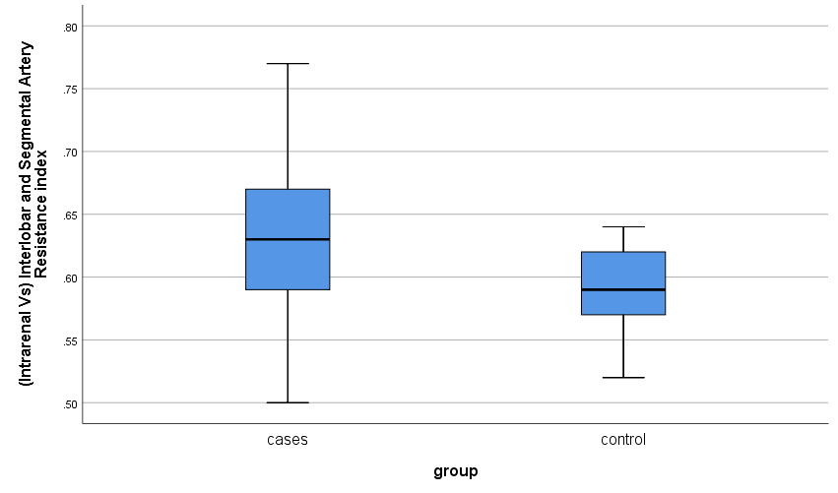
Figure (8) : Showing intrarenal vessel resistance index among the 45 SCD patients versus control group

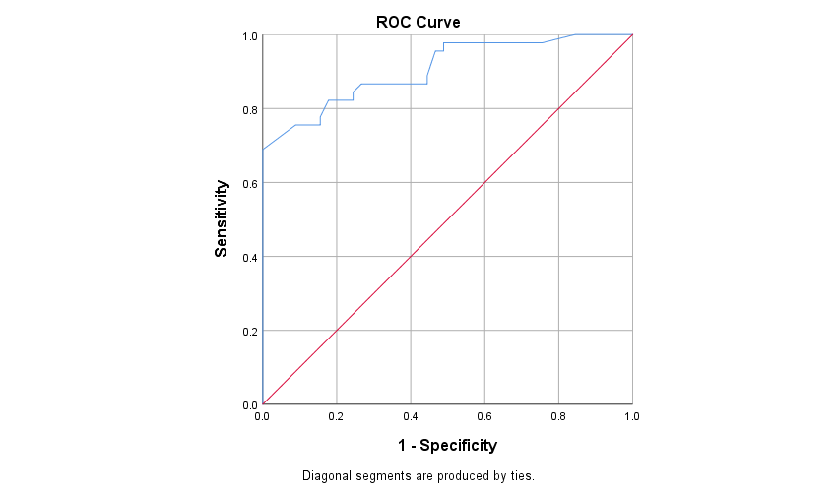
Figure (9) : Roc curve illustrating Validity of Main Renal Artery Pulsatility index as a predictor for sickle cell nephropathy

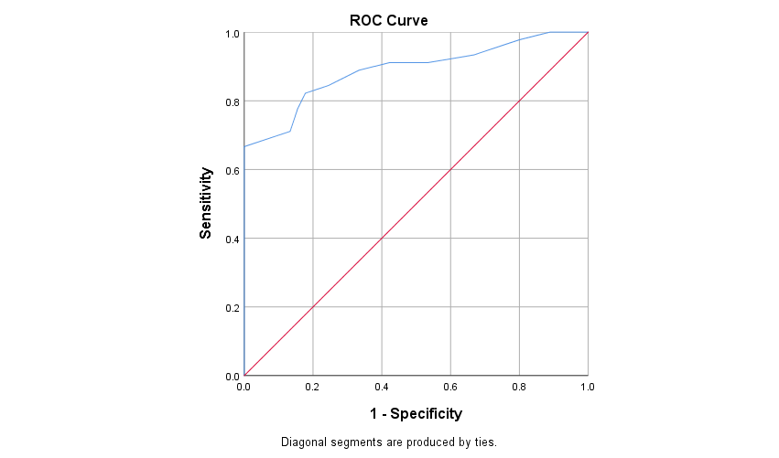
Figure (10) : Roc curve illustrating Validity of Main Renal Artery resistance index as a predictor for sickle cell nephropathy

