APPENDICES
Appendix S1. Environmental and its associated variables used in Maxent modelling and their percentage contribution in the model.
Code | Environmental variables | Unit | Percentage  Contribution | Percentage  permutation
Bio1 | Annual mean temperature | ◦C | 9.7 | 0
Bio2 | Mean diurnal range (mean of monthly max. and min. temp.) | ◦C | 13 | 38.7
Bio3 | Isothermality ((Bio2/Bio7) × 100)* |  | 19 | 16.2
Bio4 | Temperature seasonality (standard deviation ×100) |  | 0 | 0
Bio5 | Maximum temperature of warmest month* | ◦C | 6.8 | 0
Bio6 | Minimum temperature of coldest month | ◦C | 0 | 0
Bio7 | Temperature annual range (Bio5–Bio6) | ◦C | 0 | 0
Bio8 | Mean temperature of wettest quarter | ◦C | 1.3 | 0
Bio9 | Mean temperature of driest quarter* | ◦C | 0 | 0
Bio10 | Mean temperature of warmest quarter | ◦C | 2.3 | 0
Bio11 | Mean temperature of coldest quarter | ◦C | 30.7 | 14.1
Bio12 | Annual precipitation | mm | 0 | 0
Bio13 | Precipitation of wettest period | mm | 1.2 | 0
Bio14 | Precipitation of driest period* | mm | 0 | 0
Bio15 | Precipitation seasonality* | mm | 7.7 | 4.9
Bio16 | Precipitation of wettest quarter | mm | 5.4 | 13.8
Bio17 | Precipitation of driest quarter | mm | 2.4 | 11.9
Bio18 | Precipitation of warmest quarter | mm | 0 | 0
Bio19 | Precipitation of coldest quarter* | mm | 0.5 | 0.5

Appendix S2. Details of data used in the study
Year | 1998 |  | 2008 |  | 2018
Satellite Data | Landsat 5 TM |  | Landsat 5 TM |  | Landsat 8 OLI
Path/Row | 134/41 | 135/41 | 134/41 | 135/41 | 134/41 | 135/41
Resolution | 30m | 30m | 30m | 30m | 30m | 30m
Date | 26/12/1998 | 17/12/1998 | 21/02/2008 | 28/02/2008 | 16/02/2018 | 22/01/2018
Bands Used | 5, 4, 3 | 5, 4, 3 | 5, 4, 3 | 5, 4, 3 | 5, 4, 3 | 5, 4, 3
Atmospheric correction | Done | Done | Done | Done | Done | Done

Appendix S3. Land use land cover classification scheme used in the study
Sl/No. | Class | Description
1. | Forest | Areas under dense, open forest and scrublands
2. | Settlement | Areas under urban and rural built-up including homestead area
3. | Sandbar | Sandbars and other sand deposition areas including both dry and wet sand areas
4. | Agriculture | Areas under cultivation including current fallow areas
5. | Grassland | Areas dominated by grasses including vegetated sandbars and grazing areas
6. | Plantation | Forest and agricultural plantations like orchards and tea gardens with significant patterns
7. | Water | Water features such as river, stream, lakes and reservoirs.

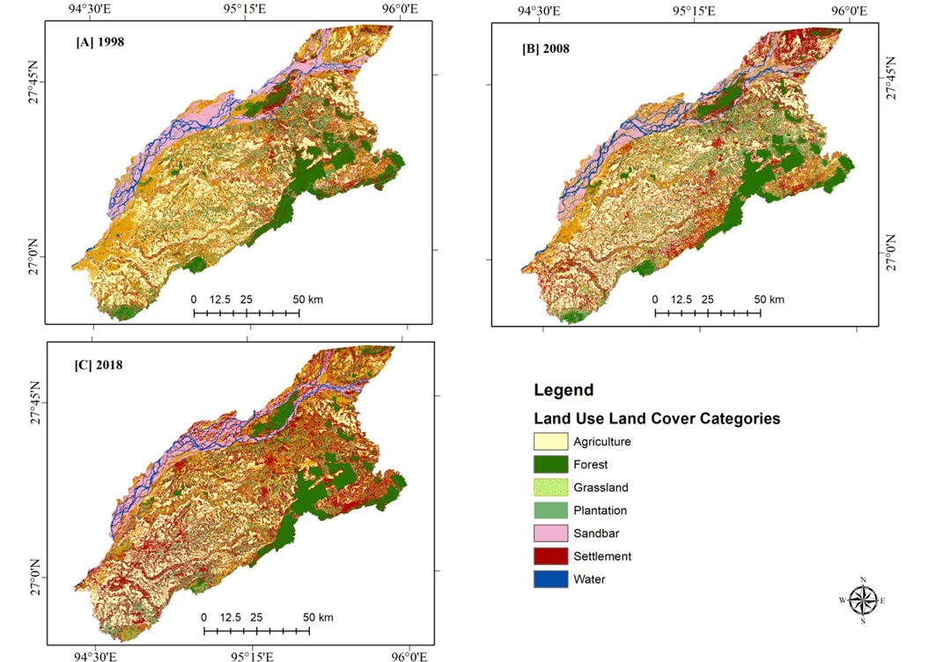
Appendix S4. Change detection maps of the study area [a] 1998, [b] 2008 & [c] 2018

Appendix S5. Inter-conversion of Land Use Land Cover (LULC) classes between 1998 and 2008 (Area in km²)
1998 | LULC classes | 2008
1998 | LULC classes | Agriculture | Forest | Grassland | Plantation | Sand  bar | Settlement | Water | Grand Total
1998 | Agriculture | 1794 | 1.6 | 242.7 | 46.9 | 29.1 | 262.1 | 2.6 | 2379
1998 | Forest | 18.3 | 802.4 | 47.6 | 169.1 | 3.2 | 113.1 | 3.5 | 1157.2
1998 | Grassland | 550.1 | 27.7 | 756.6 | 417.4 | 78.9 | 802.3 | 34.4 | 2667.4
1998 | Plantation | 57.2 | 88 | 175.8 | 427 | 13 | 172.1 | 1.2 | 934.3
1998 | Sandbar | 47 | 1.2 | 252.8 | 22.7 | 424.2 | 60 | 193.6 | 1001.5
1998 | Settlement | 164.6 | 141.3 | 220.5 | 282.3 | 22 | 601.9 | 10.9 | 1443.5
1998 | Water | 2.7 | 1.7 | 48.6 | 2.2 | 129.1 | 8.1 | 75.9 | 268.3
1998 | Grand Total | 2633.9 | 1063.9 | 1744.6 | 1367.6 | 699.5 | 2019.6 | 322.1 | 9851.2

Appendix S6. Inter-conversion of Land Use Land Cover (LULC) classes between 2008 and 2018 (Area in km²)
2008 | LULC classes | 2018
2008 | LULC classes | Agriculture | Forest | Grassland | Plantation | Sandbar | Settlement | Water | Grand Total
2008 | Agriculture | 1498.3 | 7.9 | 545.7 | 162.4 | 16.7 | 396.5 | 6.4 | 2633.9
2008 | Forest | 1.3 | 838.8 | 44.9 | 67.5 | 1.8 | 108.3 | 1.3 | 1063.9
2008 | Grassland | 175 | 32.7 | 509.9 | 262.4 | 138.4 | 574.5 | 51.7 | 1744.6
2008 | Plantation | 20.7 | 107.5 | 249.2 | 414.4 | 8.6 | 563.1 | 4.1 | 1367.6
2008 | Sandbar | 26.1 | 3.3 | 151.7 | 11.6 | 307.6 | 116.3 | 82.9 | 699.5
2008 | Settlement | 163.7 | 112.8 | 373.4 | 223.8 | 25.9 | 1108.4 | 11.6 | 2019.6
2008 | Water | 0.3 | 2.2 | 19.5 | 0.4 | 176.7 | 48.4 | 74.6 | 322.1
2008 | Grand Total | 1885.4 | 1105.2 | 1894.3 | 1142.5 | 675.7 | 2915.5 | 232.6 | 9851.2

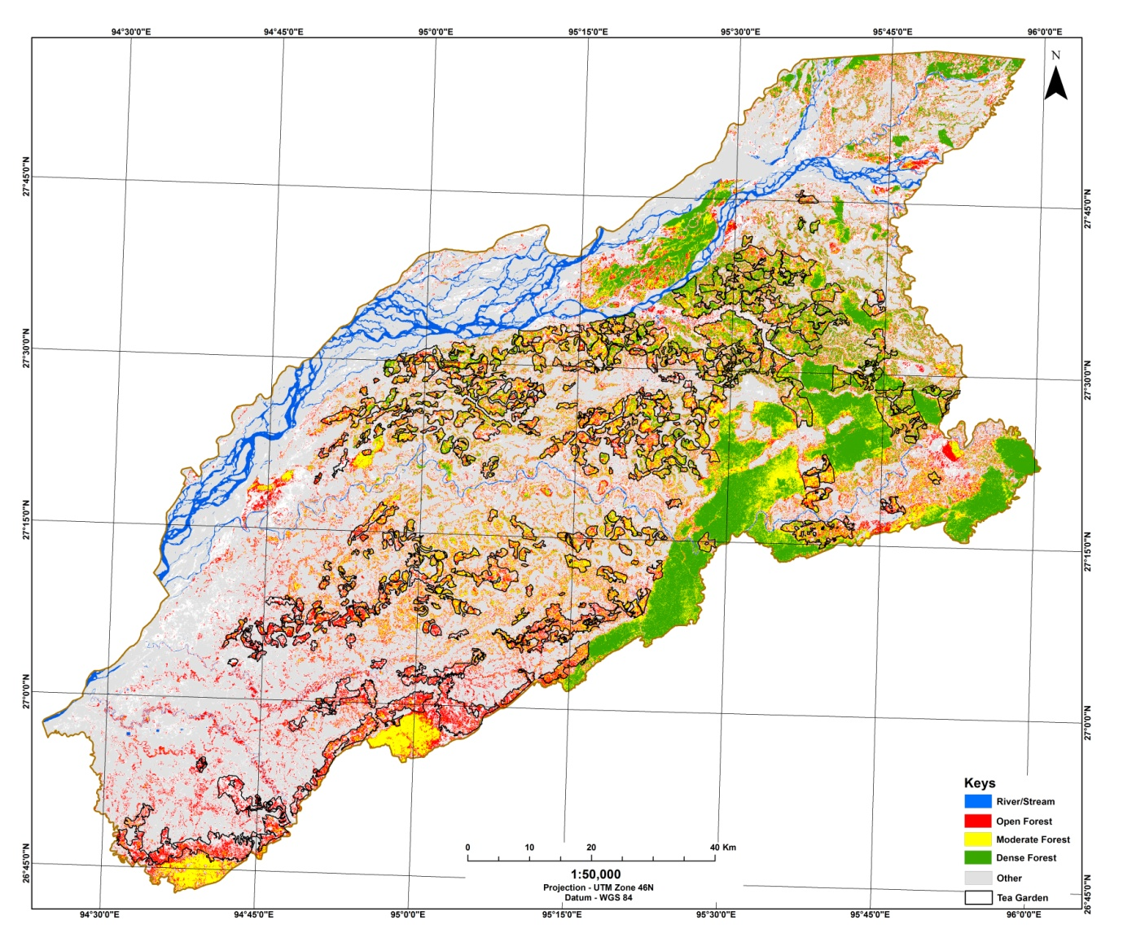
Appendix S7. NDVI map of the study area calculated from the Landsat image of 2018.

Appendix S8. Overall area (in km²) vs. tea plantation area of NDVI classes in the study area.

Appendix S9. Percentage area of NDVI classes in high potential model threshold in the study area with and without tea plantation

Appendix S10. Canopy cover change matrix between 2008 and 2018 (area in sq. km)
2018 | 2008
2018 | Area | NC | OC | DC | VDC | Grand Total
2018 | NC | 903.3 | 368.6 | 1.6 | 0.0 | 1273.5
2018 | OC | 724.3 | 5276.9 | 205.2 | 2.4 | 6208.8
2018 | DC | 1.9 | 828.3 | 700.1 | 48.8 | 1579.1
2018 | VDC | 0.0 | 6.5 | 199.3 | 584.0 | 789.8
2018 | Grand Total | 1629.5 | 6480.3 | 1106.2 | 635.2 | 9851.2
Note: No Canopy (NC); Open Canopy (OC), Dense Canopy (DC), Very Dense Canopy (VDC)

Appendix S11. Percentage covers of protected area (PA) in different potential habitats of gibbon in the study area.
Model threshold | Total Area (km²) | Area of PAs (km²) | % PA cover
High Potential | 6009.1 | 1065.27 | 17.73
Moderate Potential | 1949.3 | 536.27 | 27.51
Low Potential | 1892.7 | 449.29 | 23.74
Total | 9851.2 | 2050.83 | 20.82

Appendix S12. Canopy area statistics in protected and non protected zones of the study area and its
respective percentage out of different canopy category
Year | Protected |  |  |  | Non protected
Year | No Canopy | Open Canopy | Dense Canopy | Very Dense Canopy | No Canopy | Open Canopy | Dense Canopy | Very Dense Canopy
Area (km²)
2008 | 112.19 | 715.47 | 470.36 | 617.38 | 1517.31 | 5764.83 | 635.84 | 17.82
2018 | 220.42 | 549.41 | 395.01 | 750.55 | 1053.08 | 5659.39 | 1184.09 | 39.25
2008-2018 | -108.23 | 166.06 | 75.35 | -133.17 | 464.23 | 105.44 | -548.25 | -21.43
Percentage canopy out of total category area
2008 | 6.88 | 11.04 | 42.52 | 97.19 | 93.12 | 88.96 | 57.48 | 2.81
2018 | 17.31 | 8.85 | 25.01 | 95.03 | 82.69 | 91.15 | 74.99 | 4.97
Percentage canopy out of the total study area
2008 | 1.14 | 7.26 | 4.77 | 6.27 | 15.40 | 58.52 | 6.45 | 0.18
2018 | 2.24 | 5.58 | 4.01 | 7.62 | 10.69 | 57.45 | 12.02 | 0.40

Appendix S13. Fragmentation statistics of the identified forest fragments in the high potential gibbon habitat in the Upper Brahmaputra landscape. Patches are identified from Dense and Very Dense Canopy forest map of 2008 and 2018.
Class metrics | 2008 |  | 2018
Class metrics | Dense Canopy | Very Dense Canopy | Dense Canopy | Very Dense Canopy
Class Area (km²) | 777.81 | 553.69 | 1221.88 | 69287.50
Percent of Landscape (%) | 58.42 | 41.58 | 63.81 | 36.19
Number of patches | 658 | 69 | 840 | 71
Patch Density | 0.49 | 0.05 | 0.44 | 0.04
Largest Patch Index (%) | 5.22 | 11.35 | 18.42 | 9.46
Total Edge (km) | 776.25 | 776.25 | 729.50 | 729.50
Edge Density (m/ha) | 5.83 | 5.83 | 3.81 | 3.81
Landscape Shape Index | 31.77 | 9.83 | 35.84 | 8.59
Mean Patch Size (km²) | 1.18 | 8.02 | 1.45 | 9.76
Mean Contiguity Index | 0.22 | 0.36 | 0.23 | 0.34
Mean Euclidian Nearest Neighbour Distance (m) | 864.83 | 1242.10 | 818.99 | 1646.21

