Supplemental Information
The gut microbiota mediates triptolide-induced
liver injury via the gut-liver axis
Yulin Wang, Yeqing Hu, Yuting Liu, Haibo Zhang, Xueying Liu, Chenghai Liu, Hua Zhou and Tao Yang

Supplementary Materials for
The gut microbiota mediates triptolide-induced
liver injury via the gut-liver axis
Yulin Wang¹, Yeqing Hu¹, Yuting Liu¹, Haibo Zhang¹, Xueying Liu¹, Chenghai Liu^{2,3}*, Hua Zhou^{1*} and Tao Yang^{1,3*}
¹ Institute of Cardiovascular Disease, Shuguang Hospital Affiliated to Shanghai University of Traditional Chinese Medicine, Shanghai, China,
² Institute of Liver Diseases, Shuguang Hospital Affiliated to Shanghai University of Traditional Chinese Medicine, Shanghai, China
³ Shanghai Key Laboratory of Traditional Chinese Clinical Medicine, Shanghai, China
Correspondence to: yangtao@shutcm.edu.cn

This file includes:
Figures S1 to S5
Table S1

Fig.S1
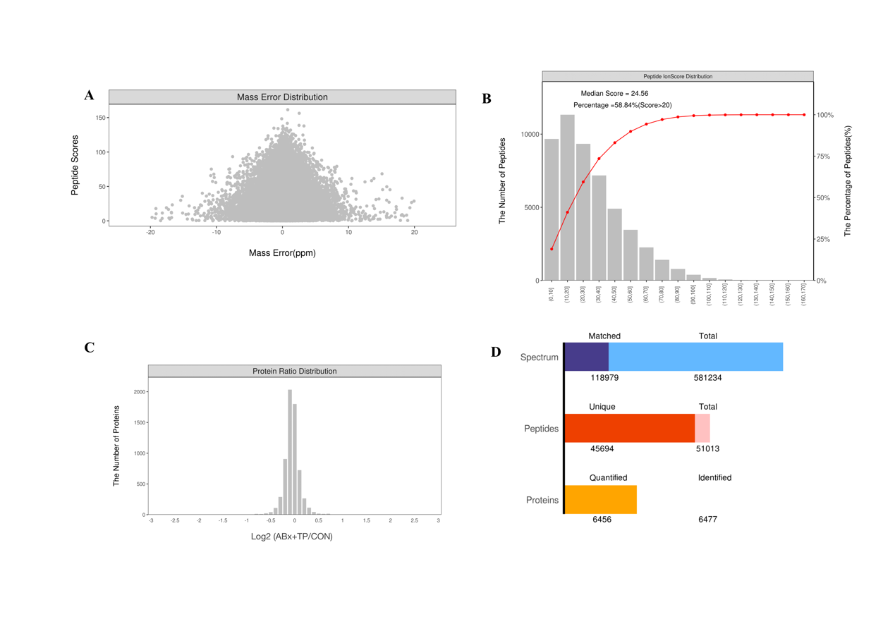
Fig.S1 Mass deviation distribution of peptide ion (A) Distribution map of mass error deviation of peptide ion (Abscissa is the mass deviation of theoretical mass charge ratio of peptide ion and mass charge ratio measured by mass spectrometry experiment (ppm), ordinate is the score of MASCOT peptides) (B)Distribution map of peptide ion score (The abscissa is the score of the MASCOT peptide segment, the principal ordinate represents the number of peptides identified with corresponding ionic score; the cumulative curve in the sub-ordinate corresponds to the cumulative percentage of the peptides that is not higher than the corresponding ion score) (C)Protein ratio distribution map of the CON-vs-ABx+TP groups (The abscissa is the fold change, and the ordinate is the number of identified proteins) (D)The bar chart of the number of chromatograms obtained, the number of peptide segments and the number of proteins

Fig.S2
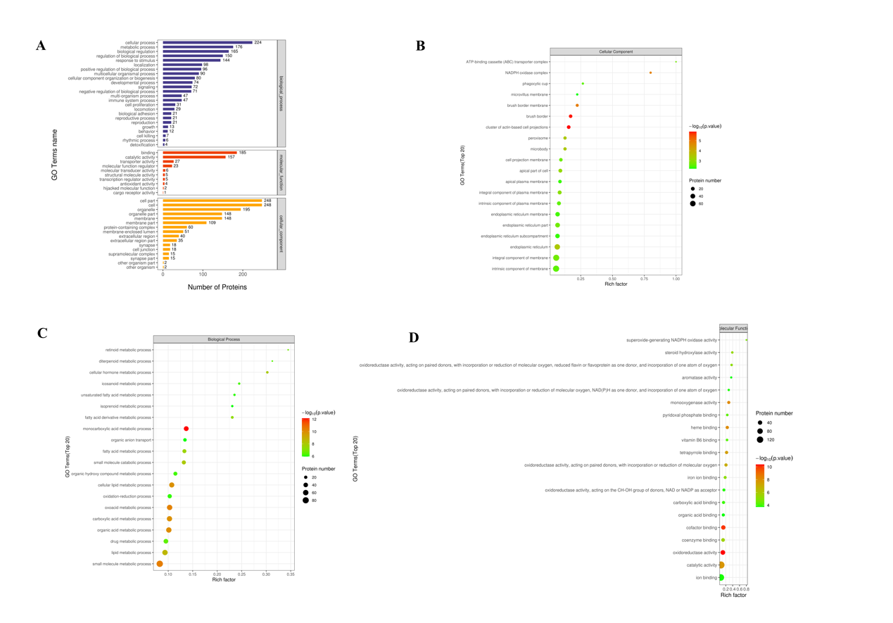
Fig.S2 All differentially expressed proteins were analyzed at the secondary function annotation level of GO, and the enrichment of GO entries under the three categories of GO biological process, molecular function and cellular component was displayed with bubble chart (A) GO annotation statistics of differentially expressed proteins in CON-vs-ABx+TP groups (level 2) (B) Bubble diagram of GO function enrichment under Biological Process (BF) classification of CON-vs-ABx+TP group (C) Bubble diagram of GO function enrichment under the Molecular Function (MF) classification of CON-vs-ABx+TP group (D) Bubble diagram of GO function enrichment under the Cellular Component (CC) classification of CON-vs-ABx+TP group

Fig.S3
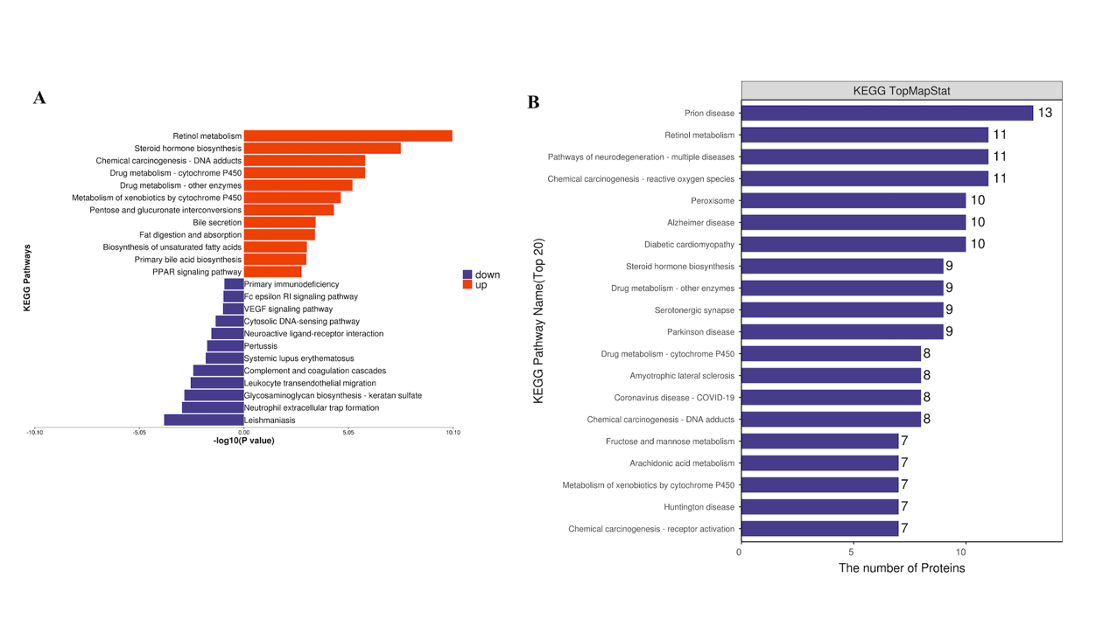
Fig.S3 KEGG pathway analysis (A) Annotation diagram of up-regulation and down-regulation KEGG pathway in CON-vs-ABx+TP groups (B) Annotation map of KEGG pathway of differentially expressed proteins in CON-vs-ABx+TP groups

Fig.S4
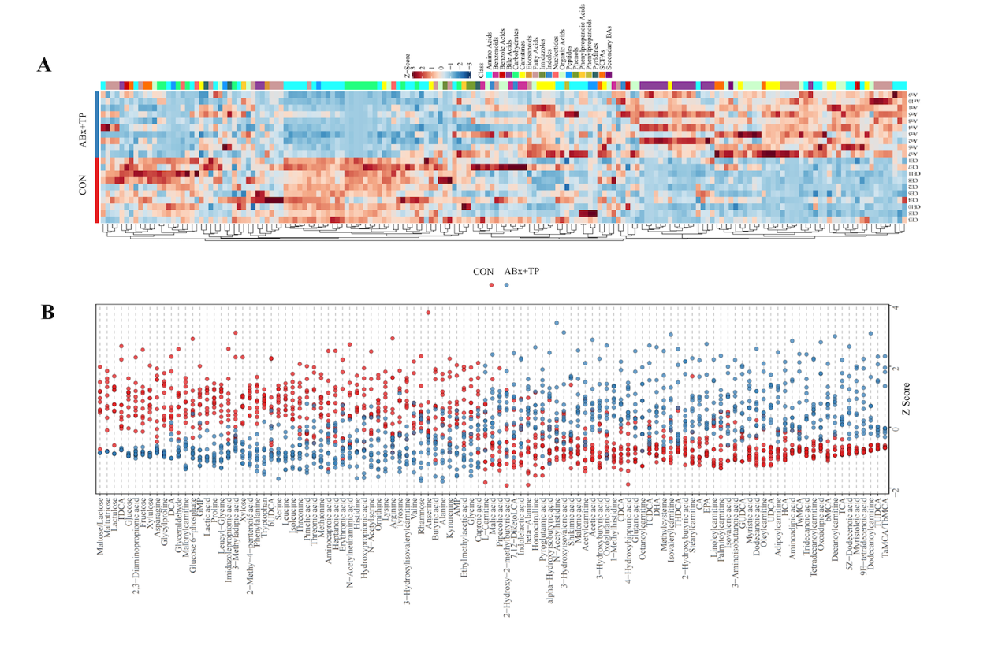
Fig.S4 Correlation analysis of potential biomarkers
(A) Heat map of potential biomarkers (B) Z Score plot of potential biomarkers
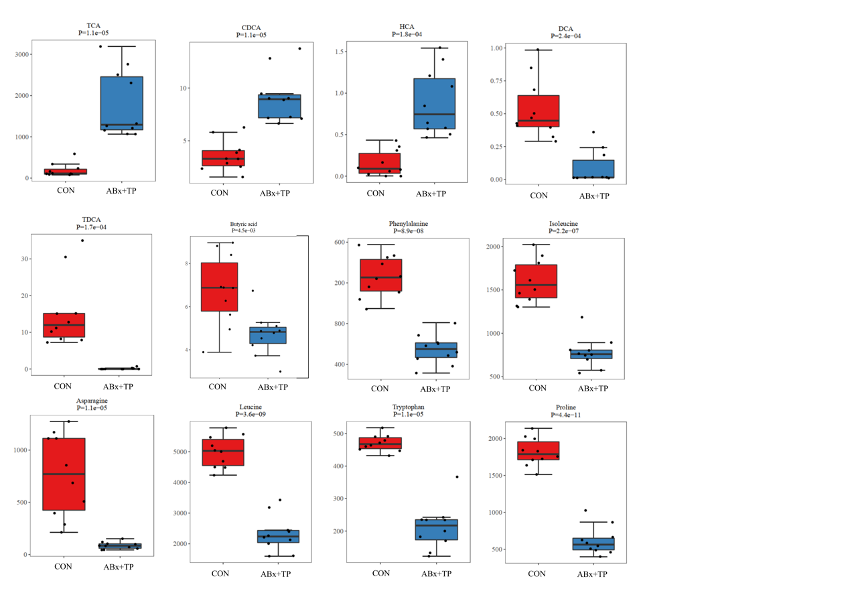
Fig.S5
Fig.S5 Boxplot of 11 potential Markers

Supplementary tables
Table S1.
NO. | Abbreviation | Protein Name
1 | CAMP | Cadherin-1
2 | CDH1 | Cadherin-11
3 | CDH11 | Cadherin-13
4 | CDH13 | Cadherin-16
5 | CDH16 | Cadherin-17
6 | CDH17 | Cadherin-11
7 | CDH2 | Cadherin-3
8 | CDH3 | Cadherin-5
9 | CDH5 | Chromogranin-A
10 | CHGA | Claudin-2
11 | CLDN2 | Claudin-3
12 | CLDN3 | Claudin-4
13 | CLDN4 | Claudin-4
14 | CLDN4 | Claudin-7
15 | CLDN7 | Interleukin-12 receptor subunit beta-2
16 | IL12RB2 | Interleukin-13 receptor subunit alpha-1
17 | IL13RA1 | Interleukin-17 receptor A
18 | IL17RA | Junctional adhesion molecule C
19 | JAM3 | Lysozyme C-1
20 | LYZ1 | Proliferation marker protein Ki-67
21 | MKI67 | Mucin-13
22 | MUC13 | Mucin-2
23 | MUC2 | NF-kappa-B inhibitor alpha
24 | NFKBIA | NF-kappa-B inhibitor beta
25 | NFKBIB | Occludin
26 | OCLN | Regenerating islet-derived protein 3-gamma
27 | REG3B | Regenerating islet-derived protein 3-beta
28 | REG3G | Tight junction protein ZO-1
29 | TJP1 | Lysozyme C-1

