Supplementary Material

APPENDIX: Material and methods

Stocking of pike
Stocking of pike was performed after filling of lakes as a biomanipulation measure to improve and maintain high water quality. In Milada (HSC lake), young-of the-year pike were stocked in 2005 and 1-2 year old pike in 2005, while in Most (LSC lake) over 1-year old pike were stocked in years 2011–2013 (Tab. A1).

Data processing

Filtering of positions estimated by the U-MAP software
U-MAP (User Managed Acoustic Positioning) is a proprietary software from Lotek Inc. that processes transmitter detection data collected with autonomous Lotek WHS-receivers. The detection data recorded by each WHS receiver include tag ID, time of arrival (TOA) and relative signal strength or power of the detected signal. U-MAP uses these data to estimate transmitter positions by means of multilateration on TOA data for transmissions that were detected at three or more receivers. The algorithms solve non-linear equations involving hydrophone positions and the difference in time of signal arrival (TDOA) at each hydrophone detecting the transmission. Depending on the number and geometry of the hydrophones involved in the position calculation, the equation may have multiple solutions ¹. These are referred to as twin solutions (or shadow solutions). U-MAP saves all twin solutions to the output file, and it is up to the user to choose, or filter, the correct position between the twin positions. Moreover, the use of TDOA implies hyperbolic equations, which also tend to give large errors for certain receiver and transmitter configurations. These configurations depend on the receiver array and the transmitter location, but also on stochastic variation in which receivers that detects the signal. Two successive position estimates may therefore differ in location although the transmitter did not move, if the receivers involved in the position estimate differ. Position estimates produced by programs using TDOA-methods, such as U-MAP, therefore requires filtering by post-processing in order to eliminate erroneous position estimates.
The performance of the position estimates and potential filters were evaluated by short terms tag-tows from boat with high-precision GPS-device above the towed transmitters, by several stationary reference tags throughout the study (Fig. S1), and by visual inspections of all fish tracks and filter results (Fig. S2).
The filtering procedure required several steps to ensure the best error exclusion:
- Calculation of detection rate D_{r} and detection mean power D_{p} at each receiver by 20 minute intervals for the transmitter in focus. Detection rate and detection power are expected to be highest closest to the receiver ². These two measures were then combined into one receiver signal scale Ds by scaling each of them before adding them together;
$D_{s}=scale\left(D_{r}\right)+scale(D_{p})$. Scaling here means centring and dividing by the standard deviation.
- Calculation of distance weights D_{w} for later use in calculation of regression weights, by the use of the logistic function: $D_{w,i}\frac{1}{{1+2∙0.001}^{\frac{(D}{1500}-0.6)}}$, where Di is distance from the receiver i to the position estimate. Parameters where subjectively fitted to obtain a desired logistic shape with high weights to receivers closer than 500 m to the position estimate, and low weight to receivers farther than 1000 m away from the position estimate.
- Calculation of regression weights R_{w} were then done for each U-MAP position estimate, by first ranking all receivers from highest to lowest Ds value within the current 20 minutes period. The Ds for the highest ranked receiver was then used together with the distance weight Dw for this receiver to obtain _{Rw} through the function $R_{w}=D_{w}(1+D_{s})$
- Lake shoreline exclusion: All position estimates farther than 50 m outside the lake shoreline polygon were excluded from further filtering, and marked as false position estimate.
- Calculation of gam-models (generalized additive model³) and gam-predictions for east and north-directions. This was done for successive periods of six hours, with one extra hour of data before and after the end of each period included in the gam-regression to stabilize the ends. The resulting gam-models was then used to predict position (Eastgam, Northgam) within the six-hour period at the same time points as the U-MAP estimated positions. Gam residual was calculated as the distance between the U-MAP position estimate and the gam prediction, including residuals for positions excluded from the gam regression. The gam-formulation was y ~ s(time), where y was either east or north, and s was the smooth term specified with a cubic spline regression model. K, the dimension of the basis used to represent the smooth term, was set as a function of the n observations included in the regression period, with K as the nearest integer to n/15, but with a minimum of value of 3.
- For U-MAP twin positions (i.e. positions with equal timestamp), the position with the lowest gam-residual was flagged as a true position, the other as false.
- In order to remove heavy outliers with a strong influence on the gam-regression, U-MAP positions with gam-residuals > 1000 m were flagged as false.
- A second gam-regression was now performed, repeating point 5 but excluding all positions now flagged as false. In addition, positions with gam-residuals > 150 m were excluded from the input data to the second gam regression. New gam-predictions were made for all time points of U-MAP position estimates.
- For U-MAP twin positions (i.e. positions with equal timestamp), the position with the lowest gam-residual was flagged as a true position, the other as false.
- Positions with gam-residual larger than 100 m were flagged as false. U-Map position estimates, gam predictions and gam residuals were stored together in the database, such that the gam residual threshold for position acceptance could later be modified if desirable.
The number of positions varied over time, as well as the relative amount of poor position estimates. This is easy to handle for a tag with known position (Fig. S1a-c), but when one does not know the true position one has to rely on filtering methods using information from the detection data. The DOP measure provided by U-MAP had poor association with the position quality, as position estimates with low DOP-value could be far from the true position, and positions estimates with high DOP-value could be close to true position (Fig. S1d). This filtering procedure described above did a great job in sorting out good from bad position estimates, and in general kept > 85 % of the positions flagged as true positions.

Calculation of q-position
The detection probability of transmitter detection and thus horizontal positioning changed over time and space due to underwater structures and thermal stratification. Numbers of position estimates for each individual ranged from 0 to 2884 per day (from 0 to 83 % of possible number of position estimates). In order to reduce potential bias resulting from varying positioning rate ⁴, the individual data was regularized by calculating mean position for every 15-minute interval (q-position hereafter). The q-position mean depth was calculated as the 15-minute mean depth for each detected transmission with sensor depth reading. Since this did not require trilateration, the q-position time series could have depth value without having position estimate. This gave a maximum of 96 q-positions per day for each individual. If no position estimate was obtained within a 15-minute interval, the q-position was interpolated between q-positions close in time if several conditions were fulfilled; a) the time difference between the two q-positions used for interpolation (last before and first after the interval(s) to be interpolated) had to be shorter than 2 hours, b) the distance between these q-positions was less than 100 m, and c) the depth difference between the q-positions was less than 2 m. Under such conditions, we assumed that the fish movement was limited between the q-positions used for interpolation (likely due to resting in an area with poor positioning coverage), and that linear interpolation in order to regularize the time series was hence justified. For each position estimate, distance to bottom was calculated as the bottom depth at that position subtracted by the sensor depth. Distance to bottom for each q-position was calculated as the mean of each distance to bottom estimate within the 15-minute interval.

Calculation of depth location
Depth of fish was measured by an internal tag sensor and transmitted together with a tag identification. Therefore, to get depth of fish, only detection of a single receiver was required (not three as for location of a horizontal position) for accurate and depth detection location was obtained in much higher detail than fish horizontal location (fewer gaps). To synchronize depth and position with horizontal position, we calculated mean depth for the same 15-minute intervals as we used for calculation of mean horizontal position from receiver detections at that particular interval.

Calculation of Structural Complexity Index
Structural complexity maps in each lake were created based on information from the 25 and 26 (HSC and LSC lake, respectively) scuba diver macrophyte assessment transect (see above). Species coverage and macrophyte height along each transect were georeferenced in a GIS-environment, and overlaid the bathymetric map for the lake. Height of macrophytes was discretized into 100 bins (from 0 to 200 cm by 2 cm) and coverage was discretized into 100 bins by 1%. The structural complexity index SCI was then defined as discretized height multiplied by discretized coverage. This gave a SCI range from 0 (no occurrence of macrophytes) to 10 000 (macrophyte coverage 100% and height ≥ 2m).

Statistical analyses

Extended Methods

Identifying interactions with Random Forest
RF is a machine learning algorithm consisting of a collection of classification trees that grow from the root node by means of bootstrap sampling of the observed data, using a subset of predictors at random to define the best cut on each node (see e.g.^{5,6} for reviews on theoretical and empirical aspects of RF, respectively). An advantage of this method is that it can detect variables with individual weak effects but significant when interacting with other variables and thus it is suitable to assess meaningful interactions between predictors ⁷. For the analysis of our dependent variables the variable importance measures (VIMs) used to assess predictors’ pairs were both the conditional minimal depth and the number of occurrences of interactions across trees. Interactions were ranked from higher to lower likelihood of occurrence and in decreasing mean conditional minimal depth. We split the data into training and test sets representing 60% and 40% of the total dataset. The RF analysis was ran on the training set with a total of 5,000 trees (ntree = 5000) for each forest and the default "top_trees" option to penalize interactions with less frequency of occurrence than the best represented interaction. Each tree was assessed with an Out-Of-Bag (OOB) sample of the test set.

GAMLSS model of pelagic habitat use (TOW)

Model definition
TOW is a proportional variable, continuous in the interval (0, 1) and with additional probabilities at zero and one, which could depend on the continuous predictors dH-KUD, dV-KS, body size, and an additional interaction term (time × Lake). We fitted GAMLSS models ⁸ assuming a mixed continuous-discrete beta inflated distribution of the response variable, denoted by TOW ~ BEINF(μ, σ, ν, τ) for 0 ≤ TOW ≤ 1, with four parameters, two location and scale parameters (μ , σ), and two shape parameters (ν, τ). The distribution parameters were modeled with the default link functions of the family BEINF: two logit links for the continuous values (0 < TOW < 1) of the beta distributed variable BE(µ, σ) (Eq. 10.46 in ⁹, pp.215), with mean E(TOW) = μ and variance/standard deviation Var(TOW) = σμ(1 – μ), i.e., sub-models ‘mu’ and ‘sigma’ in R; and two log links for the shape parameters (ν, τ) related to the skewness and kurtosis of the distribution, which model the probabilities at the endpoints of the interval (p0, p1), i.e., sub-models ‘nu’ and ‘tau’ in R. Therefore, the fitted GAMLSS model consists of four sub-models, one for each parameter of the distribution, with two logit models for the mean and variance on (0, 1) and two log models for the probabilities at 0 and 1, which can be expanded in the following equations (see ⁸):

$g_{1}\left(μ\right)=η_{1}=X_{1}β_{1}+\sum_{j=1}^{J_{1}}{h_{j1}\left(x_{j1}\right)}$ (1.1)

$g_{2}\left(σ\right)=η_{2}=X_{2}β_{2}+\sum_{j=1}^{J_{2}}{h_{j2}\left(x_{j2}\right)}$ (1.2)

$g_{3}\left(ν\right)=η_{3}=X_{3}β_{3}+\sum_{j=1}^{J_{3}}{h_{j3}\left(x_{j3}\right)}$ (1.3)

$g_{4}\left(τ\right)=η_{4}=X_{4}β_{4}+\sum_{j=1}^{J_{4}}{h_{j4}\left(x_{j4}\right)}$ (1.4)

where μ, σ, ν, τ are the distribution parameters vectors of length$η_{k}$, with link function gk, X_{k} are fixed parameter estimate design matrices incorporating the linear predictor terms that can affect the distribution parameters (e.g., factor Lake); $β_{k}$ are parameter vectors of the linear (z-score) coefficients, $h_{jk}$ are additive smoothing functions (penalized P-splines) for fixed explanatory variables $X_{jk}$ evaluated at vector $x_{jk}$ of length $η_{k}$, which are a function of the random effects such as $h_{jk}\left(x_{jk}\right)=h_{jk}=ϓ_{jk}$, where $ϓ_{jk}$represents the random additive term including the random (slope-intercept) effects and an ARMA autocorrelation structure of order (p=0, q=1).
According to (⁹ Equation 10.47, pp.215), the probability density function of the beta inflated distribution for the response variable TOW is given by the following expression:

$f_{Y}\left(TOW|μ,σ,ν,τ\right)=\left\{\begin{aligned}p_{0} \\ \left(1-p_{0}-p_{1})\right. \\ p_{1}\end{aligned}\right.f_{W}\left(TOW\right) \begin{matrix}if TOW=0 \\ if 0<TOW<1 \\ if TOW=1\end{matrix}$ (2)

for 0 ≤ y ≤ 1, where both $f_{W}\left(TOW\right)\sim BE\left(μ,σ\right)$with 0 < μ < 1, 0 < σ < 1, and the inflated beta with ν > 0, τ > 0 shape BEINF(μ, σ, ν, τ) with parameters μ, σ, ν = p0/p2, τ = p1/p2 and expected mean E(TOW) = (τ + μ)/(1 + ν + τ), where p2 = 1 – p0 – p1, and p0, p1 are non-zero probabilities at zero and one relative to p(0 < TOW < 1) such as:

$p\left(TOW=0\right)= \frac{ν}{\left(1+ν+τ\right)} for 0 < p_{0} < 1$ (3)
$p\left(TOW=1\right)= \frac{τ}{\left(1+ν+τ\right)} for 0 < p_{1} < 1-p_{0}$ (4)

Fitting a base model with autocorrelation
Within the GAMLSS framework the random effects are estimated by maximizing a penalized likelihood function ℓp (Eq. 6 in ⁸), which implies that dropping a continuous predictor from the model can modify the penalization of the random effect and discard its inclusion even being significant⁸. Thus, rather than backward removal of terms, to find the best GAMLSS model we evaluated and compared different models following a stepwise selection procedure. We started from a null model (i.e., intercept-only model) including an additive random term with the function re() for relating the random effects (time|tag_id) and the autocorrelation to the predictors. Models with different autocorrelation structures were compared by using Generalized Akaike information criterion (GAIC), which includes a k penalization for each degree of freedom of the model given by GAIC = -2$\hat{l}$ + k × df, where $\hat{l}$is the maximized log-likelihood and -2$\hat{l}$ represents the global fitted deviance (GDEV) (Rigby and Stasinopoulos 2005). Starting from the model with the chosen additive random term (μ) we fitted additional models by consecutively incorporating the random structure to sub-models σ, ν and τ. We then used the function drop1() which, by using generalized likelihood ratio test (GLRT) to calculate the significance of dropping a term from the model, determined whether including the random effect was necessary for each parameter of the distribution.

Fitting a full model (sub-models μ, σ, ν and τ)
Following selection of the preferred random term, we fitted a linear additive model for the parameter μ by adding the covariates dH-KUD, dV-KS, body size and time × Lake. From this model, we built sets of candidate models by incorporating different non-linear smoothing functions (h_{jk}) to the continuous predictors. These functions use a penalization to find the optimal value for the smoothing parameter or hyperparameter (λ) determining the degree of smoothness of the fitted curve between the smooth term and the predictor, which can be estimated by calculating the effective degrees of freedom (edf). All models were fitted using penalized P-splines with functions ps(), pb() and pbz(), that differ in how they optimize the smoothing parameter; ps() takes three degrees of freedom by default unless specified differently, which involves testing different values and re-fitting the model to find the optimal value; pb() automatically selects the smoothing parameter and thus it is not necessary to specify edf; and pbz() is based on the former function and is helpful for achieving more precise coefficients estimation (the fitted curve is shrinked toward zero degrees of freedom) (for more details on smoothing functions ¹⁰) To choose the one which minimized the GAIC criterion, we looked at the partial effects plots of predictors and re-fitted the model without the predictor of interest if necessary. After selection of the best full model (i.e., ‘mu’ sub-model from the parameter μ), we added all continuous predictors fitted with the preferred smoothing additive term to every other parameter of the distribution. We updated the mean base model by sequentially fitting extra predictors for each of σ, ν and τ, therefore building models with increasing complexity. To estimate the smoothing parameters, models were compared to minimize the values of GDEV and GAIC, and by visually checking the assumption of normality of the residuals with worm plots, i.e., detrended normal Q-Q plots of the (normalized quantile) residuals.

Fitting a final model on [0,1]
Once we had selected the final model, with general formula given by Equation 1₁₋₄, we used the functions term.plot() and getSmo() to evaluate the influence of the predictors on each of the modelled components and to obtain details of the smooth terms. To further determine the impact of smooth functions on the final model and if a simplified model formula could be used, we computed GLRTs (see above) sequentially through each of four distribution parameters using the function drop1(). This allowed us to evaluate changes in the GAIC criterion of the model and calculate the statistical significance (p-value) of each of its terms. Note that this was only used to discern whether to add an additive term to a predictor but not to rule out the predictor, given the inclusion of a random variable as noted above. The final model could therefore include smoothing functions to all, some or none terms of the model and in the latter case the model would be re-fitted with linear terms.

Testing of SCI differences between lakes
Permutation inference were used to test differences among lakes and macrophytes sampling sessions (June, September) in the SCI. SCI was dependent variable while depth, transect and sampling season were used as explanatory variables. For comparison of groups of function, we used an $F$-max method ¹¹, where $F$ statistic is computed pointwise and then the maximum over whole range of function is computed. The significance of the $F$-max statistic is determined by permutation method which have no assumptions for the residual distribution. The significance of the differences was computed from 1000 permutation of functions in the groups.

Extended Results

Effects of modeling autocorrelation
We detected significant temporal autocorrelation in our data which was properly accounted in the fitted models for the analysis of pike behaviour (H-KUD, V-KS, horizontal activity, vertical activity and depth use), allowing us to obtain unbiased estimates of the individual differences in temporal trajectories between lakes. For dH-KUD, dropping the autocorrelation term from the model entailed an increase in the variance of temporal slopes across time (τ_{11 time} = 1.20-05), an increase in the intercept variance by a factor of 1.22 (τ_{00 tag_id} = 0.072), and a reduction in the residual variance (σ²_{e} = 0.073). As a result, overall among-individual variation increased (R = 0.50 from 0.43), increasing in LSC lake (R = 0.58 from 0.49) and in HSC lake (R = 0.36 from 0.31). For dV-KS when residual correlations were excluded the variance in temporal slopes across time increased by a factor of 1.3 (τ_{11 time} = 3.64-05), the intercept variance increased by a factor of 1.25 (τ_{00 tag_id} = 0.18), and the residual variance decreased by 0.4 (σ²_{e} = 0.66). Thus, ignoring the temporal residual correlations led to an increase in among-individual variation (R = 0.21 from 0.172), with variability increasing LSC lake (R = 0.09 from 1.25-05) while keeping constant in HSC lake (R = 0.304 from 0.305). Remarkably, the observations of daily mean depth showed a strong effect of temporal autocorrelation since taking this out from the model the variance in temporal slopes across time increased by a factor of 4.5 (τ_{11 time} = 6.12-05), the intercept variance increased by a factor of 3 (τ_{00 tag_id} = 0.65), and the residual variance decreased by 16% (σ²_{e} = 0.77). Together, ignoring the temporal residual correlations resulted in a significant increase in the variability among individuals (R =0.456 from 0.185) which further accentuated differences between lakes from the autocorrelation model (R_{LSC} = 0.58, R_{HSC} = 0.25 vs. R_{LSC} = 0.18, R_{HSC} = 0.15). The analysis of horizontal activity showed that dropping the temporal residual autocorrelation from the model led to an increase in the variance of temporal slopes across time and the intercept variance by a factor of 1.5 (τ_{11 time} = 0.006, τ00 tag_id = 47.13), and a decrease in the proportion of residual variance of 4.6% (σ²_{e} = 61.38). In general, among-individual variation increased (R = 0.43 from 0.33), meaning a nearly 10% increase in LSC lake (R = 0.32 from 0.23) and 13% in HSC lake (R = 0.48 from 0.35). Lastly, ignoring the effects of temporal autocorrelation on vertical activity resulted in an increase in the variance of temporal slopes across time by a factor of 1.3 (τ_{11 time} = 0.004), an increase in the intercept variance by a factor of 1.6 (τ_{00 tag_id} = 19.22), and a decrease in the residual variance by 3.5% (σ²_{e} = 93.86). The inter-individual variation increased (R = 0.17 from 0.1), increasing in HSC lake (R = 0.27 from 0.25) but slightly decreasing in LSC lake (R = 0.08 from 0.12).

GAMLSS model of pelagic habitat use (TOW)
The sample proportions of time spent in open water (TOW) were 0.55 and 0.005, with fish not using that particular habitat (i.e., 0%) 55% of the observed time and fully using it (i.e., 100%) in 0.005% of the cases, respectively. The model selection procedure yielded numerous candidate models varying in their smoothing functions as wells as the specific predictors fitted for each distribution parameter. Overall, there were issues of convergence as models increased in complexity across the four distribution parameters, but this mostly occurred at τ if the model included one or more continuous predictors along with the full additive random term. Dropping the slope of time solved these issues in some cases meaning that for these models we couldn’t fully address the relationship between the temporal variability of individuals as TOW was highest, i.e., when P(TOW) = 1 = p₁. Convergence was generally achieved in models using the smoothing function pb() with better GDEV and GAIC values on average than models fitted with ps(), that can be explained by the automatic optimization of the smoothing parameter with the former function. On the other hand, models using the function pbz() proved inadequate to the inclusion of the additive random term as convergence issues occurred at the simpler sub-models ‘mu’ and/or ‘sigma’. This helped us to choose the models with function pb() and further determine if the smooth term could be dropped.

In the Table A7 we see that models fitted with distribution BEINF(μ, σ, ν, τ) overlap, in terms of GAIC, most models that do not specifically fit the parameter τ. The five best models fitted at BEINF(μ, σ, ν) are nearly identical (Nu₁₋₅) while subsequent models are very close except Nu₉. Indeed, the analysis of the coefficient estimates suggest that the predictors time and Lake are contributing greatly to model the shape parameter (ν), as is shown by the impact of dropping them (GAIC = 216.162) from the worst ranked model (GAIC = 192.825). It should be noted that the interaction time × Lake was highly significant for the mean parameter (μ), and therefore it was included at σ in order to reliably estimate the variance of the distribution as a function of its mean. Also note that overall, by accounting for heterogeneity in the variance, the complexity of sub-model ‘mu’ is decreased, i.e., the degrees of freedom drop from the ‘sigma’ sub-model. On the other hand, dH-KUD was important to model the distribution parameters μ, σ and ν, but not τ as all ‘Tau’ models excluded that predictor. Taking the first model Nu₁ as the reference, the addition of one of either dV-KS or body size, doesn’t seem to improve the model fit and the simpler model could probably be retained with some certainty. Yet, given the minor differences in GDEV and GAIC we can say with confidence that the first five models are equally plausible. Comparing the degree of linearity, overall Nu₄ and Nu₅ model the parameter ν more non-linearly than Nu₁₋₃ as reflected by their higher degrees of freedom (52.76 and 52.80 vs. 51.77, 52.02 and 52.07). The distribution of the residuals helped us to choose between these models.

The Q-Q plot in the Figure S3 shows that model Nu₄ (bottom left) is the only to have all the observations with residuals within the 95% confidence interval (dotted elliptic curves), Nu₃ (top right) follows closely with only one point outside the acceptance region, while Nu₁ (top left), Nu₂ (top center) and Nu₅ (bottom center) appear to fit significantly worse than those two models. As there is little difference between Nu₃ and Nu₄ let’s keep both as the basis for further exploring the fitting of parameter τ.

According to the fitted predictors at BEINF(μ, σ, ν, τ), the addition of dH-KUD and dV-KS did not provide information to fit τ as models including one or both predictors stayed out of the candidate set, while body size appeared only in the ninth ranked model (Tau₉). Overall, the addition of both time and Lake, either separately or as an interaction term, largely contributed to modeling τ, with models Tau₁, Tau_{2,} Tau₃ and Tau₄ falling apart from the others in terms of GDEV and GAIC, and only the first two within an optimal range of 2 ∆GAIC. By excluding the slope of time from the additive random term, these models do not account for the individual variability of temporal trends and they rather evaluate the mean between-lakes difference with change over time (Tau₃, Tau₄) or not (Tau₁, Tau₂) as the probability of TOW is one. In addition, as with the other ‘Tau’ models, they also differ on which one of dV-KS or body size is used to model the probability at zero (ν). Following the first four models, the parameter τ appears to be better modeled by dropping the non-linear interaction and including a random slope for time that provides information on the temporal variation occurring at the individual level. This results in the shape parameter (τ) being modeled with a lower degree of non-linearity as evidenced by the reduction in the degrees of freedom from Tau₄ (df (τ) = 26.76) to Tau₅ (df (τ) = 12.86),

Models Tau₅ and Tau₆ are partly equivalent to models Nu₄ and Nu₅, as all four models fit a single intercept with zero degrees of freedom at τ, and therefore the probability at one (p₁) is constant and independent of the predictors, i.e., none are used to model the parameter τ. When this occurs, σ is nearly equal to the coefficient of variation (CV), which may be subject to the effects of predictors at that distribution parameter. For example, the positive coefficient estimate for dH-KUD at σ suggests that, keeping other predictors constant, the range of TOW values is more heterogeneous as more horizontal area is utilized (i.e., CV significantly increases as the predictor increases), While this is true for ‘Nu’ models, ‘Tau’ models include the additive random term and thus they additionally account for the variance at τ, meaning that σ is no longer equivalent to the coefficient of variation. Note, however, that the latter have indeed lower GDEV and GAIC values indicating that they are qualitatively better for estimating the probability at one through the directed parameter formulation. Also noteworthy is the impact that the random slope of time has on the fitting of the parameter τ, as is shown by its removal from the ‘Nu’ sub-model, which leads to an increase in the GAIC criterion from Tau₅ (185.93) to Tau₂₁ (231.014). In the latter model the overall degrees of freedom for μ, σ and ν are lower than for any of the ‘Tau’ models, indicating that by including time as a linear predictor it is modeled with a lower degree of complexity at those distribution parameters; the degrees of freedom for τ are, however, high owing to the inclusion of the slope of time in the additive random term. The next best models (Tau₇, Tau₈) take into account the mean between-lake differences in TOW but as long as time remains uncontrolled, the biological meaning disappears behind a high p-value for the factor Lake. On the whole, although the two first models are apparently better, the third and fourth models have slightly better values of global deviance, which lead us to further compare the distribution of their residuals. This also gives us the opportunity to investigate the result of fitting the time by lake interaction or their main effects only.

In the Figure S4, we see that the distribution of the residuals is reasonably good in three of the top four ranked models. In all models several points partially fall outside the acceptance region between the two elliptic curves, however, models Tau₁ (top left) and Tau₄ (bottom right) in general appear to fit the distribution better than Tau₂ (top right) and Tau₃ (bottom left). In Tau₃ one point lays clearly outside the lower confidence band, and in Tau₂ several points are completely within the upper interval. This result proves it difficult to make a choice between the main-effects model Tau₁ and the interaction model Tau₄. Following the GAIC criterion and taking into account the high p-value of the interaction at τ in the second model we decided to finally keep the simpler first model as the most biologically relevant to further explore the relationship (fitted curve) between TOW and the predictors.
Finally, we explored if the selected model Tau₁ (GAIC = 173.97) could be further simplified by removing some, all or none of the non-linear smoothing functions. First, the estimated total degrees of freedom for smoothing are very high for all sub-models reflecting a significant departure from linearity (i.e., two degrees of freedom) and indicating that non-linear models are required for each distribution parameter. Whether or not these non-linear sub-models could be further simplified depended on the effective degrees of freedom (edf) of the smoothing terms. Overall, the smooth terms for time and dV-KS had degrees of freedom relatively high (edf >10) and thus they were always included. For dH-KUD, edf were 6.13 ≈ 6, 4.34 ≈ 4 and 4.04 ≈ 4 for μ, σ and τ respectively, which are close to the degrees of freedom of a linear term especially for the ‘sigma’ and ‘nu’ sub-models. For body size, edf was 2.0004 ≈ 2 which corresponds to a linear tern and thus the smooth term was not required. Note that these values already include the two degrees of freedom from the fitting of the constant and the linear term to the model. To determine if the smoothing terms for dH-KUD could be dropped, we fitted additional models by excluding them one by one from each sub-model, with a special focus on the parameters σ and ν, given its proximity to linearity. Two of the new fitted models were very close in terms of GAIC criterion, one with only a smooth term for dH-KUD at ν (Tau₁₁, GAIC = 171.80) and another with smooth terms for dH-KUD at μ and ν (Tau₁₂, GAIC = 172.51). Following were a model with none smooth terms for dH-KUD (Tau₁₃, GAIC = 175.02), with a single smooth term for dH-KUD at μ (Tau₁₄, GAIC = 175.73) or at σ (Tau₁₅, GAIC = 176.42). According to GAIC, we kept the first two models and next we checked the distribution of their residuals which showed that model Tau₁₂ with two smooth terms at μ and ν was preferred.

Therefore, model Tau₁₂ was a simplified form of Tau₁ without the smoothing term for body size from parameter ν and two relevant smoothing terms fitted for dH-KUD at μ and ν, Finally, the model was re-fitted using the edf for each smooth term which resulted in an improved distribution of residuals that minimized the global deviance and captured better the shape of the curve at zero and one. The final model can be expressed with the following notation (see Equation 4):
$$TOW=\left[\begin{aligned}logit\left(μ\right)=α_{0}+ pb\left(time\right)×Lake + pb(dHKUD)+pb\left(dVKS\right)+re\left(\sim time | ID, corARMA\right) \\ logit\left(σ\right)=β_{0}+ pb\left(time\right)×Lake + dHKUD+pb\left(dVKS\right)+re\left(\sim time | ID, corARMA\right) \\ log\left(ν\right)= δ_{0}+ pb\left(time\right)+ Lake + pb\left(dHKUD\right)+Body size+re\left(\sim time | ID, corARMA\right) \\ log\left(τ\right)=ρ_{0} + pb\left(time\right)+ Lake + re\left(\sim 1 | ID, corARMA\right)\end{aligned}\right]$$

, where $TOW\sim BEINF\left(μ,σ, ν, τ\right)$ with three P-splines smoothing terms for parameter μ, two for parameters σ and ν, and a single smoothing term for parameter τ. The first three sub-models fit a random slope-intercept with autocorrelation in the random additive term while sub-model τ fits a single random intercept with autocorrelation.

Analysis of growth rate using linear regression
Both dH-KUD and dV-KS were highly correlated with horizontal activity (r=0.85) and vertical activity (r=0.81) respectively, resulting in high multicollinearity (models were never selected) (see Tab. A8), but the RF analysis detected a meaningful interaction between those two variables. Adding the interaction to a model accounting for the differences between lakes and age (model 2, R² ~ 0.60; Tab. A8), contributed to explain 10% higher variation in growth rate (model 8, R² ~ 0.70) and marginally improved the model fit (Likelihood-ratio test, χ²_{4,7} = 7.08, P < 0.1) (Tab. A8). The interaction had a significant impact on growth (dH-KUD × dV-KS, t = 2.448, P = 0.025) but not their main effects, which is consistent with a crossover interaction and the lack of evidence for the inclusion of main effects separately (Likelihood-ratio test, χ²_{6,7} = 6.9, P < 0.01). Note that total significance was not observed probably due to the low sample size (n=24) with only three observations above the threshold of 1.32 for dV-KS.

Fish community sampling
Fish community was dominated in abundance in bentic habitats in both lakes by roach (Rutilus rutilus), perch (Perca fluviatilis), ruffe (Gymnocephalus cernua) and rudd (Scardinius erythroplthalmus). In pelagic habitat roach dominated in LSC lake, while whitefish (Coregonus lavaretus maraena) and rudd in HSC lake (Fig. S5 a, b). Both overall gillnet fish abundance and biomass were comparable between lakes (Fig. S5 a, b). Considering, size distribution of available prey (fish of body size falling into size interval within proportion of 0.03 - 0.55 of body size of tagged pike, ¹² was similar in both lakes and years with higher proportion of smaller pray available in bentic habitats and mostly large prey in pelagic habitat (Fig. S5 c).

References

1. Baktoft, H., Gjelland, K. Ø., Økland, F. & Thygesen, U. H. Positioning of aquatic animals based on time-of-arrival and random walk models using YAPS (Yet Another Positioning Solver). Sci. Rep. 7, 1–10 (2017).
2. Gjelland, K. Ø. & Hedger, R. D. Environmental influence on transmitter detection probability in biotelemetry: developing a general model of acoustic transmission. Methods Ecol. Evol. 4, 665–674 (2013).
3. Wood, S. N. Fast stable restricted maximum likelihood and marginal likelihood estimation of semiparametric generalized linear models. J. R. Stat. Soc. Ser. B Stat. Methodol. 73, 3–36 (2011).
4. Noonan, M. J. et al. The fast and the spurious : scale-free estimation of speed and distance traveled from animal tracking data. 1–15 (2019).
5. Boulesteix, A. L., Janitza, S., Kruppa, J. & König, I. R. Overview of random forest methodology and practical guidance with emphasis on computational biology and bioinformatics. Wiley Interdiscip. Rev. Data Min. Knowl. Discov. 2, 493–507 (2012).
6. Biau, G. & Scornet, E. A random forest guided tour. Test 25, 197–227 (2016).
7. Cutler, D. R. et al. Random forests for classification in ecology. Ecology 88, 2783–2792 (2007).
8. Stasinopoulos, D. M. & Rigby, R. A. Generalized additive models for Location Scale and Shape (GAMLSS) in R. (2007) doi:10.18637/jss.v023.i07.
9. Rigby, R. A. & Stasinopoulos, D. M. A Flexible Regression Approach Using GAMLSS in R. (London Metropolitan University, 2009).
10. Stasinopoulos, D. M., Rigby, R. A., Heller, Z. G., Voudouris, V. & De Bastiani, F. Flexible Regression and Smoothing Using GAMLSS in R. (CRC Press, 2017).
11. Winkler, A. M., Ridgway, G. R., Webster, M. A., Smith, S. M. & Nichols, T. E. Permutation inference for the general linear model. Neuroimage 92, 381–397 (2014).
12. Persson, L., Bertolo, A. & De Roos, A. M. Temporal stability in size distributions and growth rates of three Esox lucius L. populations. A result of cannibalism? J. Fish Biol. 69, 461–472 (2006).

Tables
Table A1. Number and mean weight of stocked pike individuals into studies lakes
Lake | Year | Mean weight (g) | Number
HSC | 2003 | 1.7 | 8500
 | 2005 | 303 | 789
LSC | 2011 | 1165 | 984
 | 2012 | 1449 | 374
 | 2013 | 885 | 974

TABLE A2-A6. Linear mixed-effects models analysing the effects of phenotype (body length) and environmental factors on differences in pike behaviour between two lakes: Horizontal area use (H-KUD, A2), Vertical range use (V-KS, A3), Depth (A4), Horizontal activity (A5) and Vertical activity (A5). Models represent the confidence set of best models ranked from more to less parsimonious according to Akaike information criterion with finite size correction (AICc). In bold, the final best fit model selected after running likelihood ratio tests (LRT) between model pairs. All variables were modelled according to an ARMA autocorrelation structure of order (p=1, q=1).
Fixed-effects: β standardized estimates of continuous variables are presented (mean-cantered and scaled by 2 s.d.), the response remains untransformed. In parenthesis, 95% confidence intervals. P, p-value of model significance computed via Wald-statistics.
Random effects: σ²_{e}, residual (within-individual) error variance; τ₀₀ _{tag_id,} random intercept variance (i.e., variation between individual intercepts and average intercept); τ₁₁ _{tag_id.time}, random slope variance (i.e., variation in individual temporal slopes across days); ρ₀₁ _{tag_id}, random slope-intercept correlation (i.e., correlation between the individual random intercepts and slopes). R, repeatability measuring the proportion of variance at the individual level. See main text for more details.
ARMA(1,1): ρ _{AR(1),} parameter Φ of the autoregressive correlation term AR(1); ρ _{MA(1),} parameter Θ of the moving average correlation term MA(1)
Metrics of the model: χ² _{LRT}, Chi-squared of the log-likelihood ratio test ran between each two nested models varying only in their fixed-effects parts (significant tests were set at the 0.95 –α level); R²_{m}, marginal-R² refers to the proportion of variation in the dependent variable explained by fixed effects; R²_{c}, conditional-R² indicates the proportion of variation explained by fixed and random effects; AICc, corrected Akaike’s information criterion for small sample size; ki, number of parameters in the model; ∆AIC, difference in AICc value relative to the model with lowest AICc. Differences <2 in AICc indicate minor (not relevant) differences between models; wi, weight of evidence in support of a model as being the best fit (range 0-1); ∑wi, cumulative sum of weights (range 0-1); logLik, Log-likelihood estimation of the model computed by Maximum Likelihood (ML).
Significance values for the regression estimates and LRTs: *p<0.1; **p<0.05; ***p<0.

Table A2. dH-KUD
 | Dependent variable: log(H-KUD)
 | Model 1 | Model 2 | Model 3 | Model 4 | Model 5 | Model 6
(Intercept) | 0.713*** | 0.814*** | 0.804*** | 0.806*** | 0.807*** | 0.772***
 | (0.511, 0.915) | (0.722, 0.906) | (0.711, 0.897) | (0.641, 0.971) | (0.642, 0.972) | (0.625, 0.920)
Time × pL [LSC] | -0.003* | -0.003** | -0.003** | -0.003* | -0.003* | -0.003*
 | (-0.005, 0.0002) | (-0.005, -0.001) | (-0.005, -0.001) | (-0.005, 0.00002) | (-0.005, 0.0001) | (-0.005, 0.00002)
Time | 0.002 | 0.002** | 0.002** | 0.002* | 0.002* | 0.002*
 | (-0.0004, 0.003) | (0.00003, 0.003) | (0.0002, 0.003) | (-0.0002, 0.004) | (-0.0003, 0.004) | (-0.0003, 0.004)
pL [LSC] | 0.567*** | 0.420*** | 0.412*** | 0.406*** | 0.404*** | 0.390***
 | (0.286, 0.848) | (0.287, 0.553) | (0.278, 0.546) | (0.173, 0.640) | (0.171, 0.637) | (0.183, 0.598)
pWT × pL [LSC] |  |  |  |  | -0.014
 |  |  |  |  | (-0.061, 0.033)
pWT |  |  | -0.041*** | -0.027** | -0.020 | -0.027**
 |  |  | (-0.069, -0.014) | (-0.049, -0.006) | (-0.053, 0.013) | (-0.048, -0.005)
pBL × pL [LSC] |  |  |  |  |  | 0.235***
 |  |  |  |  |  | (0.106, 0.365)
pBL |  | 0.213*** | 0.212*** | 0.209*** | 0.209*** | 0.135***
 |  | (0.160, 0.266) | (0.160, 0.265) | (0.136, 0.283) | (0.135, 0.282) | (0.062, 0.208)
pWT × pBL |  |  |  | 0.019* | 0.022* | 0.020*
 |  |  |  | (-0.003, 0.042) | (-0.002, 0.046) | (-0.002, 0.042)
Random Effects
σ²_{e} | 0.078 | 0.099 | 0.1 | 0.077 | 0.1 | 0.077
τ₀₀ _{tag_id} | 0.125 | 6.59⁻¹⁶ | 9.30⁻¹⁶ | 0.076 | 8.10⁻¹⁶ | 0.059
τ₁₁ _{tag_id.time} | 1.05⁻⁰⁵ | 3.47⁻⁰⁶ | 3.31⁻⁰⁶ | 1.02⁻⁰⁵ | 3.34⁻⁰⁶ | 1.02⁻⁰⁵
ρ₀₁ _{tag_id} | -0.693 | -0.533 | -0.527 | -0.792 | -0.521 | -0.822
R | 0.615 | 0 | 0 | 0.496 | 0 | 0.431
ARMA(1,1)
ρ _{AR(1)} | 0.719 | 0.834 | 0.84 | 0.719 | 0.842 | 0.719
ρ _{MA(1)} | -0.259 | -0.353 | -0.361 | -0.261 | -0.365 | -0.261
χ² _{LRT} | - | 24.55*** | 8.90*** | 44.46*** | 0.36 | 10.16***
R²_{m} / R²_{c} | 0.21/ 0.60 | 0.39/ 0.49 | 0.39/ 0.49 | 0.38/ 0.59 | 0.38/0.49 | 0.43/0.60
k_{i} | 10 | 11 | 12 | 13 | 14 | 14
AIC | 95.15 | 121.70 | 114.80 | 72.34 | 73.98 | 64.18
BIC | 150.88 | 183.00 | 181.69 | 144.80 | 152.01 | 142.21
AICc | 95.26 | 121.83 | 114.97 | 72.53 | 74.2 | 64.4
∆AICc | 30.86 | 57.43 | 50.56 | 8.13 | 9.8 | 0
w_{i} | 0 | 0 | 0 | 0.02 | 0.01 | 0.98
∑wi | 1 | 1 | 1 | 0.99 | 1 | 0.98
logLik | -37.57 | -49.85 | -45.4 | -23.17 | -22.99 | -18.09
Note: | *p<0.1; **p<0.05; ***p<0.01

Table A3. dV-KS
 | Dependent variable: log(V-KS)
 | Model 1 | Model 2 | Model 3 | Model 4 | Model 5
(Intercept) | 5.324*** | 5.325*** | 5.315*** | 5.319*** | 5.315***
 | (5.063, 5.585) | (5.059, 5.590) | (5.055, 5.576) | (5.059, 5.579) | (5.048, 5.583)
Time × pL [LSC] | -0.002 | -0.002 | -0.002 | -0.002 | -0.003
 | (-0.007, 0.003) | (-0.007, 0.003) | (-0.007, 0.002) | (-0.007, 0.003) | (-0.007, 0.002)
Time | -0.002 | -0.002 | -0.002 | -0.002 | -0.002
 | (-0.005, 0.002) | (-0.005, 0.002) | (-0.005, 0.002) | (-0.005, 0.002) | (-0.005, 0.002)
pL [LSC] | 0.315 | 0.314 | 0.311 | 0.304 | 0.318
 | (-0.053, 0.684) | (-0.065, 0.694) | (-0.057, 0.679) | (-0.064, 0.672) | (-0.065, 0.700)
pWT × pL [LSC] |  |  |  | -0.036
 |  |  |  | (-0.148, 0.075)
pWT |  |  | -0.052* | -0.033 | -0.050*
 |  |  | (-0.108, 0.004) | (-0.113, 0.047) | (-0.106, 0.005)
pWT × pBL |  |  |  |  | 0.041
 |  |  |  |  | (-0.016, 0.098)
pBL |  | 0.001 |  |  | 0.005
 |  | (-0.122, 0.124) |  |  | (-0.119, 0.128)
Random Effects
σ² | 0.702 | 0.702 | 0.701 | 0.702 | 0.698
τ₀₀ _{tag_id} | 0.146 | 0.15 | 0.145 | 0.143 | 0.155
τ₁₁ _{tag_id.time} | 2.72⁻⁰⁵ | 2.72⁻⁰⁵ | 2.71⁻⁰⁵ | 2.70⁻⁰⁵ | 2.82⁻⁰⁵
ρ₀₁ _{tag_id} | -0.749 | -0.738 | -0.751 | -0.751 | -0.746
R | 0.172 | 0.176 | 0.171 | 0.169 | 0.181
ARMA(1,1)
ρ _{AR(1)} | 0.61 | 0.61 | 0.61 | 0.612 | 0.601
ρ _{MA(1)} | -0.27 | -0.27 | -0.27 | -0.272 | -0.262
χ² _{LRT} | - | 3⁻⁰⁴ | 3.33* | 3.74 | 5.29
R²_{m} / R²_{c} | 0.02/ 0.15 | 0.02/ 0.15 | 0.02/ 0.15 | 0.02/ 0.15 | 0.027/0.16
k_{i} | 10 | 11 | 11 | 12 | 13
AIC | 4638.97 | 4640.97 | 4637.64 | 4639.24 | 4639.69
BIC | 4694.71 | 4702.28 | 4698.95 | 4706.12 | 4712.14
AICc | 4639.10 | 4641.11 | 4637.80 | 4639.40 | 4639.87
∆AICc | 1.31 | 3.33 | 0 | 1.62 | 2.09
w_{i} | 0.19 | 0.07 | 0.37 | 0.16 | 0.14
∑wi | 0.56 | 0.97 | 0.37 | 0.73 | 0.92
logLik | -2309.49 | -2309.49 | -2307.82 | -2307.62 | -2306.84
Note: N=1946 | *p<0.1; **p<0.05; ***p<0.01

Table A4. Depth
 | Dependent variable: log(Depth)
 | Model 1 | Model 2 | Model 3 | Model 4
(Intercept) | 5.578*** | 5.588*** | 5.599*** | 5.610***
 | (5.247, 5.909) | (5.244, 5.932) | (5.258, 5.940) | (5.254, 5.965)
Time × pL [LSC] | -0.002 | -0.002 | -0.002 | -0.002
 | (-0.007, 0.003) | (-0.007, 0.003) | (-0.007, 0.003) | (-0.007, 0.003)
Time | 0.003 | 0.003 | 0.002 | 0.002
 | (-0.001, 0.006) | (-0.001, 0.006) | (-0.001, 0.006) | (-0.001, 0.006)
pL [LSC] | 0.125 | 0.106 | 0.129 | 0.108
 | (-0.340, 0.590) | (-0.387, 0.599) | (-0.350, 0.608) | (-0.400, 0.617)
pWT × pBL |  |  |  | -0.005
 |  |  |  | (-0.086, 0.076)
pWT |  |  | 0.104*** | 0.104***
 |  |  | (0.026, 0.183) | (0.026, 0.183)
pBL |  | 0.023 |  | 0.024
 |  | (-0.181, 0.227) |  | (-0.186, 0.234)
Random Effects
σ² | 0.956 | 0.955 | 0.936 | 0.938
τ₀₀ _{tag_id} | 0.179 | 0.197 | 0.213 | 0.23
τ₁₁ _{tag_id.time} | 1.12⁻⁰⁵ | 1.12⁻⁰⁵ | 1.35⁻⁰⁵ | 1.33⁻⁰⁵
ρ₀₁ _{tag_id} | -0.194 | -0.216 | -0.293 | -0.302
R | 0.158 | 0.171 | 0.185 | 0.197
ARMA(1,1)
ρ _{AR(1)} | 0.774 | 0.773 | 0.764 | 0.764
ρ _{MA(1)} | -0.285 | -0.284 | -0.277 | -0.277
χ² _{LRT} | - | 0.05 | 6.62** | 0.06
R²_{m} / R²_{c} | 0.004/0.18 | 0.005/0.192 | 0.01/0.21 | 0.01/0.21
AIC | 4718.90 | 4720.85 | 4714.28 | 4718.22
BIC | 4774.64 | 4782.16 | 4775.59 | 4790.67
k_{i} | 10 | 11 | 11 | 13
AICc | 4719.02 | 4720.99 | 4714.42 | 4718.4
∆AICc | 19.28 | 21.25 | 14.68 | 18.66
w_{i} | 0 | 0 | 0 | 0
∑wi | 1 | 1 | 1 | 1
logLik | -2349.45 | -2349.43 | -2346.14 | -2346.11
Note: | *p<0.1; **p<0.05; ***p<0.01

Table A5. Horizontal activity
 | Dependent variable: sqrt(h swimspeed)
 | Model 1 | Model 2 | Model 3 | Model 4 | Model 5
(Intercept) | 26.032*** | 26.757*** | 25.756*** | 26.477*** | 26.430***
 | (22.357, 29.706) | (23.117, 30.397) | (22.102, 29.411) | (22.848, 30.106) | (22.789, 30.071)
Time × pL [LSC] | -0.052* | -0.052* | -0.054* | -0.055* | -0.057*
 | (-0.113, 0.009) | (-0.113, 0.008) | (-0.114, 0.006) | (-0.115, 0.005) | (-0.117, 0.004)
Time | -0.006 | -0.005 | -0.001 | -0.001 | 0.0004
 | (-0.049, 0.038) | (-0.048, 0.038) | (-0.044, 0.042) | (-0.044, 0.042) | (-0.043, 0.044)
pL [LSC] | 10.841*** | 9.599*** | 10.760*** | 9.620*** | 9.721***
 | (5.692, 15.990) | (4.420, 14.777) | (5.642, 15.879) | (4.460, 14.779) | (4.543, 14.899)
pWT × pL [LSC] |  |  |  |  | 0.583
 |  |  |  |  | (-0.736, 1.902)
pWT |  |  | -1.404*** | -1.388*** | -1.691***
 |  |  | (-2.023, -0.785) | (-2.002, -0.773) | (-2.613, -0.768)
pWT × pBL |  |  |  | 0.607* | 0.496
 |  |  |  | (-0.025, 1.239) | (-0.182, 1.174)
pBL |  | 1.566 |  | 1.632 | 1.644*
 |  | (-0.313, 3.444) |  | (-0.233, 3.497) | (-0.218, 3.506)
Random Effects
σ² | 68.057 | 68.102 | 66.376 | 65.981 | 65.841
τ₀₀ _{tag_id} | 34.043 | 31.668 | 34.065 | 32.075 | 32.404
τ₁₁ _{tag_id.time} | 0.004 | 0.004 | 0.004 | 0.004 | 0.004
ρ₀₁ _{tag_id} | -0.665 | -0.663 | -0.673 | -0.67 | -0.675
R | 0.333 | 0.317 | 0.339 | 0.327 | 0.330
ARMA(1,1)
ρ _{AR(1)} | 0.707 | 0.708 | 0.696 | 0.691 | 0.690
ρ _{MA(1)} | -0.24 | -0.24 | -0.234 | -0.23 | -0.230
χ² _{LRT} | - | 2.54 | 19.44*** | 6.17** | 0.74
R²_{m} / R²_{c} | 0.14/ 0.37 | 0.15/ 0.37 | 0.16/ 0.39 | 0.17/ 0.39 | 0.18/ 0.39
k_{i} | 10 | 11 | 11 | 13 | 14
AIC | 13235.78 | 13235.24 | 13218.34 | 13216.17 | 13217.43
BIC | 13291.52 | 13,296.55 | 13,279.65 | 13288.62 | 13295.46
AICc | 13235.9 | 13235.38 | 13218.48 | 13216.36 | 13217.65
∆AICc | 19.54 | 19.02 | 2.12 | 0 | 1.29
w_{i} | 0 | 0 | 0.15 | 0.44 | 0.28
∑wi | 1 | 1 | 0.6 | 0.44 | 0.81
logLik | -6607.89 | -6606.62 | -6598.17 | -6595.08 | -6594.72
Note: N=1946 | *p<0.1; **p<0.05; ***p<0.01

Table A6. Vertical activity
 | Dependent variable: sqrt(V swimspeed)
 | Model 1 | Model 2 | Model 3 | Model 4 | Model 5
(Intercept) | 29.254*** | 34.010*** | 29.161*** | 29.246*** | 36.904***
 | (26.590, 31.918) | (26.626, 41.395) | (26.494, 31.828) | (26.579, 31.913) | (28.493, 45.315)
Time × pL [LSC] | -0.044 | -0.044 | -0.045 | -0.043 | -0.043
 | (-0.099, 0.011) | (-0.099, 0.011) | (-0.100, 0.011) | (-0.098, 0.013) | (-0.098, 0.012)
Time | -0.004 | -0.005 | -0.003 | -0.004 | -0.006
 | (-0.043, 0.035) | (-0.044, 0.034) | (-0.042, 0.036) | (-0.043, 0.035) | (-0.045, 0.033)
pL [LSC] | 3.993** | 4.641** | 3.949* | 3.748* | -5.836
 | (0.220, 7.766) | (0.806, 8.475) | (0.176, 7.723) | (-0.035, 7.531) | (-22.171, 10.499)
pWT × pL [LSC] |  |  |  | -0.771
 |  |  |  | (-1.993, 0.452)
pWT |  |  | -0.468 | -0.080
 |  |  | (-1.080, 0.144) | (-0.950, 0.790)
pWT × pBL |  |  |  |  | 0.012
 |  |  |  |  | (-0.006, 0.031)
pBL |  | -0.006 |  |  | -0.010*
 |  | (-0.015, 0.003) |  |  | (-0.020, 0.0005)
Random Effects
σ² | 97.340 | 97.406 | 97.542 | 97.742 | 97.301
τ₀₀ _{tag_id} | 12.120 | 11.828 | 11.671 | 11.239 | 10.630
τ₁₁ _{tag_id.time} | 0.003 | 0.003 | 0.003 | 0.003 | 0.003
ρ₀₁ _{tag_id} | -0.728 | -0.736 | -0.729 | -0.726 | -0.718
R | 0.111 | 0.108 | 0.107 | 0.103 | 0.098
ARMA(1,1)
ρ _{AR(1)} | 0.892 | 0.895 | 0.903 | 0.911 | 0.890
ρ _{MA(1)} | -0.793 | -0.797 | -0.807 | -0.817 | -0.791
χ² _{LRT} | - | 1.76 | 2.23 | 3.75 | 3.30
R²_{m} / R²_{c} | 0.01/ 0.12 | 0.02/0.13 | 0.02/0.12 | 0.02/0.12 | 0.03/0.13
k_{i} | 10 | 11 | 11 | 12 | 12
AIC | 14424.44 | 14424.67 | 14424.21 | 14424.69 | 14425.14
BIC | 14480.17 | 14485.98 | 14485.52 | 14491.57 | 14492.02
AICc | 14424.55 | 14424.81 | 14424.34 | 14424.85 | 14425.3
∆AICc | 0.21 | 0.47 | 0 | 0.51 | 0.96
w_{i} | 0.21 | 0.19 | 0.24 | 0.19 | 0.15
∑wi | 0.45 | 0.64 | 0.24 | 0.85 | 1
logLik | -7202.22 | -7201.34 | -7201.1 | -7200.34 | -7200.57
Note: | *p<0.1; **p<0.05; ***p<0.01

Table A7. GAMLSS models analysing the effects of phenotype (body length) and behavior (H-KUD, V-KS) on the pelagic habitat use by pike as a function of the time spent in open water (TOW). All models were fitted according to a zero-one inflated beta distribution (BEINF in R package gamlss) and ordered from best to worse fitting according to their global fitted deviance (GDEV) and GAIC criterion. df, the degrees of freedom used for the four distribution parameters μ, σ, ν and τ and the total number of degrees of freedom of the models; t refers to the continuous variable ‘time’ included as a fixed effect; in the additive random term ‘time’ was included as a random slope (t_{slope}), otherwise the model was fitted with only a random-intercept (tag_ID) by default (i.e., unspecified). L, categorical variable ‘Lake’ with two levels (HSC, LSC); H, -KUD; V, V-KS); pseudo-R², generalized pseudo R-squared (Nagelkerke 1991).
Model | Description | df (μ) | df (σ) | df (ν) | df (τ) | df | GDEV | GAIC
 | BEINF(μ, σ, ν)
Nu₁ | ν (t^{h} × L, H^{h}, t_{slope}) | 71.94 | 75.20 | 51.77 | 1 | 199.91 | -210.80 | 189.014
Nu₂ | ν (t^{h}, L, H^{h}, V^{h}, t_{slope}) | 71.94 | 75.20 | 52.02 | 1 | 200.16 | -211.29 | 189.039
Nu₃ | ν (t^{h}, L, H^{h}, BS^{h}, t_{slope}) | 71.94 | 75.20 | 52.07 | 1 | 200.21 | -210.74 | 189.674
Nu₄ | ν (t^{h} × L, H^{h}, V^{h}, t_{slope}) | 71.94 | 75.20 | 52.76 | 1 | 200.89 | -211.59 | 190.208
Nu₅ | ν (t^{h} × L, H^{h}, BS^{h}, t_{slope}) | 71.94 | 75.20 | 52.80 | 1 | 200.94 | -211.00 | 190.883
Nu₆ | ν (t^{h} × L, H^{h}, V^{h}, BS^{h}, t_{slope}) | 71.94 | 75.20 | 53.80 | 1 | 201.94 | -211.81 | 192.073
Nu₇ | ν (t^{h} × L, H^{h}, V^{h}, t_{slope}) | 72.94 | 75.11 | 52.76 | 1 | 201.82 | -211.48 | 192.150
Nu₈ | ν (t^{h} × L, H^{h}, BS^{h}, t_{slope}) | 72.94 | 75.11 | 52.80 | 1 | 201.86 | -210.90 | 192.825
Nu₉ | ν (H^{h}, V^{h}, t_{slope}) | 71.94 | 75.20 | 46.21 | 1 | 194.35 | -172.54 | 216.162
 | BEINF(μ, σ, ν, τ)
Tau₁ | Nu3~τ (t^{h}, L) | 71.94 | 75.20 | 52.27 | 25.69 | 225.09 | -276.22 | 173.973
Tau₂ | Nu5~τ (t^{h}, L) | 71.94 | 75.20 | 52.98 | 25.71 | 225.84 | -276.71 | 174.965
Tau₃ | Nu4~τ (t^{h} × L) | 71.94 | 75.20 | 52.97 | 26.79 | 226.89 | -277.65 | 176.144
Tau₄ | Nu5~τ (t^{h} × L) | 71.94 | 75.20 | 52.99 | 26.76 | 226.89 | -276.81 | 176.963
Tau₅ | Nu4~τ (1, t_{slope}) | 71.94 | 75.20 | 52.71 | 12.82 | 212.67 | -239.41 | 185.926
Tau₆ | Nu5~τ (1, t_{slope}) | 71.94 | 75.20 | 52.75 | 12.86 | 212.75 | -238.84 | 186.660
Tau₇ | Nu4~τ (L, t_{slope}) | 71.94 | 75.20 | 52.71 | 13.88 | 213.73 | -239.47 | 187.990
Tau₈ | Nu5~τ (L, t_{slope}) | 71.94 | 75.20 | 52.75 | 13.93 | 213.82 | -238.91 | 188.732
Tau₉ | Nu4~τ (BS^{h}) | 71.94 | 75.20 | 52.76 | 2.92 | 202.83 | -215.95 | 189.701
Tau₁₀ | Nu4~τ (t × L, t_{slope}) | 71.94 | 75.20 | 52.69 | 14.89 | 214.71 | -239.53 | 189.903
Tau₁₁ | Nu4~τ (t × L) | 71.94 | 75.20 | 52.69 | 14.89 | 214.71 | -239.53 | 189.904
Tau₁₂ | Nu2~τ (t^{h}, L) | 71.94 | 75.20 | 52.02 | 14.18 | 213.34 | -236.58 | 190.098
Tau₁₃ | Nu4(BS)~τ (1) | 71.94 | 75.20 | 52.76 | 1.041 | 200.94 | -211.59 | 190.290
Tau₁₄ | Nu4~τ (1) | 71.94 | 75.20 | 52.76 | 1.041 | 200.94 | -211.59 | 190.292
Tau₁₅ | Nu5~τ (BS^{h}) | 71.94 | 75.20 | 52.81 | 2.964 | 202.911 | -215.49 | 190.329
Tau₁₆ | Nu5~τ (t × L, t_{slope}) | 71.94 | 75.20 | 52.73 | 14.94 | 214.81 | -239.03 | 190.600
Tau₁₇ | Nu5~τ (t × L) | 71.94 | 75.20 | 52.73 | 14.94 | 214.81 | -239.03 | 190.601
Tau₁₈ | Nu4~τ (L) | 71.94 | 75.20 | 52.76 | 2.04 | 201.94 | -212.96 | 190.921
Tau₁₉ | Nu4~τ (t^{h}, L) | 71.94 | 75.20 | 52.73 | 14.22 | 214.09 | -237.02 | 191.159
Tau₂₀ | Nu4(edf )~τ (1) | 78.25 | 81.49 | 59.78 | 1.05 | 220.57 | -241.96 | 199.187
Tau₂₁ | Nu4(t)~τ (1, t_{slope}) | 57.84 | 65.51 | 45.34 | 19.57 | 188.26 | -145.52 | 231.014
^{h} The predictor was fitted with a penalized P-spline smoothing function h_{jk} (see Equation 1₁₋₄). Otherwise, the linear term is shown.

TABLE A8. Linear models analysing the effects of phenotype (body length) and behaviour (H-KUD, V-KS, Horizontal activity, Vertical activity) on pike growth rate expressed as body increment during last year prior to study. In bold, the final model selected according to the model fit improvement with respect to the best model as determined by log-likelihood ratio (χ² _{LRT}); R², r-squared statistic measuring the proportion of variation in growth rate explained by fixed effects; Adjusted R,² r-squared adjusted for the number of predictors in the model; β standardized estimates (mean-cantered and scaled by 2 s.d.), and 95% confidence intervals (in parenthesis) are shown. P, p-value of model significance computed via Wald-statistics. N = 24
 | Model 1 | Model 2 | Model 3 | Model 4 | Model 5 | Model 6 | Model 7 | Model 8
(Intercept) | 123.685*** | 103.918*** | 87.172 | 105.567*** | 105.605*** | 105.368*** | 109.605*** | 89.963***
 | (104.611, 142.759) | (77.066, 130.769) | (-64.317, 238.661) | (74.645, 136.489) | (76.457, 134.752) | (72.315, 138.421) | (81.856, 137.354) | (57.689, 122.236)
Age | -49.526*** | -45.798*** | -47.784*** | -46.503*** | -44.178*** | -46.341*** | -40.012*** | -41.188***
 | (-69.011, -30.041) | (-64.541, -27.055) | (-73.865, -21.703) | (-66.618, -26.387) | (-65.534, -22.821) | (-66.727, -25.955) | (-60.382, -19.642) | (-61.860, -20.516)
pL [LSC] |  | 36.493* | 33.384 | 33.449 | 33.379 | 33.816 | 25.994 | 52.272**
 |  | (-0.332, 73.319) | (-13.370, 80.138) | (-12.438, 79.336) | (-8.403, 75.162) | (-16.866, 84.498) | (-13.492, 65.480) | (4.784, 99.760)
Body length |  |  | 0.022
 |  |  | (-0.176, 0.220)
dH-KUD |  |  |  | 2.690 |  |  |  | 0.802
 |  |  |  | (-20.439, 25.819) |  |  |  | (-20.373, 21.977)
dV-KS |  |  |  |  | 4.064 |  |  | -11.062
 |  |  |  |  | (-19.639, 27.768) |  |  | (-35.831, 13.706)
Horizontal activity |  |  |  |  |  | 2.017
 |  |  |  |  |  | (-23.483, 27.517)
Vertical activity |  |  |  |  |  |  | 14.824
 |  |  |  |  |  |  | (-7.385, 37.032)
dH-KUD × dV-KS |  |  |  |  |  |  |  | 28.333**
 |  |  |  |  |  |  |  | (5.646, 51.020)
χ² _{LRT} | - | 3.96** | 0.06 | 0.06 | 0.13 | 0.02 | 1.97 | 7.08*
R²/ Adjusted R² | 0.53/0.51 | 0.60/0.56 | 0.60/0.54 | 0.60/0.54 | 0.60/0.54 | 0.60/0.54 | 0.63/0.58 | 0.70/0.62
k_{i} | 3 | 4 | 5 | 5 | 5 | 5 | 5 | 7
AICc | 258.71 | 257.65 | 260.82 | 260.82 | 260.75 | 260.85 | 258.91 | 261.47
∆AICc | 1.06 | 0 | 3.17 | 3.17 | 3.09 | 3.2 | 1.26 | 3.82
w_{i} | 0.19 | 0.32 | 0.07 | 0.07 | 0.07 | 0.07 | 0.17 | 0.05
∑wi | 0.51 | 0.32 | 0.89 | 0.82 | 0.75 | 0.95 | 0.69 | 1
logLik | -125.76 | -123.77 | -123.75 | -123.74 | -123.71 | -123.76 | -122.79 | -120.23
Note: | *p<0.1; **p<0.05; ***p<0.01

Figures
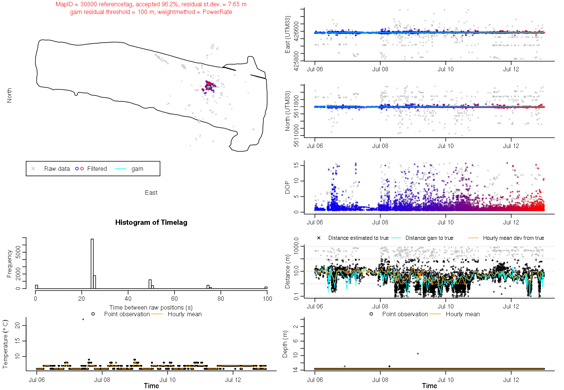

Date
d)
c)
b)
a)
Figure S1. Example of filtering one week of position data for a reference tag. Grey colour indicates positions not accepted by the filtering algorithm, blue to red indicates accepted positions with colour indicating time; blue being oldest and red being latest positions. The cyan-coloured line indicates the final gam-smoothed track. a) Horizontal position estimates, with the outline of Lake Milada indicated by a black line, b) easting of positions versus time, c) northing of position versus time, d) dilution of precision (DOP), a precision measure produced by U-MAP indicating the effective precision of a position estimate given hydrophone geometry and the time measurement resolution of the receiver.

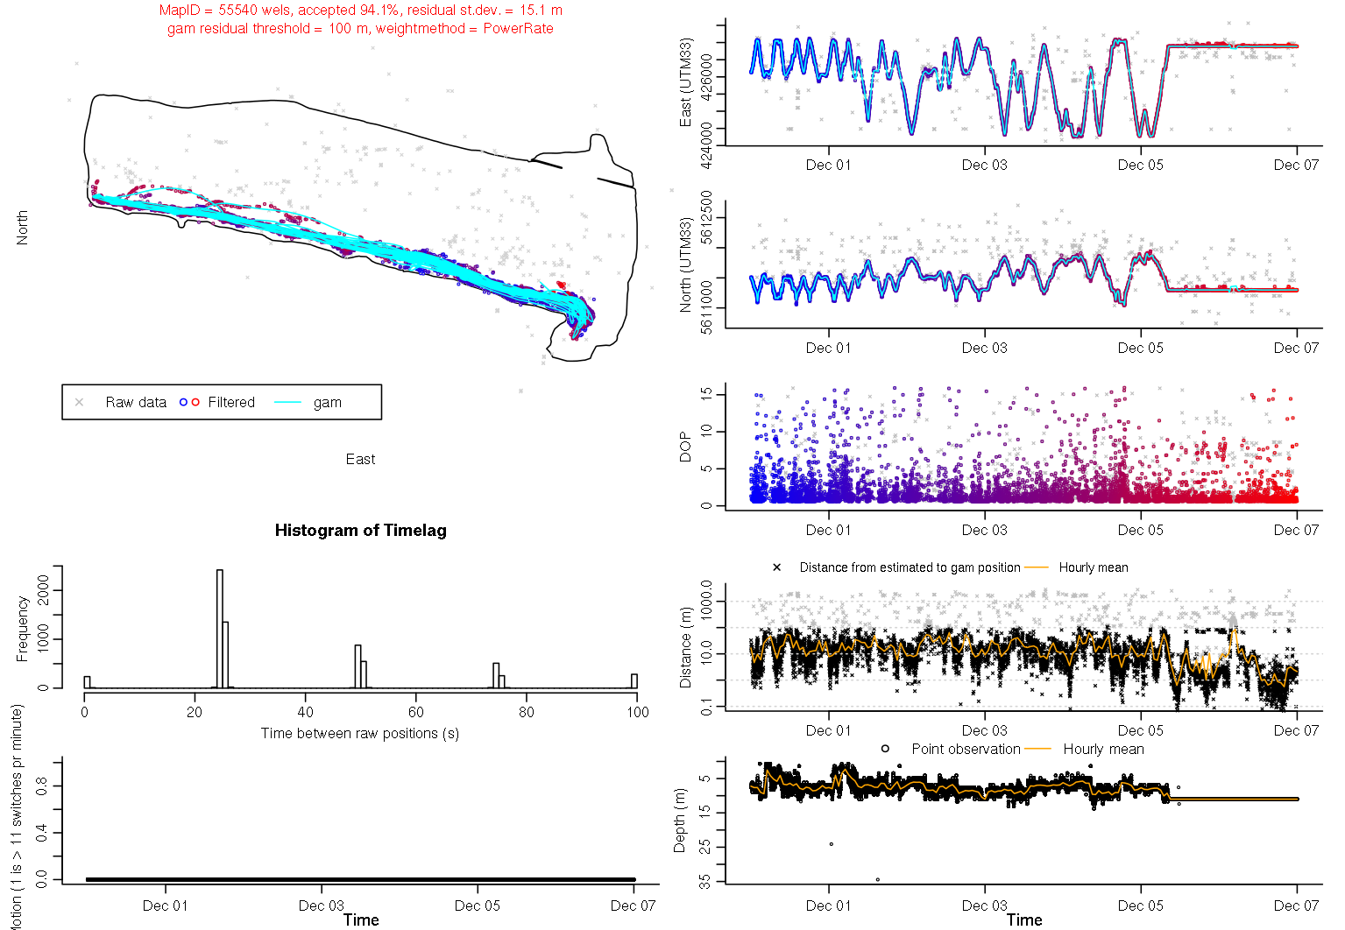

Date
a)
b)
c)
d)
Figure S2. Example of filtering one week of position data for an European wels individual. Grey colour indicates positions not accepted by the filtering algorithm, blue to red indicates accepted positions with colour indicating time; blue being oldest and red being latest positions. The cyan-coloured line indicates the final gam-smoothed track. a) Horizontal position estimates, with the outline of Lake Milada indicated by a black line, b) easting of positions versus time, c) northing of position versus time, d) dilution of precision (DOP), a precision measure produced by U-MAP indicating the effective precision of a position estimate given hydrophone geometry and the time measurement resolution of the receiver.

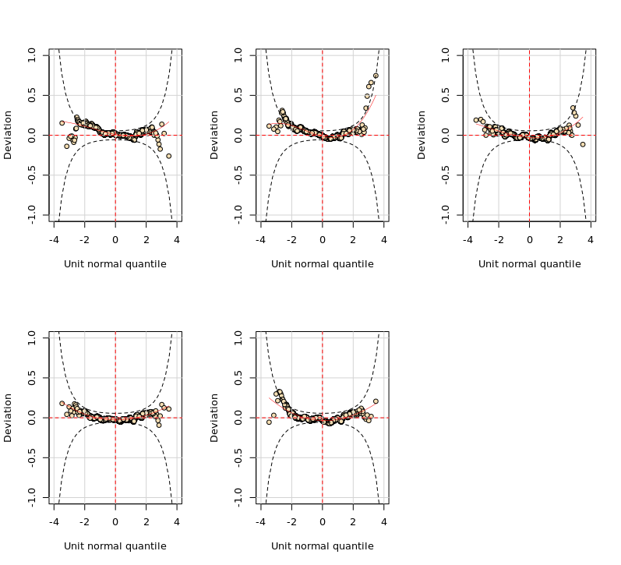Figure S3. Worm plots of the normalized quantile residuals from the first three best BEINF(μ, σ, ν) models selected in Table B1. From up to down and left to right, models Nu₁, Nu_{2,} Nu₃, Nu₄ and Nu₅.
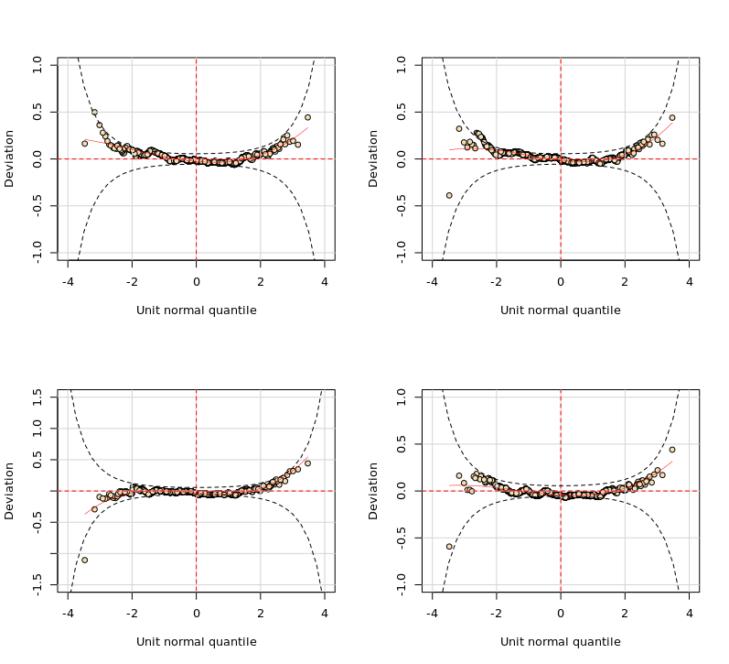
Figure S4. Worm plots of the normalized quantile residuals from the four best BEINF(μ, σ, ν, τ) models shown in Table B1, From up to down and left to right, models Tau₁, Tau₂, Tau₃ and Tau₄.

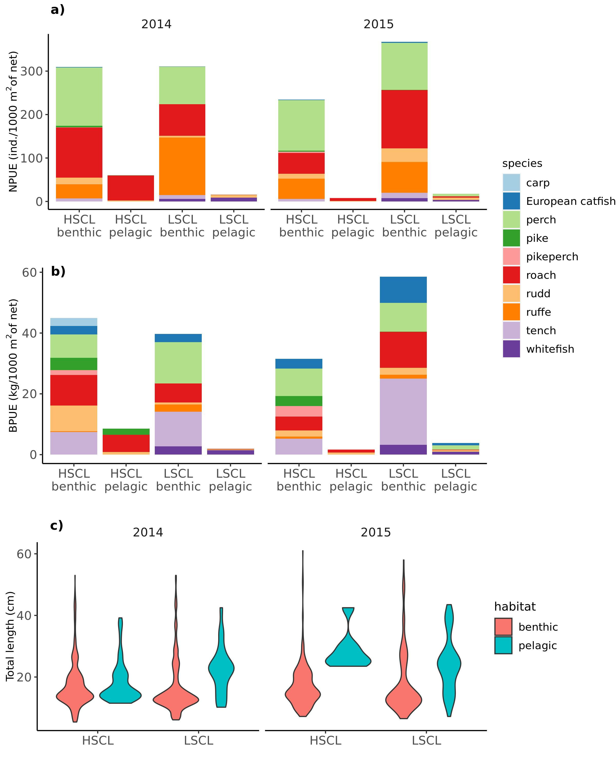
Figure S5. a) Abundance and b) biomass of fish stock and c) size distribution of available prey for pike in both lakes, given separately for bentic and pelagic habitats in one year prior to study (2014) and during study period (2015). Fish stock composition was obtained by gillnet sampling.

