Twin-assisted cracking degradation in sodium layered oxide cathodes
Cheng Chen,^{1,3∥} Zhen Han,^{2,∥}Chaoping Liang,^{1,∥} Yiming Feng,¹ Peng Wang,^{*,2} and Weifeng Wei^{*,1}
¹State Key Laboratory of Powder Metallurgy, Central South University, Changsha, Hunan 410083, People's Republic of China.
²National Laboratory of Solid State Microstructures, College of Engineering and Applied Sciences, and Collaborative Innovation Center of Advanced Microstructures, Nanjing University, Nanjing, Jiangsu 210093, People’s Republic of China.
³School of Materials Science and Engineering, Guizhou Minzu University, Guiyang, Guizhou 550025, People's Republic of China.

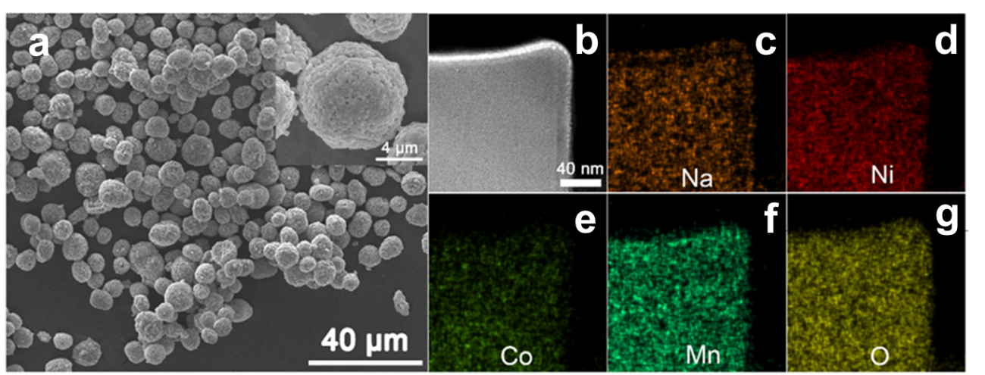
Extended Data Fig. 1 Morphology and chemical information of as-prepared NNCM cathode material. (a) Typical scanning electron microscopy (SEM) images. (b)-(g) STEM-HAADF image and elemental maps taken from cross-sectioned NNCM cathode material.

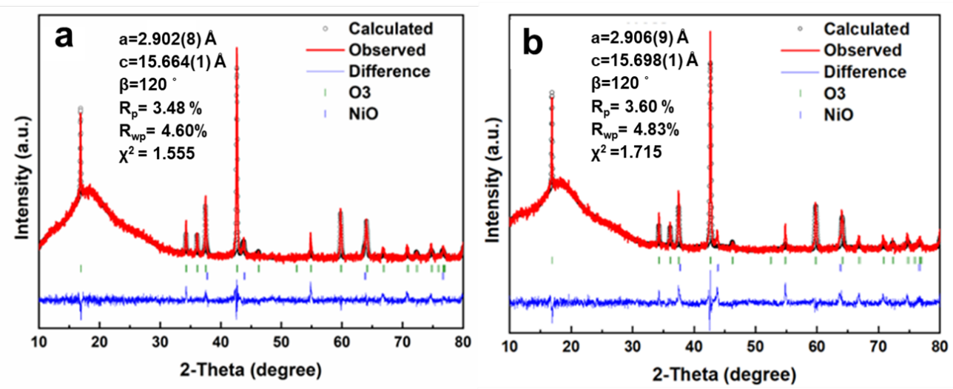
Extended Data Fig. 2 XRD patterns and refined results. (a) Pristine and (b) cycled NNCM cathode materials.

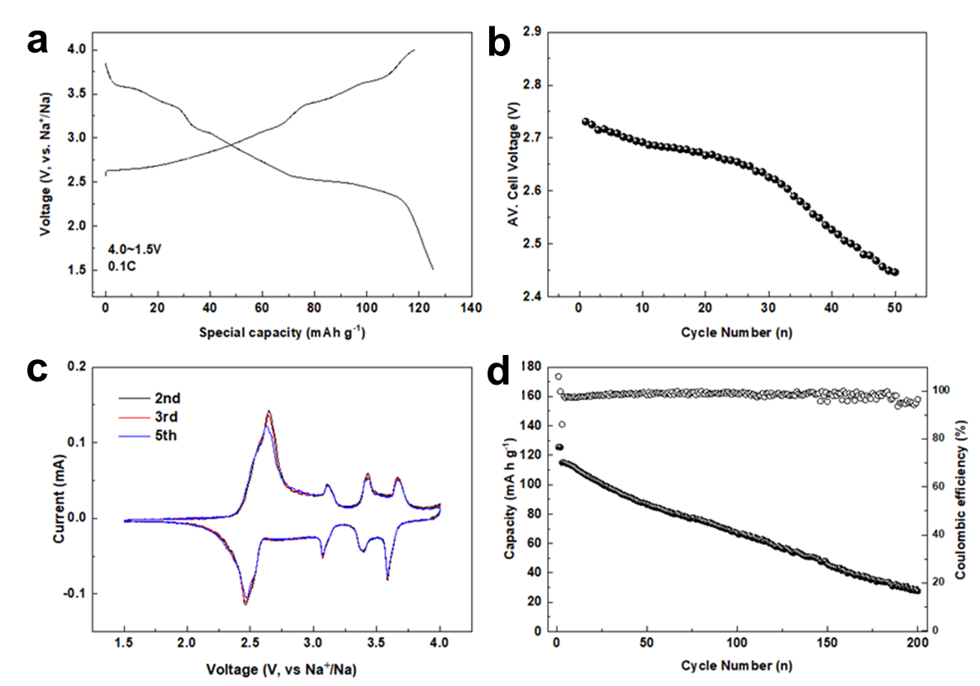
Extended Data Fig. 3 Electrochemical performance of NNCM cathode. (a) Initial charge and discharge profiles within 1.5-4.0V vs. Na⁺/Na at 0.1 C. (b) Average cell voltage upon extended cycles. (c) Cyclic voltammetry (CV) curves. (d) Electrochemical cycling properties up to 200 cycles.

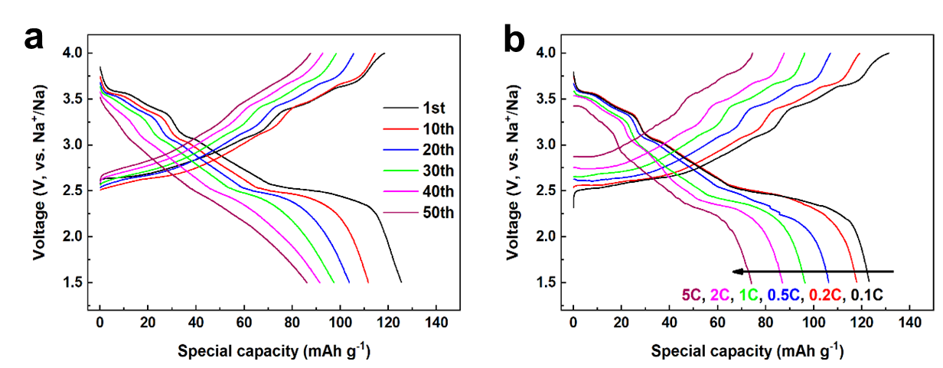
Extended Data Fig. 4 Electrochemical performance of NNCM cathode. (a) Charge and discharge profiles during extended cycles. (b) Charge and discharge profiles tested at various C rates (0.1-5 C).
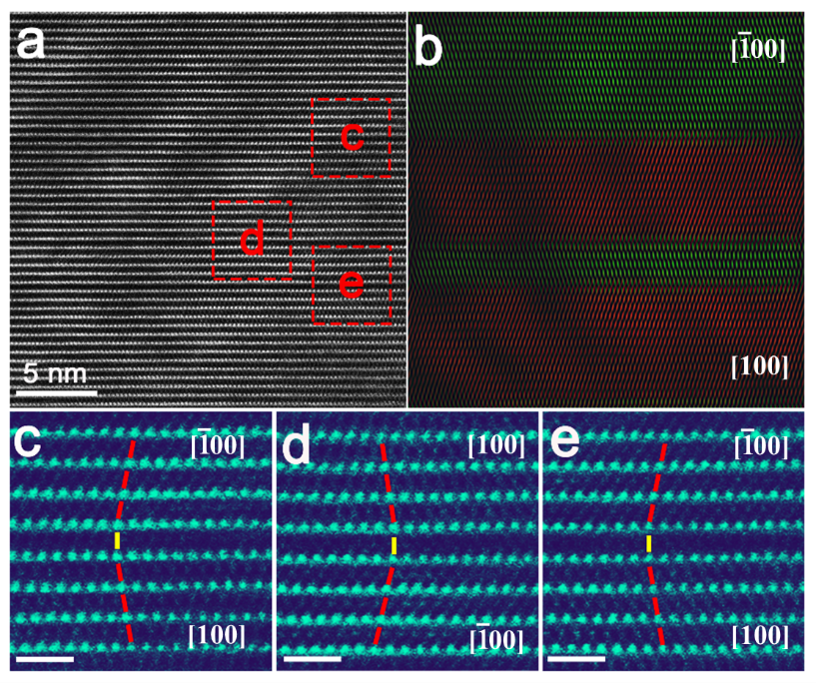
Extended Data Fig. 5 Atomic-resolution STEM images visualizes multiple twins in a single pristine NNCM particle. (a-e) STEM-HAADF images and corresponding reconstructed images of NNCM cathodes, demonstrating that twins widely exist and are stacking along [001] direction in pristine NNCM cathode. The scale bars are 1nm in c-e.

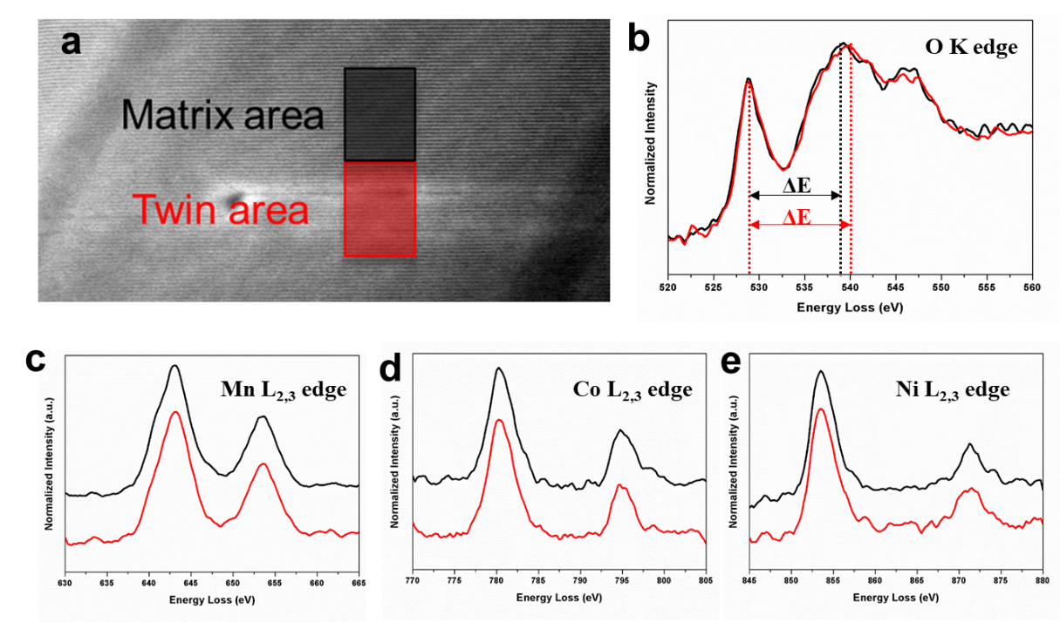
Extended Data Fig. 6 Electronic information of O and TM elements around CTBs using EELS. (a) STEM-ADF images of selected area for EELS acquisition around CTBs. The red and black rectangles indicate the acquisition areas for matrix area and CTBs area, respectively. (b-e) EELS spectra of O-K and TM-L edge acquired at selected areas in (a).

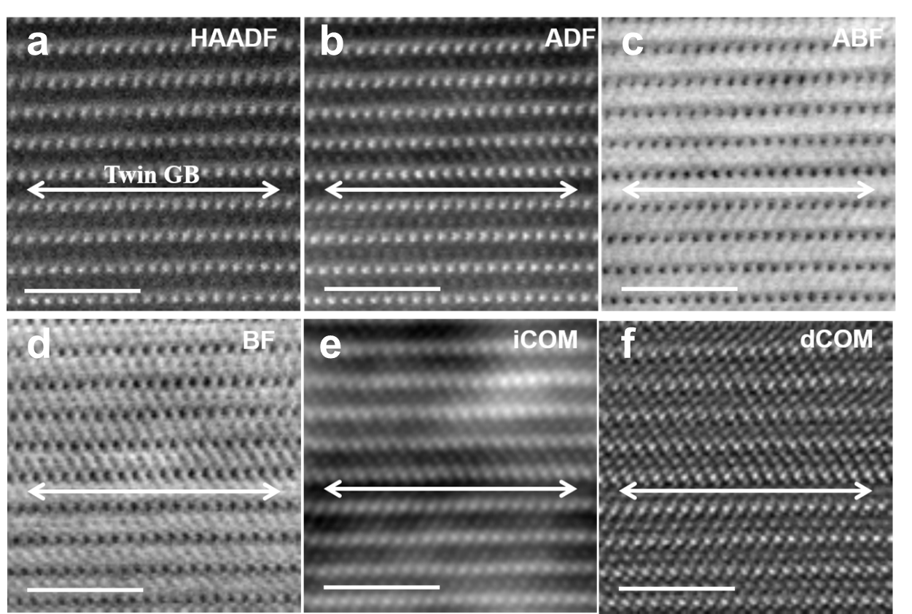
Extended Data Fig. 7 Reconstructed images acquired by 4D STEM techniques of CTBs structure. The bar is 1nm. Na and O atom columns were invisible in HAADF due to weaker scattering of electrons, and contrast of Na and O atom columns were ambiguous in ABF images due to rigorous imaging conditions. The phase reconstructed images, iCOM and dCOM images, showed all atom columns and confirmed the formation of P-type CTBs.

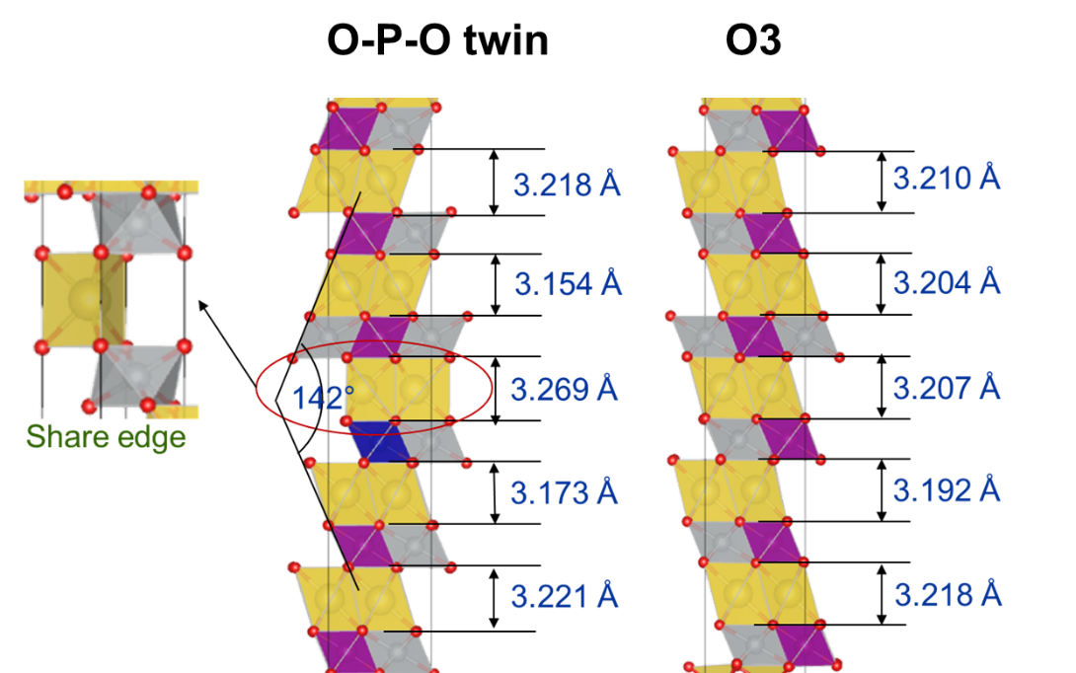
Extended Data Fig. 8 Calculated interlayer distance of Na_{1-x}[NCM211]O₂.

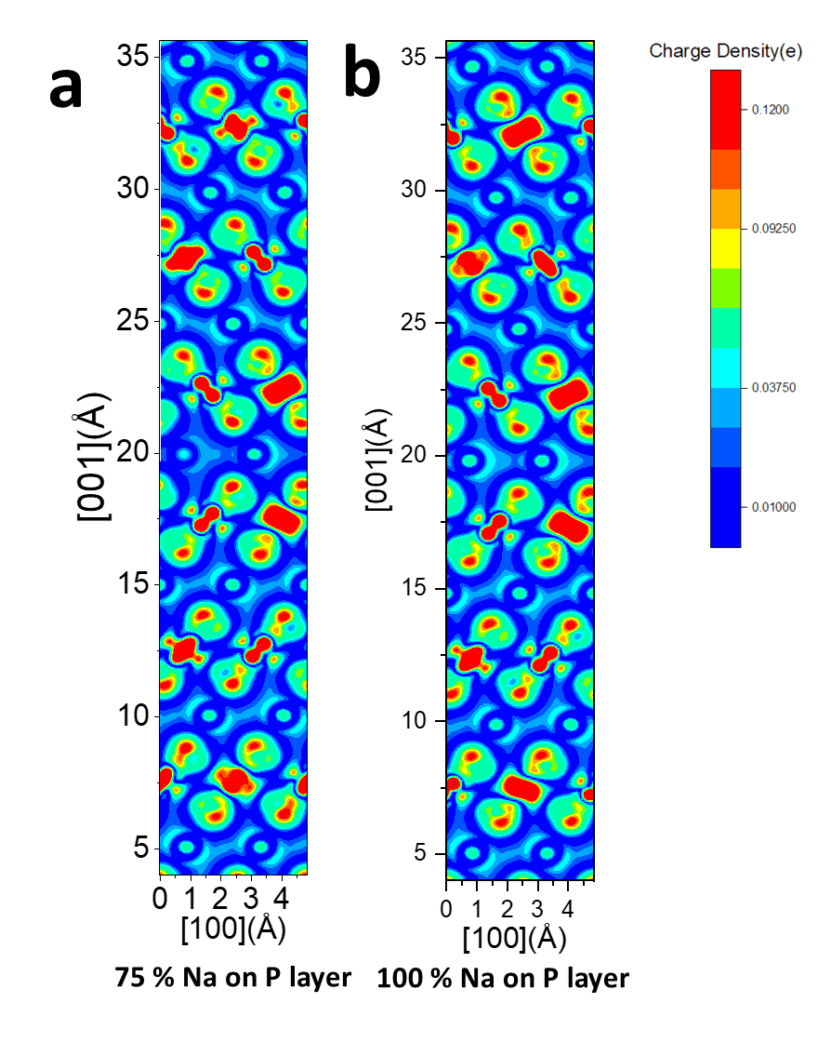
Extended Data Fig. 9 Calculated charge density difference of Na_{1-x}[NCM211]O₂, (a) x=0; (b) x=0.25

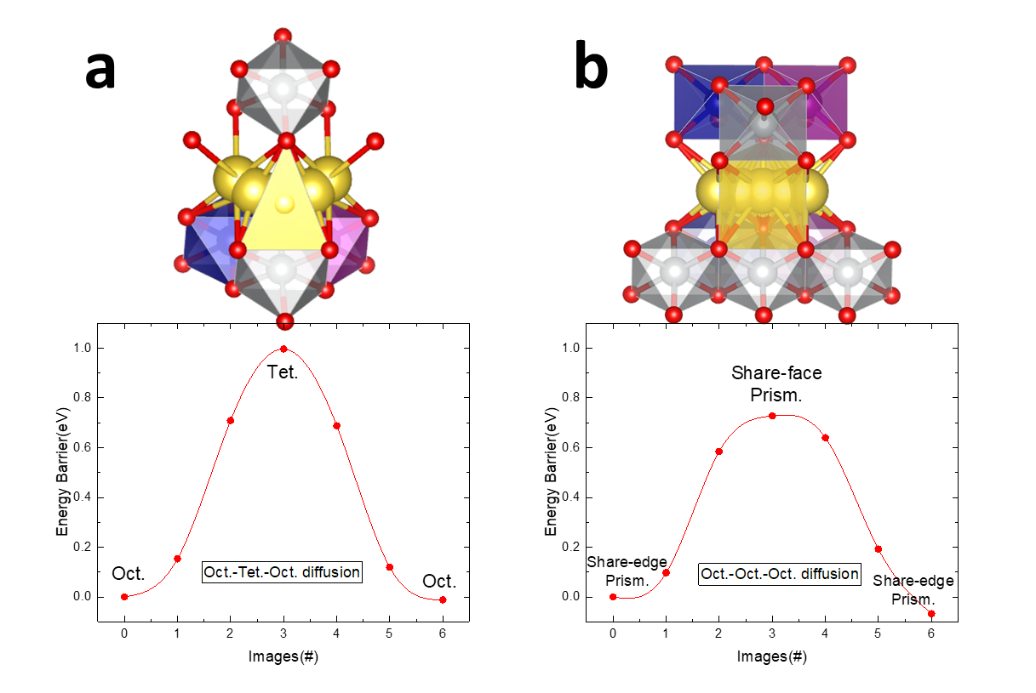
Extended Data Fig. 10 Calculated diffusion barrier for (a) O3 and (b) P2 Na_{1-x}[NCM211]O₂

