Table 1. Typical antagonists of BTK
Drug | Molecular Structure | Type | Approval year/phase
Ibrutinib |  | irreversible,  the first-generation | 2013
Acalabrutinib |  | irreversible,  the first-generation | 2017
Zanubrutinib |  | irreversible,  the first-generation | 2019
Tirabrutinib |  | irreversible,  the first-generation | 2020
Orelabrutinib |  | irreversible,  the first-generation | 2021
Pirtobrutinib |  | reversible,  the second-generation | 2023
Fenebrutinib |  | reversible,  the second-generation | Phase III
ARQ-531 |  | reversible,  the second-generation | Phase I/II
CG806 |  | reversible,  the second-generation | Phase I/II
AS-1763 |  | reversible,  the second-generation | Phase I

Table 2. The performances of traditional machine learning models
Methodª | Model | Descriptor type | Descriptors number | Splitter^{b} | 5-CV ^{c} | 10-CV ^{c} | Train set |  |  | Test set
 |  |  |  |  |  |  | Accuracy | AUC^{d} | MCC^{d} | Accuracy | SE ^{e} | SP ^{e} | AUC^{d} | MCC^{d}
SVM | Model A_1 | ECFP4 | 312 | Random | 0.898 | 0.903 | 0.993 | 1.000 | 0.984 | 0.875 | 0.915 | 0.790 | 0.942 | 0.711
SVM | Model B_1 | MACCS | 70 | Random | 0.871 | 0.879 | 0.938 | 0.979 | 0.857 | 0.860 | 0.913 | 0.746 | 0.908 | 0.672
SVM | Model C_1 | ECFP4 | 312 | SOM | 0.898 | 0.902 | 0.983 | 0.999 | 0.961 | 0.880 | 0.928 | 0.778 | 0.943 | 0.721
SVM | Model D_1 | MACCS | 70 | SOM | 0.872 | 0.871 | 0.948 | 0.983 | 0.880 | 0.892 | 0.960 | 0.745 | 0.928 | 0.745
DT | Model A_2 | ECFP4 | 312 | Random | 0.827 | 0.821 | 0.857 | 0.925 | 0.683 | 0.824 | 0.831 | 0.810 | 0.877 | 0.617
DT | Model B_2 | MACCS | 70 | Random | 0.830 | 0.836 | 0.864 | 0.912 | 0.676 | 0.823 | 0.908 | 0.641 | 0.849 | 0.578
DT | Model C_2 | ECFP4 | 312 | SOM | 0.836 | 0.826 | 0.859 | 0.934 | 0.675 | 0.826 | 0.887 | 0.698 | 0.869 | 0.595
DT | Model D_2 | MACCS | 70 | SOM | 0.823 | 0.834 | 0.864 | 0.901 | 0.678 | 0.842 | 0.936 | 0.640 | 0.877 | 0.622
RF | Model A_3 | ECFP4 | 312 | Random | 0.857 | 0.858 | 0.902 | 0.968 | 0.773 | 0.860 | 0.904 | 0.766 | 0.932 | 0.675
RF | Model B_3 | MACCS | 70 | Random | 0.851 | 0.853 | 0.888 | 0.938 | 0.737 | 0.834 | 0.900 | 0.694 | 0.895 | 0.610
RF | Model C_3 | ECFP4 | 312 | SOM | 0.861 | 0.865 | 0.907 | 0.969 | 0.781 | 0.870 | 0.936 | 0.730 | 0.927 | 0.694
RF | Model D_3 | MACCS | 70 | SOM | 0.846 | 0.850 | 0.878 | 0.932 | 0.712 | 0.861 | 0.949 | 0.672 | 0.915 | 0.670
xgboost | Model A_4 | ECFP4 | 312 | Random | 0.887 | 0.899 | 0.975 | 0.998 | 0.942 | 0.879 | 0.923 | 0.786 | 0.942 | 0.719
xgboost | Model B_4 | MACCS | 70 | Random | 0.867 | 0.875 | 0.937 | 0.982 | 0.854 | 0.877 | 0.942 | 0.738 | 0.925 | 0.709
xgboost | Model C_4 | ECFP4 | 312 | SOM | 0.886 | 0.892 | 0.970 | 0.996 | 0.931 | 0.880 | 0.932 | 0.770 | 0.943 | 0.720
xgboost | Model D_4 | MACCS | 70 | SOM | 0.871 | 0.874 | 0.938 | 0.983 | 0.856 | 0.893 | 0.962 | 0.745 | 0.941 | 0.749
ªSVM: support vector machine; DT: decision tree; RF: random forest; XGB: extreme gradient boosting;
^{b}SOM: self-organizing map splitter; random: random stratified splitter;
^{c}Accuracy;
^{d}5-CV: Accuracy of five-fold cross-validation;10-CV: Accuracy of 10-fold cross-validation;
^{e}MCC: Matthews correlation coefficient;AUC: Area under the curve of ROC;
^{f}SE: Sensitivity;SP: Specificity.

Table 3. The performances of DNN models
Method | Model | Descriptor type | Descriptors number | Splitter | Layer | Train set |  |  | Test set
 |  |  |  |  |  | Accuracy | AUC | MCC | Accuracy | SE | SP | AUC | MCC
DNN | Model A_5 | ECFP4 | 312 | Random | 3 | 0.935 | 0.983 | 0.849 | 0.875 | 0.782 | 0.919 | 0.929 | 0.710
DNN | Model A_6 | ECFP4 | 312 | Random | 4 | 0.971 | 0.995 | 0.933 | 0.875 | 0.782 | 0.919 | 0.927 | 0.710
DNN | Model B_5 | MACCS | 70 | Random | 3 | 0.945 | 0.983 | 0.872 | 0.881 | 0.774 | 0.930 | 0.912 | 0.720
DNN | Model B_6 | MACCS | 70 | Random | 4 | 0.914 | 0.966 | 0.801 | 0.881 | 0.798 | 0.919 | 0.909 | 0.723
DNN | Model C_5 | ECFP4 | 312 | SOM | 3 | 0.977 | 0.998 | 0.947 | 0.880 | 0.742 | 0.945 | 0.938 | 0.718
DNN | Model C_6 | ECFP4 | 312 | SOM | 4 | 0.994 | 1.000 | 0.987 | 0.880 | 0.770 | 0.932 | 0.940 | 0.720
DNN | Model D_5 | MACCS | 70 | SOM | 3 | 0.917 | 0.966 | 0.806 | 0.883 | 0.725 | 0.957 | 0.926 | 0.723
DNN | Model D_6 | MACCS | 70 | SOM | 4 | 0.912 | 0.964 | 0.793 | 0.892 | 0.729 | 0.968 | 0.929 | 0.746

Table 4. Evaluation of BTK Inhibitor Clusters Based on Molecular Scaffolds, SHAP Analysis, and Crystal Structures
Subset | Number of high-activity/low-activity inhibitors | Scaffoldª | Representative molecule^{b} | Feature(The average shap value of each model)
1.1 | 179/22 |  | 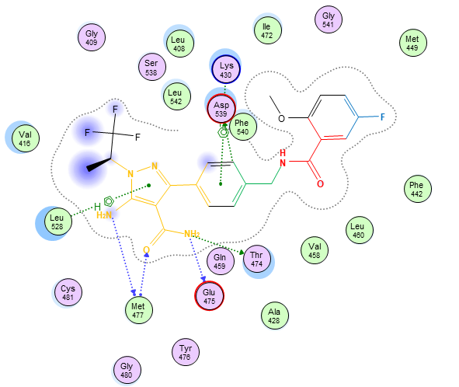  BTK and Y7W (PDB code: 8FLL) | X487=1 (0.0784)  X389=1 (0.0284)  X310=1 (0.0272)  X695=0 (0.0251)  X814=1 (0.0247)  X788=0 (-0.0222)  X65=0 (-0.0144)
1.2 | 66/59 |  | IC₅₀ = 0.1 nM | X487=0 (-0.0648)  X685=1 (0.0261)  X788=0 (-0.0223)  X695=0 (0.179)
2 | 326/105 |  | IC₅₀ = 0.2 nM | X681=1 (0.0450)  X310=1 (0.0269)  X501=1 (0.0221)  X788=0 (-0.0219)
3 | 165/556 | - | - | X695=0 (-0.0840)  X487=0 (-0.0318)  X960=0 (-0.0226)
4 | 362/53 |  | IC₅₀ =10 nM | X695=0 (0.0285)  X788=0 (-0.0221)
5.1 | 187/54 |  | IC₅₀ = 0.5 nM | X695=1 (0.0308)  X301=1 (0.0307)  X722=1 (0.0243)  X798=1 (0.0233)  X321=1 (0.0213)
5.2 | 136/21 |  | 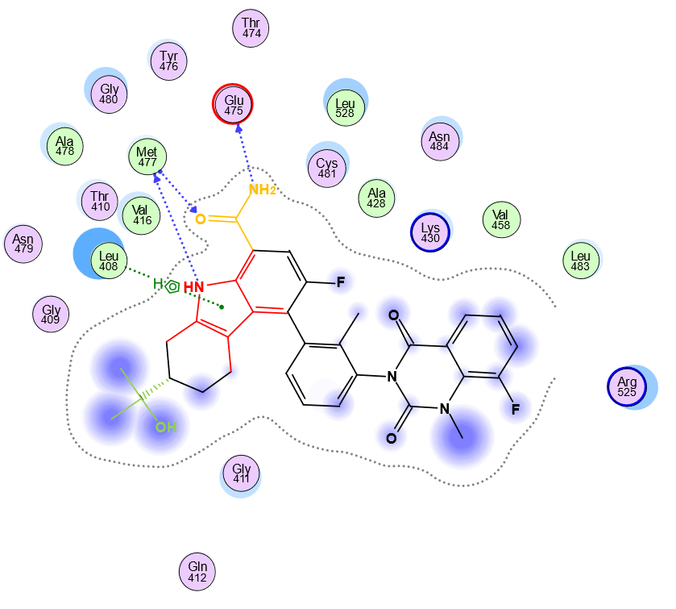  BTK and 73T (PDB code: 5T18) | X310=1 (0.0372)  X963=1 (0.0348)  X722=1 (0.0330)  X487=0 (-0.0302)  X120=1 (0.0024)  X695=0 (0.0211)
6 | 616/30 |  | 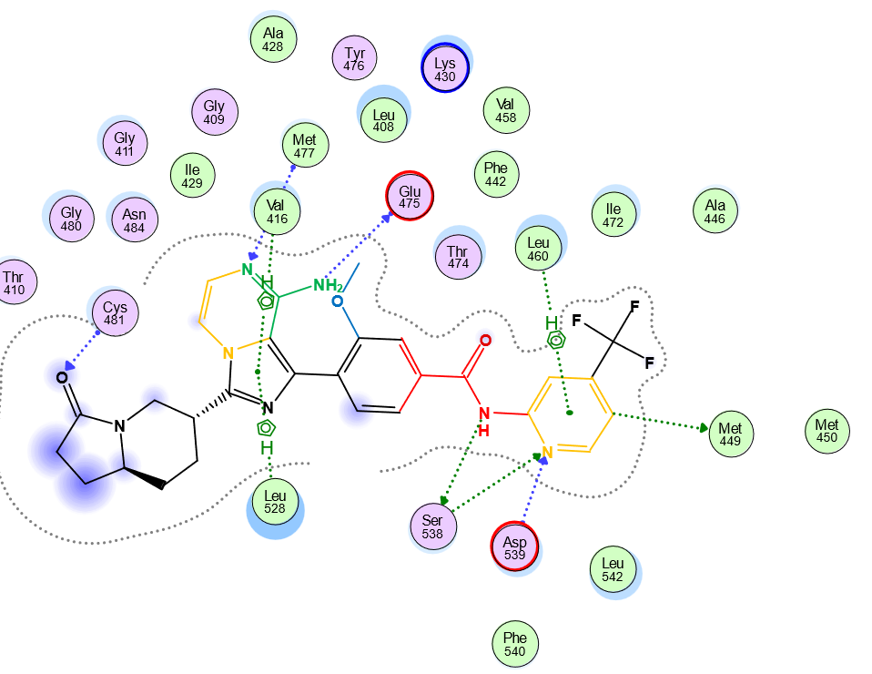  BTK and ULY (PDB:6X3O) | X487=1 (0.0876)  X788=1 (0.0548)  X65=0 (0.0251)  X695=0 (0.0243)
7 | 324/9 |  | 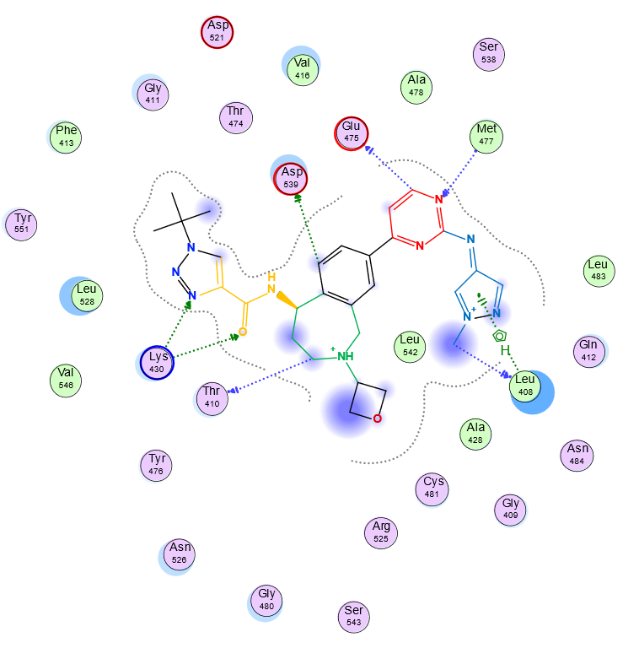  BTK and YDA (PDB:7LTZ) | X487=1 (0.0758)  X788=1 (0.0451)  X695=0 (0.0333)  X65=0 (0.0304)
8 | 86/205 | - | - | X487=0 (-0.0488)  X788=0 (-0.0291)  X434=0 (-0.013)
9 | 207/122 | N-heterocycle-aromatic ring-amide-aromatic ring | Fig 6 | X695=0 (0.0251)  X65=1 (-0.0223)  X798=0 (0.0139)  X723=1 (0.0119)
ª Features with the average SHAP values greater than 0.03 are shown in red and those less than 0.03 are shown in orange
^{b} Table 5 for feature colors

Table 5 Analysing the co-crystal structures of BTK with the second-generation non-covalent inhibitors
Subset | PDB code | Ligand code | Refs | Featureª | Color^{b}
Subset 1.1 | 8FLL | Y7W | [42] | X487 | red
 |  |  |  | X389,X310,X141 | orange
 |  |  |  | X814,X256 | green+red
 |  |  |  | X700 | blue
Subset 5.2 | 5T18 | 73T | [43] | X310,M84,X141 | orange
Subset 5.2 |  |  |  | X722,M97 | red
Subset 5.2 | 5JRS | 6MV | [43] | X722 | red
Subset 5.2 |  |  |  | M139,M112，X893 | green
Subset 6 | 5FBO | 5WH | [44] | X487 | red
Subset 6 | 6X3N | ULV | [45] | X788 | orange
Subset 6 | 6X3P | UM4 | [45] | X994,X47 | red+orange
Subset 6 | 6X3O | ULY | [45] | X76 | green
Subset 6 |  |  |  | X947 | blue
Subset 7 | 6W07 | S9A | [11] | X788 | red
Subset 7 | 7LTZ | YDA | [46]
Subset 7 | 7LTY | YD7 | [46] | X487 | orange
Subset 7 | 7KXQ | X9Y | [47]
Subset 7 | 7KXP | X9V | [47] | X213 | green
Subset 7 | 7KXO | X9S | [47]
Subset 7 | 7KXN | X9P | [47] | X683 | blue
Featureª, ‘X’ represents the bits of ECFP4, ‘M’ represents the bits of MACCS.
Color^{b}, The colors and features represented in the figure can be found in Table 6 and Fig 5.

Table 6 Specific SHAP Values of Crystal Structure Inhibitors in Subset 6
6X3N |  | SHAP | 5FBO | SHAP | 6X3O | SHAP | 6X3P | SHAP | Subset 6 | SHAP
X487=1 | 0.0917 |  | X487=1 | 0.0884 | X487=1 | 0.0971 | X487=1 | 0.1000 | X487 | 0.0876
X788=1 | 0.0805 |  | X788=1 | 0.0661 | X788=1 | 0.0649 | X788=1 | 0.0645 | X788 | 0.0548
X994=1 | 0.0323 |  | X695=0 | 0.0287 | X695=0 | 0.0315 | X695=0 | 0.0304 | X65 | 0.0251
X65=0 | 0.0247 |  | X65=0 | 0.0250 | X76=1 | 0.0259 | X76=1 | 0.0248 | X695 | 0.0244
X695=0 | 0.0241 |  | X76=1 | 0.0239 | X65=0 | 0.0245 | X65=0 | 0.0225 | X76 | 0.0188
X76=1 | 0.0231 |  | X994=1 | 0.0235 | X994=1 | 0.0241 | X994=1 | 0.0225 | X994 | 0.0178
X977=1 | 0.0218 |  | X977=1 | 0.0227 | X977=1 | 0.0203 | X977=1 | 0.0191 | X977 | 0.0138
X47=1 | 0.0163 |  | X47=1 | 0.0185 | X47=1 | 0.0181 | X47=1 | 0.0179 | X47 | 0.0118
X685=1 | 0.0157 |  | X243=1 | 0.0177 | X740=1 | 0.0167 | X740=1 | 0.0157 | X960 | 0.0117
X900=1 | 0.0138 |  | X700=1 | 0.0174 | X685=1 | 0.0167 | X685=1 | 0.0148 | X740 | 0.0115
X893=1 | 0.0137 |  | X740=1 | 0.0167 | X681=1 | 0.0147 | X947=1 | 0.0136 | X434 | 0.0092
X960=0 | 0.0125 |  | X681=1 | 0.0122 | X947=1 | 0.0123 | X120=1 | 0.0125 | X576 | 0.0072
X434=1 | 0.0118 |  | X960=0 | 0.0119 | X960=0 | 0.0113 | X681=1 | 0.0117 | X843 | 0.0065
... | ... |  | X417=1 | 0.0103 | X799=1 | 0.0112 | X960=0 | 0.0110 | ... | ...
X700=0 | -0.0061 |  | ... | ... | ... | ... | ... | ... | X947 | 0.0013
X947=0 | -0.0012 |  | X947=0 | -0.0007 | X700=0 | -0.0056 | X700=0 | -0.0065 | X700 | -0.0001
‘X’ represents the bits of ECFP4.

