Supplementary Files:
S-Figure 1.
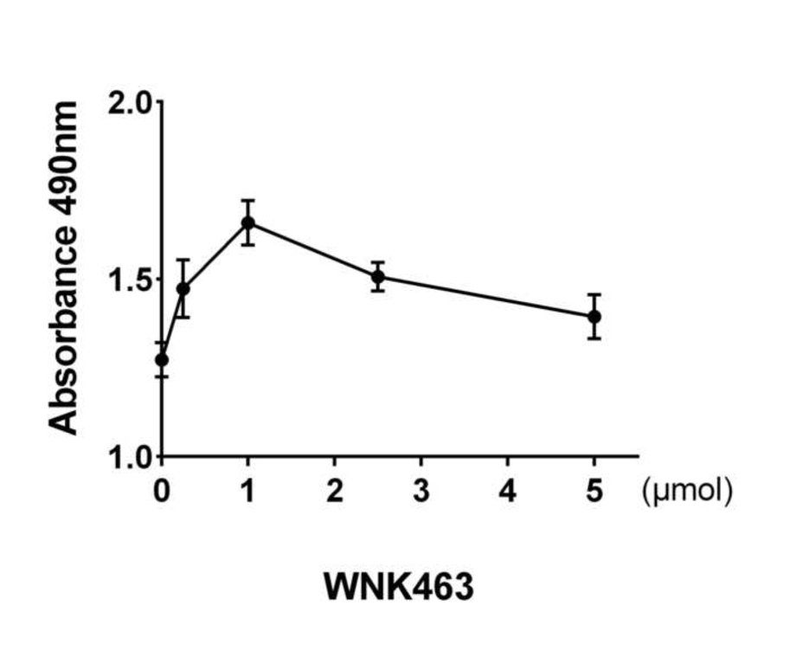
S-Figure 1. Different concentration of WNK-463 on MTS
The apoptotic cells were detected using MTS after treatment with 4.1% Sev for 6 h at different concentrations of WNK-463 in 0, 0.5, 1.0, 2.0, 3.0, 4.0, 5.0 µmol.

- Figure 2.
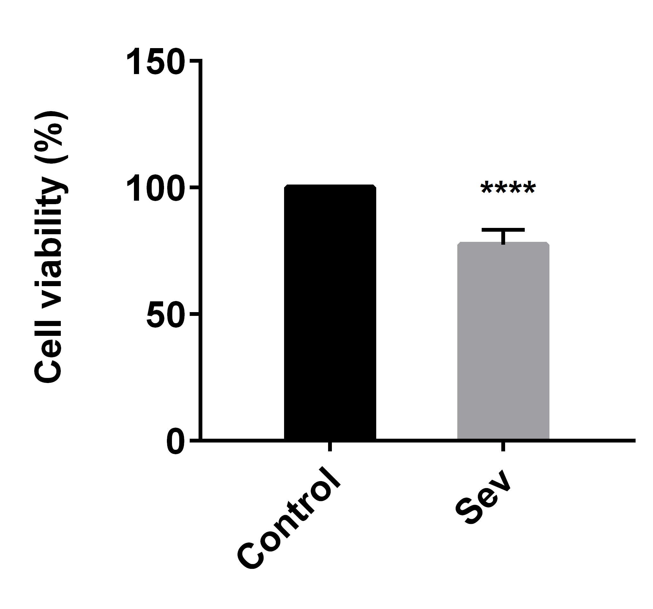
S-Figure 2. Sevoflurane-induced cell activity decreasing
The MTS used to measure cell viability in HT22 cells exposed to control or 4.1% Sev for 6 h ( ****P < 0.0001).

