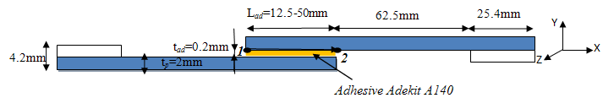
Figure 1: Schematic illustration of single lap bonded joint (case I). (Dimensions are in mm)
.

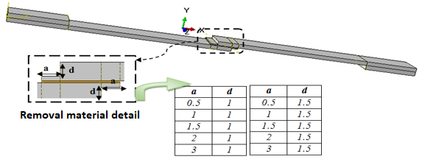

Figure 2: Schematic illustration of single lap joint with removal materiel at free edge of the
adherend.

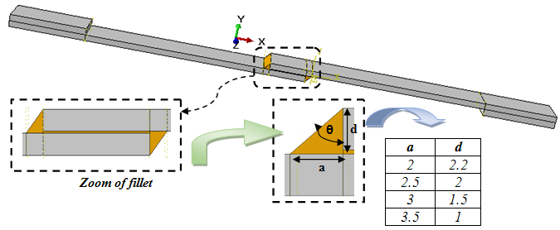

Figure 3: Global view of the structure and detail view of adhesive fillet. (Dimensions are in mm).

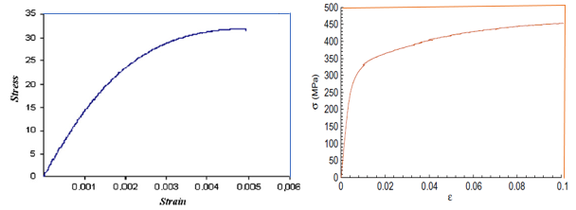

Figure 4: Tensile stress–strain curve of adhesive and Aluminum plate respectively. [16]

U2=0
U1=UR2=UR3=0

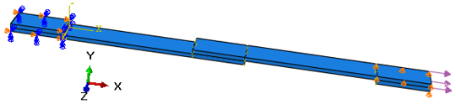
Overlap area

U2=0
σ

Figure 5: Detail of boundary condition of the single-lap-joint.

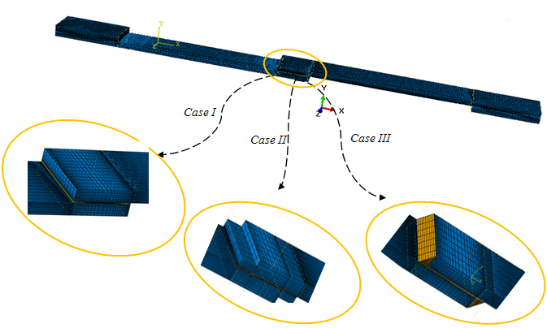
Figure 6: Detail of the mesh for numerical models of the various configurations.

Figure 7: Variation of Von mises stress in the single joint assembly as a function of mesh density.

- Adherends thickness 2mm

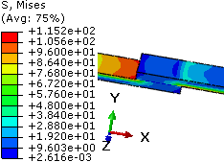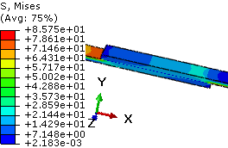
a) Adhesive length 12.5mm b) Adhesive length 50mm

- Adherends thickness 3mm

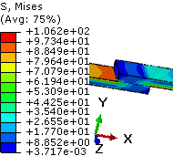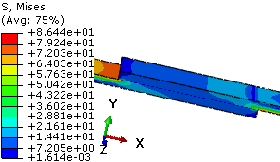
a) Adhesive length 12.5mm b) Adhesive length 50mm

Figure 8: Level of the maximal Von mises stresses in the assembly as a function of overlap length and thickness of adherends. (Adhesive thickness 0.2mm), applied stress σ =15MPa.

- Adherends thickness 2mm
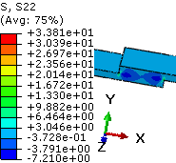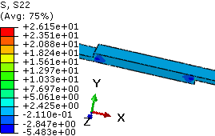
a) Adhesive length 12.5mm b) Adhesive length 50mm

- Adherends thickness 3mm
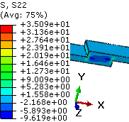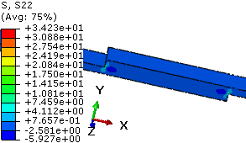
a) Adhesive length 12.5mm b) Adhesive length 50mm

Figure 9: Level of peel stress in the assembly as a function of overlap length and thickness of adherends. (Adhesive thickness 0.2mm), applied stress σ =15MPa.

- Adherends thikness 2mm
a) b) c)
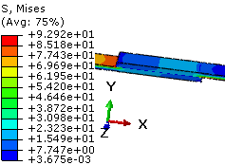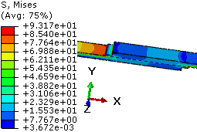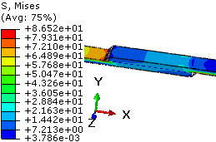
a) b) c)
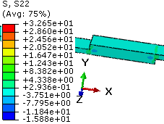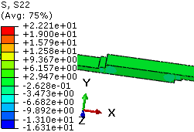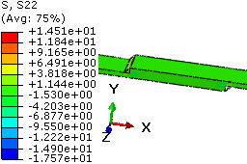
Figure 10: Level of the Von mises and the peel stresses in the different assemblies (adherends thickness 2mm and applied stress σ=15MPa).

- Adherends thikness 3mm
a) b) c)
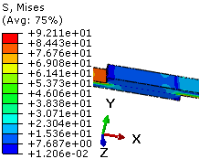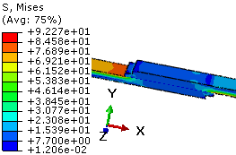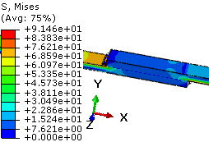

a) b) c)
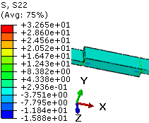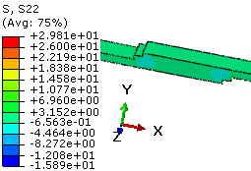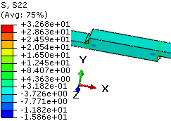

Figure 11: Level of the Von mises and the peel stresses in the different assemblies (adherends thickness 3mm and applied stress σ=15MPa).

a) b)
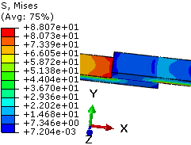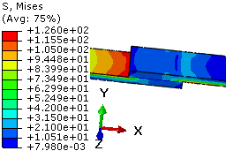

Figure 12: Von mises stress level in the assembly, overlap length L_{ad} = 12.5mm, thickness plate t_{p} =1.5mm, a) σ= 10MPa, b) σ= 15MPa.
Figure 13: Variation of the maximum stress of Von mises in the assembly for different overlap length and thickness of adherends.

a) b)
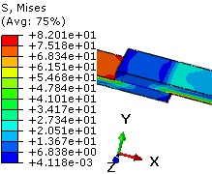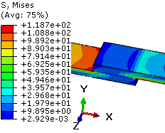

Figure 14: Von mises stress level in the assembly, overlap length L_{ad} = 12.5mm, thickness adhesive t_{p}=2mm, t_{ad} = 0.3mm, a) σ= 10MPa, b) σ= 15MPa).
Figure 15: Von mises stress variation in the assembly as function as a thickness adhesive.
a) b)
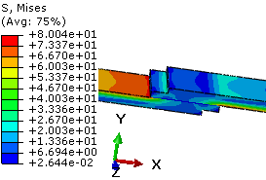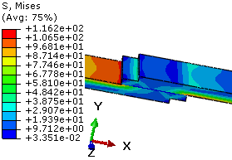
Figure 16: Maximal Von mises stress level assembly with removal of material at the edge of the plate, overlap length L_{ad} = 12.5mm, t_{p} =2mm and d=1mm, a) σ= 10MPa, b) σ= 15MPa.

Figure 17: Variation of the maximal Von mises stress in the assembly of removal material model.

- b)
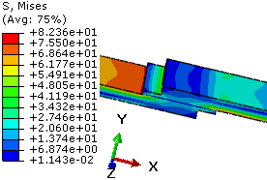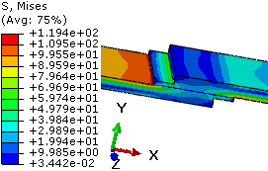

Figure 18: Maximal Von mises stress level assembly with material removal at the edge of the plate, overlap length L_{ad} = 12.5mm, t_{p} =2mm and d=1.5mm, a) σ= 10MPa, b) σ= 15MPa.

Figure 19: Variation of the maximal Von mises stress in the assembly of material removal model.

a) b)
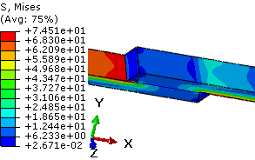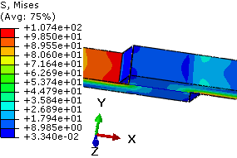

Figure 20: Maximal Von mises stress level in the assembly with adhesive fillet, overlap length L_{ad} = 12.5mm, t_{p} =2mm and a=2mm-d=2.2mm, a) σ= 10MPa, b) σ= 15MPa).

Figure 21: Variation of the maximal Von mises stress in the assembly of the adhesive fillet.

Adhesive thickness of 0.1mm
a) b)
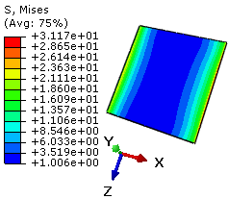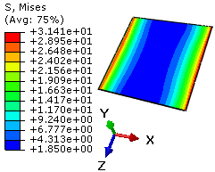
- Adhesive thickness of 0.2mm
a) b)
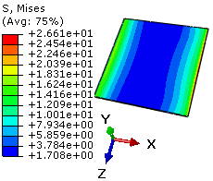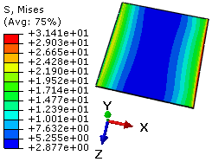

Figure 22: Contour of the maximal Von mises stress along of overlap, L_{ad} = 12.5mm, thickness adhesive. a) σ=10MPa, b) σ =15MPa.

- Adhesive thickness of 0.1mm
a) b)
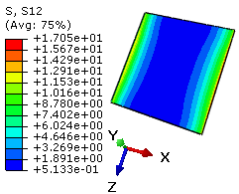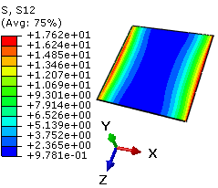
- Adhesive thickness of 0.2mm
a) b)
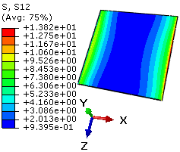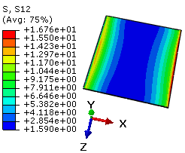

Figure 23: Contour of the shear stress along of overlap, L_{ad} = 12.5mm, thickness adhesive a) σ=10MPa, b) σ =15MPa.

Figure 24: Variation of the maximal Von mises and the shear stresses in the adhesive layer along the adhesive thickness.

Figure 25: Variation of the maximal Von mises and shear stresses in the adhesive layer as a function of adherend thickness and overlap length.

- Case of the removal surface a=3mm, d=1mm
a) c)
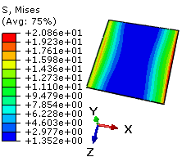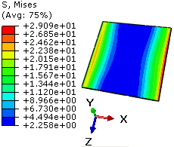
b) d)
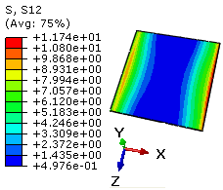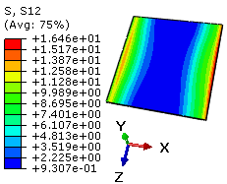

Figure 26: Level of the Von mises, the shear stresses in case of the removal material model and in the adhesive, L_{ad} =12.5mm, t_{p}=2mm. a,b) σ=10MPa, c,d) σ =15MPa.

Figure 27: Variation of the Von mises stress, the shear stress in the adhesive layer along the adhesive length and removal material length.

- Case of the removal surface a=3mm, d=1.5mm
a) c)
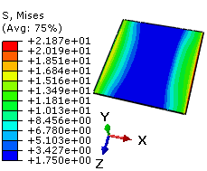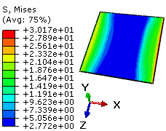

b) d)
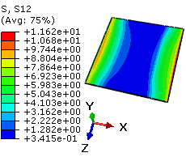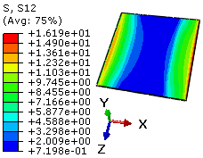

Figure 28: Contour of the Von mises, the shear stresses in case of removal material model and in adhesive layer, L_{ad} =12.5mm, t_{p}=2mm a,b) σ=10MPa, c,d) σ =15MPa.

Figure 29: Variation of the Von mises, the shear stresses in the adhesive layer along the overlap length.

Figure 30: Variation of the Von mises and shear stresses in the adhesive layer as function of the adhesive length and for different values of the adhesive fillet length.

- Overlap length 12.5mm
a) b) c)
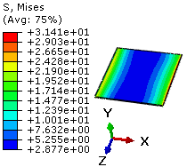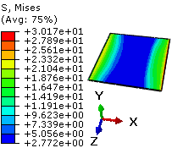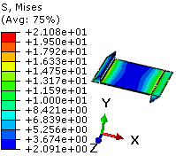
- Overlap length 50mm
a) b) c)
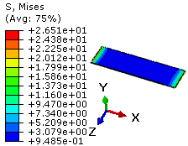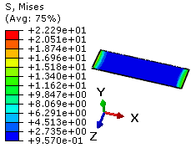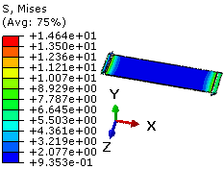

Figure 31: Contour of the Von mises stress for three models, L_{ad} =12.5mm and 50mm respectively, t_{p}=2mm, t_{ad}=0.2mm, σ=15MPa.

- Overlap length 12.5mm
a) b) c)
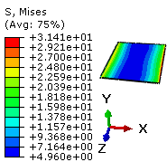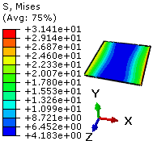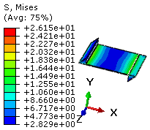

- Overlap length 50mm

a) b) c)
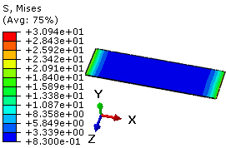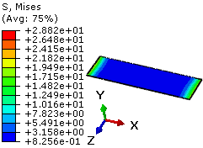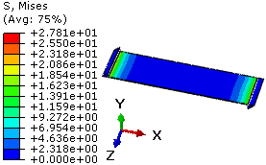

Figure 32: Contour of the Von mises stress for three models, L_{ad} =12.5mm and 50mm respectively, t_{p}=3mm, t_{ad}=0.2mm, σ=15MPa.
- Thickness plate 2mm

Figure 33: Level of the Von mises stress for overlap length 12.5 and 50mm, t_{p}=2mm, t_{ad}=0.2mm, applied load 15MPa.

- Thickness plate 3mm
Figure 34: Level of the Von mises stress for overlap length 12.5 and 50mm, t_{p}=3mm, t_{ad}=0.2mm, applied load 15MPa.

Figure 35: Level of Von mises stress along the center of overlap length in the adhesive for simple assembly, a) 12.5mm, b) 50mm, t_{p}=2mm, removing model (a=3mm, d=1mm), and spew fillet model (a=2.2mm, d=2.2mm).

