Synthesis of Novel Methylsulfonylacrylimidamide via Click Chemistry approach, Computational analysis and α- glucosidase inhibition activity
Santosh Kumar Surveª, Pramod R. Birmule ª, Sandeep.B.Patil ^{d}, Sandeep A. Sankpal ª, Virbhadra Kalalawe^{b}, Sunita Salunke-Gawali^{c*}, Shankar Hangirgekar^{a*}
ªDepartment of Chemistry, Shivaji University, Kolhapur India.
^{b}Department of Chemistry, Yogeshwari Mahavidyalaya, Ambajogai, India.
^{c}Department of Chemistry, Savitribai Phule Pune University, India
^{d} Department of Pharmacology, Dr. Shivajirao Kadam College of Pharmacy, Sangli, India
E-mail – hangirgekarshankar@gmail.com

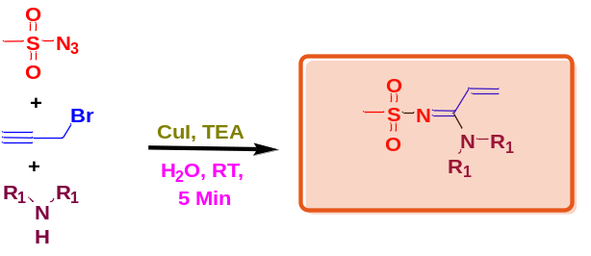
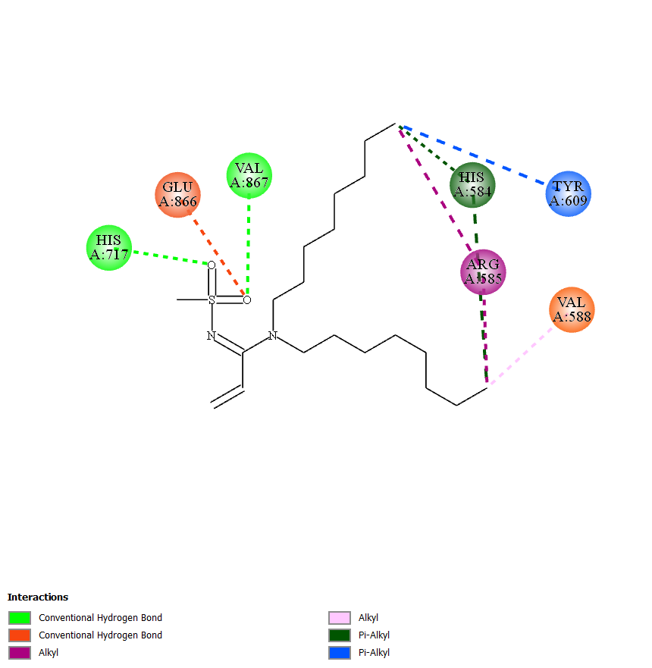
Graphical Abstract

