Figure S1. The concentrations of Pb²⁺ and F⁻ in the solution vary with Pb²⁺ : F⁻

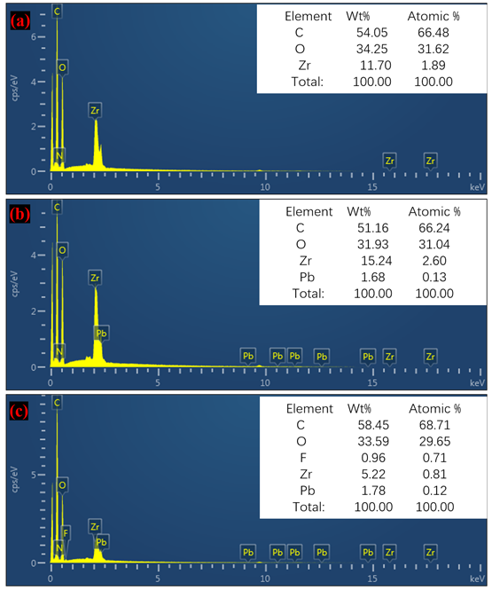
Figure S2. EDS of TF-Zr before and after adsorption (a) TF-Zr, (b) TF-Zr adsorbed lead, (c) TF-Zr adsorbed both fluorine and lead.

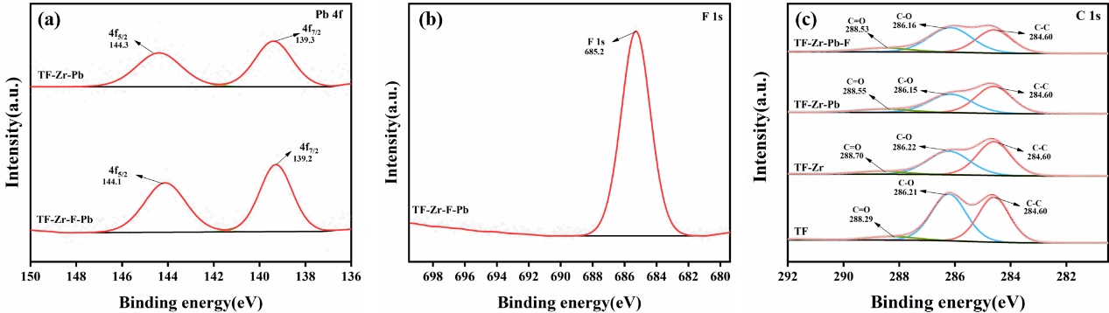
Figure S3. The XPS before and after TF-Zr adsorption (a) Pb 4f, (b) F 1s, (c) C 1s

Table S1. Basic properties of test soil samples.
 | ANª | AP^{b} | AK^{c} | OM | pH | F | Pb
 | (mg/kg) | P₂O₅(mg/kg) | K₂O(mg/kg) | (%) |  | (mg/kg) | (mg/kg)
Soil | 212.67±3.02 | 177.06±1.20 | 200.45±1.80 | 3.65±0.34 | 4.99±0.10 | 420.60±0.21 | 1290±0.31
ªAN is available nitrogen, ^{b}AP is available phosphorus, ^{c}AK is available kalium.

Table S2-1. Pearson correlation analysis of TF-Zr dosage, pH, different fractions of fluorine at different test days (20days)
 | Dosage of TF-Zr | pH | Water-F | Ex-F | Fe/Mn-F | Or-F | Res-F
Dosage of TF-Zr | 1
pH | -946** | 1
Water-F | -0.996** | 0.956** | 1
Ex-F | -0.992** | 0.962** | 0.999** | 1
Fm-F | -0.609* | 0.383 | 0.600** | 0.560 | 1
Or-F | -0.929** | 0.976** | 0.901** | 0.901** | 0.378 | 1
Res-F | 0.999** | -0.973** | -0.993** | -0.989** | -0.582 | -0.943** | 1
**. P≤0.01, the correlation was significant. *. P≤0.05, the correlation was significant.

Table S2-2. Pearson correlation analysis of TF-Zr dosage, pH, different fractions of lead at different test days (20days)
 | Dosage of TF-Zr | pH | Ex-Pb | Ca-Pb | Fe/Mn-Pb | Or-Pb | Res-Pb
Dosage of TF-Zr | 1
pH | -946** | 1
Ex-Pb | -0.949** | 0.989** | 1
Ca-Pb | -0.787** | 0.914** | 0.939** | 1
Fm-Pb | 0.369 | -0.453 | -0.578* | -0.678* | 1
Or-Pb | 0.831** | -0.804** | -0.874** | -0.776** | 0.787** | 1
Res-Pb | 0. 962** | -1.000** | -0.991** | -0.918** | 0.463 | 0.809** | 1
**. P≤0.01, the correlation was significant. *. P≤0.05, the correlation was significant.

Table S3-1. Pearson correlation analysis of TF-Zr dosage, pH, different fractions of fluorine at different test days (40days)
 | Dosage of TF-Zr | pH | Water-F | Ex-F | Fe/Mn-F | Or-F | Res-F
Dosage of TF-Zr | 1
pH | -0.182 | 1
Water-F | -0.875** | -0.312 | 1
Ex-F | -0.817** | -0.256 | 0.883** | 1
Fm-F | -0.891** | -0.257 | 0.995** | 0839** | 1
Or-F | -0.959** | 0.238 | 0.789** | 0.868** | -0.784** | 1
Res-F | 0.936** | 0.174 | -0.985** | -0.922** | -0.978** | -0.885** | 1
**. P≤0.01, the correlation was significant. *. P≤0.05, the correlation was significant.

Table S3-2. Pearson correlation analysis of TF-Zr dosage, pH, different fractions of lead at different test days (40days)
 | Dosage of TF-Zr | pH | Ex-Pb | Ca-Pb | Fe/Mn-Pb | Or-Pb | Res-Pb
Dosage of TF-Zr | 1
pH | -0.182 | 1
Ex-Pb | -0.932** | 0.520 | 1
Ca-Pb | -0.273 | -0.476 | 0.118 | 1
Fm-Pb | 0.326 | -0.605* | -0.449 | 0.820** | 1
Or-Pb | -0.808** | -0.431 | 0.546** | 0.565 | 0.092 | 1
Res-Pb | 0.919** | -0.522 | -0.999** | -0.078 | 0.481 | -0.514 | 1
**. P≤0.01, the correlation was significant. *. P≤0.05, the correlation was significant.

