Supplementary materials

Theoretical investigation of the structural evolution, electronic and magnetic properties of TMSi_{n}⁻ (TM= Mo, W; n = 8-17) clusters
Kai Wang,¹ Chengwei Hu², Zezhao Jia², Guangjia Yin², Runyu Wang², Lei Ma^{2,a}
¹ Henan Engineering Research Centre of Building-Photovoltaics, School of Mathematics and Physics, Henan University of Urban Construction, Pingdingshan 467036, China
²Tianjin International Center for Nanoparticles and Nanosystems, Tianjin University, 92 Weijin Road, Nankai District, Tianjin 300072, China
ªe-mail: lei.ma@tju.edu.cn (corresponding author)

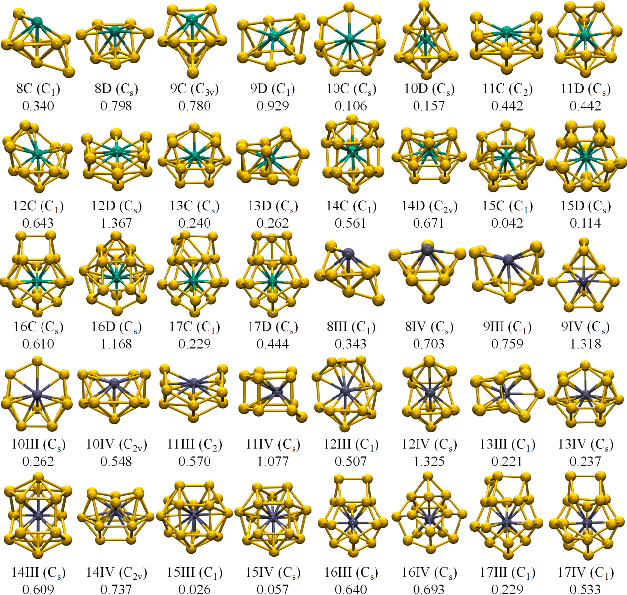
FIG. S1. The optimized structures of low-lying isomers of TMSi₈₋₁₇－ (TM = Mo, W) clusters at BP86/def2-TZVP level. For each structure, the symmetry (given inside the bracket) and the total energy difference (eV) respect to the lowest-lying isomer (nA) are provided. Yellow, green, and gray balls represent silicon, molybdenum, and tungsten atoms, respectively.

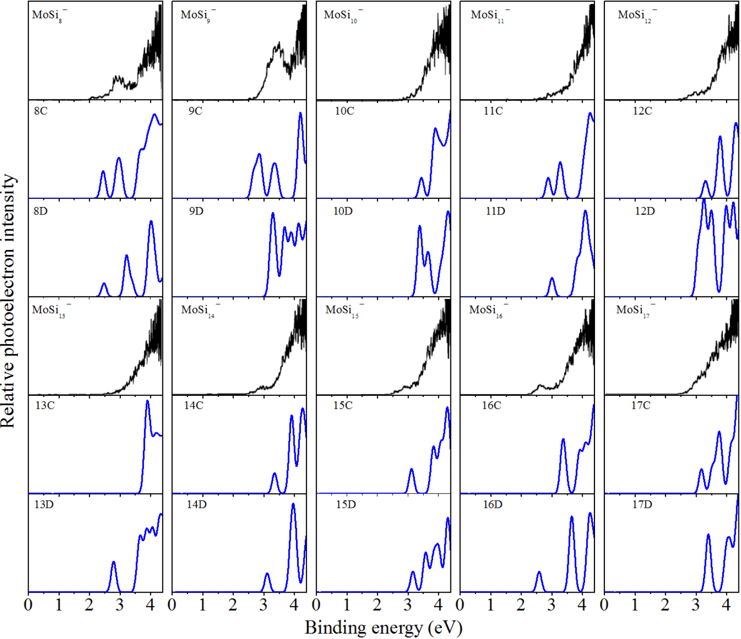
FIG. S2 Experimental and simulated photoelectron spectra of low-lying isomers of MoSi_{n}－ (n = 8-17). The black and blue lines are the experimentally measured and calculated spectra, respectively.¹

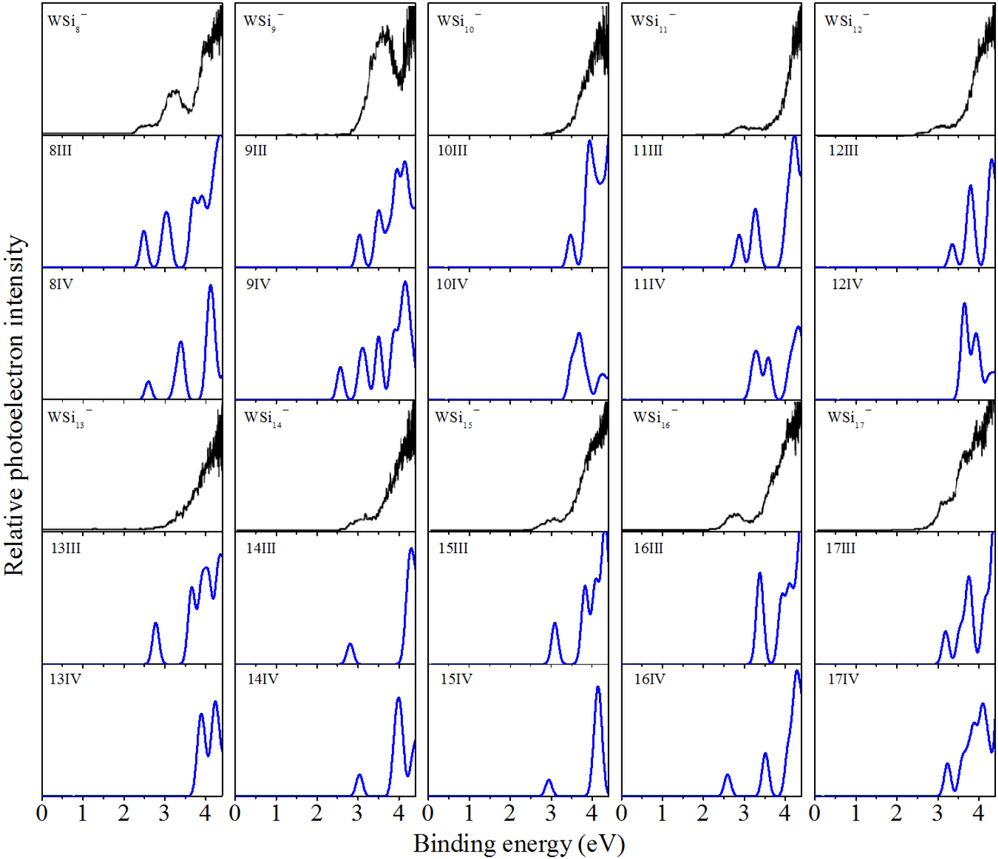
FIG. S2 Experimental and simulated photoelectron spectra of low-lying isomers of WSi_{n}－ (n = 8-17). The black and blue lines are the experimentally measured and simulated spectra, respectively.¹

Table S1. Average bond lengths (BL, in Å), bond orders (BO), vertical detachment energy (VDE), HOMO−LUMO gap (E_{HL}, in eV), average binding energies (E_{b}, in eV), and the second energy differences (Δ²E, in eV) of the ground state structures of TMSi_{n}－ (TM= Mo, W; n = 8-17) clusters.
Size | BL |  | BO |  | VDE | E_{HL} | Eb | Δ²E
Size | Si-Si | Si-TM | Si-Si | Si-Mo
MoSi₈－ | 2.49 | 2.58 | 0.63 | 1.01 | 2.97 | 0.37 | 3.76
MoSi₉－ | 2.52 | 2.60 | 0.56 | 0.94 | 3.18 | 0.34 | 3.80 | 0.14
MoSi₁₀－ | 2.42 | 2.64 | 0.49 | 0.86 | 3.03 | 0.35 | 3.81 | -0.78
MoSi₁₁－ | 2.51 | 2.65 | 0.47 | 0.79 | 3.02 | 0.35 | 3.89 | 0.26
MoSi₁₂－ | 2.39 | 2.67 | 0.44 | 0.69 | 2.84 | 0.69 | 3.94 | 0.62
MoSi₁₃－ | 2.49 | 2.70 | 0.41 | 0.67 | 3.45 | 0.30 | 3.93 | -0.99
MoSi₁₄－ | 2.44 | 2.75 | 0.38 | 0.61 | 2.97 | 0.20 | 4.00 | 1.05
MoSi₁₅－ | 2.53 | 2.74 | 0.37 | 0.58 | 2.83 | 0.28 | 3.99 | -0.17
MoSi₁₆－ | 2.44 | 2.83 | 0.39 | 0.52 | 2.80 | 0.32 | 3.99 | 0.39
MoSi₁₇－ | 2.44 | 2.76 | 0.39 | 0.50 | 3.21 | 0.26 | 3.97
WSi₈－ | 2.52 | 2.64 | 0.63 | 1.00 | 2.55 | 0.46 | 3.87
WSi₉－ | 2.53 | 2.61 | 0.55 | 0.98 | 3.22 | 0.34 | 3.90 | 0.02
WSi₁₀－ | 2.53 | 2.64 | 0.50 | 0.89 | 3.10 | 0.37 | 3.93 | -0.37
WSi₁₁－ | 2.51 | 2.66 | 0.46 | 0.82 | 3.02 | 0.35 | 3.99 | 0.21
WSi₁₂－ | 2.40 | 2.68 | 0.43 | 0.73 | 2.61 | 0.50 | 4.02 | 0.36
WSi₁₃－ | 2.50 | 2.71 | 0.41 | 0.70 | 3.45 | 0.30 | 4.02 | -0.88
WSi₁₄－ | 2.45 | 2.76 | 0.38 | 0.63 | 2.98 | 0.18 | 4.07 | 1.17
WSi₁₅－ | 2.42 | 2.82 | 0.36 | 0.59 | 3.18 | 0.28 | 4.05 | -0.39
WSi₁₆－ | 2.45 | 2.83 | 0.39 | 0.55 | 2.81 | 0.32 | 4.06 | 0.52
WSi₁₇－ | 2.45 | 2.76 | 0.38 | 0.52 | 3.23 | 0.26 | 4.03

Table S2. Average binding energies (E_{b}, in eV)² of the ground state structures of CrSi_{n}－ (n = 14-18) clusters with the zero-point-energy corrections (E_{b-ZPE}) for comparison.
Cluster | E_{b} | E_{b-ZPE}
CrSi₁₄－ | 3.84 | 3.79
CrSi₁₅－ | 3.85 | 3.81
CrSi₁₆－ | 3.85 | 3.80
CrSi₁₇－ | 3.83 | 3.78
CrSi₁₈－ | 3.83 | 3.79

References
¹ M. Ohara, K. Koyasu, A. Nakajima, K. Kaya, Chem. Phys. Lett. 371, 490-497 (2003).
² K. Wang, H.-Y. Zhao, L. Miao, Z.-Z. Jia, G.-J. Yin, X.-D. Zhu, R. Moro, B. von Issendorff and L. Ma, J. Phys. Chem. A 126 (8), 1329-1335 (2022).

