Supporting information
In Silico Analysis of Novel VHL Germline Mutations in Iranian RCH Patients

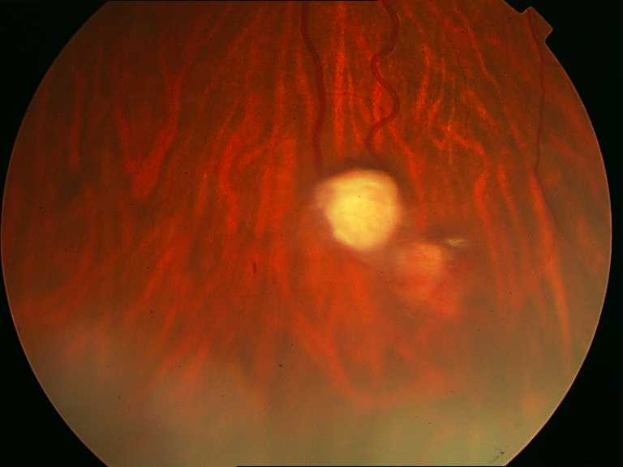
S1 Fig. The lesions treated with direct laser photocoagulation

S1Table. The participant residues in different structures of pVHL during 100ns of MDs (all values are in percent (%)).
Variant | Sructure | Coil | β-sheet | Β-bridge | Bend | Turn | Α-helix | 3-helix
Native | 0.54 | 0.31 | 0.24 | 0.03 | 0.12 | 0.13 | 0.15 | 0.04
K171Q | 0.54 | 0.29 | 0.24 | 0.02 | 0.12 | 0.13 | 0.15 | 0.04
P172S | 0.55 | 0.32 | 0.23 | 0.03 | 0.10 | 0.14 | 0.15 | 0.03
Missense | 0.54 | 0.32 | 0.32 | 0.04 | 0.12 | 0.14 | 0.04 | 0.02

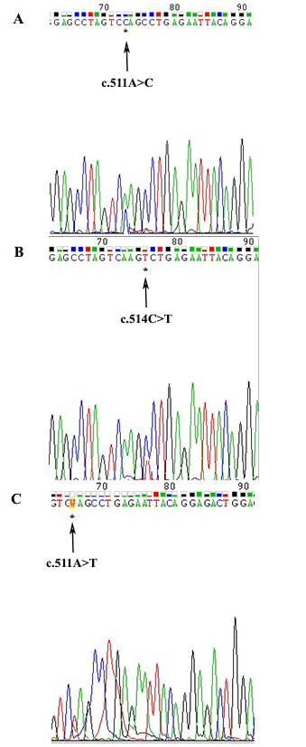
S2 Fig. Electropherogram showing the heterozygous mutation A: c.511A>C, B: c.514C>T, and C: c.511A>T in exon 3.
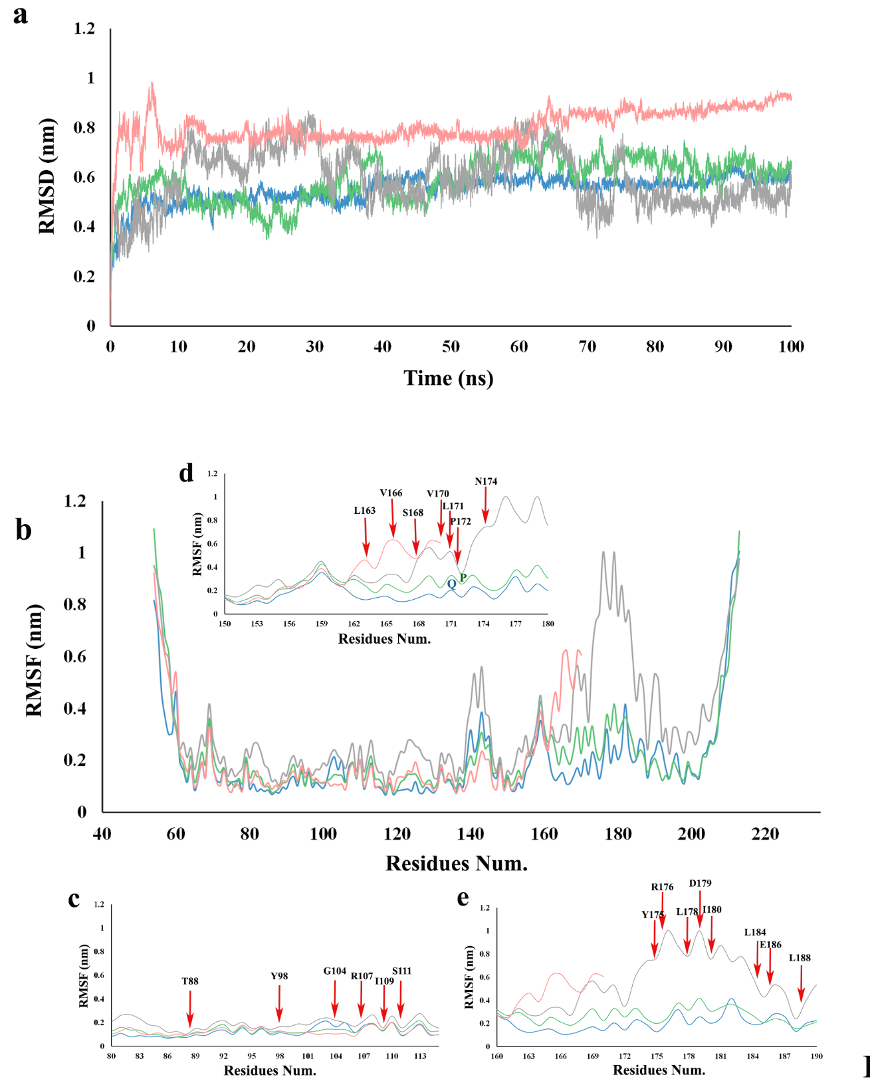
S3 Fig. a. Back-bone root mean square deviations (RMSD) all the studied structures (Native (gray), K171Q (blue), P172S (green), Missense (Pink), b. Per residue root mean square fluctuations (RMSF) of all the studied structures (Native (gray), K171Q (blue), P172S (green), Missense (Pink), c. close view of RMSF plots for residues 80-113, d. close view of RMSF plots for residues 150-180, and e. close view of RMSF plots for residues 160-190.
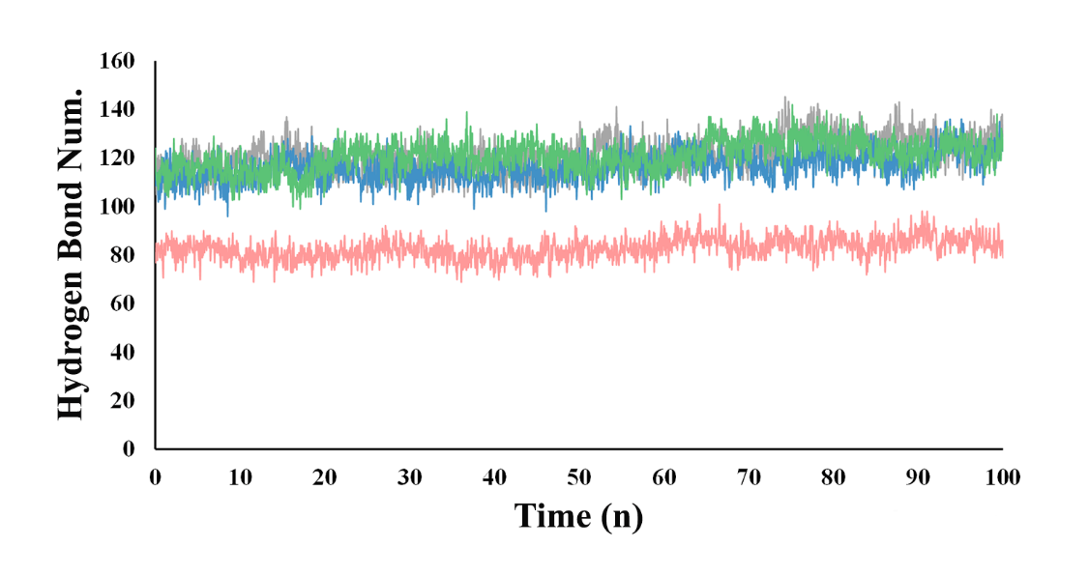
S4 Fig. Total number of hydrogen bonds formed in the native and mutant pVHL structures (Native (gray), K171Q (blue), P172S (green), Missense (Pink),

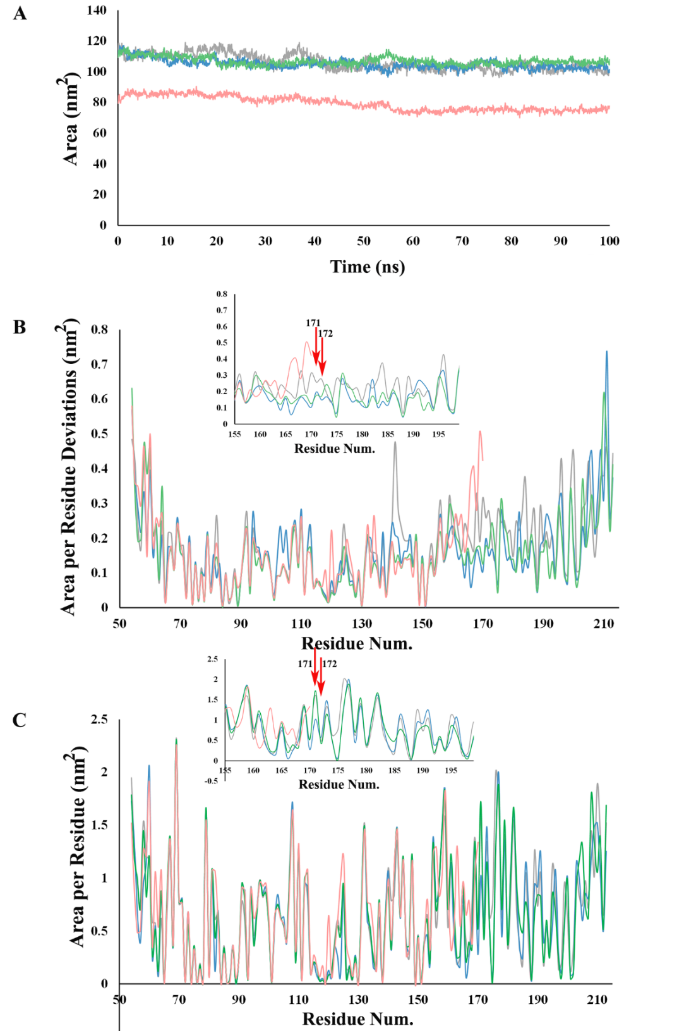
S5 Fig. Solvent accessible surface area (SASA) analysis of native and mutant structures pVHL (Native (gray), K171Q (blue), P172S (green), Missense (Pink), a. SASA of the overall structure, b. SASA deviation per residue, and c. SASA per residue

