Supplementary figures

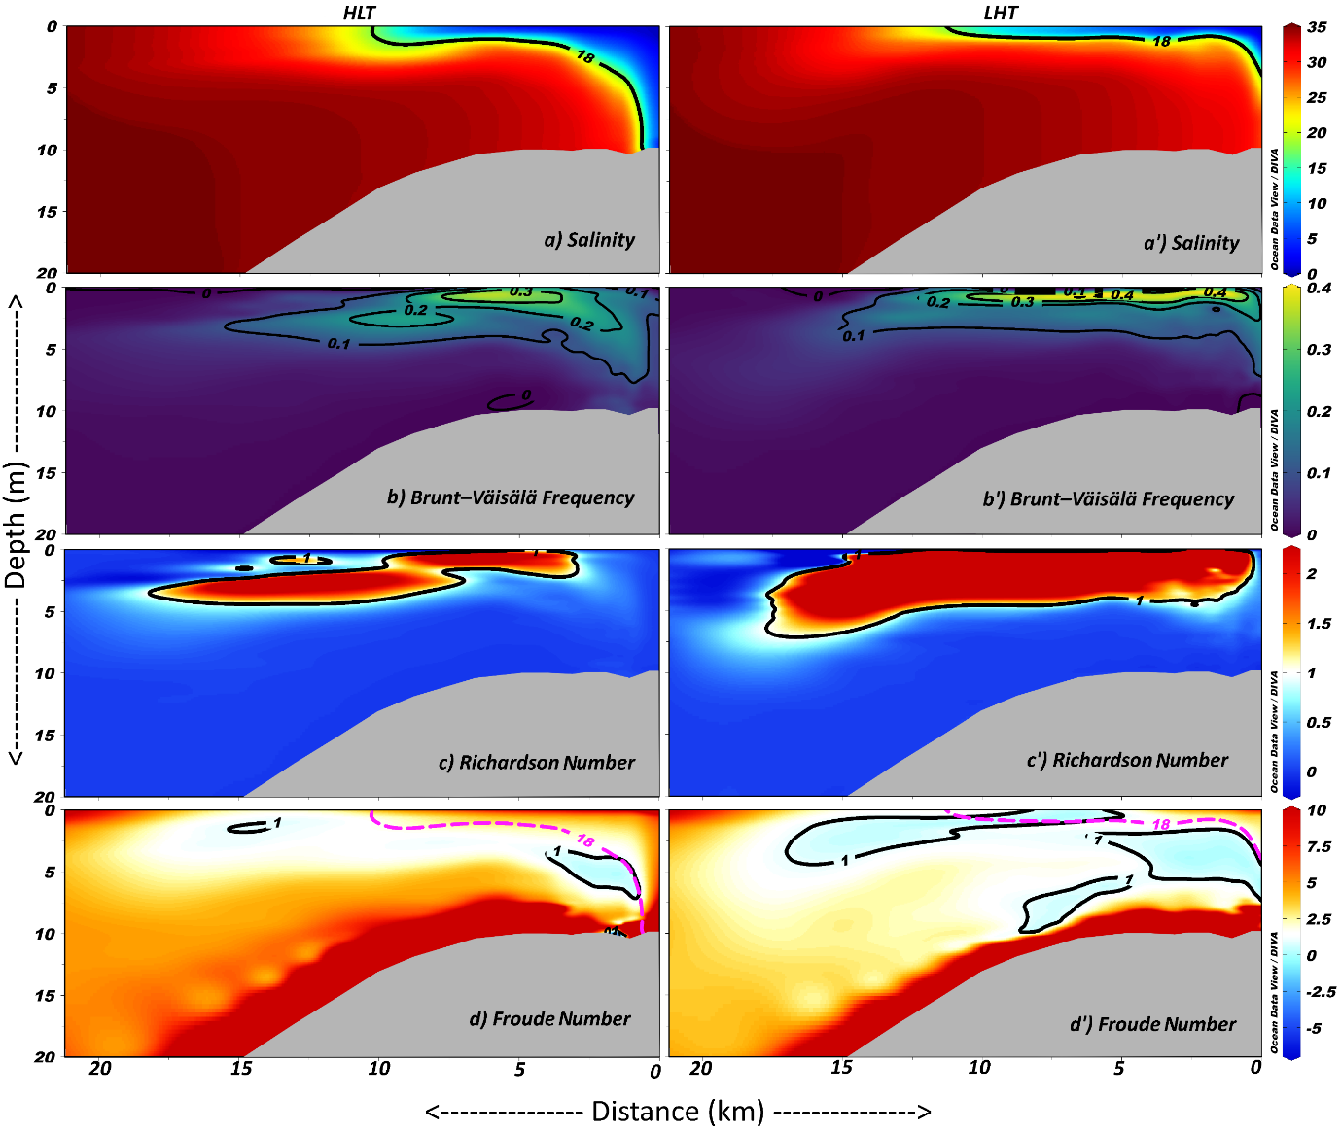
Supplementary Figure 1. The horizontal and vertical extension of front, and variations in BVF,$R_{d}$, and F in the SM during HLT and LHT.
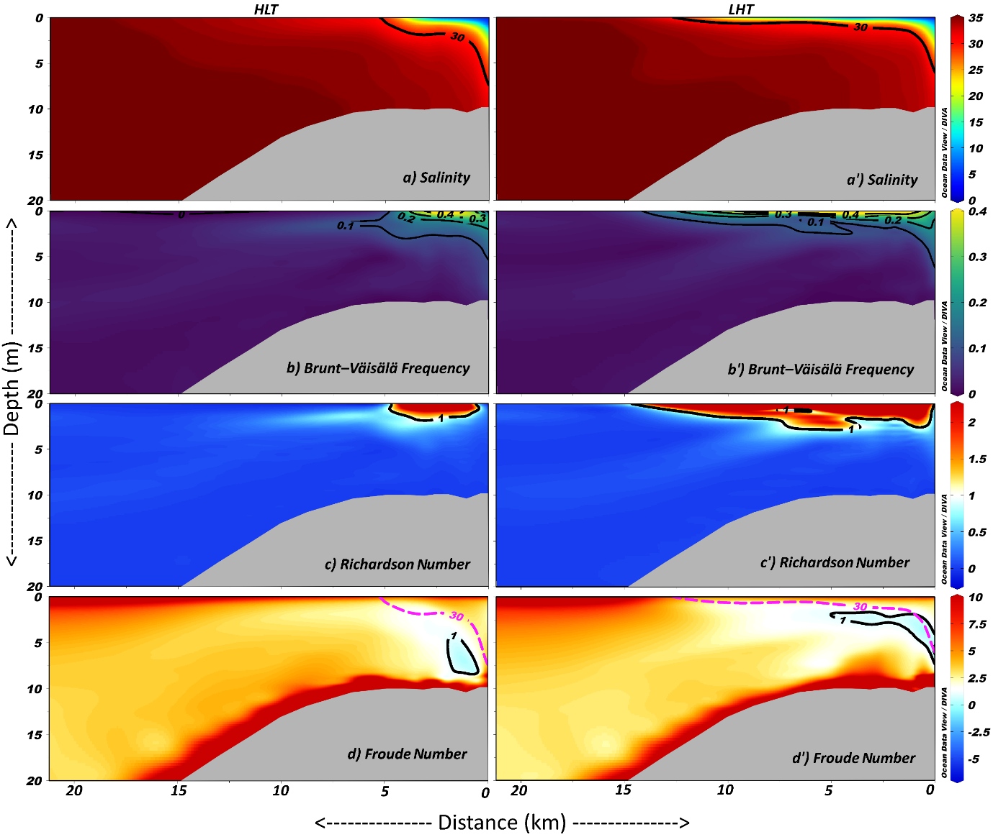
Supplementary Figure 2. The horizontal and vertical extension of front, and variations in BVF,$R_{d}$, and F in the FIM during HLT and LHT.
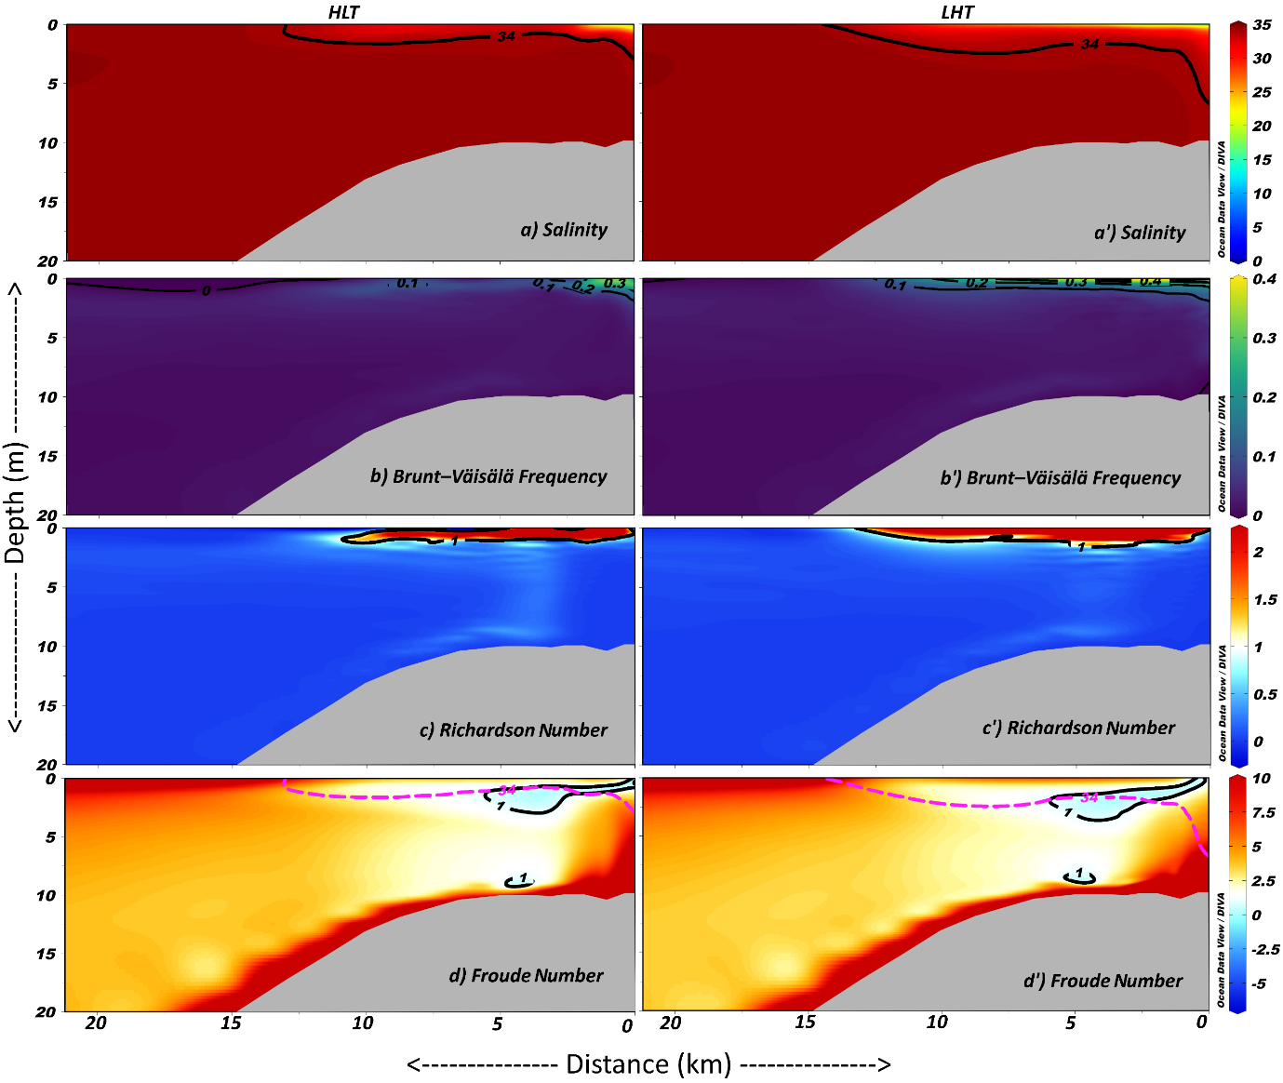
Supplementary Figure 3. The horizontal and vertical extension of front, and variations in BVF,$R_{d}$, and F in the WM during HLT and LHT.
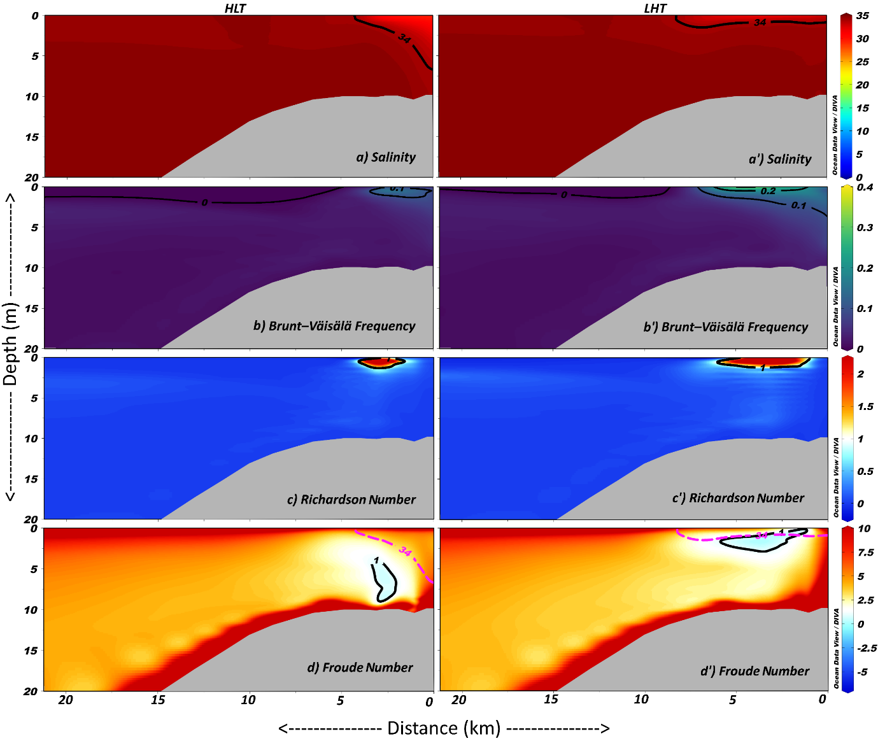
Supplementary Figure 4. The horizontal and vertical extension of front, and variations in BVF,$R_{d}$, and F in the SIM during HLT and LHT.

