Table S1. Detailed information of all identified Prunus sibirica WRKY proteins
Protein name | Sequence ID | Number of amino acids | Molecular weight  /Da | pI | Instability index | Aliphatic index | Grand average of hydropathicity | Chromosomal Location | Subcellular location prediction | Group
PsWRKY1 | PaF106G0100000825.01 | 284 | 30910.93 | 9.91 | 48.58 | 65.6 | -0.58 | Chr1 | Nuclear | II-d
PsWRKY2 | PaF106G0100001343.01 | 388 | 42657.78 | 5.95 | 63.4 | 47.58 | -0.886 | Chr1 | Nuclear | II-c
PsWRKY3 | PaF106G0100002721.01 | 185 | 20880.43 | 9.56 | 44.73 | 54.81 | -0.821 | Chr1 | Nuclear | II-c
PsWRKY4 | PaF106G0100003357.01 | 515 | 55892.53 | 8.13 | 62.24 | 50.82 | -0.924 | Chr1 | Nuclear | I
PsWRKY5 | PaF106G0100003388.01 | 424 | 46980.96 | 10.33 | 55.69 | 60.8 | -0.764 | Chr1 | Nuclear | II-c
PsWRKY6 | PaF106G0100004627.01 | 325 | 36428.04 | 7.63 | 55.27 | 63.94 | -0.733 | Chr1 | Nuclear | II-a
PsWRKY7 | PaF106G0100004628.01 | 285 | 31577.44 | 8.38 | 51.29 | 75.65 | -0.599 | Chr1 | Nuclear | II-a
PsWRKY8 | PaF106G0100004783.01 | 163 | 18833.51 | 5.12 | 46.95 | 48.34 | -1.164 | Chr1 | Nuclear | II-c
PsWRKY9 | PaF106G0100005037.01 | 364 | 39656.95 | 9.32 | 54.08 | 59.23 | -0.573 | Chr1 | Nuclear | II-d
PsWRKY10 | PaF106G0100005329.01 | 345 | 37660.39 | 9.42 | 56.09 | 58.26 | -0.649 | Chr1 | Nuclear | II-d
PsWRKY11 | PaF106G0100006525.01 | 562 | 62075 | 5.21 | 52.62 | 58.54 | -0.963 | Chr1 | Nuclear | II-b
PsWRKY12 | PaF106G0200008520.01 | 244 | 27730.33 | 7.29 | 44.4 | 44.67 | -1.026 | Chr2 | Nuclear | II-c
PsWRKY13 | PaF106G0200009086.01 | 363 | 40001.12 | 7.16 | 54.03 | 48.9 | -0.837 | Chr2 | Nuclear | II-e
PsWRKY14 | PaF106G0200009090.01 | 221 | 24717.93 | 9.22 | 45.21 | 68.42 | -0.725 | Chr2 | Peroxisome | II-c
PsWRKY15 | PaF106G0200009172.01 | 358 | 39659.14 | 5.03 | 43.98 | 61.62 | -0.582 | Chr2 | Nuclear | III
PsWRKY16 | PaF106G0200009748.01 | 209 | 23893.9 | 8.9 | 46.54 | 61.1 | -0.904 | Chr2 | Peroxisome | II-c
PsWRKY17 | PaF106G0200010134.01 | 323 | 36428.42 | 5.7 | 47.03 | 56.13 | -0.853 | Chr2 | Nuclear | III
PsWRKY18 | PaF106G0200010574.01 | 296 | 32774.38 | 9.68 | 54.08 | 67.26 | -0.603 | Chr2 | Nuclear | II-e
PsWRKY19 | PaF106G0200010641.01 | 290 | 31551.62 | 5.02 | 57.96 | 51.52 | -0.74 | Chr2 | Nuclear | III
PsWRKY20 | PaF106G0300011395.01 | 505 | 55472.74 | 6.62 | 51 | 64.93 | -0.687 | Chr3 | Nuclear | II-b
PsWRKY21 | PaF106G0300011494.01 | 533 | 58223.38 | 8.18 | 62.79 | 56.75 | -0.892 | Chr3 | Nuclear | I
PsWRKY22 | PaF106G0300012051.01 | 652 | 71121.59 | 6.31 | 49.94 | 59.92 | -0.798 | Chr3 | Nuclear | II-b
PsWRKY23 | PaF106G0300012177.01 | 486 | 52923.2 | 5.9 | 41.99 | 63.29 | -0.903 | Chr3 | Nuclear | I
PsWRKY24 | PaF106G0300012509.01 | 363 | 41058.09 | 6.89 | 53.75 | 49.45 | -1.066 | Chr3 | Nuclear | II-c
PsWRKY25 | PaF106G0300013322.01 | 258 | 28060.17 | 5.13 | 54.12 | 55.19 | -0.696 | Chr3 | Nuclear | II-e
PsWRKY26 | PaF106G0300013492.01 | 272 | 30035.4 | 8.12 | 48.26 | 65.96 | -0.795 | Chr3 | Nuclear | II-a
PsWRKY27 | PaF106G0300014526.01 | 165 | 18526.84 | 9.3 | 64.88 | 53.21 | -0.681 | Chr3 | Nuclear | II-c
PsWRKY28 | PaF106G0300014596.01 | 611 | 66391.05 | 6.23 | 54.24 | 64.14 | -0.588 | Chr3 | Nuclear | II-b
PsWRKY29 | PaF106G0400015495.01 | 587 | 64119.61 | 6 | 50.75 | 54.92 | -0.831 | Chr4 | Nuclear | I
PsWRKY30 | PaF106G0400015665.01 | 536 | 58725.97 | 6.02 | 48.68 | 66.44 | -0.544 | Chr4 | Nuclear | II-b
PsWRKY31 | PaF106G0400017105.01 | 527 | 57094.68 | 6.06 | 56.09 | 54.52 | -0.761 | Chr4 | Nuclear | II-e
PsWRKY32 | PaF106G0400017434.01 | 340 | 37588.33 | 6.55 | 55.43 | 48.53 | -0.941 | Chr4 | Nuclear | II-c
PsWRKY33 | PaF106G0400017534.01 | 342 | 38516.69 | 9.16 | 53.39 | 50.23 | -0.691 | Chr4 | Nuclear | II-e
PsWRKY34 | PaF106G0400018245.01 | 617 | 67027.07 | 7.34 | 46.93 | 60.16 | -0.761 | Chr4 | Nuclear | II-b
PsWRKY35 | PaF106G0500019357.01 | 330 | 36942.17 | 9.68 | 54.35 | 72.7 | -0.623 | Chr5 | Nuclear | II-d
PsWRKY36 | PaF106G0500019756.01 | 314 | 35487.83 | 5.18 | 60.23 | 70.83 | -0.593 | Chr5 | Nuclear | II-e
PsWRKY37 | PaF106G0500019874.01 | 248 | 28031.79 | 5.12 | 64.54 | 47.22 | -0.866 | Chr5 | Nuclear | III
PsWRKY38 | PaF106G0500020691.01 | 683 | 73580.87 | 6.95 | 49.02 | 55.94 | -0.811 | Chr5 | Nuclear | II-b
PsWRKY39 | PaF106G0500020010.01 | 205 | 23126.62 | 4.78 | 31.07 | 72.73 | -0.768 | Chr5 | Chloroplast | I
PsWRKY40 | PaF106G0600021797.01 | 697 | 75002.92 | 5.61 | 52.3 | 53.49 | -0.776 | Chr6 | Nuclear | I
PsWRKY41 | PaF106G0600021917.01 | 590 | 64692.37 | 6.58 | 52.5 | 45.15 | -0.945 | Chr6 | Nuclear | I
PsWRKY42 | PaF106G0600023566.01 | 196 | 21998.11 | 6.21 | 56.69 | 42.19 | -0.989 | Chr6 | Nuclear | II-c
PsWRKY43 | PaF106G0600024291.01 | 326 | 35586.26 | 9.6 | 41.21 | 67.33 | -0.54 | Chr6 | Nuclear | II-d
PsWRKY44 | PaF106G0600024432.01 | 479 | 52136.65 | 8.91 | 49.61 | 55.55 | -0.92 | Chr6 | Nuclear | I
PsWRKY45 | PaF106G0600024597.01 | 252 | 28590.67 | 9.27 | 47.6 | 62.34 | -0.775 | Chr6 | Peroxisome | II-c
PsWRKY46 | PaF106G0600024936.01 | 536 | 59540.37 | 7.17 | 62.54 | 48.21 | -0.94 | Chr6 | Nuclear | I
PsWRKY47 | PaF106G0600025042.01 | 354 | 39732.74 | 5.65 | 53.66 | 57.37 | -0.781 | Chr6 | Nuclear | III
PsWRKY48 | PaF106G0600025043.01 | 337 | 38056.18 | 5.5 | 45.51 | 61.6 | -0.698 | Chr6 | Nuclear | III
PsWRKY49 | PaF106G0600025044.01 | 336 | 37434.25 | 5.81 | 49.6 | 61.22 | -0.708 | Chr6 | Nuclear | III
PsWRKY50 | PaF106G0600025642.01 | 355 | 40054.93 | 9.68 | 50.11 | 69.18 | -0.763 | Chr6 | Nuclear | II-d
PsWRKY51 | PaF106G0600025823.01 | 512 | 56847.87 | 6.53 | 52.82 | 59.22 | -0.818 | Chr6 | Nuclear | I
PsWRKY52 | PaF106G0700026001.01 | 533 | 58804.27 | 5.54 | 57.32 | 66.02 | -0.834 | Chr7 | Nuclear | I
PsWRKY53 | PaF106G0800029338.01 | 262 | 29836.13 | 5.29 | 67.04 | 58.36 | -1.011 | Chr8 | Nuclear | II-d
PsWRKY54 | PaF106G0800029773.01 | 355 | 40061.3 | 9.61 | 58.09 | 62.59 | -0.85 | Chr8 | Nuclear | II-d
PsWRKY55 | PaF106G0800031110.01 | 291 | 32971.63 | 8.91 | 44.92 | 79.07 | -0.387 | Chr8 | Nuclear | II-c

Table S2. Primer pairs used for qRT-PCR analysis on the target sequences in P. sibirica
PsWRKY | Primer pairs
PsWRKY | Forward primer (5'-3') | Reverse primer (5'-3')
PsWRKY1 | TCGTCGGGTTCTCAAGGAT | TCGGTGATTTCTCGGCAGT
PsWRKY4 | GGCAGAAAGTCGTCAAAG | GTTGTTGGCTGCGTAGTG
PsWRKY6 | TATTCCTTTCCACCCTGCTAG | TGCTGCCTCTTGTTTCACC
PsWRKY9 | TCTTCCTCATCGAACCCTG | GGAGGCGGAGATGGAGT
PsWRKY10 | CCAGCAGCAAACTAACCAG | TGTGAATACGAGGGATGAGAAG
PsWRKY12 | CTTAGGGAGCCAAGATTC | TTCTTCACCCGACAGTTAC
PsWRKY13 | AAAGGGCAGTCCTATGGTC | ACAAAGAAATCGTCGCTCAC
PsWRKY14 | TAATGTTGGTGCCTCTGCT | CTGGCTTTCTCATCTTACCC
PsWRKY18 | AACAAGTGGAGCGGAGTAC | CGTTGGACGAGGGTGATT
PsWRKY21 | ATGGCGGTGAGAACAAGTC | AAAGAAGCCAGGCGAGTTAAG
PsWRKY27 | TGGCTACAGATGGAGAAAG | GAGTTGGGCGAGGTATGAG
PsWRKY36 | TAGCAGGAAGAATCAGAGC | TGCCCATATTTACGCCAC
PsWRKY38 | AATCATTGGCAGCAACAGT | GCGTTTGGAGGTATGGAGAAG
PsWRKY42 | ATGGGTCATAGGGTTGCTT | TTGGATTTGGGCTGTTCTT
PsWRKY44 | ATCAGTCGAGGCTGGTGTT | TATTGGCTGTGGACGGTAT
PsWRKY51 | TGCCTCAGCCTAATCGT | CCAGACCTTCAGCCCTC
PsWRKY52 | GACATGCCTGTTCCAAAG | TCACCAGTCAATTCTCCC
PsWRKY54 | GGAGACGATGGGAGTGT | TTGGCTTCTGTCCATACTT
PsWRKY55 | ACCAAGCCACGAGAACACT | CCAACAGCATACCGAATAG
PsWRKY15 | CTGGAACAGGGCTAGATGG | TTTGAACTTGCTTGGTGGC
PsWRKY17 | TTTTGGCGAGGTTTATC | CCTGCACCTTCCTACTCT
PsWRKY49 | TCAAATAGGGAAAGGGTG | CCTCTGCCGACTCAACAT
PsWRKY5 | GCTTGTTGCGGACTGCTTAC | GTATCTCGGGCGGTGGTTT
18SrRNA | AAACGGCTACCACATCCA | CACCAGACTTGCCCTCCA

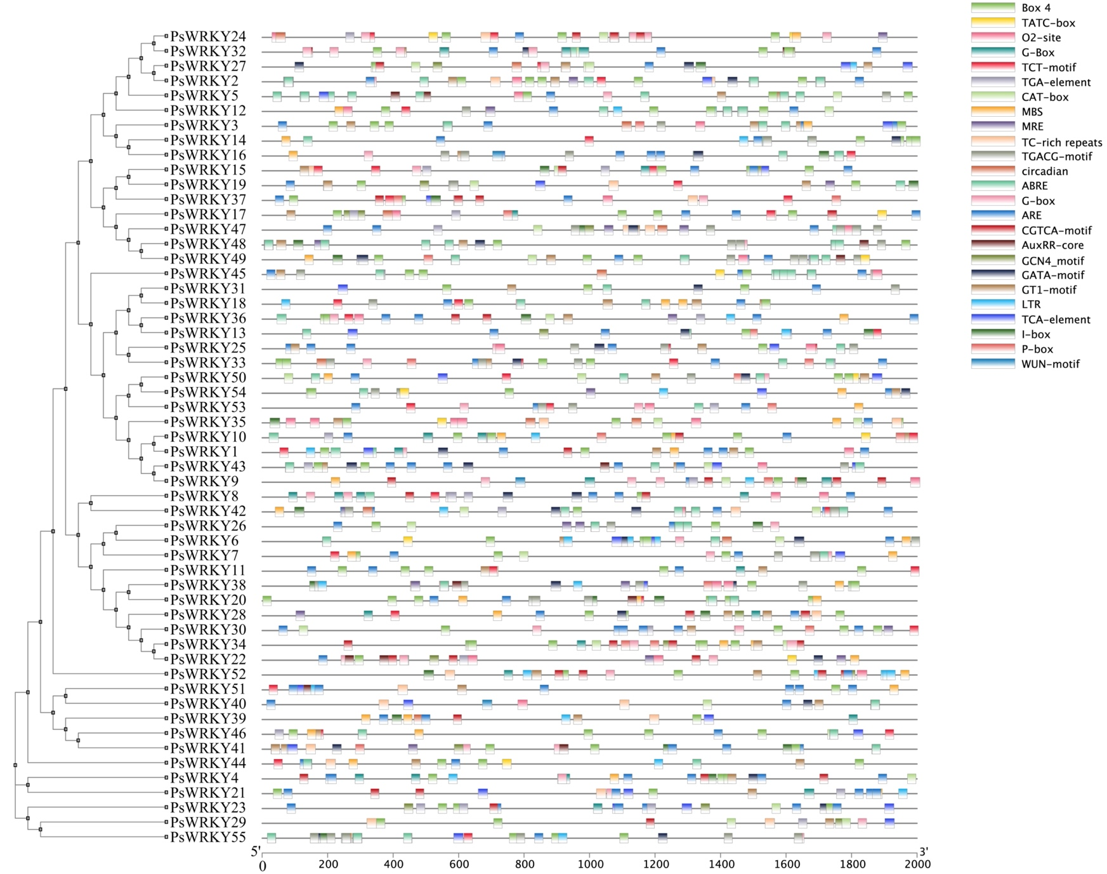
Figure S1. Cis-acting elements of the PsWRKYs

