Supplementary Figures

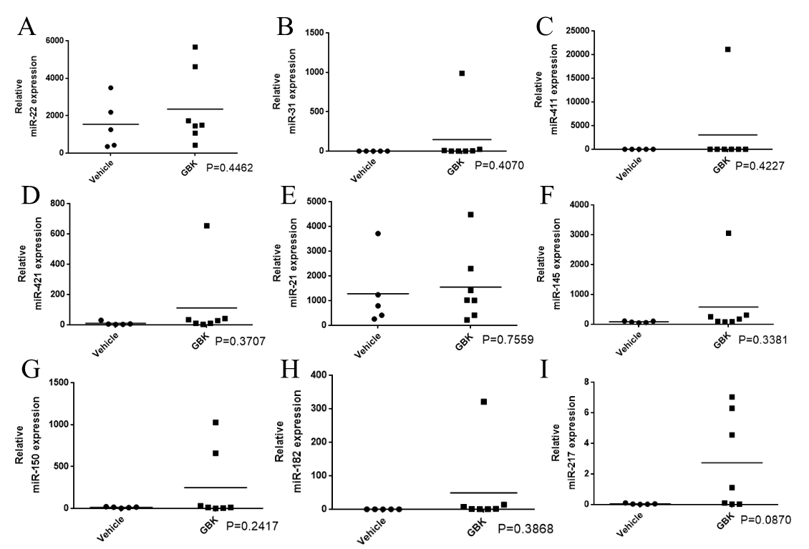
Supplementary Figure 1. Validation of miRNAs expression levels in beast cancer xenograft mouse serum after GBK treatment by RT-qPCR analysis
The mice in the experimental group were administered with GBK, and other feeding conditions were consistent with the control group. Serum samples were collected and miRNA expression was detected by RT-qPCR. Expression of (A) miR-22, (B) miR-31, (C) miR-411, (D) miR-421, (E) miR-21, (F) miR-145, (G) miR-150, (H) miR-182, (I) miR-217 was detected by RT-qPCR. Student's t test, * p<0.05, ** p<0.01, *** p<0.001.

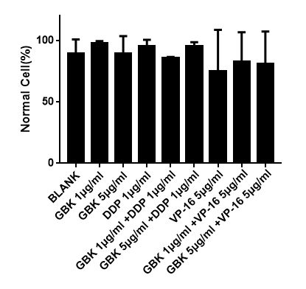
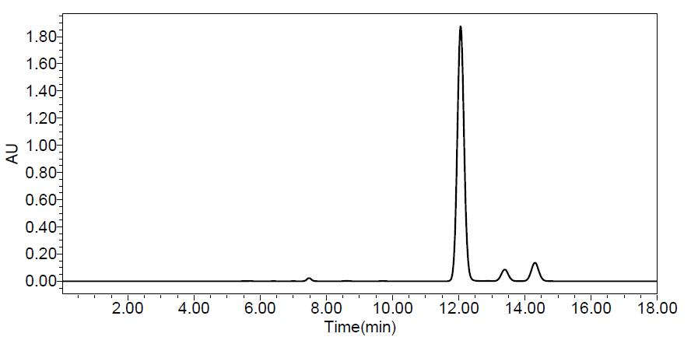
Supplementary Figure 2. High-pressure liquid chromatography to verify GBK purity

Supplementary tables

Supplementary table 1. miRNAs Primer list Ⅰ
Primer Name | Primer sequence (5'-3')
mmu-miR-21a | CCGTAGCTTATCAGACTGATGTTG
mmu-miR-22 | GCGAAGCTGCCAGTTGAAGAACT
mmu-miR-31 | GAGGCAAGATGCTGGCATAGCTGAA
mmu-miR-145a | CGTCCAGTTTTCCCAGGAATCCC
mmu-miR-150 | GTCTCCCAACCCTTGTACCAGTG
mmu-miR-182 | GCTTTGGCAATGGTAGAACTCACAC
mmu-miR-217 | CGTACTGCATCAGGAACTGACTGGA
mmu-miR-411 | CGTAGTAGACCGTATAGCGTA
mmu-miR-421 | GCATCAACAGACATTAATTGGGCG
has-mir-21 | CCGTAGCTTATCAGACTGATGTTG
has-mir-22 | GCGAAGCTGCCAGTTGAAGAACT
has-mir-31 | GAGGCAAGATGCTGGCATAGCTGAA
has-mir-145 | CGTCCAGTTTTCCCAGGAATCCC
has-mir-150 | GTCTCCCAACCCTTGTACCAGTG
has-mir-182 | GCTTTGGCAATGGTAGAACTCACAC
has-mir-217 | CGTACTGCATCAGGAACTGACTGGA
has-mir-411 | CGTAGTAGACCGTATAGCGTA
has-mir-421 | GCATCAACAGACATTAATTGGGCG
Note: the internal reference gene miR- 39 (miRNeasy® Serum/ Plasma Spike-In Control) and the 3' microRNA Primer universal downstream primer (Mir-XTM miRNA First-Strand Synthesis Kit) are provided by the corresponding kit.

Supplementary table 2. Primer listⅡ
Gene name | Forward primer sequence | Reverse primer sequence
RhoA | GGACTTAAGCGTCTGGCTC | AGTGCCACCCATGAGAACTG
WAVE3 | CCGCGGACCGTTTTAGTT | GACGCTCCATGGTACACACT
Gα13 | AGGGAACTTTTTGCCCGAGA | ACCCTCATACCTGACCGTGA
Ubc13 | AGGCCTTGTTAAGTGCTCCC | GCAAAATCCACCTCTTGCCAT
ITGA5 | GGCTTCAACTTAGACGCGGA | GGCCGGTAAAACTCCACTGA
RDX | ACAGTTGGTTTGCGTGAGGT | TGTTCCAATACACGCTGGGG
SATB2 | ATCGGAAACCGAGGACAACC | GTGTCTTCTTCTGGTGCGGA
PKC | CCATGTCGCCATTTCTTCGG | GCCCGTTCTCTGATTCGACA
RHOBTB1 | CGGCTTCAGGGTAAGTCCAG | CCTGCCATATGCAAAGCGTC
β-actin | TTAGTTGCGTTACACCCTTTC | ACCTTCACCGTTCCAGTTT

Supplementary table 3. Primer list III
Gene name | Forward primer sequence | Reverse primer sequence
GAPDH | TGAAGGTCGGAGTCAACGATTTGGT | CATGTGGGCCATGAGGTCCACCAC
LOC554202 Ex1 | CAGAGCTGGGAGGCGGTGTTC | -
LOC554202 Ex4 | - | CTCTACACTGGCCTTGAGGAGGTA

