Running title: SKP1 promotes colorectal cancer stemness
SKP1 promotes YAP-mediated colorectal cancer stemness via suppressing RASSF1
Cong Tian^{1,2*}, Tingyuan Lang^{3*}, Jiangfeng Qiu^{4*}, Kun Han^{1,2}, Lei Zhou^{5,6,7}, Daliu Min^{1,2}, Zhiqi Zhang^{8,9#}, Dachuan Qi^{9#}
¹Department of Medical Oncology, Shanghai University of Medicine & Health Sciences Affiliated Sixth People’s Hospital East Campus, No. 222 HuanhuXisan Road,Pudong New Area,Shanghai, 201306, P.R. China
²Department of Medical Oncology, Shanghai Jiao Tong University Affiliated Sixth People's Hospital East Campus, No. 222 Huan Hu Xi San Road, Pudong New Area, Shanghai 201306, P.R. China.
³Department of Gynecologic Oncology, Chongqing University Cancer Hospital & Chongqing Cancer Institute & Chongqing Cancer Hospital, Chongqing 400030, Chongqing, P.R. China.
⁴Department of Gastrointestinal Surgery, Renji Hospital Shanghai Jiao Tong University School of Medicine, Shanghai 200127, P.R. China.
⁵Singapore Eye Research Institute, The academia, 20 College Road, Discovery Tower Level 6, Singapore, 169856, Singapore.
⁶Department of Ophthalmology, Yong Loo Lin School of Medicine, National University of Singapore, 1E Kent Ridge Road, NUHS Tower Block Level 7, Singapore, 119228, Singapore.
⁷Ophthalmology and Visual Sciences Academic Clinical Research Program, Duke-NUS Medical School, 8 college Road, Singapore, 169867, Singapore.
⁸Department of General Surgery, Shanghai University of Medicine & Health Sciences Affiliated Sixth People’s Hospital East Campus, No. 222 HuanhuXisan Road,Pudong New Area,Shanghai, 201306, P.R. China
⁹Department of General Surgery, Shanghai Jiao Tong University Affiliated Sixth People’s Hospital, No. 600 Yishan Road, Xuhui District, Shanghai, 200233, P.R. China.
*These authors contributed equally to this work.
Correspondence:
Zhiqi Zhang
Department of Medical Oncology, Shanghai University of Medicine & Health Sciences Affiliated Sixth People’s Hospital East Campus, No. 222 HuanhuXisan Road,Pudong New Area,Shanghai, 201306, P.R. China.
Department of Medical Oncology, Shanghai Jiao Tong University Affiliated Sixth People's Hospital East Campus, No. 222 Huan Hu Xi San Road, Pudong New Area, Shanghai 201306, P.R. China.
Tel +86 189 6435 5142 Fax +86 21 3829 7000 Email: zzq72@163.com
Dachuan Qi
Department of General Surgery, Shanghai Jiao Tong University Affiliated Sixth People’s Hospital, No. 600 Yishan Road, Xuhui District, Shanghai, 200233, P.R. China. Tel +86 189 3017 2935 Fax +86 21 3829 7000 Email: alexqi7@163.com

Method details:

Primers:

For cloning:

SKP1:
F: 5’- TGATGACCCAGTTCTCTACCA-3’
R: 5’- TCTCCTTCATCATCCATTCCC-3’

RASSF1:
F: 5’- CACCTGCATGTGCTGTCACG-3’
R: 5’- TAAAAGGAAGTGCGGCGCC-3’

For qRT-PCR:

SKP1:
F: 5’- GACCATGTTGGAAGATTTGGGA-3’
R: 5’- TGCACCACTGAATGACCTTTT-3’

SOX2:
F: 5’- TACAGCATGTCCTACTCGCAG-3’;
R: 5’- GAGGAAGAGGTAACCACAGGG-3’

ALDH1:
F: 5’-CCGTGGCGTACTATGGATGC-3’;
R: 5’-GCAGCAGACGATCTCTTTCGAT-3’

SNAI2:
F: 5’- CGAACTGGACACACATACAGTG-3’;
R: 5’- CTGAGGATCTCTGGTTGTGGT-3’

CDH1:
F: 5’- ATTTTTCCCTCGACACCCGAT-3’;
R: 5’- TCCCAGGCGTAGACCAAGA-3’

VIM:
F: 5’- TGCCGTTGAAGCTGCTAACTA -3’;
R: 5’- CCAGAGGGAGTGAATCCAGATTA -3’

FGF1:
F: 5’- GCCCTGACCGAGAAGTTTAATC-3’
R: 5’- CCCCGTTGCTACAGTAGAGG-3’

ID2:
F: 5’- GCTATACAACATGAACGACTGCT-3’
R: 5’- AATAGTGGGATGCGAGTCCAG-3’

BIRC2:
F: 5’- AGCACGATCTTGTCAGATTGG-3’
R: 5’- GGCGGGGAAAGTTGAATATGTA-3’

BIRC5:
F: 5’- AGGACCACCGCATCTCTACAT-3’
R: 5’- AAGTCTGGCTCGTTCTCAGTG-3’

RASSF1:
F: 5’- AGGACGGTTCTTACACAGGCT-3’
R: 5’- TGGGCAGGTAAAAGGAAGTGC-3’

GAPDH:
F: 5’-ACAACTTTGGTATCGTGGAAGG-3’;
R: 5’-GCCATCACGCCACAGTTTC-3’

Antibodies:
Anti-SKP1 (CST, # 2156, 1:1000); Anti-SOX2 (CST, # 3579, 1:1000); Anti-ALDH1 (CST, # 36671, 1:1000); Anti-E-cadherin (CST, # 3195, 1:1000); Anti-Vimentin (CST, # 5741, 1:1000); Anti-SNAI2 (CST, # 9585, 1:1000); Anti-ID2 (CST, # 3431, 1:1000); Anti-FGF1 (CST, # 3139, 1:1000); Anti-BIRC2 (CST, # 7065, 1:1000); Anti-BIRC5 (CST, # 56674, 1:1000); Anti-β-actin (CST, # 4970, 1:1000); Anti-rabbit IgG, HRP-linked (CST, # 7074, 1:1000);

Supplementary Figures

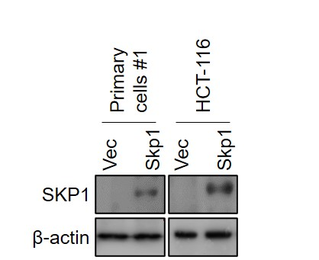
Supplementary Figure 1. Characterization of SKP1-overexpressing CRC cells.
The protein levels of SKP1 in indicated cells were detected by western blot.

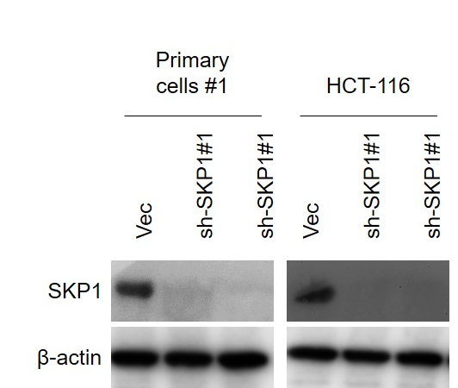
Supplementary Figure 2. Characterization of SKP1-knockdown CRC cells.
The protein levels of SKP1 in indicated cells were detected by western blot.

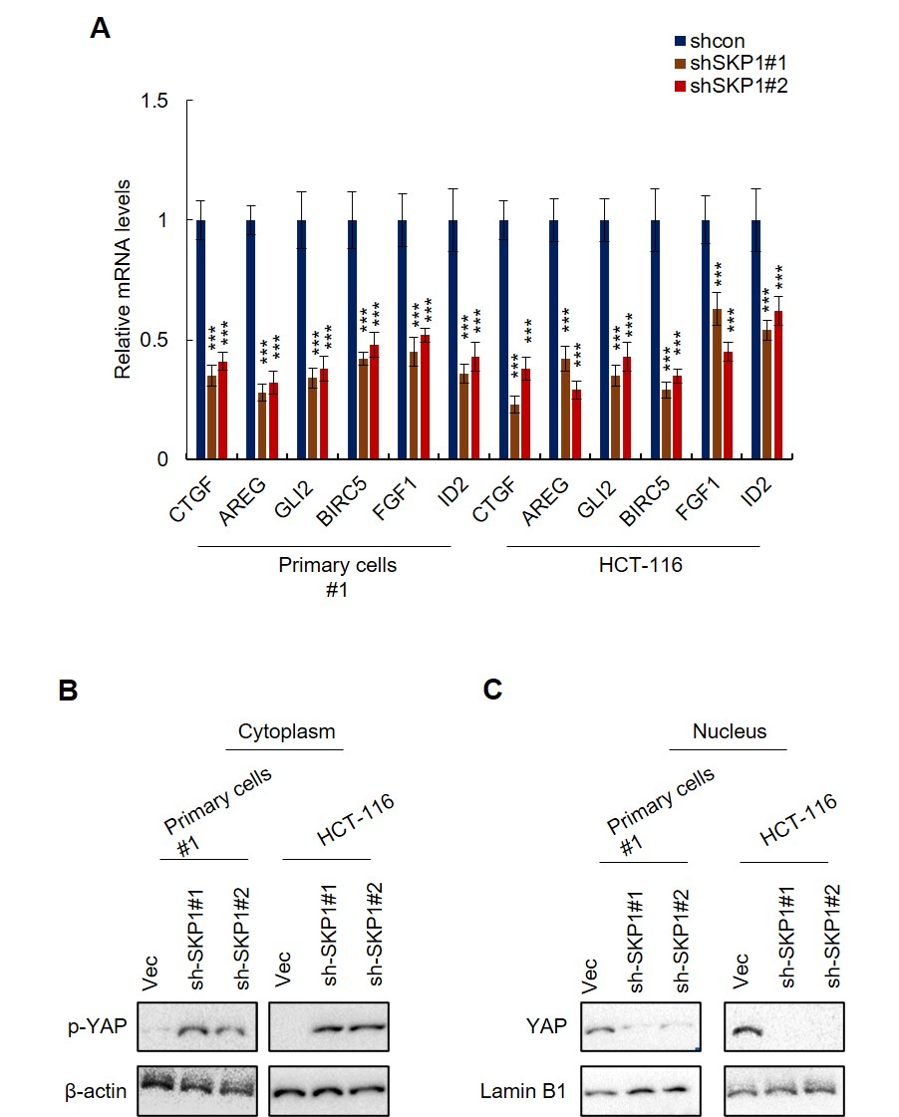
Supplementary Figure 3. SKP1 knockdown inhibits the Hippo/YAP signaling in colorectal cancer cells.
(A) The mRNA levels of YAP target genes were downregulated by SKP1 knockdown in colorectal cancer cells. The mRNA levels of YAP target genes in indicated cells were analyzed by qRT-PCR. (B) The phosphorylation level of YAP in indicated cells was analyzed by western blot. (C) The protein level of nuclear YAP in indicated cells was analyzed by western blot. Student’s t-test (***p<0.001).

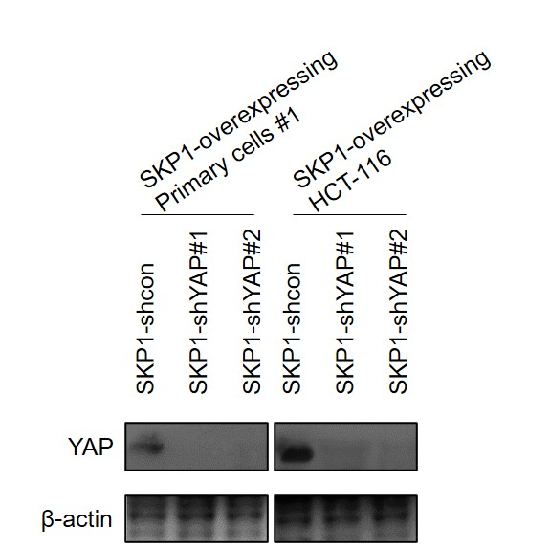
Supplementary Figure 4. Characterization of YAP-knockdown SKP1-overexpressing CRC cells. The protein levels of YAP in indicated cells were detected by western blot.

