Electronic Supplementary Material

S-doped C@MoSe_{2(1-x)}S_{2x}@MWCNT heterostructure as high-rate and long-cycle stability anodes for Na⁺ batteries
Yincai Yang, ^{‡1} Feng Wang, ^{‡1} Youwen Chen,^{1,2}() Shiguo Zhang,¹ Ming Zhang,¹ Zhen-Qiang Yu,³() Chak-Tong Au,¹ Shuang-Feng Yin¹() & Renhua Qiu¹()

1 State Key Laboratory of Chemo/Biosensing and Chemometrics, Advanced Catalytic Engineering Research Centre of the Ministry of Education, College of Chemistry and Chemical Engineering, School of physics & Electronics, College of Material Science and Chemical Engineering, Hunan University, Changsha 410082, China.
2 College of Information and Mechatronic Engineering, Hunan International Economics University, Changsha 410082, China.
3 College of Chemistry and Environmental Engineering, Shenzhen University, Shenzhen, China.
‡ These authors contributed equally to this work

Supporting information to DOI

Address correspondence to: Dr. Youwen Chen, youwenchen1@hnu.edu.cn; Prof. Z-Q Yu zqyu@szu.edu.cn; Prof. S-F Yin, sf_yin@hnu.edu.cn and Prof. R. Qiu, renhuaqiu1@hnu.edu.cn

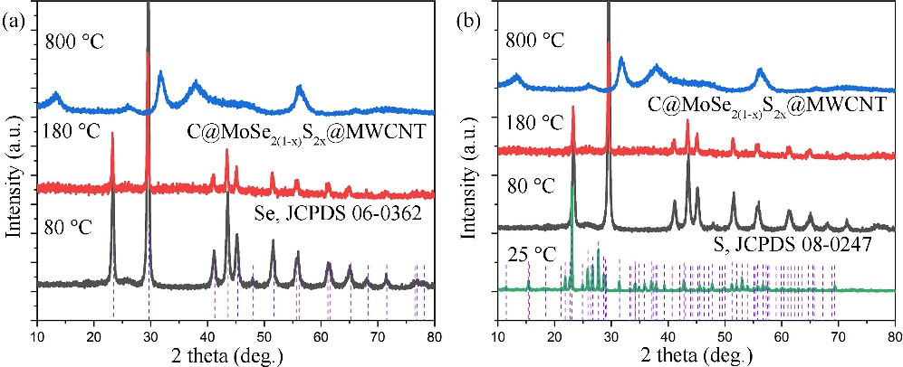
Fig. S1. XRD patterns of samples collected at different temperatures: (a) comparison with Se standard card data, (b) comparison with S standard card data.

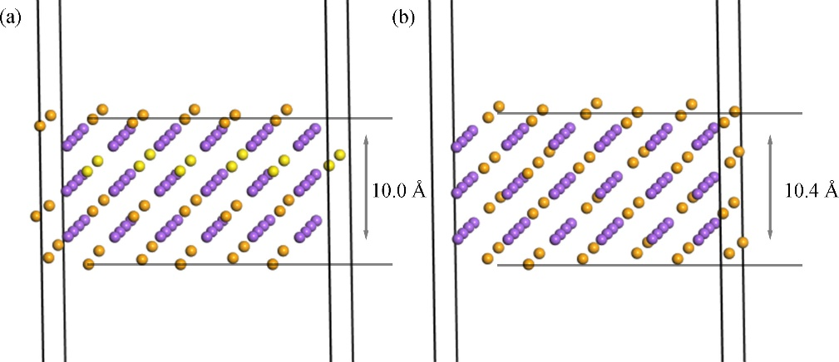
Fig. S2. Structures of (a) Na₂Se_{0.75}S_{0.25} and (b) Na₂Se after geometry optimization [1].

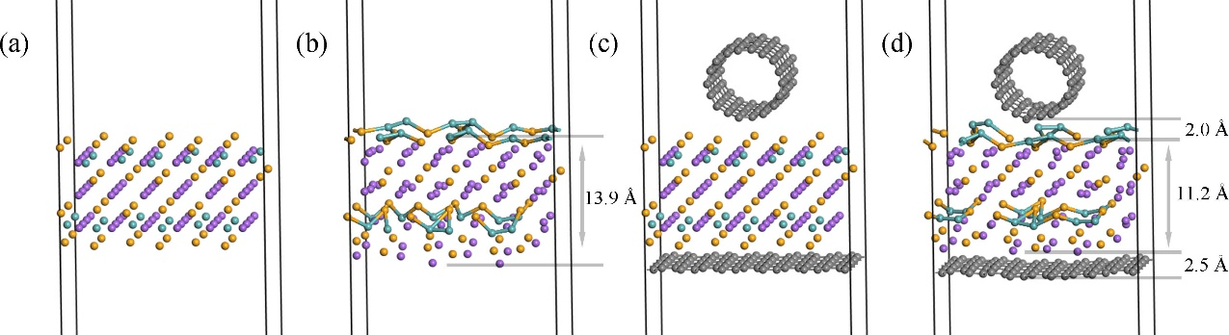
Fig. S3 Initial and final structures of (a, b) MoNa₄Se₂ and (c, d) GR@MoNa₄Se₂@CNT upon geometry optimization, respectively [1].

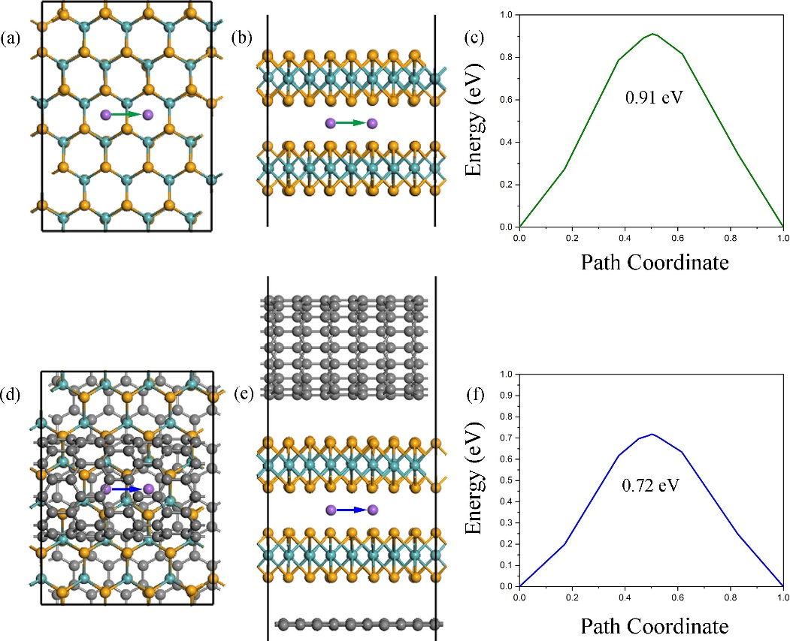
Fig. S4 Diffusion energy barrier for Na atoms in MoSe₂ and GR@MoSe₂@CNT: top view and side view of Na atoms migration in (a,b) MoSe₂ and (d,e) GR@MoSe₂@CNT, respectively; (c) and (f) is the energy barrier for Na atoms migration in MoSe₂ and GR@MoSe₂@CNT, respectively [1].

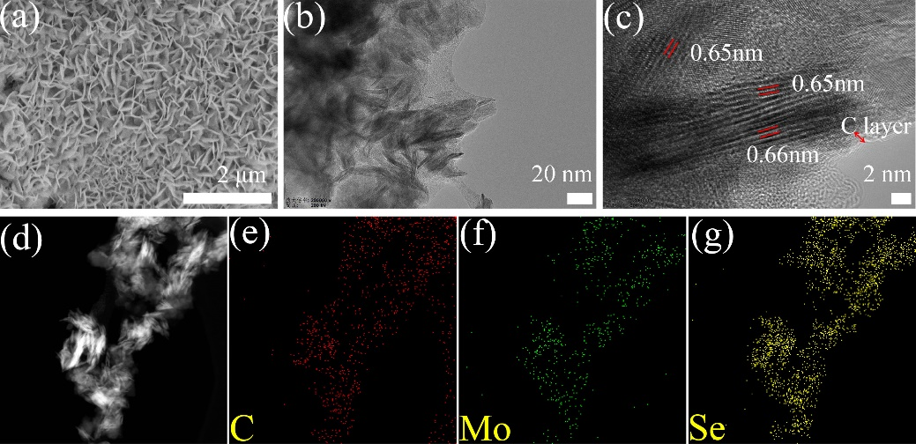
Fig. S5. (a) SEM, (b) TEM and (c) HRTEM images of C@MoSe₂, (d) TEM image and the corresponding EDS elemental mappings (e) C, (f) Mo and (g) Se [1].

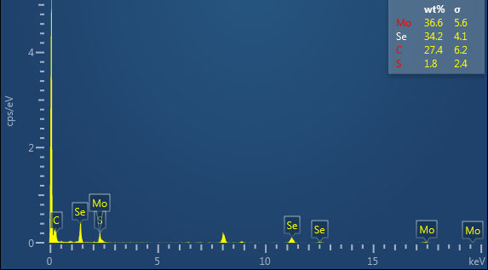
Fig. S6. Corresponding TEM-EDX profile of PEG-200-2-C@MoSe_{2(1-x)}S_{2x}@MWCNT.
Table S1. Corresponding TEM-EDX table of PEG-200-2-C@MoSe_{2(1-x)}S_{2x}@MWCNT.
General spectrogram | Atomic percentage
C | 72.36
S | 1.82
Se | 13.73
Mo | 12.10
Total | 100.00
According to atomic percentage of sulfur and selenium, the ratio between sulfur atoms and selenium atoms is 1.82/13.73, then the x in PEG-200-2-C@MoSe_{2(1-x)}S_{2x}@MWCNT is 0.12, giving the chemical formula PEG-200-2-C@MoSe_{1.76}S_{0.24}@MWCNT.

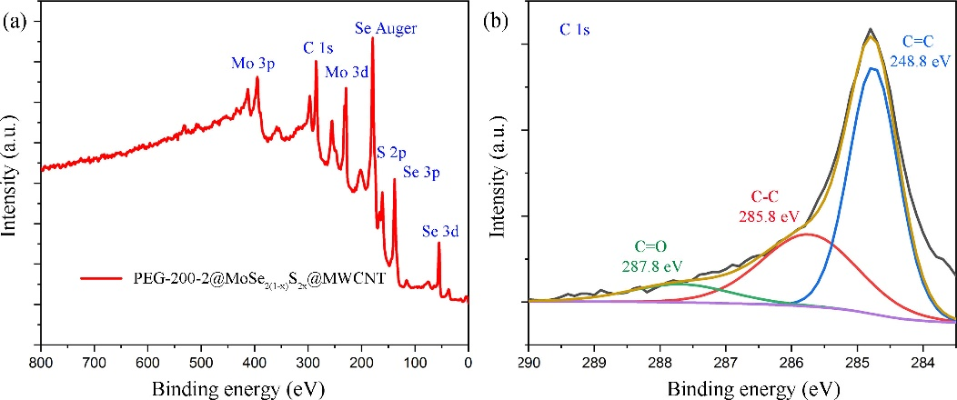
Fig. S7. XPS analysis of PEG-200-2-C@MoSe_{2(1-x)}S_{2x}@MWCNT anode materials: (a) Survey scan and (b) high-resolution C 1s spectrum.

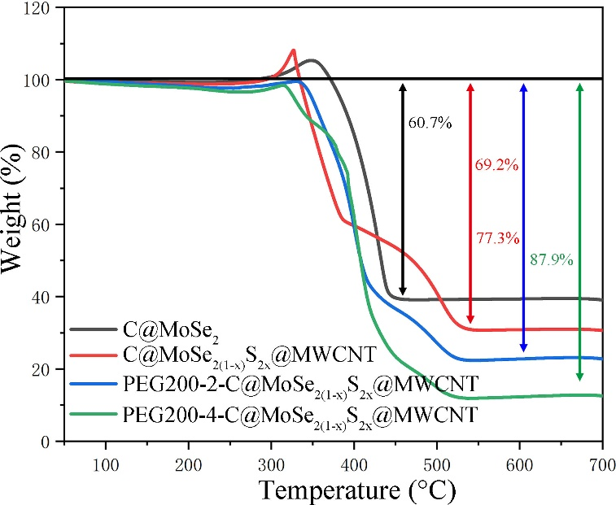
Fig. S8. TG analysis of C@MoSe₂, C@MoSe_{2(1-x)}S_{2x}@MWCNT, PEG200-2-C@ MoSe_{2(1-x)}S_{2x}@MWCNT and PEG200-4-C@MoSe_{2(1-x)}S_{2x} @MWCNT. According to Mo element conservation, the following equation (Eq. S1) is obtained,
$m_{{{MoSe}_{2(1-x)}S}_{2x}}\%=\frac{M_{{{MoSe}_{2(1-x)}S}_{2x}}}{M_{{MoO}_{3}}}*m_{{MoO}_{3}}\%$ Eq. S1
where $M_{{{MoSe}_{2(1-x)}S}_{2x}}$ and $M_{{MoO}_{3}}$ stands for the average molecular weight of MoSe_{2(1-x)}S_{2x} and MoO₃, respectively,$m_{{{MoSe}_{2(1-x)}S}_{2x}}\%$ and $m_{{MoO}_{3}}\%$ represents the percentage content of MoSe_{2(1-x)}S_{2x} and MoO₃ in the system, respectively. $M_{{MoS}_{2}}=160.06$, $M_{{MoSe}_{2}}=253.86$ and $M_{{MoO}_{3}}=143.94$. According to Table S1 (high-resolution S 2p spectrum), x is 0.12 (0.16), and then $M_{{{MoSe}_{2(1-x)}S}_{2x}}=M_{{{MoSe}_{1.76}S}_{0.24}}(M_{{{MoSe}_{1.68}S}_{0.32}})=$242.59 (238.86), $m_{{MoO}_{3}}\%$ equals 39.3%, 30.8%, 22.7% and 12.1% for C@MoSe₂, C@MoSe_{2(1-x)}S_{2x}@MWCNT, PEG200-2-C@MoSe_{2(1-x)}S_{2x}@CNT and PEG200-4-C@MoSe_{2(1-x)}S_{2x}@MWCNT, respectively. Therefore, the estimated MoSe₂ mass loading in C@MoSe₂ is 69.3%, while the MoSe_{2(1-x)}S_{2x} mass loading in C@MoSe_{2(1-x)}S_{2x}@MWCNT, PEG-200-2-C@MoSe_{2(1-x)}S_{2x}@MWCNT and PEG-200-4-C@MoSe_{2(1-x)}S_{2x}@MWCNT is 51.9% (51.1%), 38.3% (37.7%) and 20.3% (20.1%), respectively.

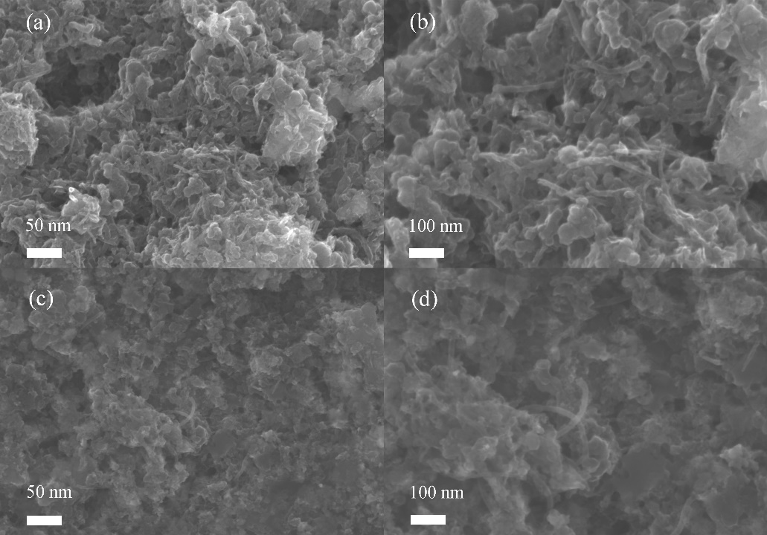
Fig. S9. SEM of PEG200-2-C@MoSe_{2(1-x)}S_{2x}@MWCNT electrode (a, b) after smeared and (c, d) after 200 cycles with decomposition.

References
[1] Yang Y., Wang F., Chen Y., Chen C., Zhang S., Yu Z.-Q., Au C.-T., Yin S.-F., Qiu R. Building a PEG-C@MoSe₂@CNT heterostructure via in-situ selenidation as highly reversible anodes for Na⁺ batteries. Sci. China-Chem., 2023, 66(2): 475–491.

