Supplementary information
Exploring the molecular mechanism of Licorice rose beverage anti-melasma based on network pharmacology, molecular docking technology and in vivo and in vitro experimental verification
Dan Zhai^{#a}, Yi Hu^{#a}, Li Liu^{#a}, Zhuxian Wangª, Peiyi Liangª, CuiPing Jiangª, Hui Li^{b} Quanfu Zengª, Hongkai Chenª, Yufan Wuª, Yinglin Guoª, Yankui Yiª, Chunyan Shenª, Hongxia Zhu*^{c}, Qiang Liu*ª

ªSchool of Traditional Chinese Medicine, Southern Medical University, Guangzhou
510515, PR China
^{b}Department of Traditional Chinese Medicine, Guangzhou Red Cross Hospital, Jinan
University, Guangzhou,510220, China
^{c}Integrated Hospital of Traditional Chinese Medicine, Southern Medical University,
Guangzhou 510315, PR China

#Zhai Dan and Yi Hu contributed equally to this work.

*Corresponding author: School of Traditional Chinese Medicine, Southern Medical University, Guangzhou, 510515, China. Tel.: +86-20-6164-8264, (Qiang Liu) Email-address: liuqiang@smu.edu.cn
*Corresponding author: Integrated Hospital of Traditional Chinese Medicine, Southern Medical University, Guangzhou, 510315, China. Tel.: +86-20-62789408, (Hongxia Zhu) Email-address: gzzhx2012@163.com

Table of Contents
1.The tables of Pubchem ID of LRB S3
2.The figure of venn diagram of coincidence targets S7

1. The tables of Pubchem ID of LRB
Table S1 Pubchem ID of 178 compounds
Number | Compound | Pubchem ID | Number | Compound | Pubchem ID
Licorice
1 | Inermine | 91510 | 2 | Calycosin | 5280448
3 | DFV | 114829 | 4 | kaempferol | 5280863
5 | Mairin | 64971 | 6 | naringenin | 932
7 | Glycyrol | 5320083 | 8 | Shinflavanone | 197678
9 | Jaranol | 5318869 | 10 | euchrenone | 10291003
11 | Medicarpin | 336327 | 12 | glyasperin B | 480784
13 | isorhamnetin | 5281654 | 14 | glyasperin F | 392442
15 | sitosterol | 222284 | 16 | Glyasperin C | 480859
17 | Lupiwighteone | 5317480 | 18 | Isotrifoliol | 5318679
19 | formononetin | 5280378 | 20 | Kanzonol B | 10881804
21 | kanzonols W | 15380912 | 22 | Gancaonin B | 5317479
23 | (2S)-6-(2,4-dihydroxyphenyl)-2-(2-hydroxypropan-2-yl)-4-methoxy-2,3-dihydrofuro[3,2-g]chromen-7-one | 637112 | 24 | licorice glycoside E | 42607811
25 | Semilicoisoflavone B | 5481948 | 26 | Glycyrin | 480787
27 | Glepidotin A | 5281619 | 28 | Licocoumarone | 503731
29 | Phaseolinisoflavan | 4484952 | 30 | Licoisoflavone | 5281789
31 | Glypallichalcone | 5317768 | 32 | Licoisoflavone B | 5481234
33 | Licochalcone B | 5318999 | 34 | licoisoflavanone | 392443
35 | licochalcone G | 49856081 | 36 | shinpterocarpin | 10336244
37 | Licoricone | 5319013 | 38 | 5-Prenylbutein | 11267805
39 | Gancaonin A | 5317478 | 40 | liquiritin | 503737
41 | licopyranocoumarin | 122851 | 42 | Sigmoidin-B | 73205
43 | Glyuranolide | 195396 | 44 | Isoglycyrol | 124050
45 | Glyzaglabrin | 5317777 | 46 | Isolicoflavonol | 5318585
47 | Glabridin | 124052 | 48 | HMO | 5283468
49 | Glabranin | 124049 | 50 | 1-Methoxyphaseollidin | 480873
51 | Glabrene | 480774 | 52 | 3'-Hydroxy-4'-O-Methylglabridin | 15228662
53 | Glabrone | 5317652 | 54 | licochalcone a | 5318998
55 | Eurycarpin A | 5317300 | 56 | 3'-Methoxyglabridin | 5319439
57 | glycyroside | 101939210 | 58 | icos-5-enoic acid | 3349565
59 | (-)-Medicocarpin | 23724664 | 60 | Kanzonol F | 101666840
61 | 7,2',4'-trihydroxy－5-methoxy-3－arylcoumarin | 25015742 | 62 | Phaseol | 44257530
63 | 7-Acetoxy-2-methylisoflavone | 268208 | 64 | Xambioona | 14769500
65 | gadelaidic acid | 5460988 | 66 | quercetin | 5280343
67 | Vestitol | 92503 | 68 | Glabrocoumarone A | 10542808
69 | Gancaonin G | 480780 | 70 | Licoarylcoumarin | 10090416
71 | Gancaonin H | 5481949 | 72 | Gancaonin L | 14604077
73 | Licoagrocarpin | 15840593 | 74 | Gancaonin M | 14604078
75 | Glycyrrhiza flavonol A | 5317765 | 76 | 6-Prenylluteolin | 14604081
77 | Licoagroisoflavone | 636883 | 78 | Hedysarimcoumestan B | 11558452
79 | Odoratin | 13965473 | 80 | 1,3-dihydroxy-8,9-dimethoxy-6-benzofurano[3,2-c]chromenone | 11602329
81 | (2R)-7-hydroxy-2-(4-hydroxyphenyl)chroman-4-one | 928837 | 82 | Quercetin der. | 5316900
83 | Isobavachin | 193679 | 84 | 4'-Methoxyglabridin | 10338211
85 | Inflacoumarin A | 5318437
Rose Rugosae Flos
86 | rubixanthin | 5281252 | 87 | beta-carotene | 5280489
88 | beta-sitosterol | 222284 | 89 | quercetin | 5280343
90 | cyanin | 441688 | 91 | LYC | 446925
92 | vitamin-e | 69540411 | 93 | rugosin D_qt | 12444662
94 | Demethoxycapillarisin | 5316511
Citrus Reticulata
95 | sitosterol | 222284 | 96 | Rac-Hesperetin | 3593
97 | naringenin | 932 | 98 | Citromitin | 12303287
99 | nobiletin | 72344
Lycii Fructus
100 | Sitosterol alpha1 | 9548595 | 101 | 24-ethylcholesta-5,22-dienol | 69473919
102 | Cycloartenol | 92110 | 103 | Fucosterol | 5281328
104 | Mandenol | 5282184 | 105 | 31-norlanosterol | 102179328
106 | Ethyl linolenate | 5367460 | 107 | Lophenol | 160482
108 | LAN | 246983 | 109 | 4alpha,14alpha,24-trimethylcholesta-8,24-dienol | 129716078
110 | Stigmasterol | 5280794 | 111 | 4alpha,24-dimethylcholesta-7,24-dienol | 129726843
112 | beta-sitosterol | 222284 | 113 | 4alpha-methyl-24-ethylcholesta-7,24-dienol | 66727568
114 | atropine | 174174 | 115 | Cycloeucalenol | 101690
116 | campesterol | 173183 | 117 | Lantadene A | 6436598
118 | cyanin | 441688 | 119 | Physcion Diglucoside | 442762
120 | 24-methylidenelophenol | 5283640 | 121 | Obtusifoliol | 65252
122 | glycitein | 5317750 | 123 | quercetin | 5280343
124 | delta-Carotene | 5281230 | 125 | CLR | 5997
126 | 24-ethylcholest-22-enol | 129725503 | 127 | methyl (1R,4aS,7R,7aS)-4a,7-dihydroxy-7-methyl-1-[(2S,3R,4S,5S,6R)-3,4,5-trihydroxy-6-(hydroxymethyl)oxan-2-yl]oxy-1,5,6,7a-tetrahydrocyclopenta[d]pyran-4-carboxylate | 11968619
128 | lanost-8-en-3beta-ol | 440560
Poria Cocos(Schw.) Wolf.
129 | A-Hydroxydehydrotrametenolic Acid | 10743008 | 130 | poricoic acid C | 56668247
131 | trametenolic acid | 12309443 | 132 | hederagenin | 73299
133 | Cerevisterol | 10181133 | 134 | dehydroeburicoic acid | 15250826
135 | Ergosterol peroxide | 5351516 | 136 | 7,9(11)-dehydropachymic acid | 15226717
137 | pachymic acid | 5484385 | 138 | Dehydrotumulosic Acid | 15225964
139 | Poricoic acid A | 5471851 | 140 | ergosta-7,22E-dien-3beta-ol | 5283628
141 | Poricoic acid B | 3086648 | 142 | Polyporenic Acid C | 9805290
143 | Eburicoic Acid | 73402
Mori Follum
144 | Clionasterol | 457801 | 145 | quercetin | 5280343
146 | scopolin | 439514 | 147 | beta-sitosterol | 222284
148 | beta-carotene | 5280489 | 149 | kaempferol | 5280863
150 | Inophyllum E | 5254 | 151 | Stigmasterol | 5280794
152 | Moracin B | 5319887 | 153 | arachidonic acid | 444899
154 | Moracin C | 155248 | 155 | Supraene | 638072
156 | Moracin D | 641378 | 157 | Iristectorigenin A | 5491637
158 | Moracin E | 5319888 | 159 | Norartocarpetin | 5481970
160 | Moracin F | 5319889 | 161 | Linolenic acid ethyl ester | 5367460
162 | Moracin G | 5319890 | 163 | Tetramethoxyluteolin | 631170
164 | Moracin H | 5319891 | 165 | FA | 6037
166 | 4-Prenylresveratrol | 5281725 | 167 | Methyl Icosa-11,14,17-Trienoate | 5367326
168 | Oxysanguinarine | 443716 | 169 | Skimmin (8CI) | 99693
Cinnanmomi Cortex
170 | cinnamaldehyde | 637511 | 171 | O-coumaric acid | 637540
172 | 2-methoxy cinnamaldehyde | 641298 | 173 | cinnacassinol | 46881367
174 | cinnamic acid | 444539 | 175 | dihydromelilotoside | 5316728
176 | coniferaldehyde | 5280536 | 177 | dihydrocinnacasside | 44178764
178 | cassiferaldehyde | 44178761

2. The figure of venn diagram of coincidence targets
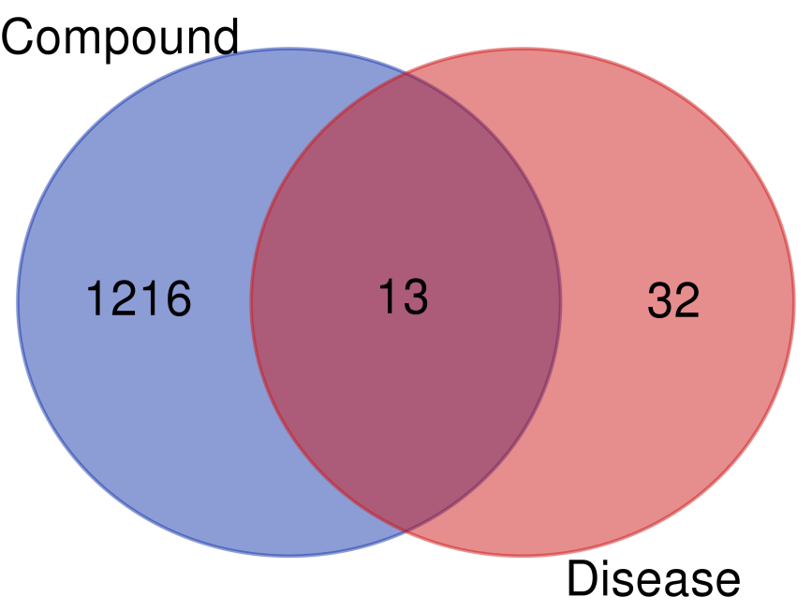
Figure S1 Intersection of predicted targets of disease and compounds

