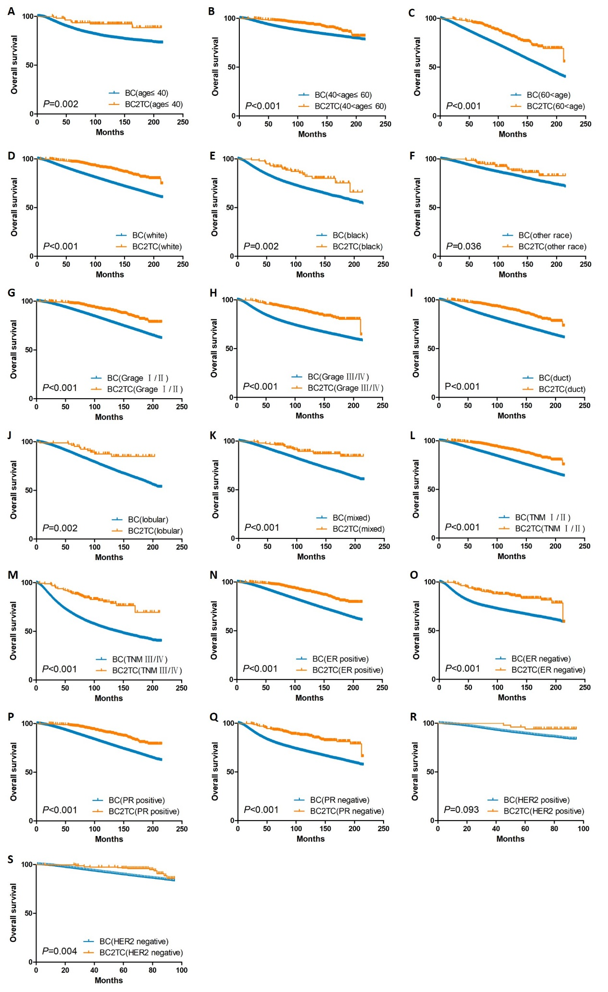
Figure S1. The subgroup survival analysis for OS of patients in the BC2TC and BC groups

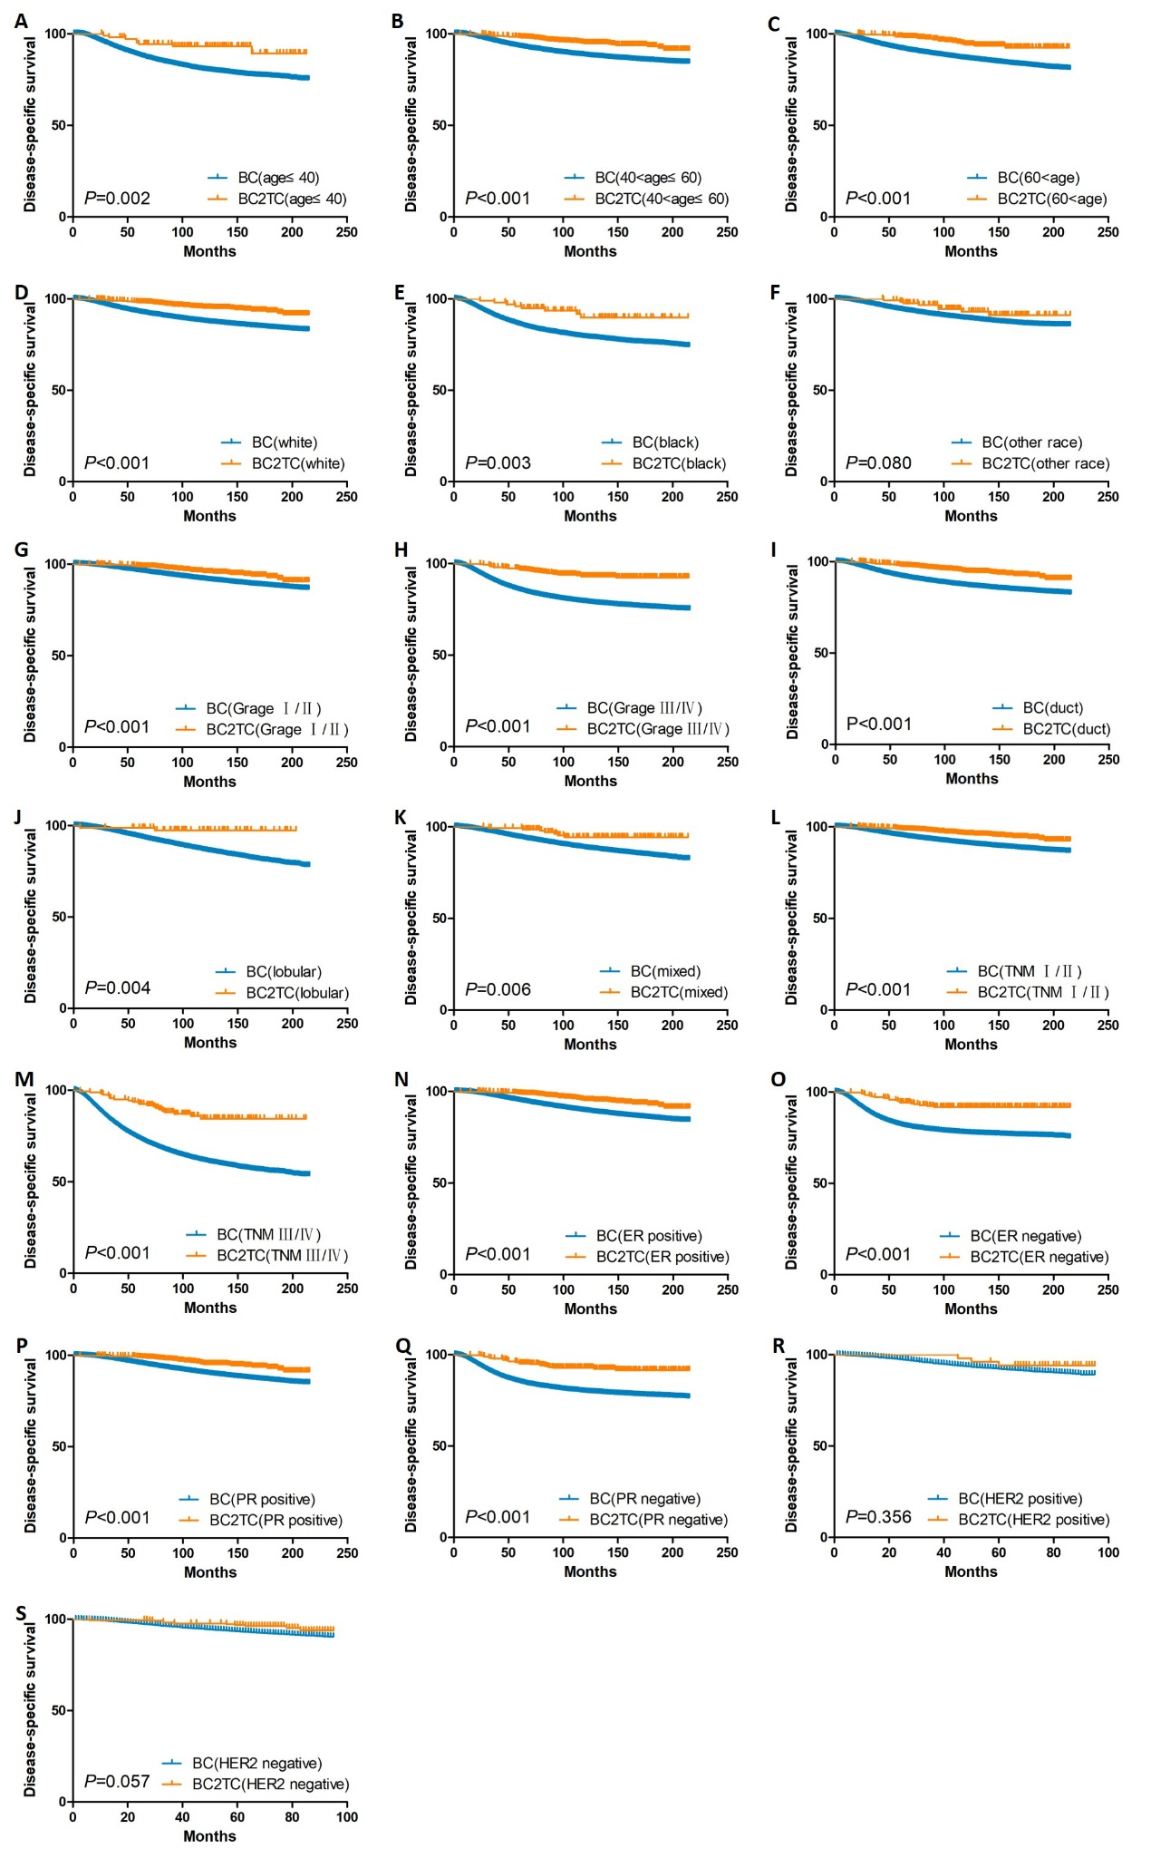
Figure S2. The subgroup survival analysis for DSS of patients in the BC2TC and BC groups

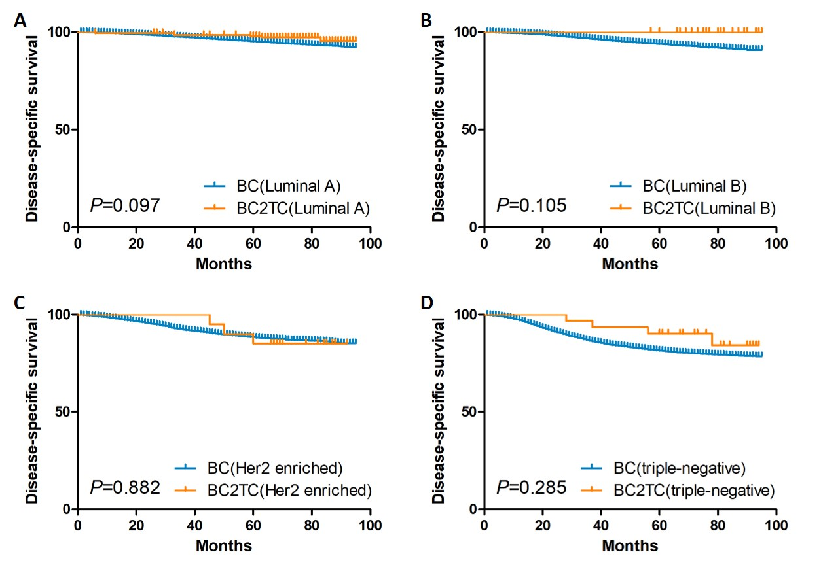
Figure S3. The DSS of patients between BC2TC and BC groups in the subgroup survival analysis for breast cancer subtypes

