Supplementary
Supplementary Table 1. Questionnaire survey data information
Location | Province | City | County | Number
East | Inner Mongolia | Chifeng city | Aohan banner | 238
East | Inner Mongolia | Chifeng city | Hongshan district | 246
East | Inner Mongolia | Tongliao city | Kulun banner | 234
East | Inner Mongolia | Tongliao city | Zhalut banner | 239
East | Inner Mongolia | Hinggan league | Ulanhot city | 217
East | Inner Mongolia | Hinggan league | Horqin right centre banner | 229
Sum |  |  |  | 1403
Middle | Inner Mongolia | Baotou city | Guyang county | 50
Middle | Inner Mongolia | Erdos city | Hanggin banner | 149
Middle | Shaanxi | Yulin city | Shenmu city | 150
Middle | Shanxi | Shuozhou city | Youyu county | 168
Sum |  |  |  | 517
West | Gansu | Wuwei city | Gulang county | 223
West | Gansu | Wuwei city | Tianzhu Zangzu autonomous county | 223
West | Gansu | Zhangye city | Shandan county | 185
West | Gansu | Zhangye city | Sunan Yugur autonomous county | 202
Sum |  |  |  | 833

Supplementary Table 2. Remote sensed data information
Dataset | Type | Resolution | Time series
MOD13Q1 | NDVI | 250 m | 2000-2005, 2015-2020
MOD11A1 | LST | 1 km | 2000-2005, 2015-2020
CHIRPS | Precipitation | 0.05° | 2000-2005, 2015-2020
ERA5 | RH | 0.25° | 2000-2005, 2015-2020
Note: Relative humidity (RH) is calculated by the 2 m temperature and the 2 m dew point temperature.

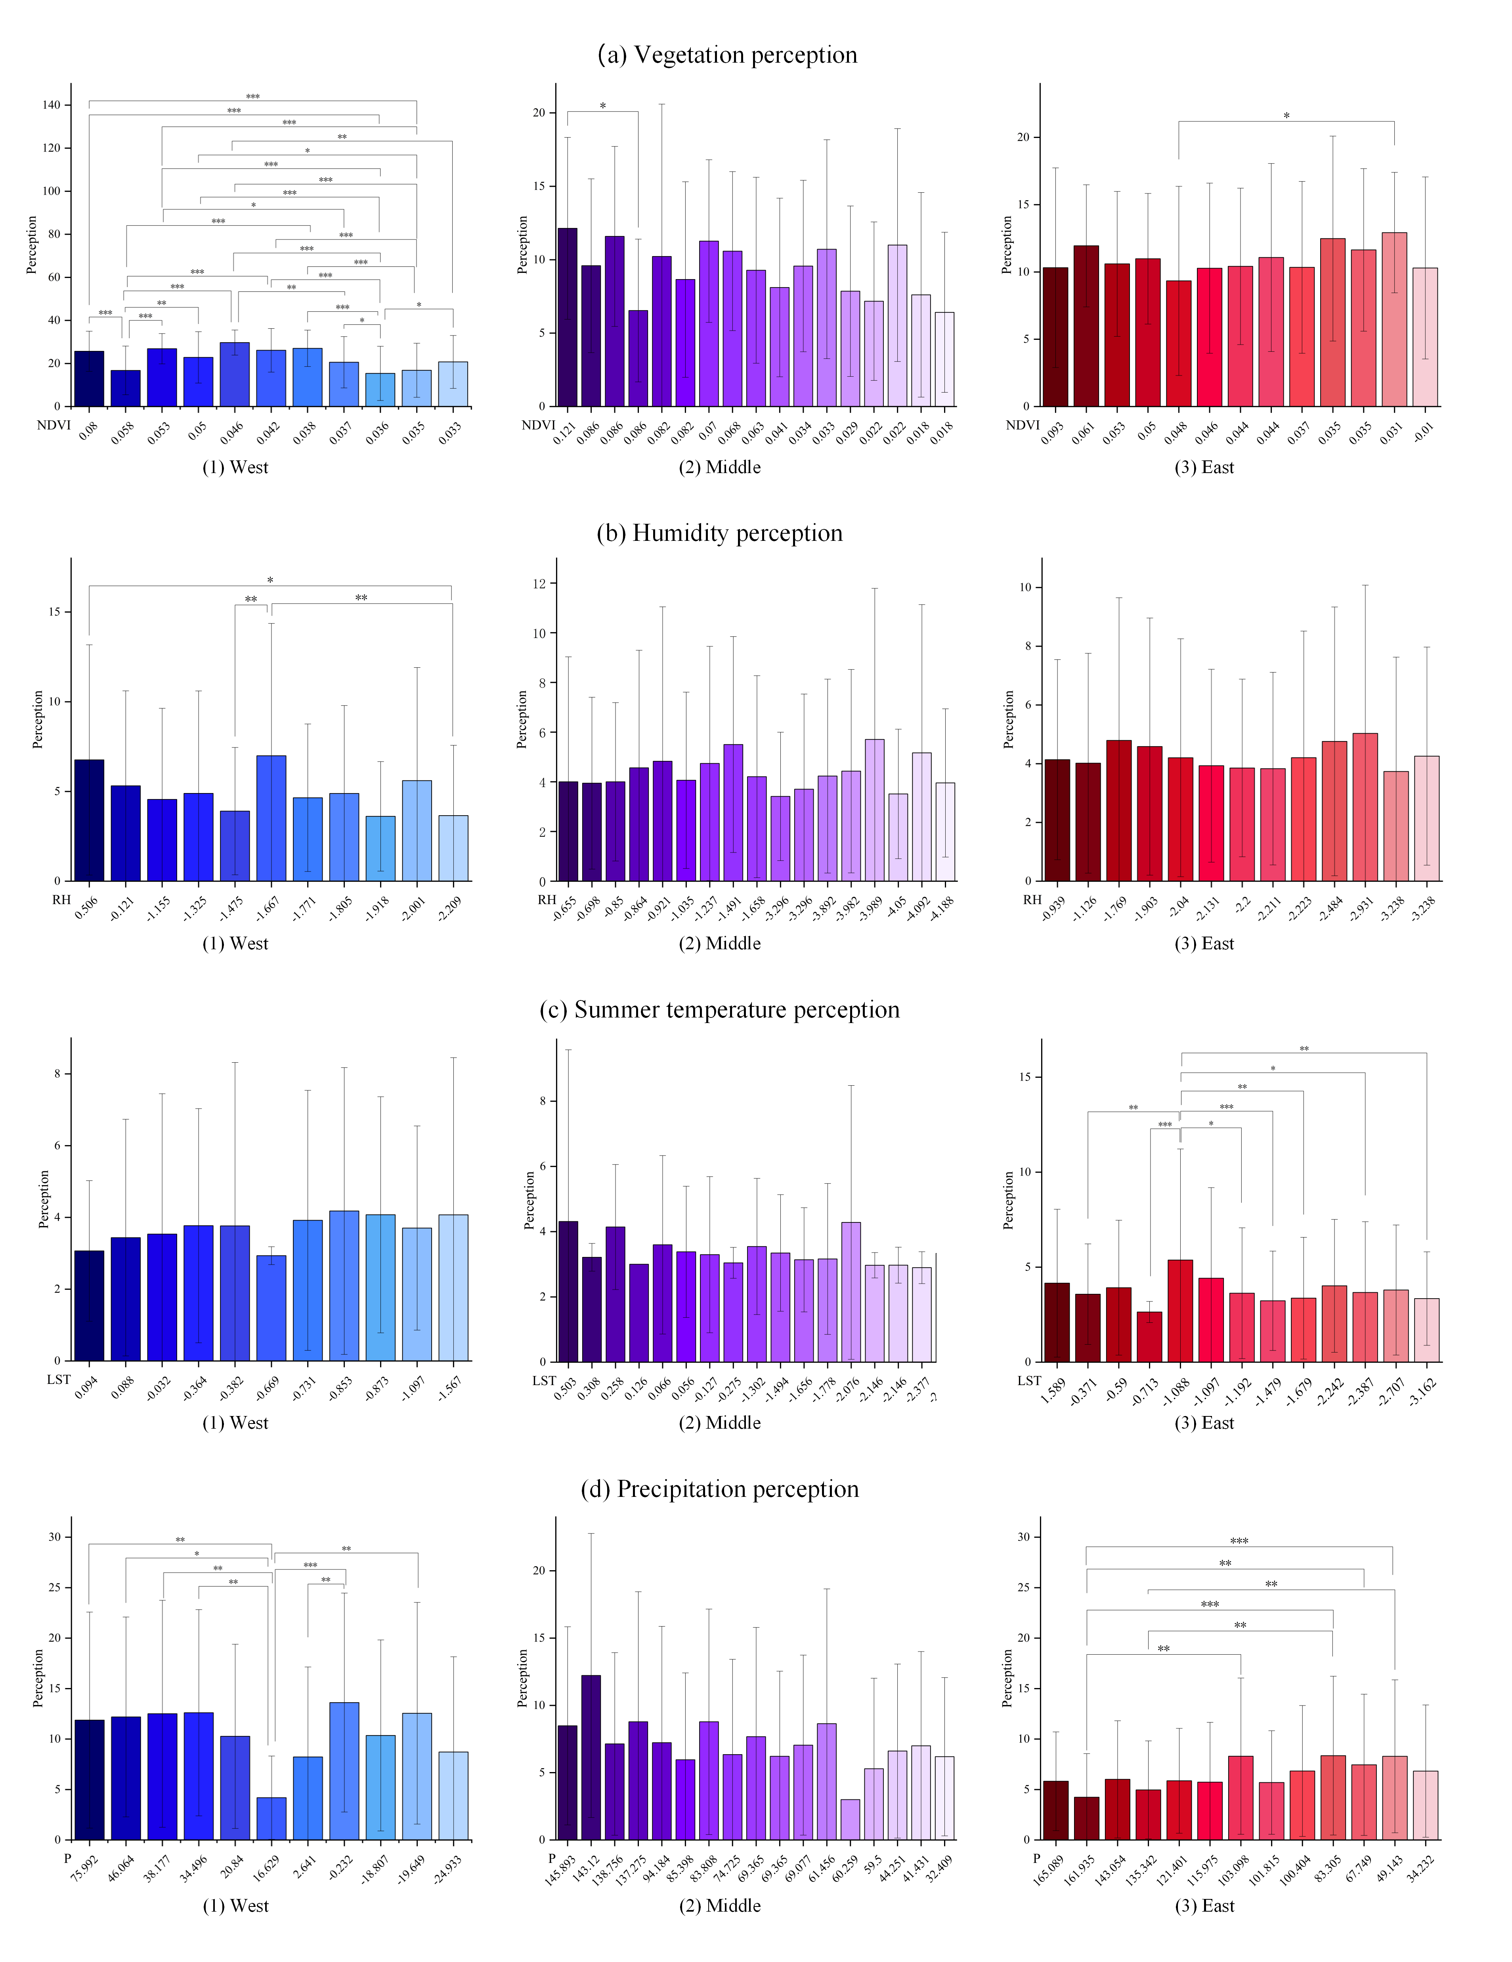
Supplementary Fig. 1. ANOVA results regarding environmental contexts (NDVI, RH, LST, P) and single EPs (vegetation, humidity perception, summer temperature perception, precipitation perception) in the west, middle, east. *** p < 0.01, ** p < 0.05, and * p < 0.1

Supplementary Table 3. The variance inflation factor (VIF) for each individual-level characteristic variable
Variable | Single EPs |  |  |  |  |  | Composite EP
Variable | Vegetation | Humidity | Sandy weather | Soil quality | Summer temperature | Precipitation | Composite EP
Gender | 1.06 | 1.06 | 1.06 | 1.06 | 1.06 | 1.06 | 1.06
 | 1.05 | 1.11 | 1.05 | 1.05 | 1.05 | 1.05 | 1.05
 | 1.11 | 1.11 | 1.11 | 1.11 | 1.11 | 1.11 | 1.11
Age | 1.61 | 1.61 | 1.61 | 1.61 | 1.61 | 1.61 | 1.61
 | 1.78 | 2.05 | 1.78 | 1.78 | 1.78 | 1.78 | 1.78
 | 2.05 | 2.05 | 2.05 | 2.05 | 2.05 | 2.05 | 2.05
Education | 1.46 | 1.46 | 1.46 | 1.46 | 1.46 | 1.46 | 1.46
 | 1.68 | 1.98 | 1.68 | 1.68 | 1.68 | 1.68 | 1.68
 | 1.98 | 1.98 | 1.98 | 1.98 | 1.98 | 1.98 | 1.98
Migration | 1.01 | 1.01 | 1.01 | 1.01 | 1.01 | 1.01 | 1.01
 | 1.02 | 1.04 | 1.02 | 1.02 | 1.02 | 1.02 | 1.02
 | 1.04 | 1.04 | 1.04 | 1.04 | 1.04 | 1.04 | 1.04
Income | 1.46 | 1.46 | 1.46 | 1.46 | 1.46 | 1.46 | 1.46
 | 1.78 | 1.24 | 1.78 | 1.78 | 1.78 | 1.78 | 1.78
 | 1.24 | 1.24 | 1.24 | 1.24 | 1.24 | 1.24 | 1.24
Agricultural income | 1.08 | 1.08 | 1.08 | 1.08 | 1.08 | 1.08 | 1.08
 | 1.19 | 1.08 | 1.19 | 1.19 | 1.19 | 1.19 | 1.19
 | 1.08 | 1.08 | 1.08 | 1.08 | 1.08 | 1.08 | 1.08
Farmland | 1.15 | 1.15 | 1.15 | 1.15 | 1.15 | 1.15 | 1.15
 | 1.22 | 1.08 | 1.22 | 1.22 | 1.22 | 1.22 | 1.22
 | 1.08 | 1.08 | 1.08 | 1.08 | 1.08 | 1.08 | 1.08
Family structure | 1.04 | 1.04 | 1.04 | 1.04 | 1.04 | 1.04 | 1.04
 | 1.11 | 1.06 | 1.11 | 1.11 | 1.11 | 1.11 | 1.11
 | 1.06 | 1.06 | 1.06 | 1.06 | 1.06 | 1.06 | 1.06
Place of residence | 1.11 | 1.11 | 1.11 | 1.11 | 1.11 | 1.11 | 1.11
 | 1.12 | 1.07 | 1.12 | 1.12 | 1.12 | 1.12 | 1.12
 | 1.07 | 1.07 | 1.07 | 1.07 | 1.07 | 1.07 | 1.07
Outgoing frequency | 1.33 | 1.11 | 1.33 | 1.33 | 1.33 | 1.33 | 1.33
 | 1.47 | 1.07 | 1.47 | 1.47 | 1.47 | 1.47 | 1.47
 | 1.53 | 1.53 | 1.53 | 1.53 | 1.53 | 1.53 | 1.53
Mean VIF | 1.23 | 1.23 | 1.23 | 1.23 | 1.23 | 1.23 | 1.23
 | 1.34 | 1.32 | 1.34 | 1.34 | 1.34 | 1.34 | 1.34
 | 1.32 | 1.32 | 1.32 | 1.32 | 1.32 | 1.32 | 1.32
Note: In this table, the initial row of each variable presents the variance inflation factor (VIF) for the basic environmental perception of respondents from the eastern region, followed by the second and third rows denoting the middle and western regions, respectively.

Supplementary Table 4. Regression coefficients between regional environmental variable changes and slope of the single EPs to individual factors.
Single EPs | Region | Regression coefficient | NDVI | P | LST | RH
Vegetation | East | Place of residence | -0.5022 | -0.0008* | 0.0002 | 0.0413**
Vegetation |  | Intercept | 11.7144 | 0.0153 | 0.2493 | -0.3037
Vegetation | West | Migration | -17.5840** | -0.0025 | -0.0451 | 0.1348
Vegetation |  | Outgoing frequency | 2.5991* | 0.0006 | 0.012 | -0.0285
Vegetation |  | Agricultural income | 0.1507 | 0.0002** | -0.0019 | -0.0129*
Vegetation |  | Intercept | 35.1704 | -0.0219 | -0.658 | 0.6075
Humidity | Middle | Family structure | 1.0487 | -0.0020* | -0.0374 | 0.0188
Humidity |  | Intercept | -7.1626 | 0.0012 | -0.6597 | -0.0654
Humidity | West | Gender | -9.2166 | 0.0052* | 0.054 | 0.0245
Humidity |  | Intercept | 73.3362 | -0.0397* | -0.4266 | -0.1274
Sandy weather | East | Gender | -13.4128** | -0.0057** | -0.2319 | 0.1002
Sandy weather |  | Farmland | -0.0177 | 0 | 0.001 | 0.0034**
Sandy weather |  | Intercept | 45.9178 | 0.0199* | 0.9041 | -0.2793
Sandy weather | Middle | Migration | -33.1328** | 0.0094 | -0.5029 | -0.3319**
Sandy weather |  | Age | -4.3292 | 0.0035* | 0.0964 | -0.1425***
Sandy weather |  | Family structure | -4.4279** | 0.001 | -0.0612 | -0.0474**
Sandy weather |  | Intercept | 37.5489 | -0.0256 | -0.5647 | 1.1595***
Soil quality | East | Farmland | 0.0243 | 0 | 0.0021 | 0.0024**
Soil quality |  | Intercept | 24.5707 | 0.0115 | 0.628 | 0.0295
Soil quality | Middle | Migration | 1.9622 | -0.0081** | -0.3152* | 0.1847*
Soil quality |  | Intercept | 16.0609 | -0.0012 | 0.2191 | 0.1642
Soil quality | West | Gender | -5.8397 | 0.0015 | -0.34753** | -0.0858
Soil quality |  | Age | -0.3464 | 0.0005 | -0.0349 | -0.1081*
Soil quality |  | Family structure | 1.9966 | -0.0014* | -0.0416 | -0.0442
Soil quality |  | Intercept | 17.3978 | -0.0163 | 0.6536 | 0.9869
Summer temperature | East | Agricultural income | -0.1693** | -0.0001* | -0.0041** | -0.0002
Summer temperature |  | Farmland | 0.0676 | 0 | 0.0030* | 0.0021
Summer temperature |  | Intercept | 27.5413 | 0.0134 | 0.5675 | 0.0046
Summer temperature | Middle | Place of residence | 0.3832 | -0.0009 | -0.0245 | 0.0212*
Summer temperature |  | Gender | -4.7168 | -0.0048* | -0.1868 | 0.0688
Summer temperature |  | Intercept | -7.9286 | 0.0091 | -0.3763 | -0.3508
Summer temperature | West | Migration | -7.2641 | -0.0005 | 0.1945 | 0.3072*
Summer temperature |  | Outgoing frequency | 0.433 | 0.0010* | 0.0577 | -0.0326
Summer temperature |  | Intercept | 26.3172 | -0.0128 | 0.0827 | 0.5435
Precipitation | East | Migration | -1.3814 | -0.0052 | 0.1407 | 0.7202**
Precipitation |  | Age | 4.1498 | 0.0019 | 0.1196** | -0.0787**
Precipitation |  | Intercept | -26.8811 | -0.0157 | -0.5518 | 0.2511
Precipitation | Middle | Gender | -3.9361 | -0.0022 | -0.3072* | 0.0682
Precipitation |  | Intercept | 29.0427 | 0.0124 | 1.4008 | -0.0436
Precipitation | West | Age | -7.3735 | 0.0023* | 0.0942 | -0.0448
Precipitation |  | Intercept | 67.0417 | -0.0197 | -0.3282 | 0.6011
Note: *** p < 0.01, ** p < 0.05, and * p < 0.1. Only significant indicators (p < 0.1) with a positive variance interpretation rate are displayed in the figure.

Supplementary Table 5. Variance components of the single EPs explained by landscape-level environment contexts.
Single EPs | Region | Level2 | Level1 | Original  variance | Conditional  variance | Explained variance  ratio
Vegetation | East | P | Intercept | 0.8612 | 0.8695 | -0.96%
Vegetation |  |  | Place of residence | 0.0014 | 0.0009 | 33.09%
Vegetation |  | RH | Intercept | 0.8612 | 1.0123 | -17.54%
Vegetation |  |  | Place of residence | 0.0014 | 0.0016 | -15.44%
Vegetation | West | NDVI | Intercept | 0.7367 | 0.8014 | -8.78%
Vegetation |  |  | Migration | 0.0538 | 0.0180 | 66.62%
Vegetation |  |  | Outgoing frequency | 0.0020 | 0.0014 | 30.81%
Vegetation |  | P | Intercept | 0.7367 | 0.9133 | -23.96%
Vegetation |  |  | Agricultural income | 0.0017 | 0.0018 | -2.33%
Vegetation |  | RH | Intercept | 0.7367 | 0.4343 | 41.05%
Vegetation |  |  | Agricultural income | 0.0017 | 0.0021 | -24.42%
Humidity | Middle | P | Intercept | 1.4115 | 0.2471 | 82.50%
Humidity |  |  | Family structure | 0.0045 | 0.0008 | 81.72%
Humidity | West | P | Intercept | 1.9316 | 1.8401 | 4.74%
Humidity |  |  | Gender | 0.0122 | 0.0079 | 35.33%
Sandy weather | East | NDVI | Intercept | 0.1918 | 0.1920 | -0.10%
Sandy weather |  |  | Gender | 0.0142 | 0.0117 | 17.83%
Sandy weather |  | P | Intercept | 0.1918 | 0.2184 | -13.87%
Sandy weather |  |  | Gender | 0.0142 | 0.0134 | 5.92%
Sandy weather |  | LST | Intercept | 0.1918 | 0.1886 | 1.64%
Sandy weather |  |  | Gender | 0.0142 | 0.0153 | -7.82%
Sandy weather |  | RH | Intercept | 0.1918 | 0.2402 | -25.25%
Sandy weather |  |  | Farmland | 0.0009 | 0.0005 | 51.06%
Sandy weather | Middle | NDVI | Intercept | 0.6879 | 0.3634 | 47.18%
Sandy weather |  |  | Migration | 0.0323 | 0.2258 | -599.85%
Sandy weather |  |  | Family structure | 0.0007 | 0.0016 | -127.14%
Sandy weather |  | P | Intercept | 0.6879 | 0.3722 | 45.89%
Sandy weather |  |  | Age | 0.0059 | 0.0039 | 34.30%
Sandy weather |  | RH | Intercept | 0.6879 | 0.3767 | 45.23%
Sandy weather |  |  | Migration | 0.0323 | 0.1292 | -300.43%
Sandy weather |  |  | Age | 0.0059 | 0.0015 | 73.72%
Sandy weather |  |  | Family structure | 0.0007 | 0.0005 | 24.29%
Soil quality | East | RH | Intercept | 0.0245 | 0.0150 | 38.57%
Soil quality |  |  | Farmland | 0.0009 | 0.0008 | 14.61%
Soil quality | Middle | P | Intercept | 0.6879 | 0.7115 | -3.43%
Soil quality |  |  | Migration | 0.0323 | 0.0371 | -14.91%
Soil quality |  | LST | Intercept | 0.6879 | 0.7220 | -4.96%
Soil quality |  |  | Migration | 0.0323 | 0.0214 | 33.57%
Soil quality |  | RH | Intercept | 0.6879 | 0.6378 | 7.28%
Soil quality |  |  | Migration | 0.0323 | 0.0391 | -21.33%
Soil quality | West | P | Intercept | 0.8477 | 0.9658 | -13.94%
Soil quality |  |  | Family structure | 0.0015 | 0.0010 | 35.57%
Soil quality |  | LST | Intercept | 0.8477 | 1.4090 | -66.22%
Soil quality |  |  | Gender | 0.0312 | 0.0323 | -3.36%
Soil quality |  | RH | Intercept | 0.8477 | 0.8224 | 2.99%
Soil quality |  |  | Age | 0.0047 | 0.0028 | 41.24%
Summer temperature | East | NDVI | Intercept | 0.0371 | 0.0532 | -43.28%
Summer temperature |  |  | Agricultural income | 0.0011 | 0.0012 | -6.25%
Summer temperature |  | P | Intercept | 0.0371 | 0.0323 | 13.02%
Summer temperature |  |  | Agricultural income | 0.0011 | 0.0010 | 8.04%
Summer temperature |  | LST | Intercept | 0.0371 | 0.0443 | -19.43%
Summer temperature |  |  | Agricultural income | 0.0011 | 0.0010 | 12.50%
Summer temperature |  |  | Farmland | 0.0015 | 0.0011 | 23.13%
Summer temperature | Middle | P | Intercept | 0.4057 | 0.3289 | 18.93%
Summer temperature |  |  | Gender | 0.0027 | 0.0025 | 7.38%
Summer temperature |  | RH | Intercept | 0.4057 | 0.2864 | 29.41%
Summer temperature |  |  | Place of residence | 0.0006 | 0.0006 | -1.61%
Summer temperature | West | P | Intercept | 0.1435 | 0.1967 | -37.11%
Summer temperature |  |  | Outgoing frequency | 0.0017 | 0.0019 | -14.79%
Summer temperature |  | RH | Intercept | 0.1435 | 0.1302 | 9.23%
Summer temperature |  |  | Migration | 0.0360 | 0.0265 | 26.43%
Precipitation | East | LST | Intercept | 0.0816 | 0.0851 | -4.29%
Precipitation |  |  | Age | 0.0040 | 0.0020 | 50.12%
Precipitation |  | RH | Intercept | 0.0816 | 0.0824 | -0.97%
Precipitation |  |  | Migration | 0.2223 | 0.1525 | 31.39%
Precipitation |  |  | Age | 0.0040 | 0.0022 | 45.16%
Precipitation | Middle | LST | Intercept | 0.8301 | 0.7726 | 6.93%
Precipitation |  |  | Gender | 0.0446 | 0.0285 | 35.96%
Precipitation | West | P | Intercept | 1.4001 | 1.7099 | -22.13%
Precipitation |  |  | Age | 0.0091 | 0.0123 | -35.79%
Note: We examined the reduction in unconditional model variance as each predictor (level 2) was added, and the proportion of variance in the slope of EPs to each individual factor (level 1) explained by the respective environmental context change was calculated. Only the individual factors that are significant (p < 0.1) in the overall model are shown in the table.

Supplementary Table 6. Regression coefficients between landscape-level environment context changes and slope of the composite EP to individual factors
Region | Regression coefficient | NDVI | P | LST | RH
East | Place of residence | -9.4184 | -0.0045 | -0.0109 | 0.5200*
East | Income | 125.6988** | 0.0592*** | 2.4802** | -1.3570*
East | Family structure | -67.5194** | -0.0100 | -1.2111* | 0.2686
East | Intercept | -660.2204 | -0.3796* | -12.6362 | 2.8766
Middle | Migration | -445.6518* | 0.1949* | -4.3059 | -6.5483**
Middle | Gender | -210.2017* | -0.0195 | -4.8210 | 0.1468
Middle | Income | 112.2395* | -0.0011 | 2.0830 | 0.0148
Middle | Family structure | -60.3582* | -0.0093 | -0.4415 | 0.0168
Middle | Intercept | 1056.7182 | 0.2430 | 24.0704 | 0.3663
West | Age | -6.3651* | 0.0022 | 0.0430 | -0.0257
West | Agricultural income | 0.0958 | 0.0002** | -0.0031 | -0.0085*
West | Family structure | 0.1038 | -0.0017* | -0.0359 | 0.0036
West | Intercept | 61.5833* | -0.0196 | -0.0469 | 0.3723
Note: *** p < 0.01, ** p < 0.05, and * p < 0.1. Only significant indicators (p < 0.1) with a positive variance interpretation rate are displayed in the figure.

Supplementary Table 7. Variance components of the composite EP explained by landscape-level environment contexts.
Region | Level 2 | Level 1 | Original  variance | Conditional  variance | Explained variance  ratio
East | NDVI | Intercept | 48.6556 | 50.1760 | -3.12%
East |  | Income | 2.0435 | 1.8968 | 7.18%
East |  | Family structure | 0.4804 | 0.3525 | 26.63%
East | P | Intercept | 48.6556 | 20.8376 | 57.17%
East |  | Income | 2.0435 | 2.0753 | -1.56%
East | LST | Intercept | 48.6556 | 47.4995 | 2.38%
East |  | Income | 2.0435 | 1.9640 | 3.89%
East |  | Family structure | 0.4804 | 0.5170 | -7.62%
East | RH | Intercept | 48.6556 | 54.2563 | -11.51%
East |  | Place of residence | 0.0855 | 0.0730 | 14.63%
East |  | Income | 2.0435 | 1.7825 | 12.77%
Middle | NDVI | Intercept | 95.1994 | 150.0025 | -57.57%
Middle |  | Migration | 9.7884 | 7.1613 | 26.84%
Middle |  | Gender | 1.3675 | 4.1345 | -202.35%
Middle |  | Income | 1.4240 | 1.1424 | 19.78%
Middle |  | Family structure | 0.7877 | 0.1780 | 77.40%
Middle | P | Intercept | 95.1994 | 37.9666 | 60.12%
Middle |  | Migration | 9.7884 | 8.7620 | 10.49%
Middle | RH | Intercept | 95.1994 | 93.8729 | 1.39%
Middle |  | Migration | 9.7884 | 14.0095 | -43.12%
West | NDVI | Intercept | 0.9794 | 0.6666 | 31.94%
West |  | Age | 0.0082 | 0.0054 | 34.02%
West | P | Intercept | 0.9794 | 1.2817 | -30.86%
West |  | Agricultural income | 0.0019 | 0.0016 | 17.89%
West |  | Family structure | 0.0033 | 0.0016 | 51.67%
West | RH | Intercept | 0.9794 | 0.6907 | 29.48%
West |  | Agricultural income | 0.0019 | 0.0015 | 22.11%
Note: We examined the reduction in unconditional model variance as each predictor (level 2) was added, and the proportion of variance in the slope of EPs to each individual factor (level 1) explained by the respective environmental context change was calculated. Only the individual factors that are significant (p < 0.1) in the overall model are shown in the table.

