Supplemental material
Table S1. Description of habitats selected from the Canadian Landcover 2015 vegetation map ("LC2015", adapted from Latifovic 2019) and reclassification into relevant habitats to fox activities to test for differences between species in the home range composition
Habitat LC2015 | Habitat reclassified | ID | description (LC2015)
Barren land | Barren Land | 1 | Bare mineral material, vegetation accounts for <10% of total cover
Sub-polar barren-lichen-moss | Lichen-moss habitats | 2 | Mixture of bare area with lichen-moss accounting for at least 20% of total vegetation cover (typical of tundra)
Sub-polar shrubland-lichen-moss | Lichen-moss habitats | 2 | Dwarf shrubs with lichen and moss accounting for at least 20% of vegetation cover (typical of tundra)
Sub-polar grassland-lichen-moss | Lichen-moss habitats | 2 | Grassland with lichen and moss accounting for at least 20% of total vegetation cover (typical of tundra)
Wetland | Wetland | 3 | Herbaceous or woody vegetation influenced by water table at or near surface and present for a substantial part of the year
Sub-polar shrubland | Shrubland | 4 | Woody perrenial plants <3m accounting for >20% of total vegetation cover
Sub-polar grassland | Shrubland | 4 | Herbaceous vegetation accounting for at least 80% of total vegetation cover interspersed between shrubland patches
Sub-polar needleleaf forest | Forest | 5 | Forest >3m accounting for >20% of total vegetation cover, needleleaf-tree species account for >75% of canopy coverage
Sub-polar taiga needleleaf forest | Forest | 5 | Woodlands, treed wetland with needleleaf-tree species >3m accounting for >5% of total vegetation cover, shrub and lichen understory often present, canopy variable and sparse
Sub-polar broadleaf deciduous forest | Forest | 5 | Forest >3m accounting for >20% of total vegetation cover, broadleaf deciduous species account for >75% of canopy coverage
Mixed forest | Forest | 5 | Forest >3m accounting for >20% of total vegetation cover, broadleaf and needleleaf tree species co-dominate, neither reaching 75% of total tree cover
Intertidal flats | Intertidal flats | 6 | Marine-terrestrial ecotone between high and low tides
Sea ice | Sea ice | 7 | Marine ecosystem of the Hudson Bay. Covered by ice during the study period

Table S2. Proportion of each habitat type in the total area of each individual fox’s mnlv- and nsv-home range (50% UD) between March 15 and June 15 in northeastern Manitoba, Canada (habitat IDs described in Table S1).
 |  |  |  |  | Proportion** of habitat (ID)
species | year | Fox ID* | Estimator | area** | 1 | 2 | 3 | 4 | 5 | 6 | 7
Arctic fox | 2019 | B | MNLV | 23.25 | 0.07 | 0.13 | 0.20 | 0.02 | 0.03 | 0.10 | 0.39
 |  |  | NSV | 18.08 | 0.11 | 0.24 | 0.32 | 0.03 | 0.04 | 0.07 | 0.00
Arctic fox | 2019 | DL | MNLV | 11.89 | 0.16 | 0.16 | 0.15 | 0.04 | 0.00 | 0.22 | 0.03
 |  |  | NSV | 17.56 | 0.15 | 0.17 | 0.25 | 0.04 | 0.00 | 0.12 | 0.00
Arctic fox | 2018 | Gh | MNLV | 4.88 | 0.05 | 0.31 | 0.25 | 0.01 | 0.00 | 0.01 | 0.00
 |  |  | NSV | 8.81 | 0.13 | 0.30 | 0.31 | 0.01 | 0.00 | 0.01 | 0.00
Arctic fox | 2018 | Gi | MNLV | 8.51 | 0.09 | 0.39 | 0.31 | 0.01 | 0.00 | 0.00 | 0.00
 |  |  | NSV | 5.98 | 0.11 | 0.49 | 0.26 | 0.01 | 0.00 | 0.00 | 0.00
Arctic fox | 2018 | GK | MNLV | 4.60 | 0.08 | 0.46 | 0.39 | 0.01 | 0.00 | 0.00 | 0.00
 |  |  | NSV | 7.96 | 0.09 | 0.52 | 0.32 | 0.00 | 0.00 | 0.00 | 0.00
Arctic fox | 2019 | M | MNLV | 4.94 | 0.00 | 0.03 | 0.11 | 0.08 | 0.09 | 0.36 | 0.17
 |  |  | NSV | 30.38 | 0.01 | 0.09 | 0.27 | 0.05 | 0.26 | 0.04 | 0.00
Arctic fox | 2017 | MM | MNLV | 9.33 | 0.02 | 0.25 | 0.43 | 0.11 | 0.11 | 0.00 | 0.00
 |  |  | NSV | 12.65 | 0.02 | 0.18 | 0.47 | 0.11 | 0.14 | 0.00 | 0.00
Arctic fox | 2019 | T | MNLV | 13.74 | 0.02 | 0.14 | 0.60 | 0.00 | 0.00 | 0.02 | 0.00
 |  |  | NSV | 9.86 | 0.11 | 0.20 | 0.51 | 0.01 | 0.00 | 0.01 | 0.00
Arctic fox | 2017 | U | MNLV | 16.89 | 0.08 | 0.47 | 0.33 | 0.05 | 0.00 | 0.00 | 0.00
 |  |  | NSV | 9.37 | 0.08 | 0.39 | 0.41 | 0.05 | 0.00 | 0.01 | 0.00
Red fox | 2020 | A | MNLV | 21.73 | 0.10 | 0.08 | 0.27 | 0.19 | 0.30 | 0.00 | 0.00
 |  |  | NSV | 33.54 | 0.10 | 0.12 | 0.27 | 0.34 | 0.03 | 0.00 | 0.00
Red fox | 2017 | AB | MNLV | 3.83 | 0.00 | 0.24 | 0.50 | 0.08 | 0.13 | 0.00 | 0.00
 |  |  | NSV | 6.10 | 0.00 | 0.31 | 0.44 | 0.10 | 0.10 | 0.00 | 0.00
Red fox | 2017 | FJ | MNLV | 9.31 | 0.11 | 0.09 | 0.39 | 0.04 | 0.23 | 0.03 | 0.00
 |  |  | NSV | 9.73 | 0.29 | 0.16 | 0.15 | 0.05 | 0.04 | 0.23 | 0.00
Red fox | 2017 | LR&I | MNLV | 12.51 | 0.00 | 0.14 | 0.36 | 0.39 | 0.06 | 0.00 | 0.00
 |  |  | NSV | 15.27 | 0.00 | 0.15 | 0.30 | 0.36 | 0.07 | 0.00 | 0.00
Red fox | 2019 | S&Br | MNLV | 4.05 | 0.00 | 0.09 | 0.42 | 0.29 | 0.17 | 0.00 | 0.00
 |  |  | NSV | 11.02 | 0.00 | 0.06 | 0.45 | 0.24 | 0.21 | 0.00 | 0.00
Red fox | 2018 | W | MNLV | 2.40 | 0.31 | 0.39 | 0.14 | 0.02 | 0.00 | 0.00 | 0.00
 |  |  | NSV | 3.01 | 0.23 | 0.39 | 0.18 | 0.03 | 0.00 | 0.00 | 0.00
*Fox individual (or pair) ID
**medians are listed for fox pairs and foxes followed multiple years

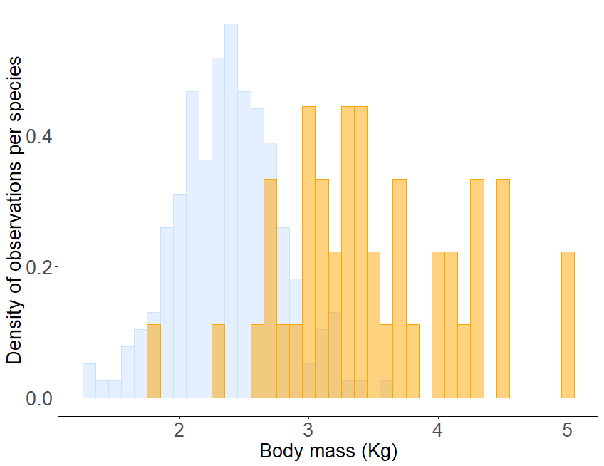
Fig. S1. Density histogram of body mass of red foxes (in orange) and Arctic foxes (in blue) legally harvested in the Churchill area, Manitoba, Canada in 2017 and 2018.
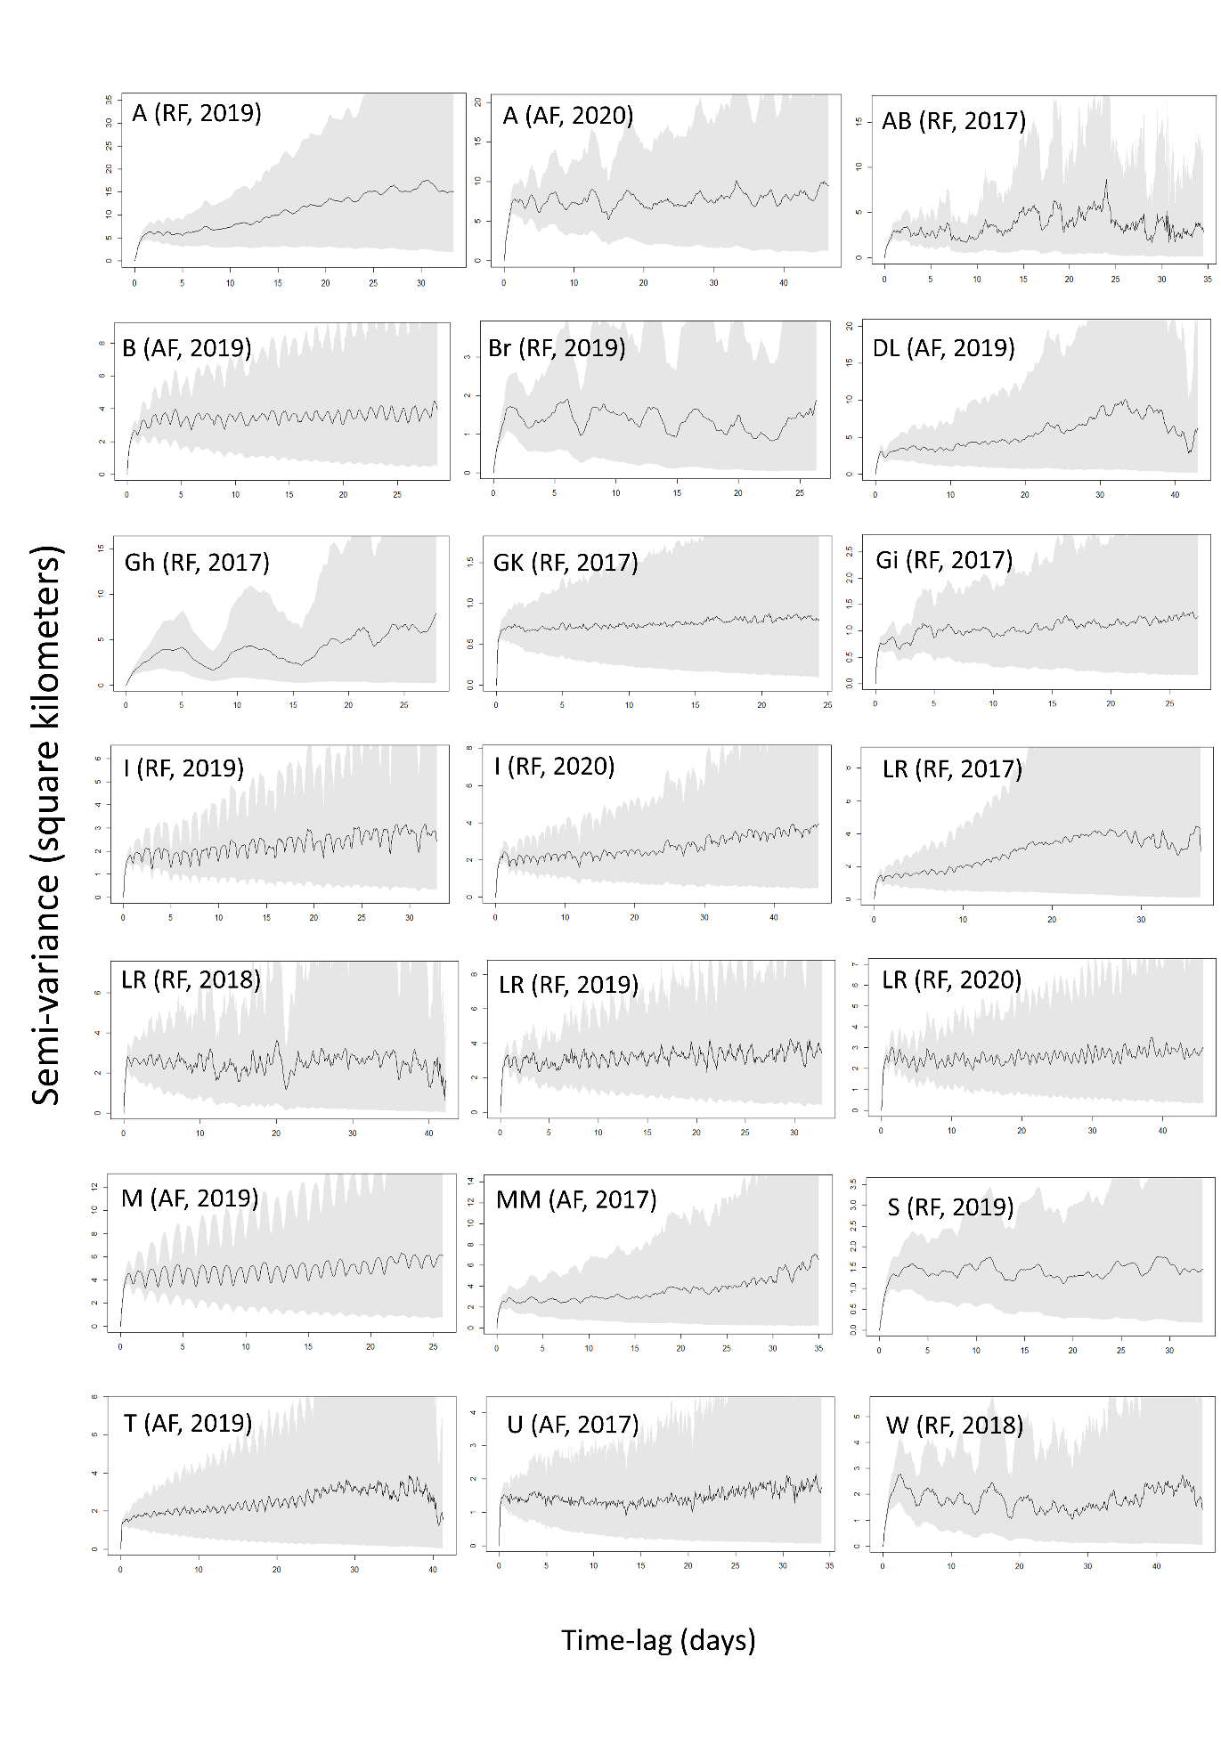
Fig. S2. Variograms of foxes identified as resident after inspection of their raw tracks at large time lags (25-40 days). AF = Arctic fox, RF = red fox.

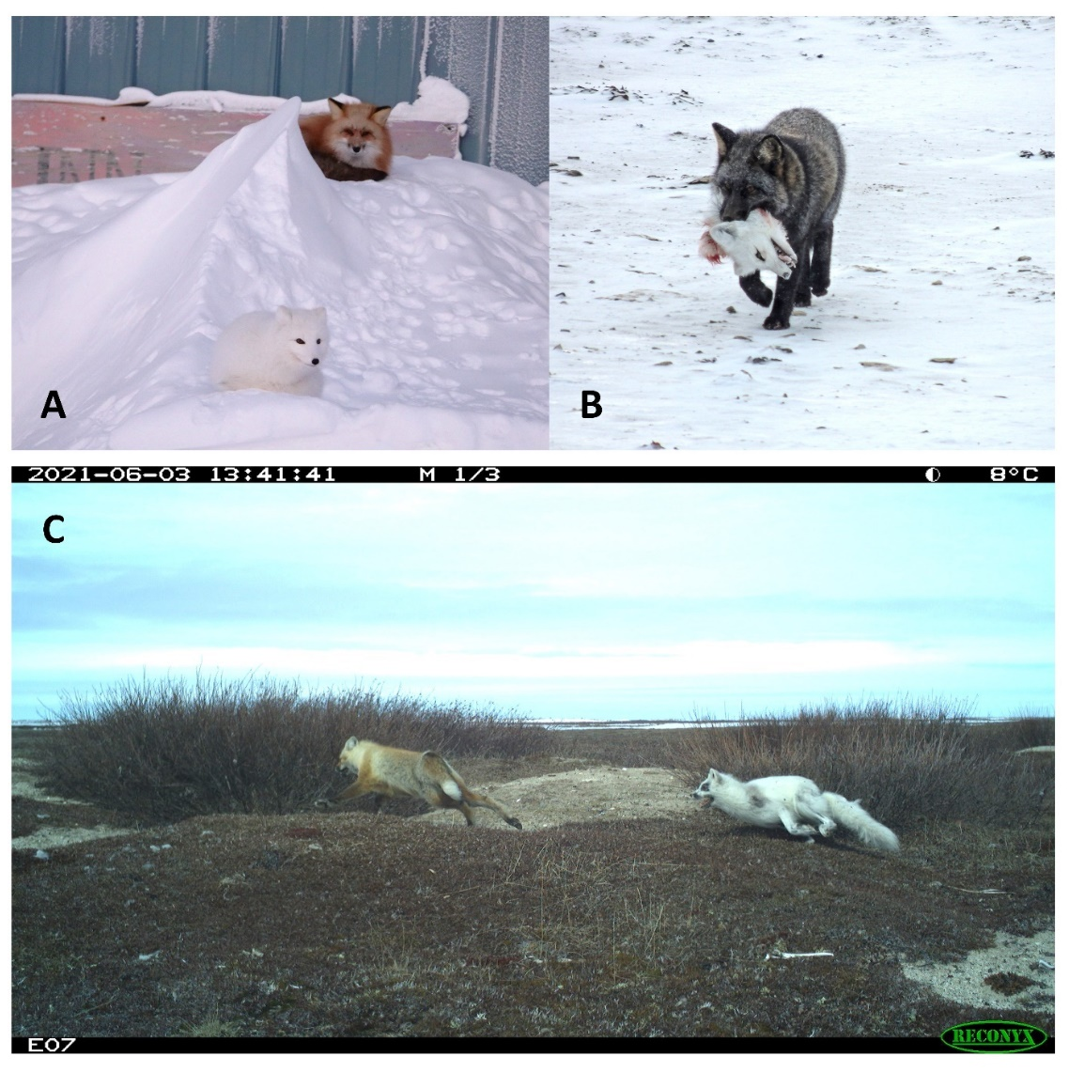
Fig. S3. Examples of interactions between Arctic and red foxes in the Churchill and Wapusk area in northeastern Manitoba, Canada. A) The two species can be observed tolerating each other, notably where they may access anthropogenic food subsidies (in town). B) Rarely but regularly, interference interactions can be lethal for the Arctic foxes. These extreme events were always observed in November (B. Debets, pers. obs., November 2014; J. Waterman, pers. obs., November 2017; D. Alcorn, pers. obs., November 2020), which, in Churchill, marks the beginning of food scarcity and harsher climate (Warret Rodrigues and Roth 2023). C) Arctic fox chasing a red fox from its den (interference interaction) in June, when geese have started reproduction and resources are becoming more abundant, but pups are likely born and highly vulnerable (both foxes remained alive at least until the camera stopped working the following week). Photos courtesy of Churchill resident Dave Allcorn (A; March 2022) and Dr. Jane Waterman (B; November 2017), and retrieved from our Reconyx trail camera by Sean Johnson-Bice (C; June 2021).

