Supplementary Material

EEF1A1 knock-down regulates the expression and alternative splicing of genes associated with Parkinson`s disease in U251 cells
Jing Lei¹, Zaolaguli Aisha¹, Yan Zhang¹ and Jianhua Ma^{2*}
* Correspondence: Jianhua Ma. Email：mjh9191@163.com
Supplementary Data

Supplementary Figures and Tables

Supplementary Figures
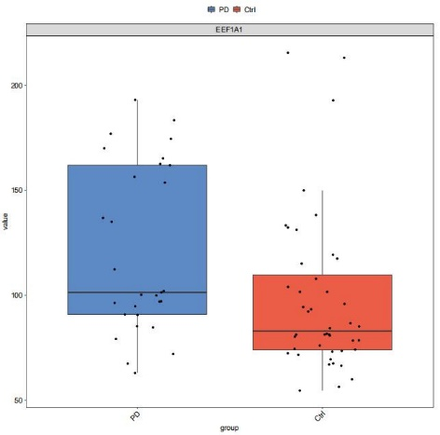
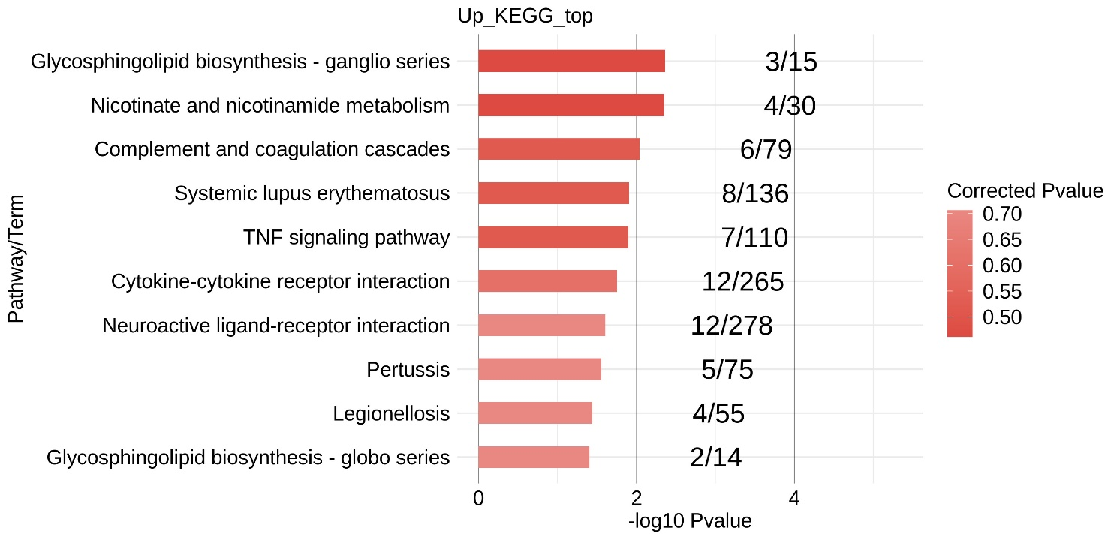
Supplementary Figure 1. Down loaded the GEO database data GSE68719, and BA9 brain tissue autopsied from 29 PD patients and 44 neurologically normal controls were obtained. RNA-seq analysis was performed. Our results showed that EEF1A1 was significantly over-expressed in PD brain tissue.
Supplementary Figure 2. KEGG enrichment analysis shows the up-regulated expressed genes.
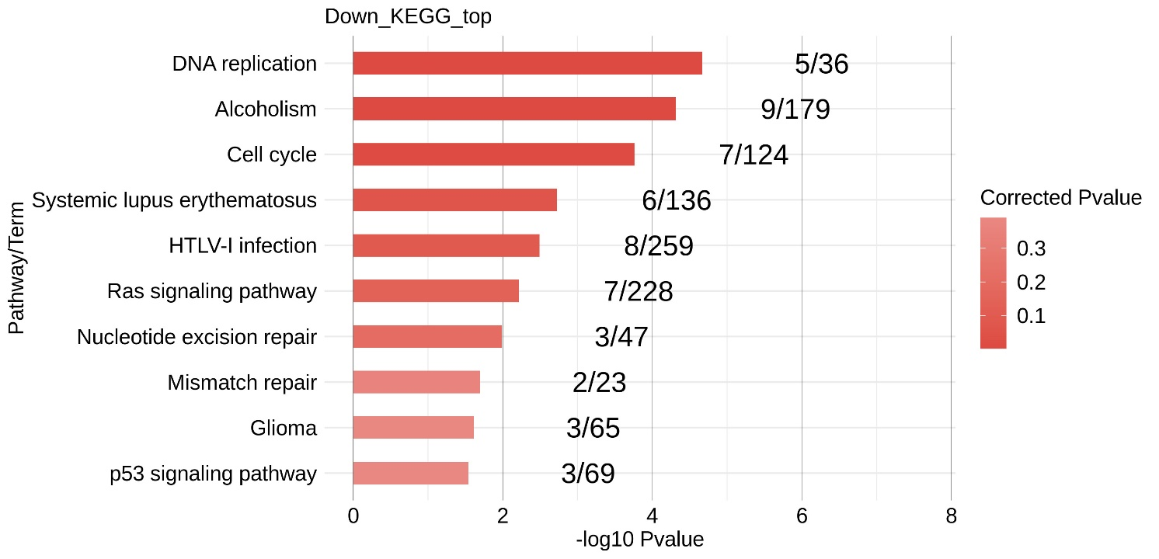
Supplementary Figure 3. KEGG enrichment analysis shows the down-regulated expressed genes.
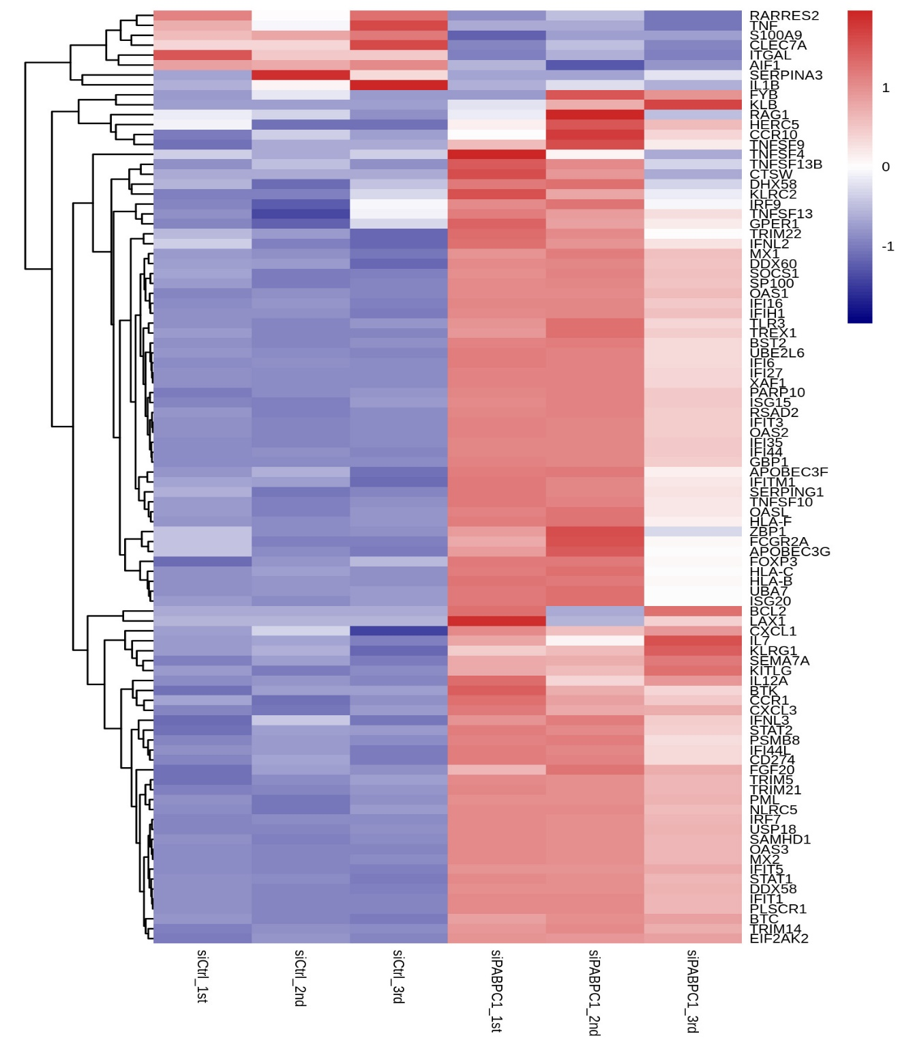
Supplementary Figure 4. The genes CXCL10, NGF, PTX3, IL6, ST6GALNAC3, NUPR1, TNFRSF21, CXCL2 were significantly up-regulated in the siRNA group.
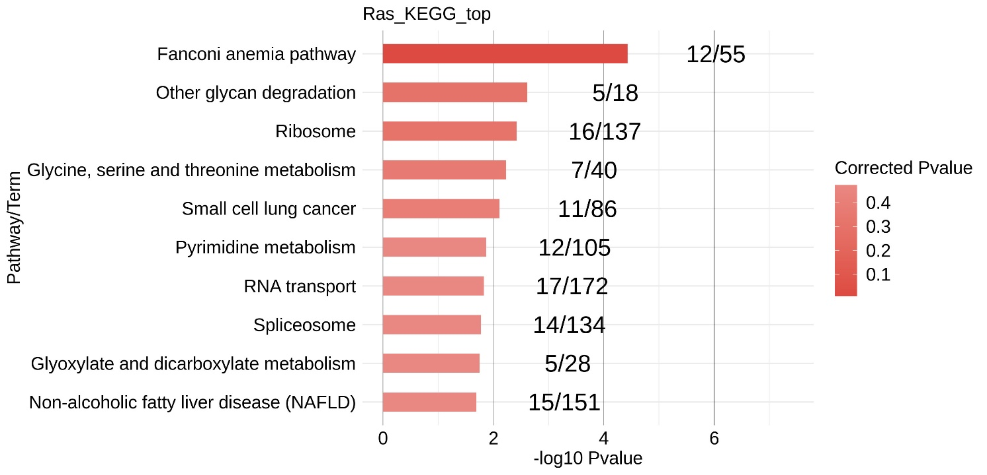
Supplementary Figure 5. Results of gene alternative splicing KEGG enrichment analysis.

Supplementary Tables
RT-qCR primers for gene expression qualification.
Gene | Primer | Sequence (5'-3') | Related Figures
GAPDH | Forward | GGTCGGAGTCAACGGATTTG | Figure 1A
GAPDH | Reverse | GGAAGATGGTGATGGGATTTC | Figure 1A
EEF1A1 | Forward | GCATCCTACCACCAACTC | Figure 1A
EEF1A1 | Reverse | ACGACGAACATCCTTGAC | Figure 1A
Supplementary Table 1. primer sequences.
#Sample | All_Junction | Novel_Junction | Known_Junction
siCtrl_1st | 186787 | 50717 | 136070
siCtrl_2nd | 182714 | 47929 | 134785
siCtrl_3rd | 190315 | 53291 | 137024
siEEF1A1_1st | 193843 | 54816 | 139027
siEEF1A1_2nd | 189844 | 52202 | 137642
siEEF1A1_3rd | 184600 | 48813 | 135787
Total | 320978 | 156965 | 164013
Supplementary Table 2. Aligning the quality-filtered reads to the human GRch38 genome and the expression values were calculated in units of FPKM, yielding a total of 30,729 expressed genes (FPKM > 0) for the six samples.

#Sample | All_Junction | Novel_Junction | Known_Junction
siCtrl_1st | 186787 | 50717 | 136070
siCtrl_2nd | 182714 | 47929 | 134785
siCtrl_3rd | 190315 | 53291 | 137024
siEEF1A1_1st | 193843 | 54816 | 139027
siEEF1A1_2nd | 189844 | 52202 | 137642
siEEF1A1_3rd | 184600 | 48813 | 135787
Total | 320978 | 156965 | 164013
Supplementary Table 3. 156,965 novel and 164,013 known splice sites were detected using TopHat2.
Supplementary Table 4. Using ABLas, ASEs from the concatenated reads were analyzed to identify 18,658 known ASEs (annotated ASEs) and 47,122 new ASEs (unannotated ASEs).

