Supplemental Material

Hippocampal overexpression of Nos1ap promotes endophenotypes related to mental disorders

Florian Freudenberg, Esin Candemir, Xufeng Chen, Li-Li Li, Dilhan Esen-Sehir, Nicole Schenk, Makoto Kinoshita, Lena Grünewald, Veronika Frerichs, Nikolai Fattakhov, Jessica Manchen, Solmaz Bikas, Anita Kumar, Aet O’Leary, David A. Slattery, Jakob von Engelhardt, Michael J. Courtney, Andreas Reif

Florian Freudenberg and Esin Candemir contributed equally to this work

Corresponding author: Dr. Florian Freudenberg, Department of Psychiatry, Psychosomatic Medicine and Psychotherapy, University Hospital, Goethe University, Heinrich-Hoffmann-Str. 10, 60528 Frankfurt am Main, Germany, Phone: +49 69 6301-85665, Fax: +49 69 6301-84481 florian.freudenberg@kgu.de

Supplemental Materials and Methods

Cloning of pAAV-hSyn-mCherry.3xFLAG.Nos1ap₃₉₆₋₅₀₃-WPRE
The pAAV-hSyn-mCherry.3xFLAG.Nos1ap₃₉₆₋₅₀₃-WPRE plasmid was generated analogous to the Nos1ap expressing recombinant adeno-associated virus (rAAV) described in [1]. In short, the DNA sequence coding for the carboxyterminal 108 amino acids of Nos1ap was amplified from mouse cDNA using primers Nos1ap₃₉₆₋₅₀₃-F and Nos1ap₃₉₆₋₅₀₃-R (Table S1), and the resulting PCR product was inserted in frame into the NheI and HindIII sites of pAAV-hSyn-mCherry.3xFLAG-WPRE) resulting in pAAV-hSyn-mCherry.3xFLAG.Nos1ap₃₉₆₋₅₀₃-WPRE.

Stereotaxic surgeries
Mice were given metamizole (Ratiopharm GmbH) in the drinking water (2 mg/ml) 48 h before and after surgery. Surgeries were performed at 7 weeks of age using a stereotaxic frame (Stoelting Co) under 1-2% isoflurane anesthesia (induction of anesthesia at 5-6%). To avoid heat-loss during anesthesia, the body temperature was maintained at 37 °C by a thermostatically controlled pad. For local anesthesia, 100-200 µl ropivacaine (2 mg/ml) was administered subcutaneously 5-10 min before making an incision above the scalp. Small holes were drilled using 0.6 mm carbide burrs at stereotaxic coordinates. Mice were injected bilaterally with virus-containing solution using stereotaxic coordinates for the dorsal hippocampus (AP: 2.1 mm, ML: ±1.6 mm, DV: 1.3 mm and 2.0 mm; 1 µl/injection site; flow rate: 0.1 µl/min) as previously published [2–4]. Mice were closely monitored after surgery and were allowed to recover for 4-5 weeks before starting experiments.
Mice used for electrophysiological measurements were injected at 5 weeks of age using coordinates for the ventral hippocampus (AP: 2.7 mm, ML: ±3.3 mm, DV: 3.3 mm; 2 µl virus/injection site; flow rate: 0.1 µl/min) as previously published [2–4]. Mice were closely monitored after surgery and were allowed to recover for 2-3 weeks and then were transported from the University Hospital Frankfurt to Mainz University Medical Center. Mice were allowed to acclimate to the new environment for at least two weeks before they were killed for electrophysiological recordings.

Molecular analyses of mouse brain tissue

Quantitative PCR (qPCR)
Hippocampal tissue from dorsal hippocampus of mice with virus-mediated overexpression of mCherry, Nos1ap, and Nos1ap₃₉₆₋₅₀₃ in dorsal hippocampus (5 mice per group) was dissected 4-5 weeks after injection and stored in RNA preserving solution (25 mM sodium citrate, 10 mM EDTA, 5.3 M ammonium sulfate, pH 5.2) at 4°C for one week. Hippocampi from both hemispheres were isolated on a cooling plate at 4°C and then stored at -20°C. RNA was isolated using the MagJET RNA Kit (ThermoFisher Scientific) according to the manufacturer’s instructions using a pipetting robot (Biomek NX^{P}, Beckman Coulter). A total of 375 ng RNA per sample was reverse transcribed using the iScript™ cDNA Synthesis Kit (Bio-Rad), using both random hexamers and oligo(dT) primers.
Target-specific quantitative PCR (qPCR) for Actb, B2m, Hprt, and Sdha (as reference genes) and for the 17 Nos1ap-associated genes (i.e. genes of gene products directly interacting with Nos1ap or functionally dependent on Nos1ap interactions) Cpe, Dlg1, Dlg3, Dlg4, Gria1, Gria2, Grin2a, Grin2b, Gucy1a1, Gucy1a2, Gucy1b1, Gucy1b2, Map2k3, Mapk14, Nos1, Nos1ap, Rasd1, Scrib, Syn1 (as target genes) was performed in 10 µl reactions containing 5 µl AMPLIFYME SG No-ROX Mix (Blirt), target specific forward and reverse primers (final concentration: 0.3 µM each; see Table S2 for primer sequences), and cDNA (final dilution: 1:200) using a 384-well plate (primaPLATE, Steinbrenner Laborsysteme GmbH) with LightCycler® 480 Sealing Foil (Roche) on the LightCycler® 480 Instrument II (Roche). All reactions were run in duplicates. PCR conditions: 3 min at 95 °C, followed by 45 cycles of 5 s at 95 °C, 10 s at 60 °C, and 10 s at 72 °C followed by a plate read. At the end of amplification, a melting curve was generated. Crossing point (Cp) values were calculated by the LightCycler 480 software (release 1.5.1.62) using the Second Derivative Maximum method. Relative gene expression levels were analyzed using GenEx6 v3.1.3 (MultiD Analyses AB). For every target, a standard curve was created on the same plate as the target samples and Cp values were corrected for efficiencies calculated from these standard curves (see Table S2). Missing data points (Hprt [1 from mCherry and 2 from Nos1ap], Dlg3 [1 from mCherry, 1 from Nos1ap], Scrib [1 from Nos1ap], Gucy1a2 [1 from mCherry]) were imputed. Expression data were calculated relative to the expression of Sdha which was selected as the most stable of the four reference genes by analysis with Normfinder. Data are displayed relative to the average of the mCherry group and converted to log2. Statistical significance was calculated using one-way ANOVAs for every target, and the significant P-value (i.e. significance threshold) was set to 0.05 corrected for the number of tested targets using the Bonferroni method (P_{Bonf} = $\frac{\text{0.05}}{\text{18 target genes}}$= 0.00278).

Protein isolation and co-IP
Hippocampal tissue from dorsal hippocampus of uninjected mice, and from mice with virus-mediated overexpression of mCherry, Nos1ap, and Nos1ap₃₉₆₋₅₀₃ in dorsal hippocampus was dissected 4-5 weeks after injection and snap-frozen in isopentane chilled with dry ice. Frozen tissue was weighed, and homogenized while thawing in 30 µl/mg low-salt buffer (LSB, [5]) supplemented with protease inhibitors, 1 mM DTT and nonionic detergent (0.5% Igepal CA-630) using 10 strokes of a dounce homogenizer, and precleared at 20,000 x g/4°C for 10 min. Protein content of each homogenate was quantified with the Bio-Rad DC protein assay kit (Bio-Rad) and equal amounts from each sample were used in parallel in the subsequent steps.
Co-immunoprecipitation was performed as previously described [6]. Briefly, immunoprecipitating (IP) antibody, nNOS antibody (mouse monoclonal clone A-11, RRID: AB_626757, Santa Cruz Biotechnology, 2.5 μg/ml) was added to each lysate. Lysates were rotated for 2 h/4°C, 5 μl of protein-A resin (GenScript) was added, and rotation continued for 1 h. The resin was washed three times with LSB, and protein was eluted from drained resin by incubation at 95° for 10 min in SDS-PAGE sample loading buffer and analyzed by Western blotting. Immunoprecipitated nNOS, and co-immunoprecipitated Nos1ap and PSD-95 in all samples were determined by Western blotting with anti-nNOS antibody (rabbit polyclonal IgG, RRID:AB_2313734, Invitrogen), anti-NOS1AP antibody (rabbit polyclonal IgG, R-300, RRID: AB_2251417, Santa Cruz Biotechnology) and anti-PSD-95 antibody (mouse monoclonal IgG2a, clone K28/43, RRID:AB_2307331,UC Davis/NIH NeuroMab Facility) respectively. Secondary antibodies conjugated to HRP (Santa Cruz Biotechnology) were used and detected with enhanced chemiluminescence (ECL) reagent (Thermo Scientific).
Immunoblots of co-IP and input protein were quantified using ImageJ. For analysis of the endogenous Nos1ap levels in the input samples, differences in intensities of the bands per lane required a more precise quantification as follows. Data from scanned exposures of blots trimmed to remove the bulk of excess signal from over-expressed protein (Figure S2E) were collected from equal width regions of interest in ImageJ and imported to Excel. The data for each lane was fitted to gaussians (one per band present in the analyzed lane data) using the Excel solver add-in.

Electrophysiology
Brains were quickly removed from deeply anesthetized 2-month-old C57BL/6JRj mice with ventral hippocampus injections of mCherry, Nos1ap or Nos1ap₃₉₆₋₅₀₃ expressing rAAVs. Horizontal 250 μm slices were cut in oxygenated 0-4 °C cutting solution containing 87 mM NaCl, 2.5 mM KCl, 37.5 mM choline chloride, 25 mM NaHCO₃, 1.25 mM NaH₂PO₄, 25 mM glucose, 0.5 mM CaCl₂, and 7 mM MgCl₂. Slices were kept for 30 mins in the cutting solution at 34 °C and then for at least another 30 mins in the recording artificial cerebrospinal fluid (ACSF) containing 125 mM NaCl, 25 mM NaHCO₃, 1.25 mM NaH₂PO₄, 2.5 mM KCl, 2 mM CaCl2, 1 mM MgCl₂, 25 mM glucose at 34 °C (pH 7.2, maintained by continuous bubbling with carbogen). Slices were continuously perfused with recording ACSF. Intracellular recordings were performed in the whole-cell configuration using pipettes pulled from borosilicate glass capillaries with a resistance of 3–5 MΩ when filled with a solution containing 120 mM Cs-gluconate, 10 mM CsCl, 8 mM NaCl, 10 mM HEPES, 10 mM phosphocreatine-Na, 0.3 mM Na₃GTP, 2 mM MgATP, 0.2 mM EGTA (pH 7.3, adjusted with CsOH). Liquid junction potentials were not corrected. Series resistance and input resistance were continuously monitored by measuring peak and steady-state currents in response to 5 mV depolarizing pulses.
Evoked excitatory postsynaptic currents (EPSCs) were recorded at room temperature by electrically stimulating Schaffer collateral fibers. AMPA receptor-mediated currents were recorded at a holding potential of -70 mV. NMDA receptor-mediated currents were recorded at a holding potential of + 40 mV. 10 μM SR 95531 hydrobromide was used to block GABA_{A}-receptors. AMPA/NMDA ratio was calculated from the amplitudes of AMPA receptor-mediated and NMDA receptor-mediated currents. Amplitudes of NMDA receptor-mediated currents were measured 25 ms after the stimulus artifact. Synaptic short-term plasticity was investigated by two stimulations of equal stimulation strength of Schaffer collateral fibers with 30 ms and 100 ms inter-stimulus intervals. 50 µM D-APV and 10 μM SR 95,531 hydrobromide were added to block NMDA receptors and GABA_{A} receptors, respectively. The paired-pulse ratio was calculated by dividing the amplitude of the second EPSC by that of the first EPSC (EPSC2/EPSC1).
Miniature EPSCs (mEPSCs) were recorded from CA1 neurons at a holding potential of -70 mV at 34 °C and with 1 µM tetrodotoxin in the ACSF. 10 µM SR 95531 hydrobromide and 50 µM D-APV were added to block GABA_{A} receptors and NMDA receptors, respectively.

Dendritic spine analysis

Golgi Staining
For Golgi staining, mice were killed by cervical dislocation one month after stereotaxic delivery of the viral vectors into the dorsal hippocampus. The freshly dissected brains were fixed in 4% Histofix (Carl Roth) for 4 h at room temperature and then transferred to 30% sucrose in 1xPBS at 4°C overnight. Brains were then stained using the FD Rapid GolgiStain kit (FD NeuroTechnologies) according to the manufacturer’s instructions. In short, brains were immersed in FD Solution A + B at room temperature for 10 days followed by FD Solution C for 4 days. Brains were stored at - 20°C until sectioning. Sagittal sections (100 µm thickness) were made at -22°C using a cryostat (Leica CM 3050 S) and transferred to glass slides (Superfrost, ThermoFisher Scientific). After drying sections at room temperature for at least 24 h, slides were temporarily coverslipped with 20% Glycerol (in 1xPBS) and microscopically imaged for mCherry fluorescence at 2.5x (0.085 numerical aperture) on an automated Axio Observer.Z1 equipped with an Axiocam 506 mono and Colibri.2 LED light source (all microscopic equipment from ZEISS). After imaging, coverslips were removed, and slides were rinsed with double distilled water 2x3 min each, then placed in a mixture containing FD Solution D and E (25% each) and double distilled (50%) water for 10 min. Brains were rinsed 2x3 min in double distilled water and dehydrated in a series of 50%, 75%, 95%, 100% ethanol each for 3 min before clearing 2x3 min in xylenes. Brains were coverslipped using Histofluid (Paul Marienfeld).

Spine Imaging and quantification
Golgi-stained dendrites were imaged using an EC Plan-Neofluar 40x (1.3 numerical aperture) Oil M27 objective combined with 1.6x Tubelens Optovar on an Axio Observer.Z1 equipped with an Axiocam 506 mono (all microscopic equipment from ZEISS). Z-stacks (~20-30 µm Z-axis in total; distance between optical sections = 0.33 µm) were taken from randomly chosen secondary dendrites in the stratum radiatum of dorsal hippocampal CA1 pyramidal cells. For each viral vector, a total of 25 dendrites from 5 different mice (i.e. 5 dendrites per mouse) were analyzed.
Dendritic spines were classified using the trainable classifier in NeuronStudio software (version 0.9.92). Output classes were defined as stubby, mushroom, long-thin, thin, filopodia and branched. The training set contained 200 spines (24 stubby, 60 mushroom, 23 thin, 56 long-thin, 35 filopodia, 2 branched). A region of interest with a length of 30 µm was set and spines were classified according to the classification scheme. After automatic detection spine identification was manually verified and corrected. For analysis, thin and long-thin spines were combined. Branched spines were excluded from analysis. The total number of mature spines was calculated as the sum of all spine types excluding branched or filopodia.

Analysis of behavior

Light dark box (LDB)
The LDB apparatus (Stoelting Co) consisted of a chamber made from infrared transparent black acrylic glass (W: 40 cm x L: 40 cm x H: 35 cm), separated into a brightly lit (~400 lux) and a dark (~3 lux illuminated by an infrared light source) compartment (each 20 x 40 cm in size) connected by an opening. Each mouse was placed in the dark compartment facing a corner and allowed to freely explore the LDB for 10 min. Behavior was recorded with an infrared sensitive USB camera (The Imaging Source) and the first 5 min were automatically quantified using ANY-maze (Stoelting Co).

Elevated zero maze (EZM)
The EZM apparatus consisted of a circular platform (diameter: 50 cm, lane width: 5 cm, elevated 50 cm from the ground) that contained two opposing closed sections (wall height: 15 cm; illumination: ~30 lux) and two opposing open sections with a 5 mm high lip (illumination: ~120 lux). Mice were placed on the start of a closed compartment facing that compartment and their behavior was recorded under infrared illumination for 10 min by use of an infrared sensitive USB camera (The Imaging Source) and the first 5 min were automatically quantified using ANY-maze (Stoelting Co).

Open field (OF)
The OF apparatus (Stoelting Co) was surrounded by walls made from black acrylic glass (W: 40 cm x
L: 40 cm x H: 35 cm). Each mouse was placed into the OF facing one of the corners and allowed to explore the chamber for 10 min. Horizontal activity was monitored using a USB camera (The Imaging Source) and vertical activity was measured using an infrared array (Stoelting Co). Behavior was automatically quantified using ANY-maze (Stoelting Co).

Social interaction and social recognition
One day after the OF test (see 1.6.3) mice were placed back into the OF arena (light level: 40 lux) for 1 min to re-habituate to the environment. A juvenile conspecific stimulus mouse (4 weeks of age) was placed into the OF arena and both mice could freely explore each other for 5 min. The test was terminated prematurely if the test mouse attacked the stimulus mouse. Mice were returned to their home cage and after 30 min, the test mouse was returned to the OF and habituated again for 1 min. The same ‘familiar’ juvenile mouse and a ‘novel’ juvenile stimulus mouse were placed into the OF arena and they were allowed to freely explore each other for 5 min.
For both sessions the first 3 min of interaction were manually evaluated using the ANY-Maze software. Social interaction was defined as time spent when test mice explored (e.g. sniffing, touching, licking) the stimulus mice; i.e. investigation of the test mouse by the juvenile was not included in the scoring. All mice that attacked the juvenile interaction partner (one mCherry and one Nos1ap expressing mouse each) and mice with barbered whiskers (2 mCherry, 1 Nos1ap, 1 Nos1ap₃₉₆₋₅₀₃) were excluded from data analysis for social interaction.

Prepulse inhibition (PPI) of the acoustic startle response (ASR)
PPI of the ASR was measured using the SR-LAB™ startle response system (San Diego Instruments, Inc., USA) as described previously [7]. Briefly, after 5 min acclimation to the background noise (65 dB white noise), mice were exposed to six startle pulse trials (120 dB broadband noise for 40 ms, 10 s inter trial interval [ITI]). Subsequently, mice were presented with 10 x no-stimulus, 10 x startle pulse, 10 x each prepulse (4, 8, 12, 16 dB above background = 69, 73, 77, 81 dB for 20 ms) followed after 80 ms by a startle pulse, 10 x prepulse only (81 dB) in pseudorandomized order with a variable ITI (20-30 s). The test session ended with six startle pulse trials separated by 10 s ITIs. Overall, this protocol lasted about 35 min. The magnitude of the ASR (whole body reflex) to pulse only trials were averaged for each mouse and defined as startle amplitude. PPI percentage was calculated as described in [7] using the following formula:
PPI(%) = 100 × $\frac{{\text{startle amplitude}}_{\text{startle trials}}\text{-}{\text{startle amplitude}}_{\text{prepulse+startle trials}}}{{\text{startle amplitude}}_{\text{startle trials}}}$

Sucrose preference
To measure preference for a sucrose containing solution mice were provided with two bottles, one filled with 1% sucrose in tap water and another only containing tap water for 48 hours. To avoid any side preferences, bottles containing sucrose were first positioned on the right side of the feeder grid where mice were used to receive drinking water and bottles containing water were positioned to left of the grid. After 24 h, bottle positions were switched. Sucrose preference was calculated by the following formula:
Sucrose preference (%) = 100 × $\frac{\text{Amount of sucrose solution consumed}}{\text{Total amount of liquid consumed}}$

Rewarded alternation task
Rewarded alternation was performed on a grey T-maze apparatus (Stoelting Co) with a start arm (35 cm x 5 cm) and two equal goal arms (28 cm x 5 cm) enclosed by 10 cm high walls as described previously [2,3]. In brief, mice were weighed daily and fed with chopped food pellets sufficient to maintain their body weight at 80-85% of their free-feeding weight. For each trial, 20 μl of sweetened condensed milk (Dovgan, 50% diluted in water) per goal arm was provided as a reward. A trial started by placing a mouse into the start arm facing away from the goal arms. Mice were forced into one of the goal arms by blocking the other goal arm and were retrieved after consuming the milk. Mice were placed back to the start arm, the block was removed, and they were allowed to freely choose one of the goal arms. The correct choice (previously unvisited arm) was rewarded. Animals received one session (4 trials) per day for the first two days and two sessions (4 trials each) per day for 11 days (i.e. 96 trials in total). Each mouse received an equal number of right and left arm runs. Performance was calculated as the percentage of correct choices per block (24 trials per block).

Spatial novelty preference
Spatial novelty preference was performed as described [2] on a Y-maze apparatus (Stoelting Co) consisting of three equal arms (35 cm x 5 cm enclosed with 10 cm high walls). Briefly, for each mouse, one of the arms was randomly designated as the novel arm, which remained blocked, except during the last trial. The mouse was placed at the end of one of the unblocked arms (start arm) and allowed to freely explore both arms for 2 min after leaving the start arm. This procedure was repeated five times in total (i.e. 5 x 2 min trials) with 1 min ITIs and alternating the start arm. After the 5th trial the block was removed from the novel arm and the mouse was placed back to the start arm to explore the maze for a final 2 min. Time spent exploring the novel arm was recorded using ANY-maze (Stoelting Co.) and preference for the novel arm was calculated.

Spatial reference memory
Spatial reference memory was performed under food deprivation as described in 1.7.7 using the same Y-maze described under 1.7.8. Each mouse was randomly assigned a goal arm that remained constant throughout training. For each trial, a mouse was placed into one of the other arms, which alternated pseudo-randomly. If a mouse chose the correct goal arm it received a reward (20 µl of sweetened condensed-milk, Dovgan, 50% diluted in water). Animals received two sessions (4 trials each) per day for the first two days and 3 sessions (4 trials each) for the following four days. At the end of the day, the percentage of correct choices were calculated per session.

Analysis of brains after behavioral analysis

Fixation and cryosectioning
Within two weeks after behavioral testing, animals were deeply anesthetized with 5-6% isoflurane and immediately fixed via transcardial perfusion with 6 ml 1x PBS solution followed by 30 ml 4% formaldehyde (FA) in 1x PBS with a perfusion speed of 3 ml/min. Brains were post-fixed in 4% FA in 1x PBS for 2 h, cryoprotected in 30% sucrose in 1x PBS for 48 h and then frozen at -20 °C. Coronal sections (20 µm thickness) were made at -20°C using Leica CM 3050 S and transferred to glass slides (Superfrost, ThermoFisher Scientific). Sections were kept at -80°C until further use.

Evaluation of viral infections
Glass slides with brain sections were mounted with a coverslip using Fluoroshield mounting medium (Sigma-Aldrich) and analyzed at 2.5x magnification on a fluorescence microscope Axio Observer Z1 (ZEISS). Viral infections were assessed in CA1/CA2, CA3 and dentate gyrus (DG) separately by applying a semi-quantitative value on a scale from 0 to 4 (0 = no mCherry fluorescence visible, 1 = ~1-25% cells showing mCherry fluorescence, 2 = ~25-50%, 3 = ~50-75%, 4 = ~75-100%). Slices between ~-1.3 mm to ~-2.7 mm from bregma according to the mouse brain atlas [8] with 200 µm between sections were scored for both hemispheres and the results were averaged to obtain a mean score for the dorsal hippocampus.

Supplemental Figures

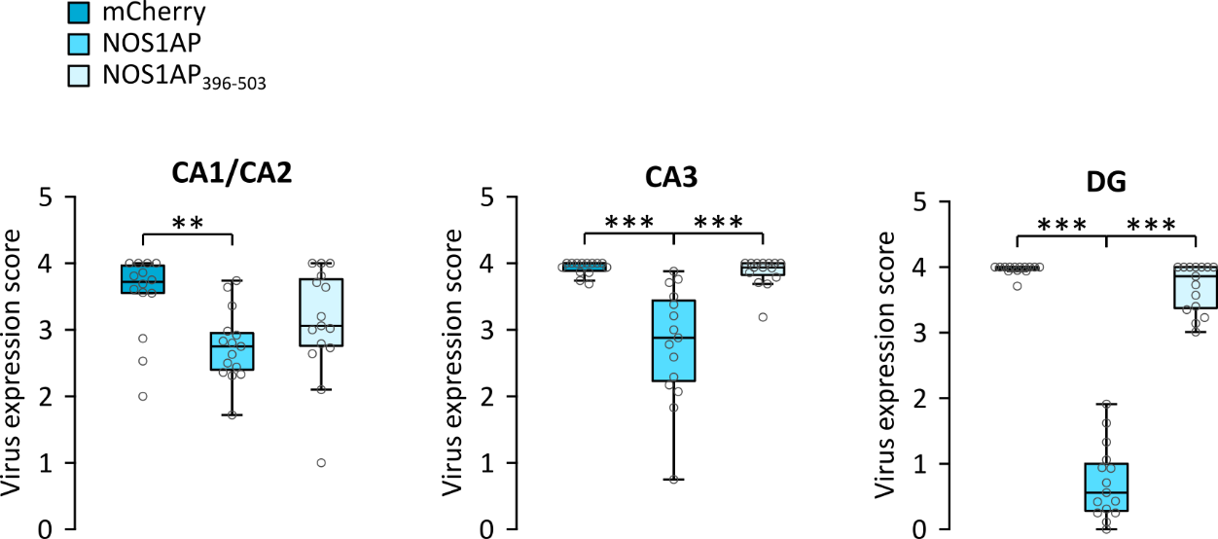

Figure S1: Expression of viral vectors in subregions of the dorsal hippocampus of mice used for behavioral analyses. Expression of viral vectors was assessed in coronal sections throughout the dorsal hippocampus, CA1/CA2, CA3 and dentate gyrus (DG) separately by applying a semi-quantitative value on a scale from 0 to 4 (0 = no mCherry fluorescence, 1 = 1-25% cells showing mCherry fluorescence, 2 = 26-50%, 3 = 51-75%, 4 = 76-100%). Expression levels were significantly affected in all hippocampal subregions, i.e. CA1/CA2 (F_{2,41}=4.692, P=0.015), CA3 (F_{2,41}=22.602, P<0.001), and DG (F_{2,41}=302.384, P<0.001). Asterisks indicate significant differences for uncorrected post-hoc t-tests: **P<0.01, ***P<0.001

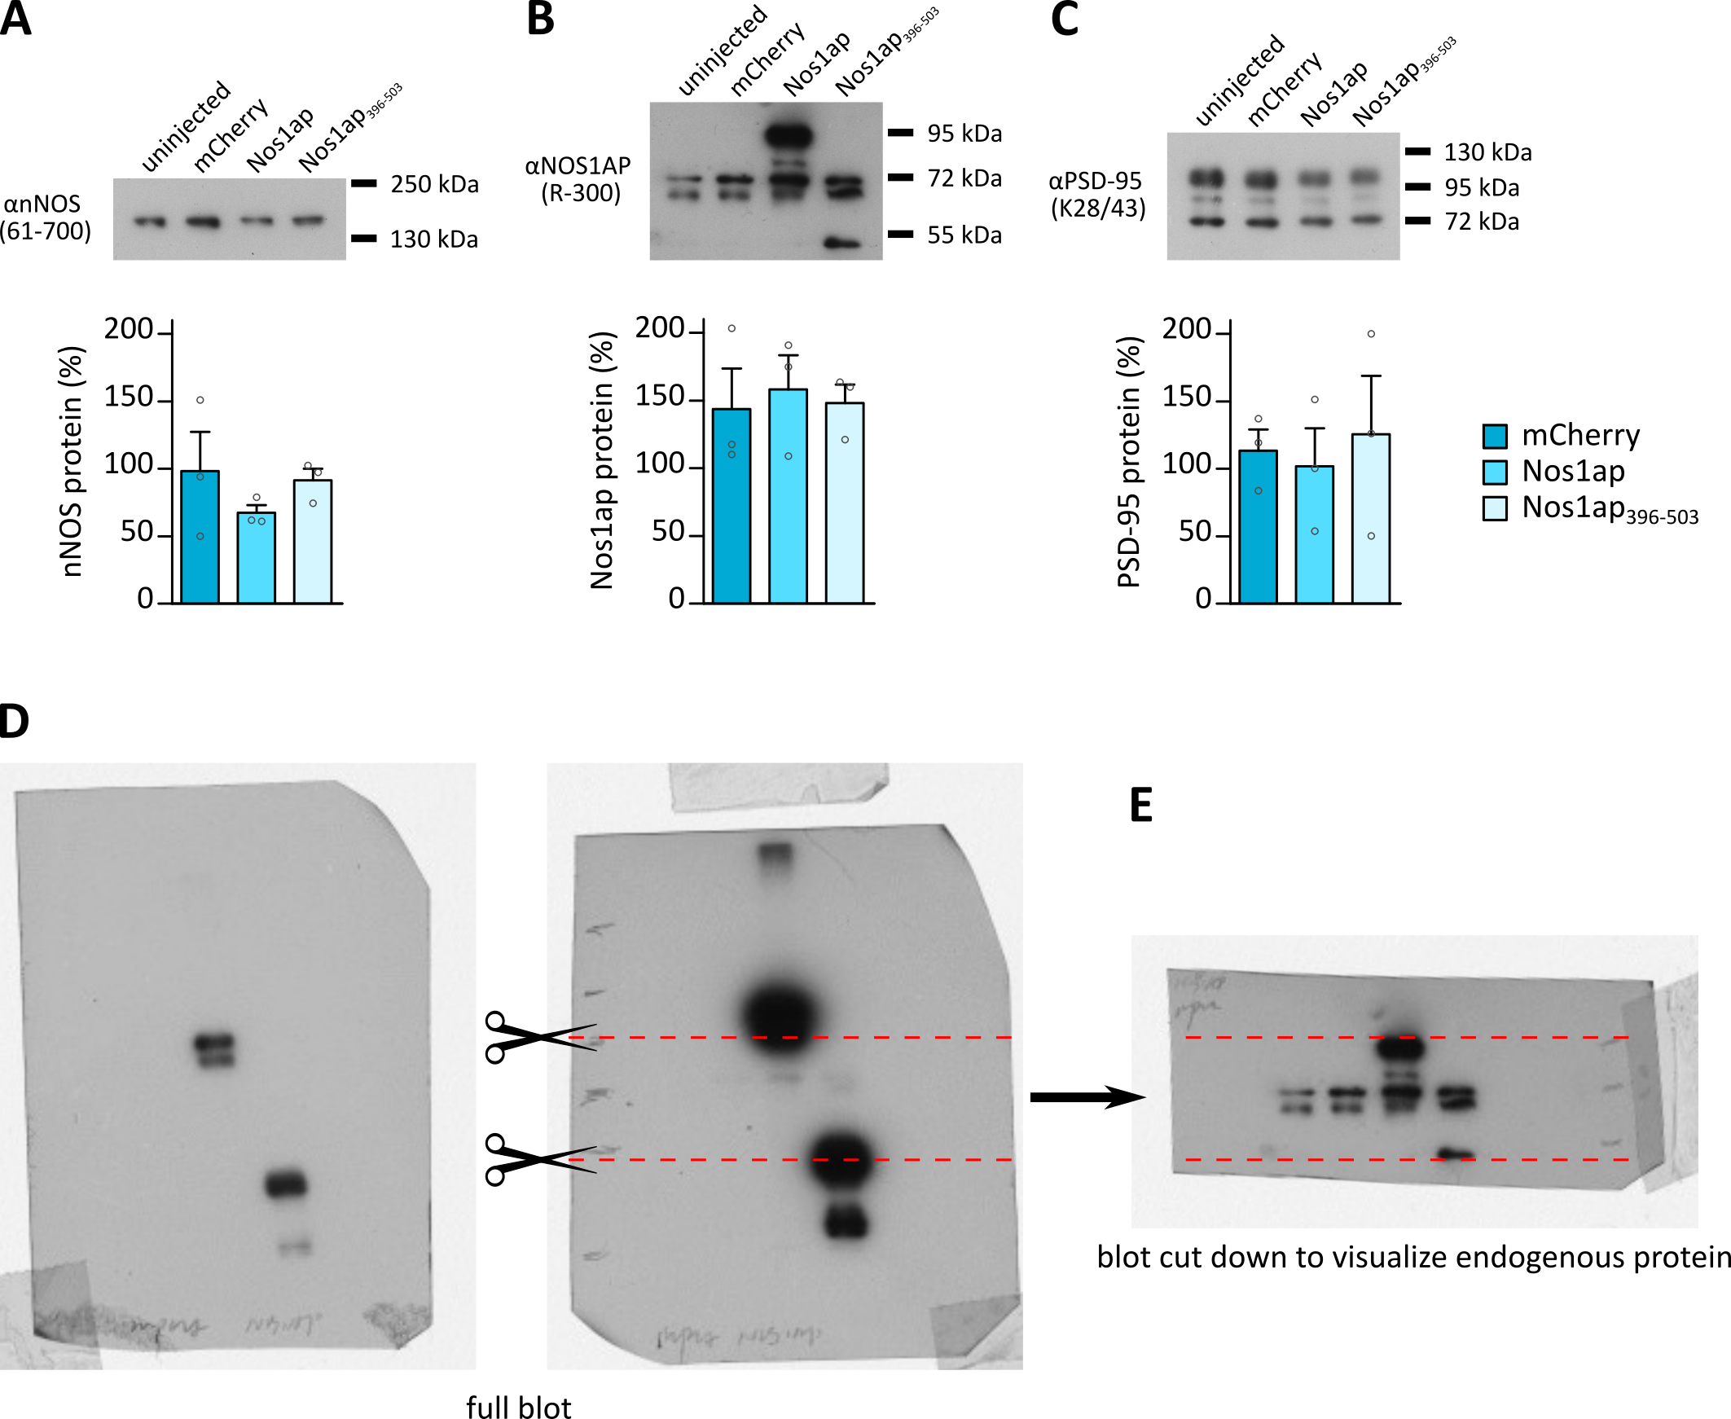

Figure S2: Endogenous protein levels of nNOS, endogenous Nos1ap, and PSD-95 are not affected by viral overexpression of Nos1ap or Nos1ap₃₉₆₋₅₀₃. (A-C, top) Representative blots showing immunosignal for nNOS, NOS1AP and PSD-95 in co-IP samples. (A-C, bottom) Quantification of the Western blot signal relatively to the levels from uninjected mice, showing no significant changes in levels of (A) nNOS (F_{2,6}=0.833, P=0.479), (B) Nos1ap (only endogenous protein level estimates were used; see D and E) (F_{2,6}=0.099, P=0.907), or (C) PSD-95 (F_{2,6}=0.144, P=0.869). Note that equal amounts of total protein were loaded on the gel, but protein levels were not normalized otherwise. (D) Two different exposures of the same blot stained for NOS1AP. Blots are dominated by the virally overexpressed proteins, whereas the endogenous protein bands are only faintly visible. After a shorter exposure to show the overexpressed proteins with minimal saturation (left panel) and longer exposure to visualize both endogenous and overexpressed protein (right), the blot was cut as indicated by the dashed red line. This was necessary to remove most of the viral proteins and reduce the disturbance caused by their extremely high signals on subsequent detection of the endogenous protein. (E) The same blot as in D after cutting as described above, was re-incubated (note that this is the full image of this example blot shown in B).

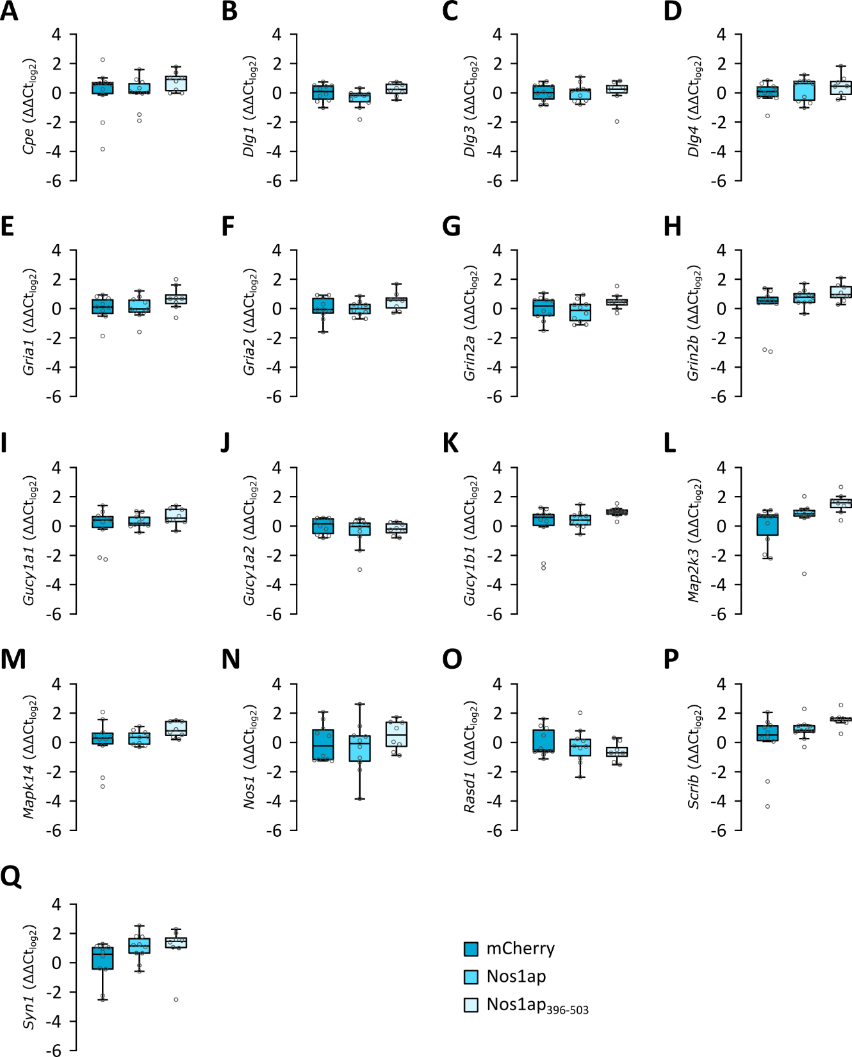

Figure S3: Quantification of mRNA expression of selected Nos1ap-associated genes. Gene expression of the following genes was quantified by quantitative PCR: (A) Cpe (F_{2,25}=1.045, P=0.366), (B) Dlg1 (F_{2,25}=3.009, P=0.067), (C) Dlg3 (F_{2,25}=0.017, P=0.983), (D) Dlg4 (F_{2,25}=0.811, P=0.456), (E) Gria1 (F_{2,25}=1.978, P=0.159), (F) Gria2 (F_{2,25}=1.725, P=0.199), (G) Grin2a (F_{2,25}=1.903, P=0.17), (H) Grin2b (F_{2,25}=2.628, P=0.092), (I) Gucy1a1 (F_{2,25}=1.219, P=0.312), (J) Gucy1a2 (F_{2,25}=0.539, P=0.402), (K) Gucy1b1 (F_{2,25}=2.115, P=0.142), (L) Map2k3 (F_{2,25}=3.835, P=0.035), (M) Mapk14 (F_{2,25}=1.668, P=0.209), (N) Nos1 (F_{2,25}=0.785, P=0.467), (O) Rasd1 (F_{2,25}=0.956, P=0.398), (P) Scrib (F_{2,25}=3.384, P=0.05), (Q) Syn1 (F_{2,25}=2.076, P=0.147). Expression of none of the tested genes was significantly affected after correction for multiple testing (Bonferroni-corrected P-value: P_{Bonf}=0.00278).

Supplemental Tables
Table S1: Sequences of oligonucleotides used in this study
Name | Sequence (5’ 3’)
WPRE-F | TGCTTCCCGTATGGCTTTCAT
WPRE-R | CATAGCGTAAAAGGAGCAACA
Nos1ap₃₉₆₋₅₀₃-F | AGTgctagctCACTCACCACTGCTGGGCGC
Nos1ap₃₉₆₋₅₀₃-R | GTCaagcttaCTACACGGCGATCTCATCATC

Table S2: Primer pairs used for qPCR
Name (Target)ª | Sequences^{b} | Target transcripts^{c} | Std. curve^{d}
Actb (Mus musculus actin, beta) | F: GCTTCTTTGCAGCTCCTTCG  R: ATGCCGGAGCCGTTGTC | 60-156 of NM_007393.5 | y = -3.45x+18.4  r² = 0.995  E = 0.951
B2m (Mus musculus beta-2 microglobulin | F: ACTGACCGGCCTGTATGCTA  R: CAATGTGAGGCGGGTGGAA | 93-217 of NM_009735.3 | y = -2.97x+17.8  r² = 0.956  E = 1.172
Cpe (Mus musculus carboxypeptidase E) | F: AGGGTTTGTCCGTGACCTTC  R: GGAGCGGAGGCTGTAAGTTT | 1291-1437 of NM_013494.4 | y = -3.13x+14.9  r² = 0.977  E = 1.088
Dlg1 (Mus musculus discs large MAGUK scaffold protein 1) | F: GTCACCAGCCAGGTACTCAC  R: AGTCCTGTTGAGCCACGATG | 1744-1845 of NM_007862.3, 1645-1746 of NM_001252433.1, NM_001252434.1, NM_001357282.1, 1403-1504 of NM_001252435.1, 1510-1611 of NM_001252436.1, 1498-1599 of NM_001252436.1, 1455-1556 of NM_001357281.1 | y = -3.6x+21.3  r² = 0.984  E = 0.896
Dlg3 (Mus musculus discs large MAGUK scaffold protein 3) | F: GCAGCATGAGTTCTGGGTCT  R: GCTGTCACGAGTCCGATCAT | 1864-1958 of NM_016747.4 and NM_001177778.2, 765-859 of NM_001177779.1, 157-251 of NM_001177780.1, 1810-1904 of NM_001290402.1 | y = -2.71x+22.5  r² = 0.978  E = 1.34
Dlg4 (Mus musculus discs large MAGUK scaffold protein 4) | F: GCTATGCTCCCCCAGACATC  R: GGTAGTCGGTGCCCAAGTAG | 1076-1162 of NM_007864.3, 1067-1153 of NM_001109752.1, 864-950 of NM_001370671.1, 862-948 of NM_001370672.1, 697-783 of NM_001370674.1, 893-979 of NM_001370675.1 | y = -3.26x+18.6  r² = 0.986  E = 1.025
Gria1 (Mus musculus glutamate receptor, ionotropic, AMPA1 (alpha 1)) | F: ATCCTGACACAAAGGCCTGG  R: TCCTCCCGGACCAAGGTTAT | 1819-1918 of NM_001113325.2 and NM_008165.4, 1446-1545 of NM_001252403.1 | y = -3.52x+18.5  r² = 0.964  E = 0.924
Gria2 (Mus musculus glutamate receptor, ionotropic, AMPA2 (alpha 2)) | F: ATGCGACCTGACCTCAAAGG  R: AGCAGAATCCAGCACAGCTT | 691-813 of NM_001083806.3, NM_013540.4, NM_001039195.3, NM_001357924.2 and NM_001357927.2 | y = -3.54x+16.6  r² = 0.975  E = 0.916
Grin2a (Mus musculus glutamate receptor, ionotropic, NMDA2A (epsilon 1)) | F: CTGCCGCATCTTCCATGTTG  R: TCCTTGCCATCCCAAGTCAC | 2102-2240 of NM_008170.4 | y = -3.52x+21  r² = 0.955  E = 0.923
Grin2b (Mus musculus glutamate receptor, ionotropic, NMDA2B (epsilon 2)) | F: TTCTGTCCCTTTATCCTCCGTCTT  R: TCATCTTCAGCTCGTCGACTC | 657-801 of NM_008171.4, 491-635 of NM_001363750.1 | y = -3.48x+19.2  r² = 0.998  E = 0.939
Hprt (Mus musculus hypoxanthine guanine phosphoribosyl transferase) | F: TGCTGACCTGCTGGATTACA  R: TTTATGTCCCCCGTTGACTGA | 371-490 of NM_013556.2 | y = -3.28x+18.8  r² = 0.98  E = 1.016
Gucy1a1 (Mus musculus guanylate cyclase 1, soluble, alpha 1) | F: AAGCCGCAACAGAGTCTACC  R: AAGTGCAAGGTTCAGTCGCT | 571-658 of NM_021896.6, 684-771 of NM_001356988.1, 558-645 of NM_001356987.1 | y = -3.83x+22.7  r² = 0.988  E = 0.824
Guc1a2 (Mus musculus guanylate cyclase 1, soluble, alpha 2) | F: GCCACCTTTGATAGAGTCTTGC  R: ATGGCACTTGATTCTGGGACA | 1565-1704 of NM_001033322.2 | y = -3.43x+21.8  r² = 0.973  E = 0.956
Gucy1b1 (Mus musculus guanylate cyclase 1, soluble, beta 1) | F: TCTGCCAGGAGTCTGGCTAT  R: TAAATGGTGGCGAGGTGGTC | 367-472 of NM_017469.4 and NM_001161796.1 | y = -4.06x+21.8  r² = 0.996  E = 0.764
Map2k3 (Mus musculus mitogen-activated protein kinase kinase 3) | F: GGACCTAGACATCAACATGCG  R: CATGCAGATCCATACATCCCC | 496-589 of NM_008928.5 | y = -3.17x+25.7  r² = 0.965  E = 1.068
Mapk14 (Mus musculus mitogen-activated protein kinase 14) | F: TCACGCCAAAAGGACCTACC  R: ATTCCTCCAGTGACCTTGCG | 587-693 of NM_011951.3 and NM_001168508.1, 188-294 of NM_001168513.1 and NM_001357724.1, 632-738 of NM_001168514.1 | y = -4.07x+19.2  r² = 0.996  E = 0.761
Nos1ap (Mus musculus nitric oxide synthase 1 (neuronal) adaptor protein) | F: TCATGGTCTCTGTGGACGGT  R: TCTTGCTCTCATCCCACGTC | 706-786 of NM_001109985.2 | y = -3.54x+14.4  r² = 0.98  E = 0.915
Nos1 (Mus musculus nitric oxide synthase 1, neuronal) | F: CTGGTGAAGGAACGGGTCAG  R: CCGATCATTGACGGCGAGAAT | 469-588 of NM_008712.3 | y = -3.78x+16.1  r² = 0.999  E = 0.838
Rasd1 (Mus musculus RAS, dexamethasone-induced 1) | F: GATGTGCCCAAGCGACTCT  R: TGAGGAAGCGCGACACAAT | 166-275 of NM_009026.5 | y = -3.81x+22  r² = 0.99  E = 0.831
Scrib (Mus musculus scribbled planar cell polarity) | F: GGTTTTGACACCAGCACCAC  R: GTTCCCGGTCAATGGACGAA | 3926-4046 of NM_134089.2, NM_001310542.1 and NM_001310543.1 | y = -3.28x+24.2  r² = 0.976  E = 1.016
Sdha (Mus musculus succinate dehydrogenase complex, subunit A, flavoprotein (Fp)) | F: GGACAGGCCACTCACTCTTAC  R: CACAGTGCAATGACACCACG | 616-745 of NM_023281.1 | y = -3.92x+19.2  r² = 0.991  E = 0.799
Syn1 (Mus musculus synapsin I) | F: TGCCCAGATGGTTCGACTAC  R: CACAGGGTATGTTGTGCTGC | 816-927 of NM_013680.4 and NM_001110780.1 | y = -3.67x+20.6  r² = 0.994  E = 0.874

Supplemental References
1. Candemir E, Kollert L, Weißflog L, Geis M, Müller A, Post AM, et al. Interaction of NOS1AP with the NOS-I PDZ domain: Implications for schizophrenia-related alterations in dendritic morphology. Eur Neuropsychopharmacol. 2016;26:741–755.
2. Freudenberg F, Resnik E, Kolleker A, Celikel T, Sprengel R, Seeburg PH. Hippocampal GluA1 expression in Gria1−/− mice only partially restores spatial memory performance deficits. Neurobiol Learn Mem. 2016;135:83–90.
3. Freudenberg F, Marx V, Seeburg PH, Sprengel R, Celikel T. Circuit mechanisms of GluA1-dependent spatial working memory. Hippocampus. 2013;23:1359–1366.
4. Freudenberg F, Marx V, Mack V, Layer LE, Klugmann M, Seeburg PH, et al. GluA1 and its PDZ-interaction: A role in experience-dependent behavioral plasticity in the forced swim test. Neurobiol Dis. 2013;52:160–167.
5. Cao J, Viholainen JI, Dart C, Warwick HK, Leyland ML, Courtney MJ. The PSD95-nNOS interface: A target for inhibition of excitotoxic p38 stress-activated protein kinase activation and cell death. J Cell Biol. 2005;168:117–126.
6. Li L-L, Ginet V, Liu X, Vergun O, Tuittila M, Mathieu M, et al. The nNOS-p38MAPK pathway is mediated by NOS1AP during neuronal death. J Neurosci. 2013;33:8185–8201.
7. Esen-Sehir D, Courtney MJ, Bittner RA, Reif A, Freudenberg F. Establishing an effective dose for chronic intracerebroventricular administration of clozapine in mice. Acta Neuropsychiatr. 2019:1–23.
8. Franklin KBJ, Paxinos G. The Mouse Brain in Stereotaxic Coordinates. 2007.

