Supplementary information
Grain yield and adaptation of spring wheat to Norwegian growing conditions is driven by allele frequency changes at key adaptive loci discovered by genome-wide association mapping
Tomasz Mroz¹, Jon Arne Dieseth² & Morten Lillemo¹
¹Department of Plant Sciences, Norwegian University of Life Sciences, NO-1432 Ås, Norway
²Graminor, AS, Bjørke Gård, Hommelstadvegen 60, NO‐2322 Ridabu, Norway
Corresponding author:
Morten Lillemo
morten.lillemo@nmbu.no
Orcid-ID: 0000-0002-8594-8794

Table S1 Planting dates for the main and validation panels’ trials
Season | Vollebekk |  | Staur
Season | Main panel | Validation panel | Main panel | Validation panel
2015 | 2015-04-24 | - | - | -
2016 | 2016-04-24 | - | 2016-05-10 | -
2017 | 2017-05-04 | - | 2017-05-12 | -
2018 | 2018-05-10 | - | 2018-05-09 | -
2019 | 2019-05-19 | 2019-04-24 | 2019-06-04 | -
2020 | 2020-05-15 | 2020-04-15 | 2020-04-21 | 2020-04-21
2021 | 2021-04-20 | 2021-04-19 | 2021-04-27 | 2021-04-27
2022 | - | 2022-04-26 | - | -
Table S2 Overview of the number of lines which were phenotyped in each season/environment combination in the main panel
Location | Field season
Location | 2015 | 2016 | 2017 | 2019 | 2020 | 2021 | Total†
Vollebekk | 163 | 100 | 240 | 220 | 288 | 295 | 301
Staur | - | 100 | 240 | 220 | 288 | - | 296
† Total number of unique lines for which a cross-season, cross-environment means were computed

Table S3 Overview of the number of lines phenotyped in each season/location combination in the validation panels
Location | Field season |  |  |  | Total unique lines
Location | 2019 | 2020 | 2021 | 2022 | Total unique lines
Vollebekk | 309 | 397 | 267 | 265 | 889
Staur | 90 | 354 | - | - | 889

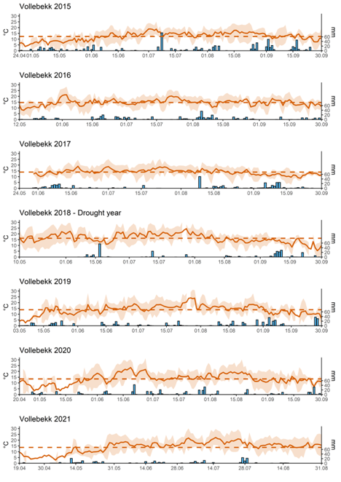
Fig. S1 Weather data for field seasons 2015-2021 in Vollebekk research station, from seeding the trial to the end of September. Solid line marks the average temperature for each day, dashed line marks the mean temperature across the season, bars mark the daily rainfall in mm per m². Primary y axis – temperature in ⁰C, secondary y axis – rainfall in mm per m²
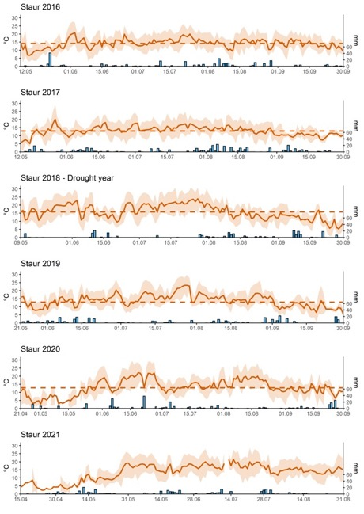
Fig. S2 Weather data for field seasons 2016-2021 in Staur, from seeding the trial to the end of September. Solid line marks the average temperature for each day, dashed line marks the mean temperature across the season, bars mark the daily rainfall in mm per m². Primary y axis – temperature in ⁰C, secondary y axis – rainfall in mm per m²

Table S4 Descriptive statistics of weather conditions at Vollebekk research station over the analyzed growing seasons. T_{avg} – average temperature in °C, Rf_{sum} – sum of rainfall in mm, Ir_{avg} – average solar irradiance in Wm⁻²
 | 2015 |  |  | 2016 |  |  | 2017 |  |  | 2018 (drought) |  |  | 2019 |  |  | 2020 |  |  | 2021
 | T_{avg} | Rf_{sum} | Ir_{avg} | T_{avg} | Rf_{sum} | Ir_{avg} | T_{avg} | Rf_{sum} | Ir_{avg} | T_{avg} | Rf_{sum} | Ir_{avg} | T_{avg} | Rf_{sum} | Ir_{avg} | T_{avg} | Rf_{sum} | Ir_{avg} | T_{avg} | Rf_{sum} | Ir_{avg}
Apr | 5.5 | 8.8 | 15.4 | 5.2 | 100 | 11.7 | 4.4 | 35.0 | 13.4 | 5.1 | 32.4 | 14,0 | 7.9 | 14.6 | 16.2 | 6.4 | 30.2 | 15.1 | 4.7 | 18.2 | 17.1
May | 8.3 | 116.6 | 16.3 | 11.6 | 50.2 | 18.5 | NA | 68.0 | NA | 15.0 | 0 | 22.2 | 9.7 | 100.6 | 17.0 | 9.5 | 47.2 | 21.4 | 9.7 | 72.2 | 15.4
Jun | 13.1 | 65.6 | 21.4 | 15.6 | 89.8 | 21.1 | 14.3 | 94.0 | 19.1 | 16.7 | 82.4 | 23.9 | 14.8 | 63.6 | 17.8 | 17.6 | 115.4 | 21.2 | 16.1 | 34.6 | 19.9
Jul | 15.0 | 158.8 | 19.4 | 16.1 | 54.8 | 19.1 | 15.9 | 20.2 | 19.8 | 20.2 | 44.6 | 23.2 | 17.2 | 52.0 | 20.2 | 14.3 | 127.9 | 18.0 | 18.9 | 95.4 | 19.8
Aug | 15.3 | 140.2 | 16.0 | 14.6 | 140 | 14.1 | 14.5 | 104.0 | 14.9 | 15.4 | 21.4 | 14.2 | 16.2 | 110.2 | 13.7 | 16.2 | 50.6 | 15.7 | 15.3 | 7.8 | 15.2
Sep | 11.5 | 220.2 | 8.8 | 14.1 | 41 | 9.9 | 11.5 | 119.2 | 6.7 | 12.1 | 128.4 | 9.4 | 11.0 | 190.8 | 8.3 | 12.0 | 81.0 | 9.0 | 12.5 | 75.2 | 8.7
Table S5 Descriptive statistics of weather conditions at Staur research farm over the analyzed growing seasons. T_{avg} – average temperature in °C, Rf_{sum} – sum of rainfall in mm, Ir_{avg} – average solar irradiance in Wm⁻²
 | 2015 |  |  | 2016 |  |  | 2017 |  |  | 2018 (Drought) |  |  | 2019 |  |  | 2020 |  |  | 2021
 | T_{avg} | R_{fsum} | Ir_{avg} | T_{avg} | R_{fsum} | Ir_{avg} | T_{avg} | R_{fsum} | Ir_{avg} | T_{avg} | R_{fsum} | Ir_{avg} | T_{avg} | R_{fsum} | Ir_{avg} | T_{avg} | R_{fsum} | Ir_{avg} | T_{avg} | R_{fsum} | Ir_{avg}
Apr | 4.6 | 6.9 | 14.0 | 3.9 | 74.3 | 12.1 | 3.6 | 33.4 | 12.9 | 3.5 | 40.3 | 13.8 | 5.6 | 3.0 | 15.3 | 5.5 | 19.4 | 14.3 | 3.7 | 16.0 | 15.5
May | 7.4 | 89.0 | 14.2 | 10.6 | 66.5 | 16.8 | 10.1 | 59.3 | 15.7 | 15.1 | 22.8 | 21.1 | 8.5 | 91.4 | 15.1 | 8.3 | 33.8 | 18.5 | 9.0 | 81.2 | 14.9
Jun | 12.6 | 39.3 | 19.9 | 15.2 | 29.5 | 20.7 | 13.5 | 58.3 | 17.3 | 16.0 | 55.8 | 22.3 | 14.4 | 103.6 | 16.8 | 17.4 | 98.9 | 21.5 | 16.4 | 62.4 | 20.7
Jul | 14.8 | 116.3 | 16.4 | 15.8 | 59.4 | 17.7 | 15.0 | 58.8 | 18.3 | 20.7 | 24.8 | 22.4 | 16.6 | 37.6 | 19.6 | 13.3 | 70.8 | 16.8 | NA | 93.4 | NA
Aug | 14.6 | 52.7 | 15.8 | 14.2 | 109.1 | 12.9 | 13.7 | 144.2 | 13.9 | 14.7 | 61.2 | 13.6 | 15.5 | 63.1 | 12.4 | 16.0 | 17.1 | 15.7 | 14.3 | 16.4 | 14.2
Sep | 10.9 | 164.6 | 7.3 | 13.6 | 21.4 | 9.4 | 10.3 | 64.3 | 5.4 | 11.1 | 85.1 | 8.6 | 9.9 | 103.2 | 7.2 | 11.3 | 80.7 | 8.1 | 11.6 | 34.1 | 7.8

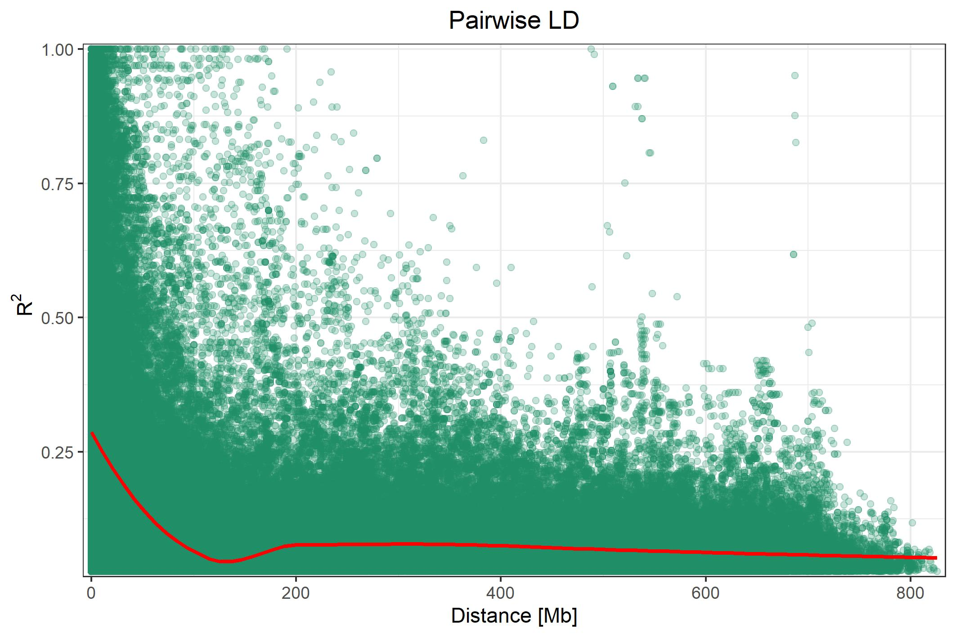
Figure S3 Linkage disequilibrium (LD) between markers for the main panel
Figure S4 Pearson’s correlation matrix for days to maturity between trial means, environmental means, and the global mean. Variables named according to scheme: Location_season. V – Vollebekk, S – Staur
Figure S5 Pearson’s correlation matrix for grain yield between trial means, environmental means, and the global mean. Variables named according to scheme: Location_season. V – Vollebekk, S – Staur
Figure S6 Pearson’s correlation matrix for days to heading between trial means, environmental means, and the global mean. Variables named according to scheme: Location_season. V – Vollebekk, S – Staur

Figure S7 Pearson’s correlation matrix for plant height between trial means, environmental means, and the global mean. Variables named according to scheme: Location_season. V – Vollebekk, S – Staur
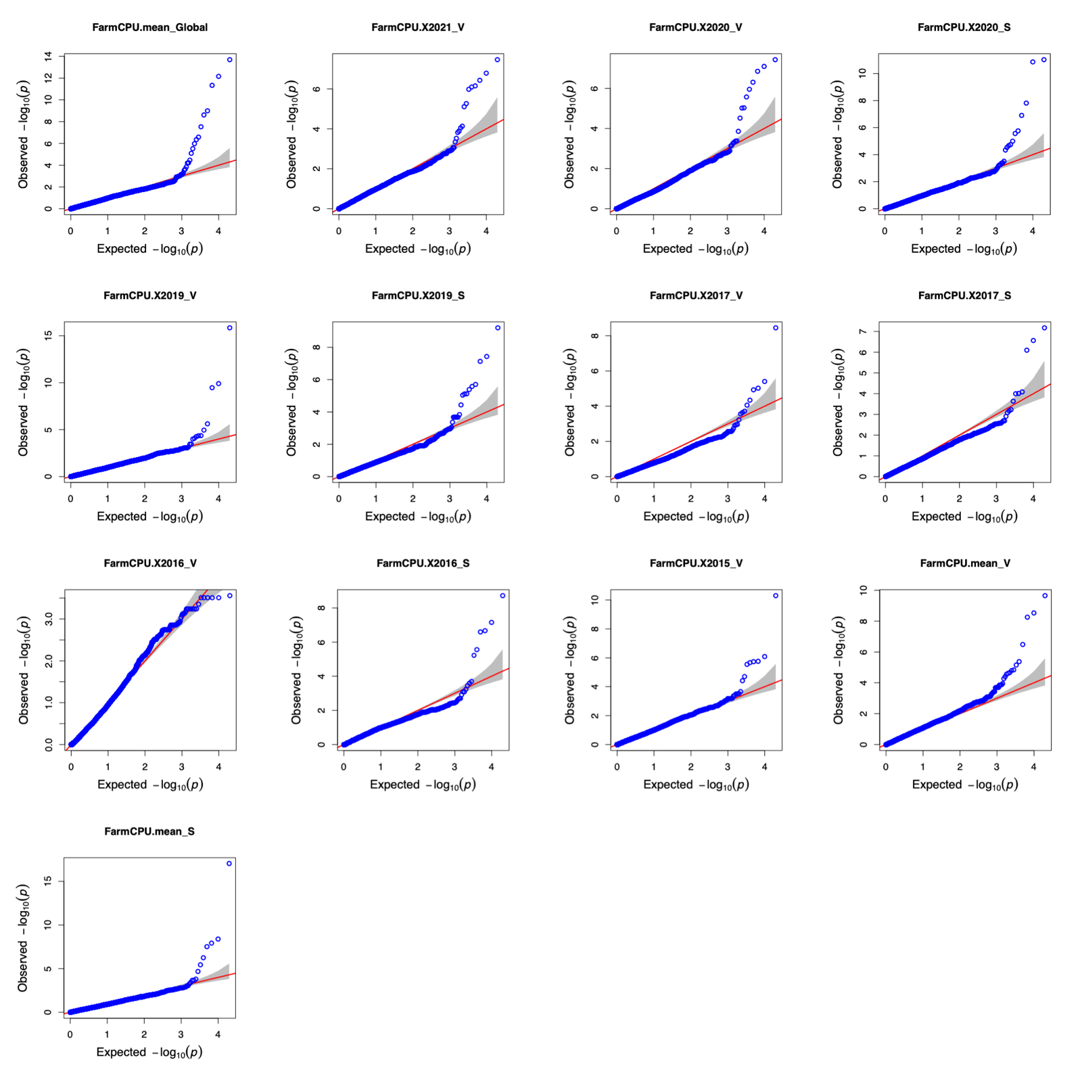
Figure S8 Quantile-quantile (QQ) plots for GWAS analysis of days to maturity for the adapted part of the main panel. Phenotypes named according to the scheme: FarmCPU.season_location. Location: V – Vollebekk, S – Staur
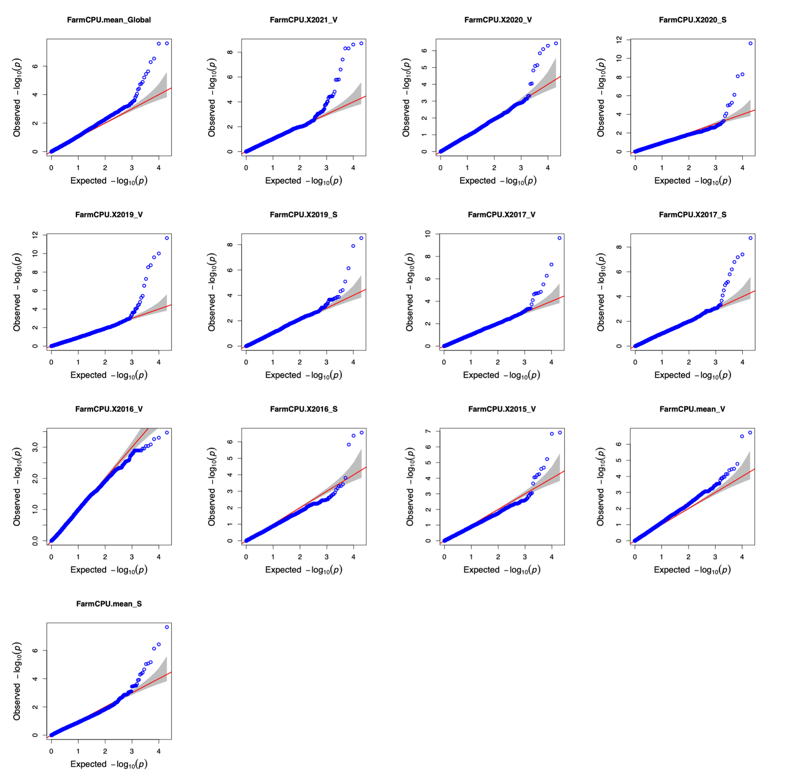
Figure S9 Quantile-quantile (QQ) plots for GWAS analysis of days to maturity for the main panel (all lines). Phenotypes named according to the scheme: FarmCPU.season_location. Location: V – Vollebekk, S – Staur
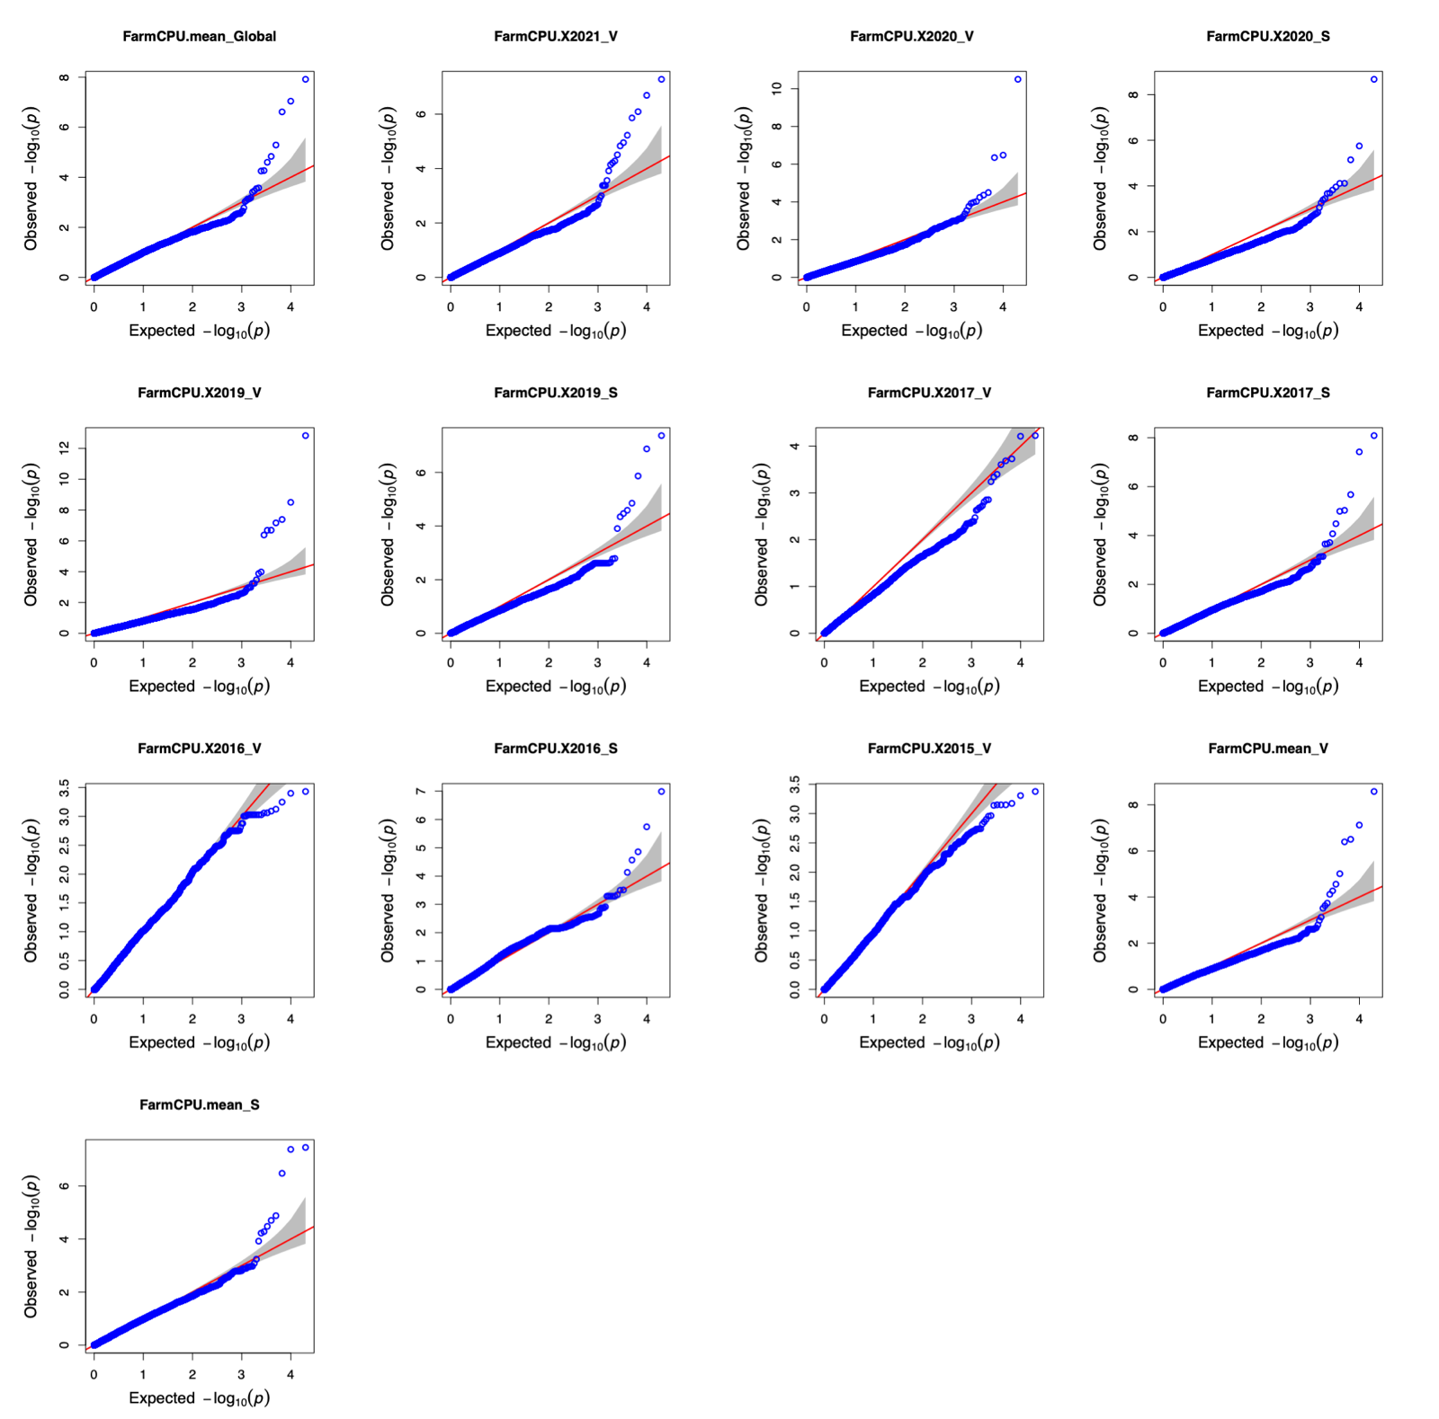
Figure S10 Quantile-quantile (QQ) plots for GWAS analysis of grain yield for the adapted part of the main panel. Phenotypes named according to the scheme: FarmCPU.season_location. Location: V – Vollebekk, S – Staur
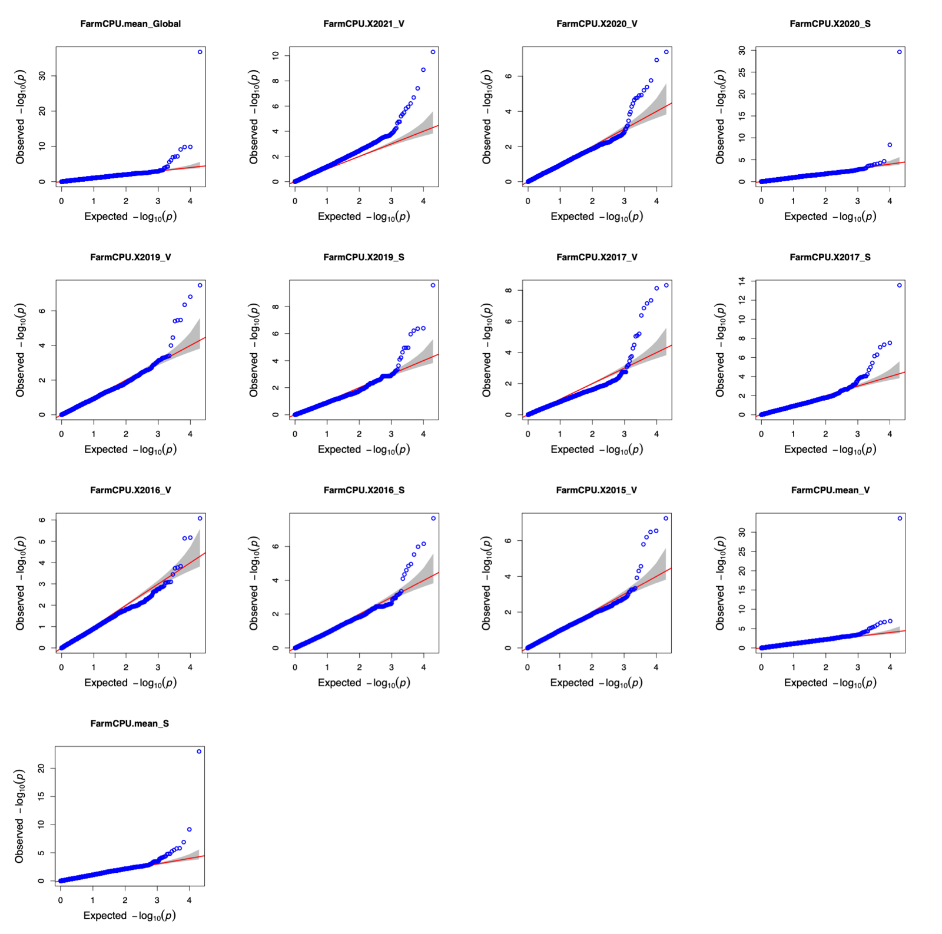
Figure S11 Quantile-quantile (QQ) plots for GWAS analysis of grain yield for the main panel (all lines). Phenotypes named according to the scheme: FarmCPU.season_location. Location: V – Vollebekk, S – Staur.
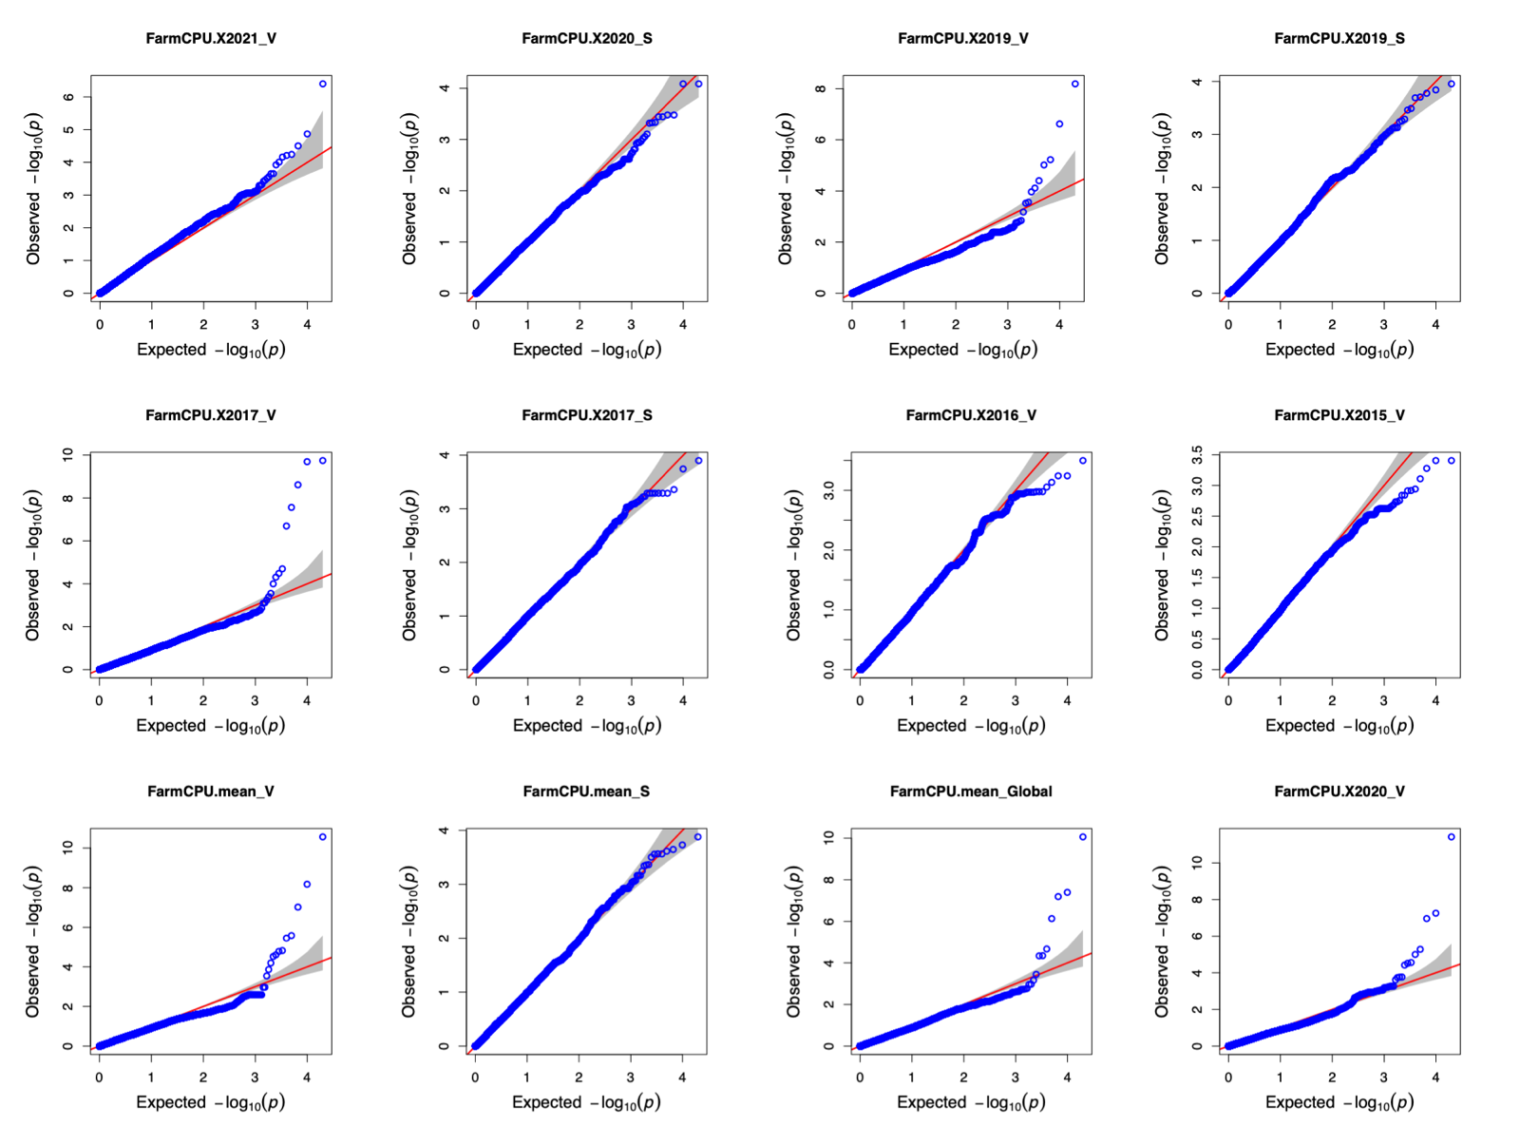
Figure S12 Quantile-quantile (QQ) plots for GWAS analysis of days to heading for the adapted part of the main panel. Phenotypes named according to the scheme: FarmCPU.season_location. Location: V – Vollebekk, S – Staur
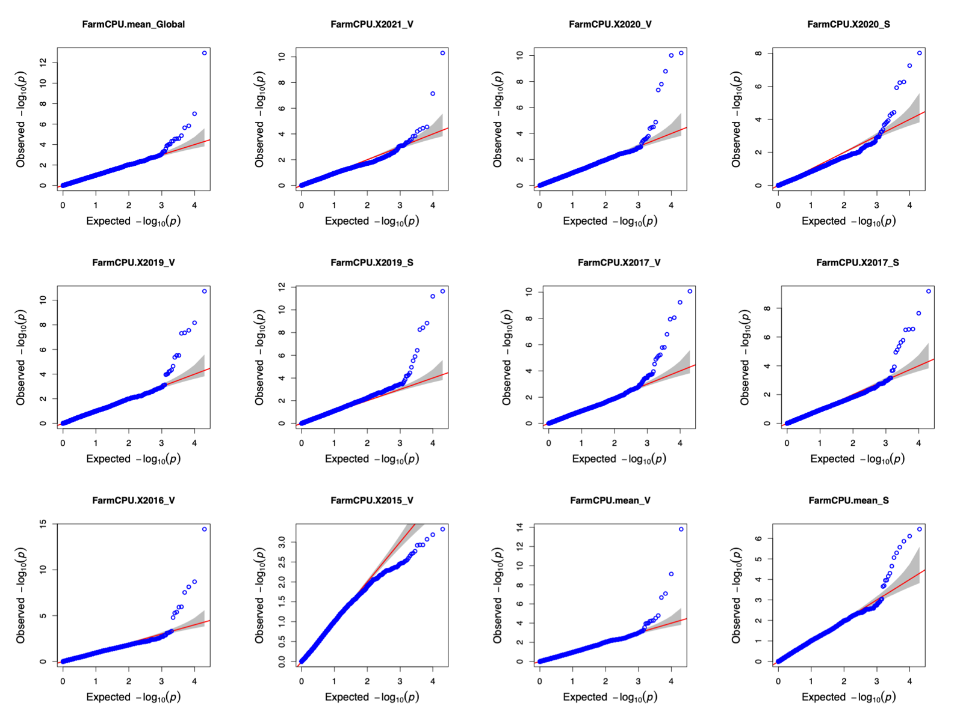
Figure S13 Quantile-quantile (QQ) plots for GWAS analysis of days to heading for the main panel (all lines). Phenotypes named according to the scheme: FarmCPU.season_location. Location: V – Vollebekk, S – Staur
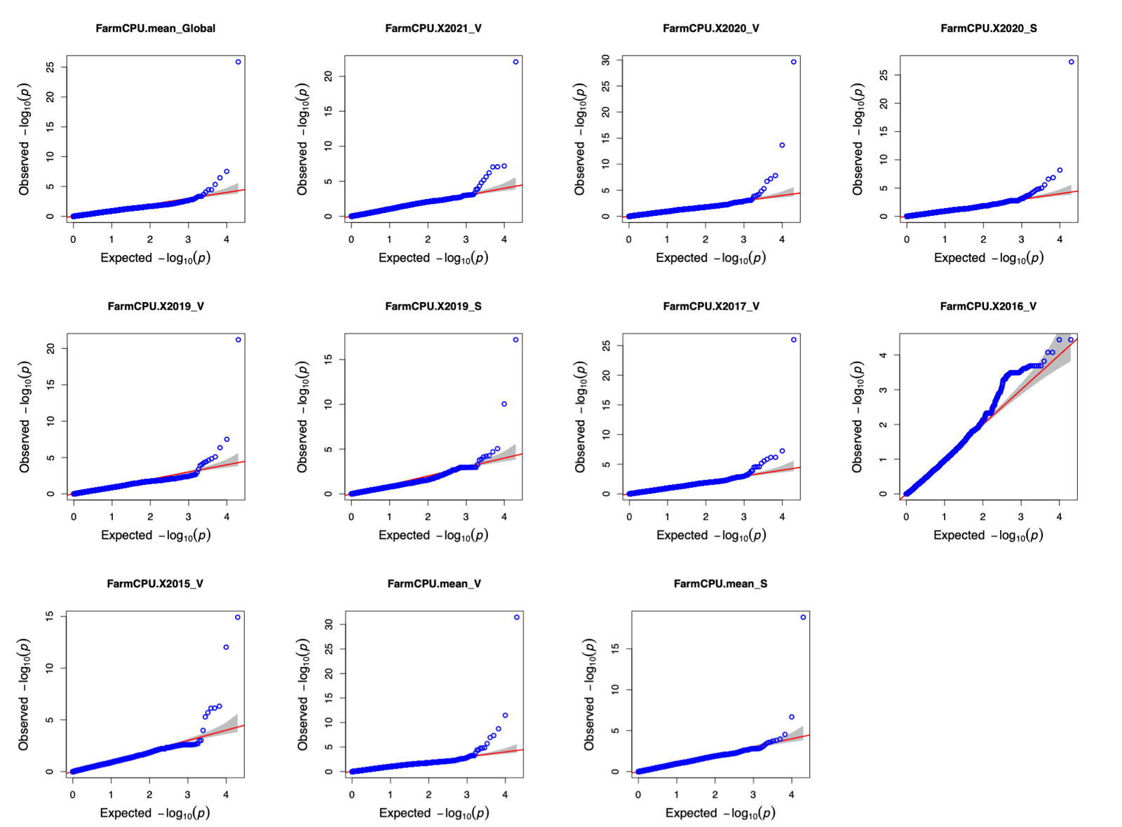
Figure S14 Quantile-quantile (QQ) plots for GWAS analysis of plant height for the adapted part of the main panel. Phenotypes named according to the scheme: FarmCPU.season_location. Location: V – Vollebekk, S – Staur
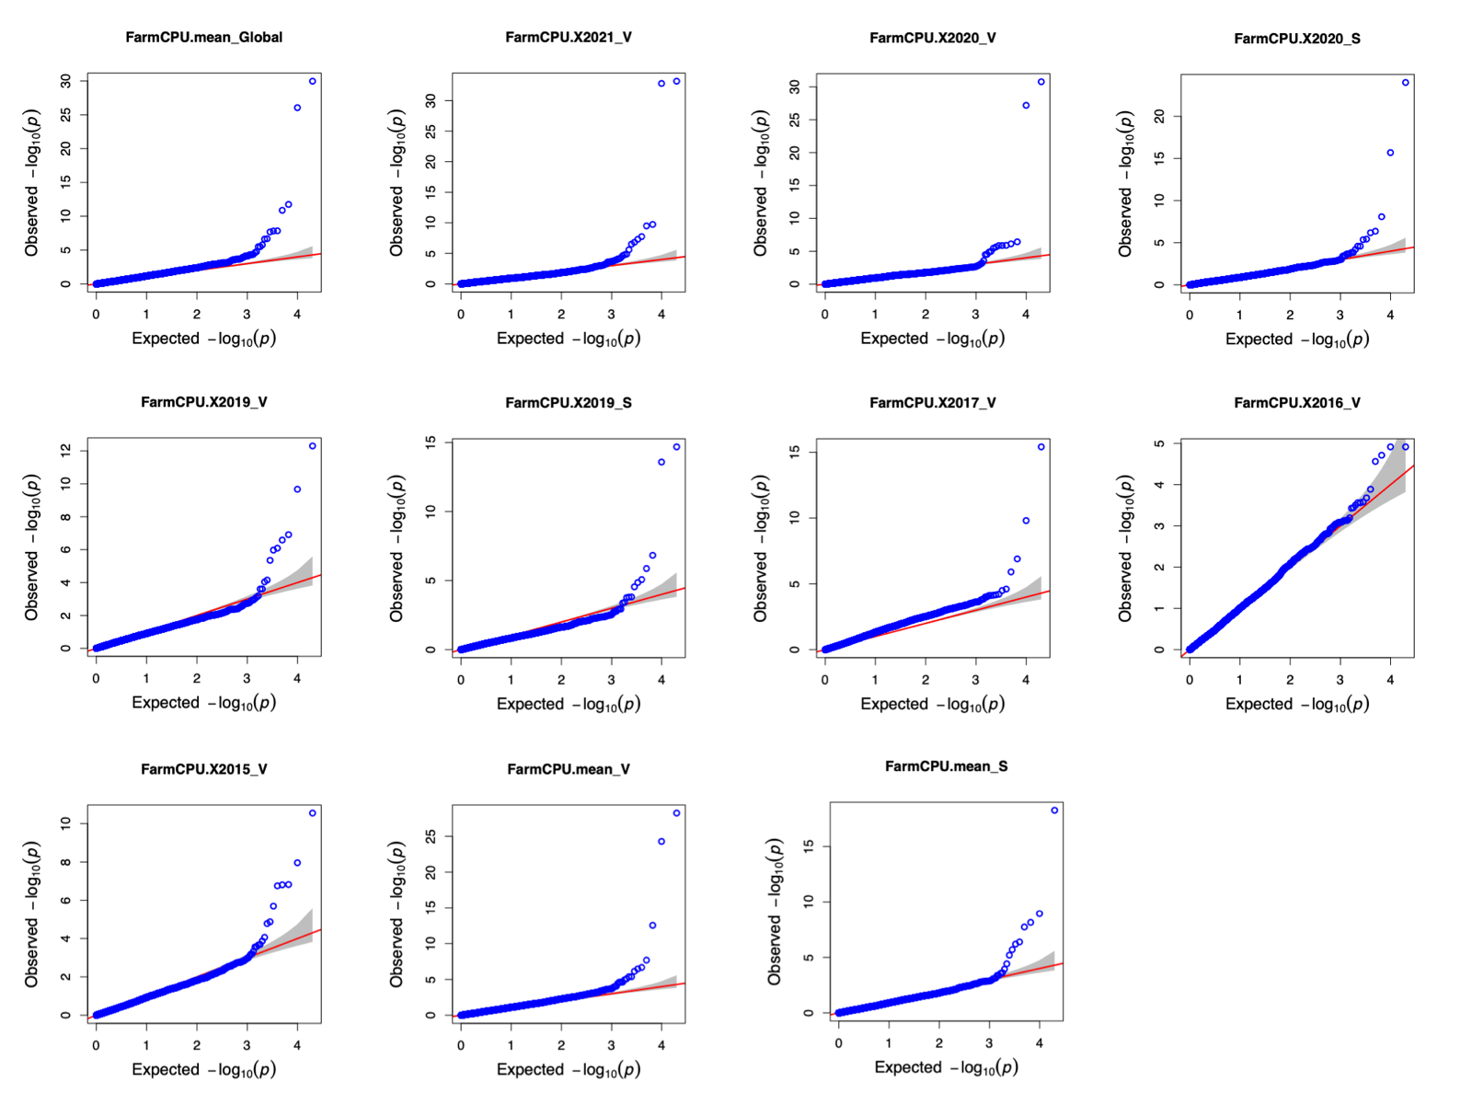
Figure S15 Quantile-quantile (QQ) plots for GWAS analysis of plant height for the main panel (all lines). Phenotypes named according to the scheme: FarmCPU.season_location. Location: V – Vollebekk, S – Staur
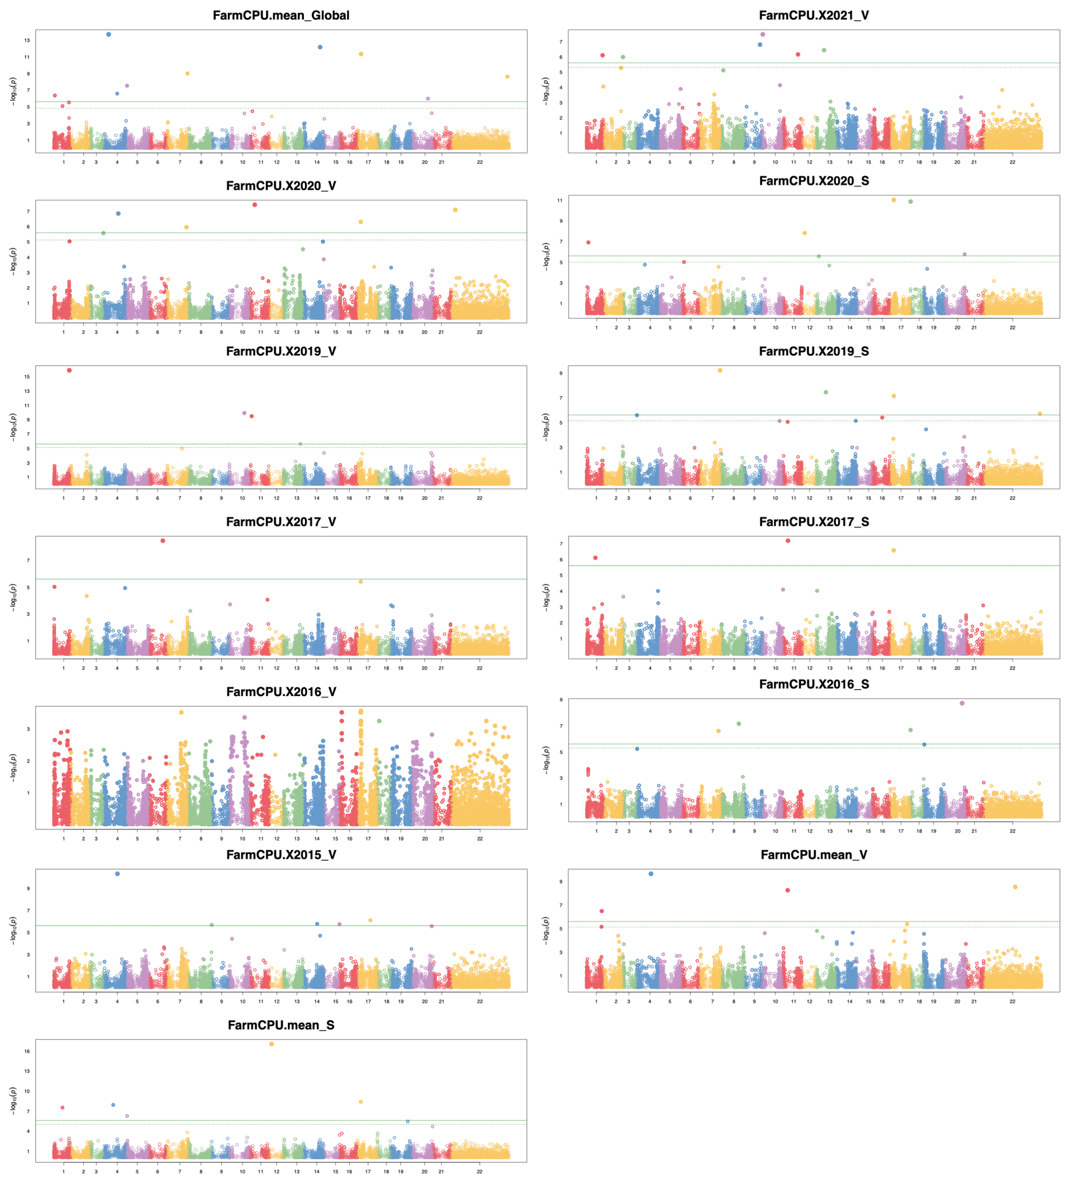
Figure S16 Manhattan plots for GWAS analysis of days to maturity for the adapted part of the main panel. Phenotypes named according to the scheme: FarmCPU.season_location. Location: V – Vollebekk, S – Staur
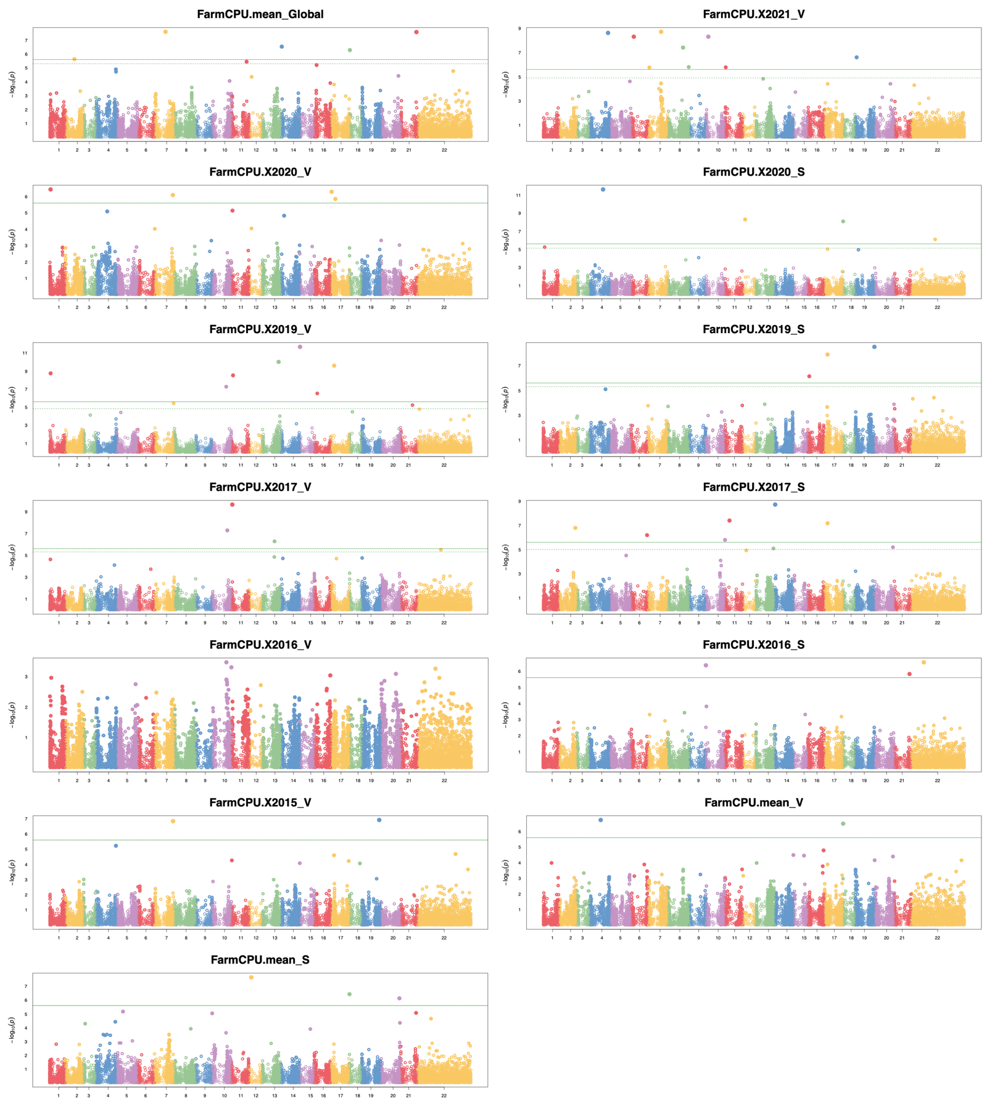
Figure S17 Manhattan plots for GWAS analysis of days to maturity for the main panel (all lines). Phenotypes named according to the scheme: FarmCPU.season_location. Location: V – Vollebekk, S – Staur
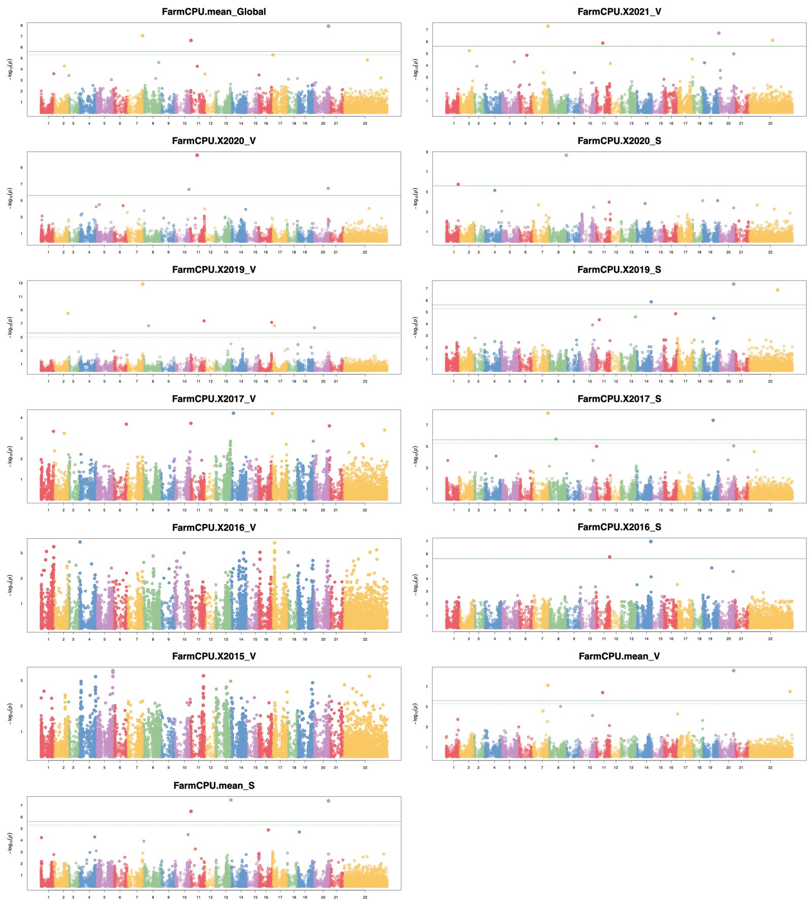
Figure S18 Manhattan plots for GWAS analysis of grain yield for the adapted part of the main panel. Phenotypes named according to the scheme: FarmCPU.season_location. Location: V – Vollebekk, S – Staur
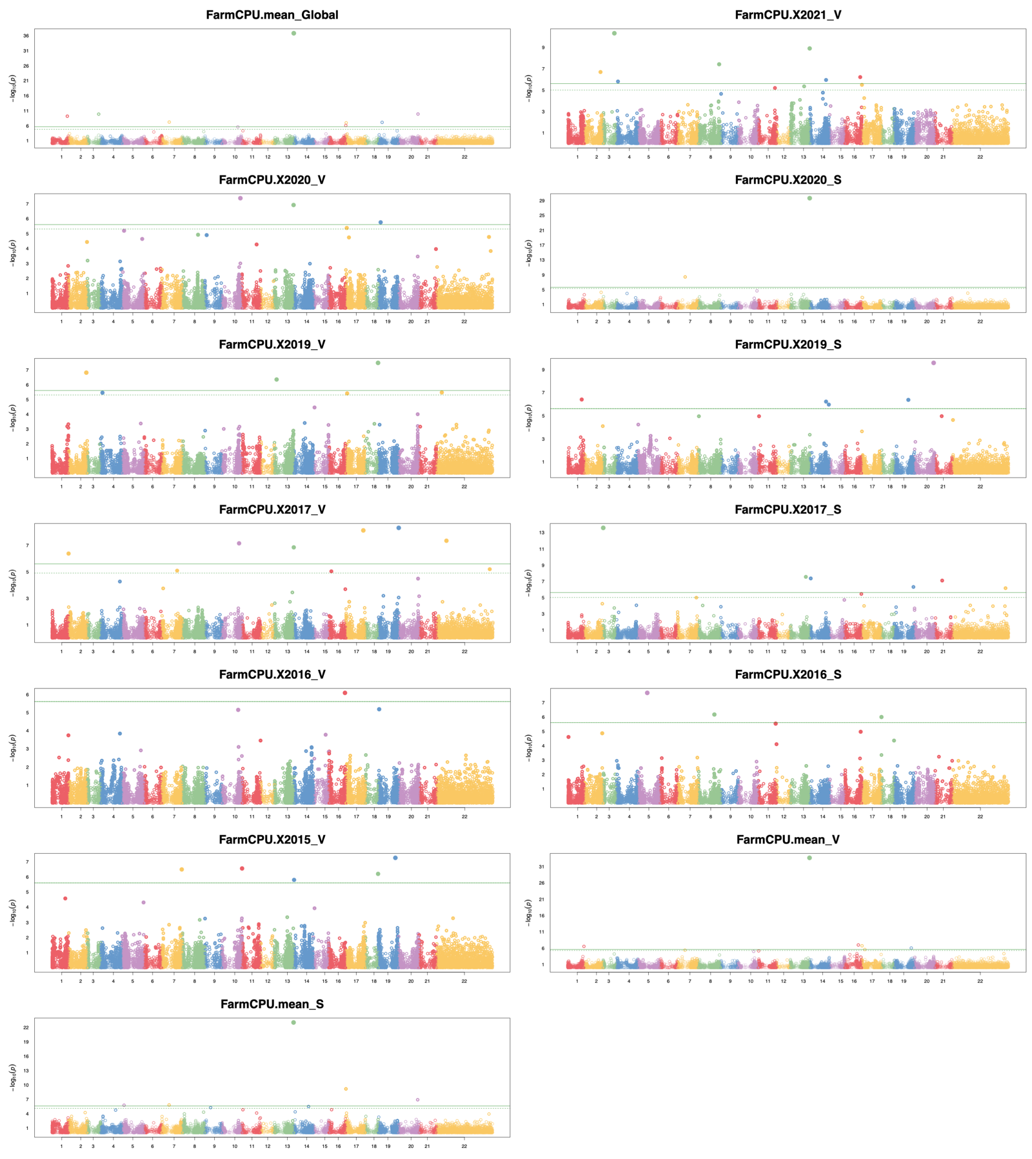
Figure S19 Manhattan plots for GWAS analysis of grain yield for the main panel (all lines). Phenotypes named according to the scheme: FarmCPU.season_location. Location: V – Vollebekk, S – Staur
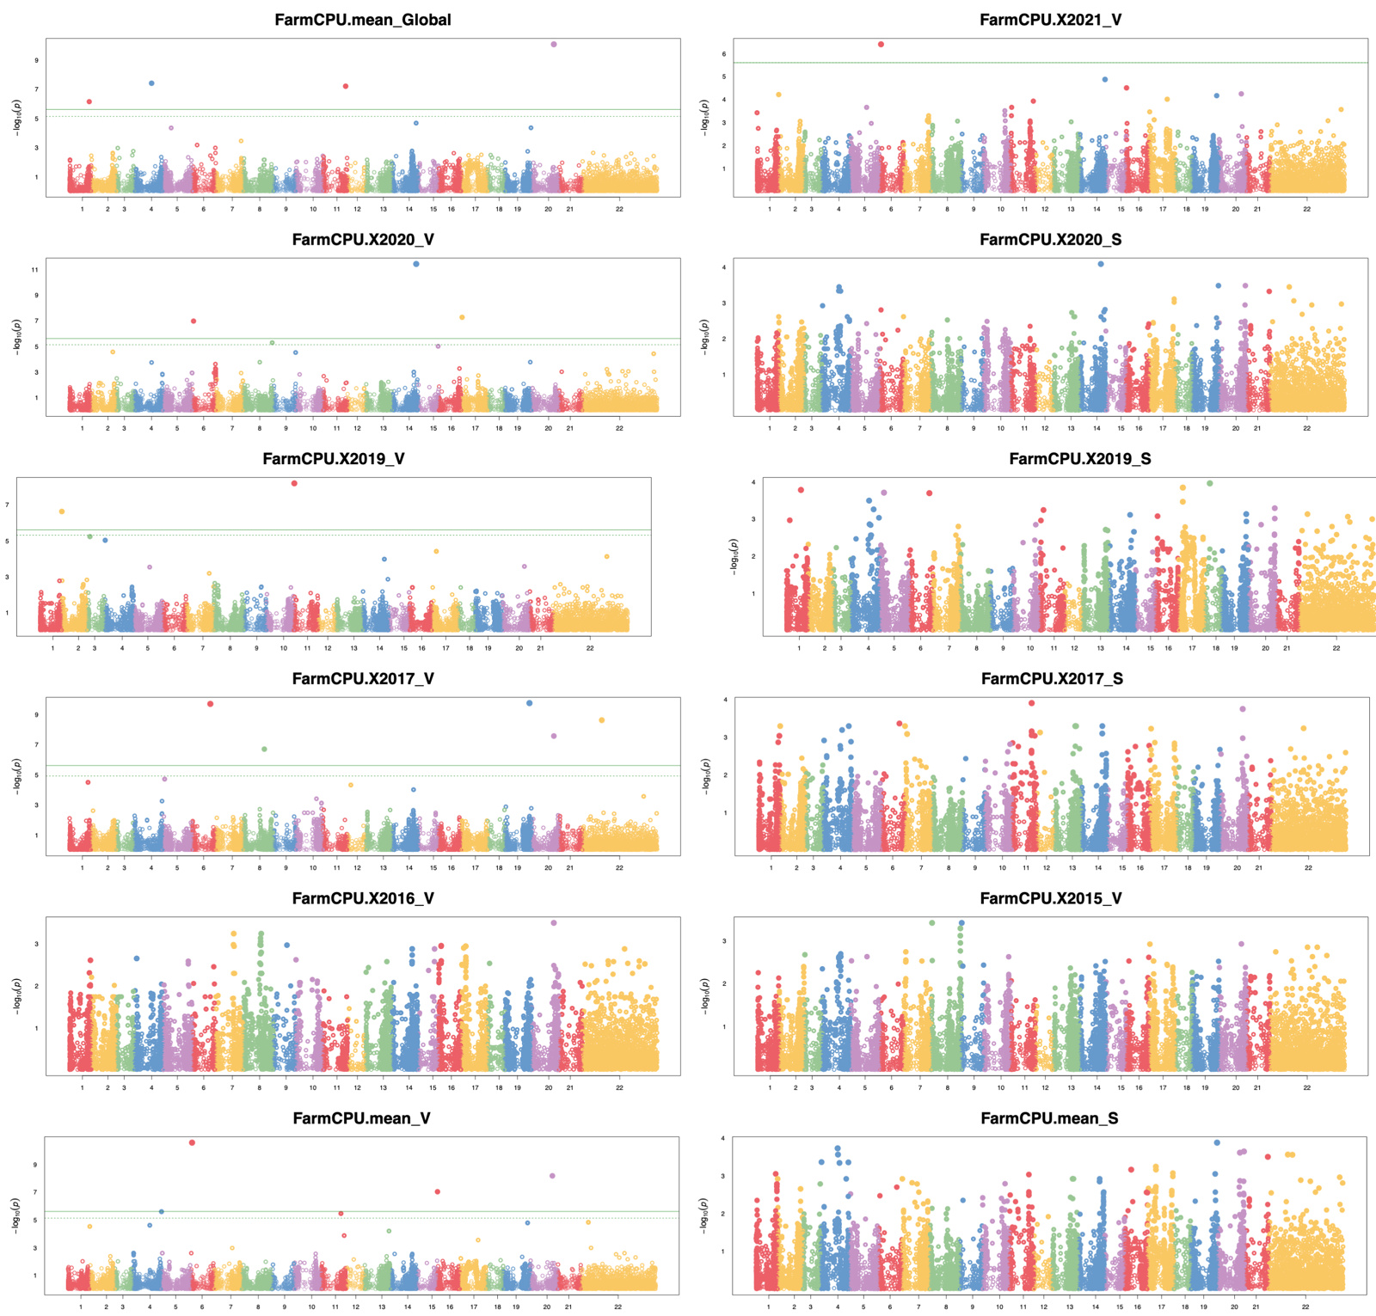
Figure S20 Manhattan plots for GWAS analysis of days to heading for the adapted part of the main panel. Phenotypes named according to the scheme: FarmCPU.season_location. Location: V – Vollebekk, S – Staur
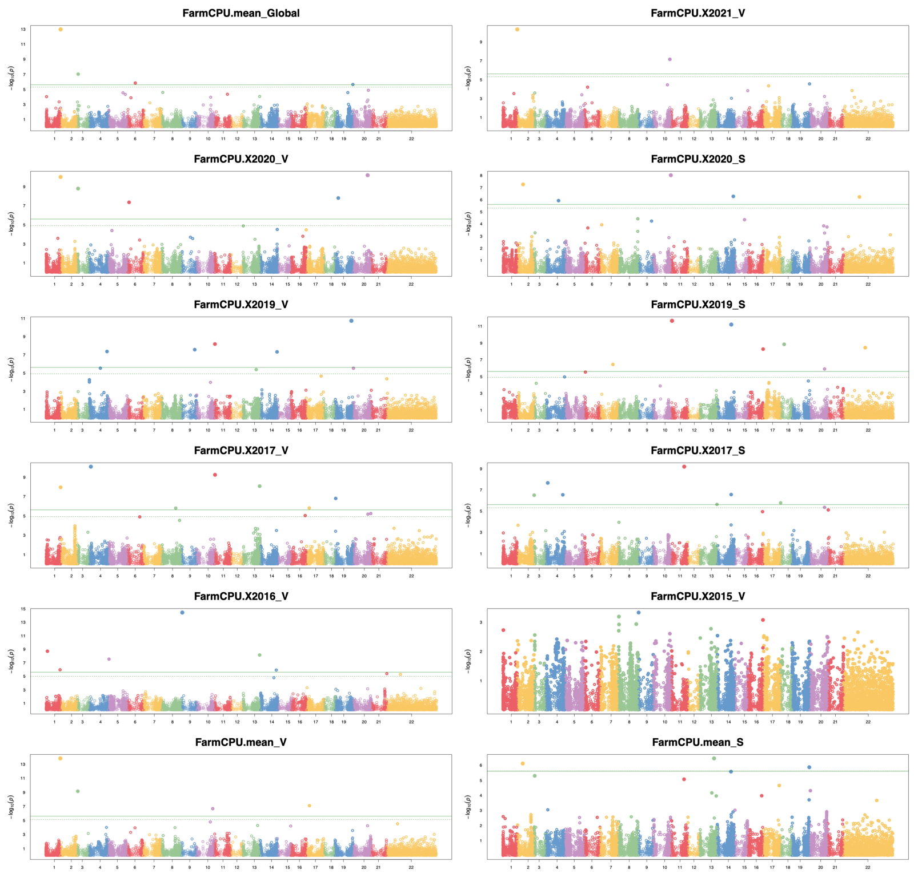
Figure S21 Manhattan plots for GWAS analysis of days to heading for the main panel (all lines). Phenotypes named according to the scheme: FarmCPU.season_location. Location: V – Vollebekk, S – Staur
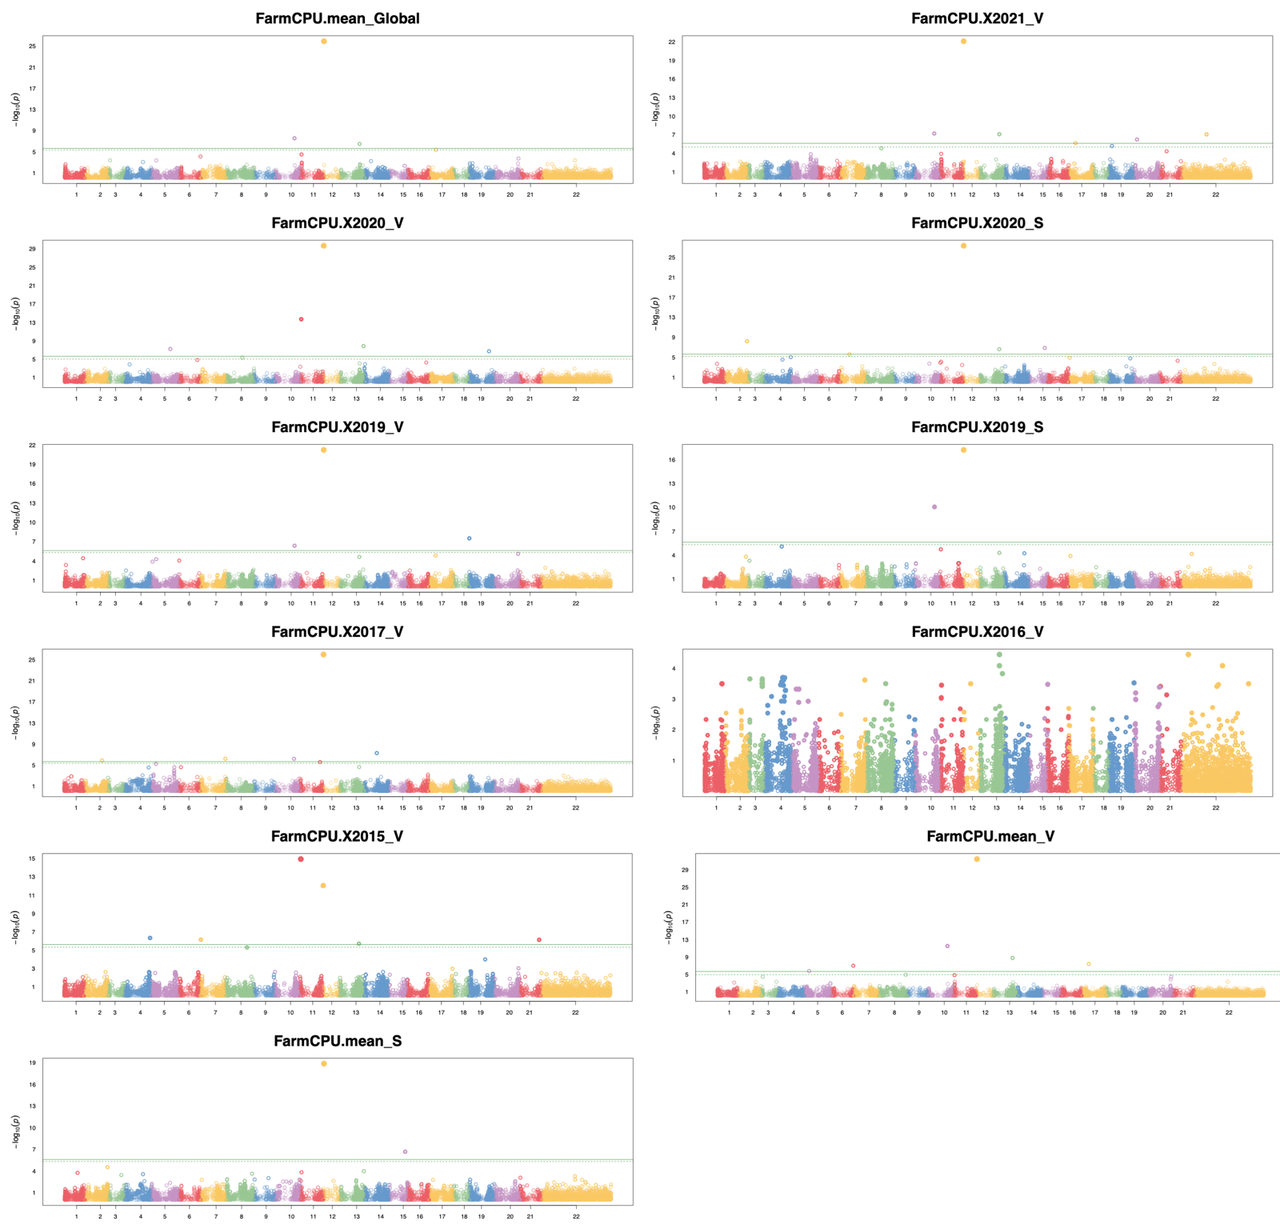
Figure S22 Manhattan plots for GWAS analysis of plant height for the adapted part of the main panel. Phenotypes named according to the scheme: FarmCPU.season_location. Location: V – Vollebekk, S – Staur
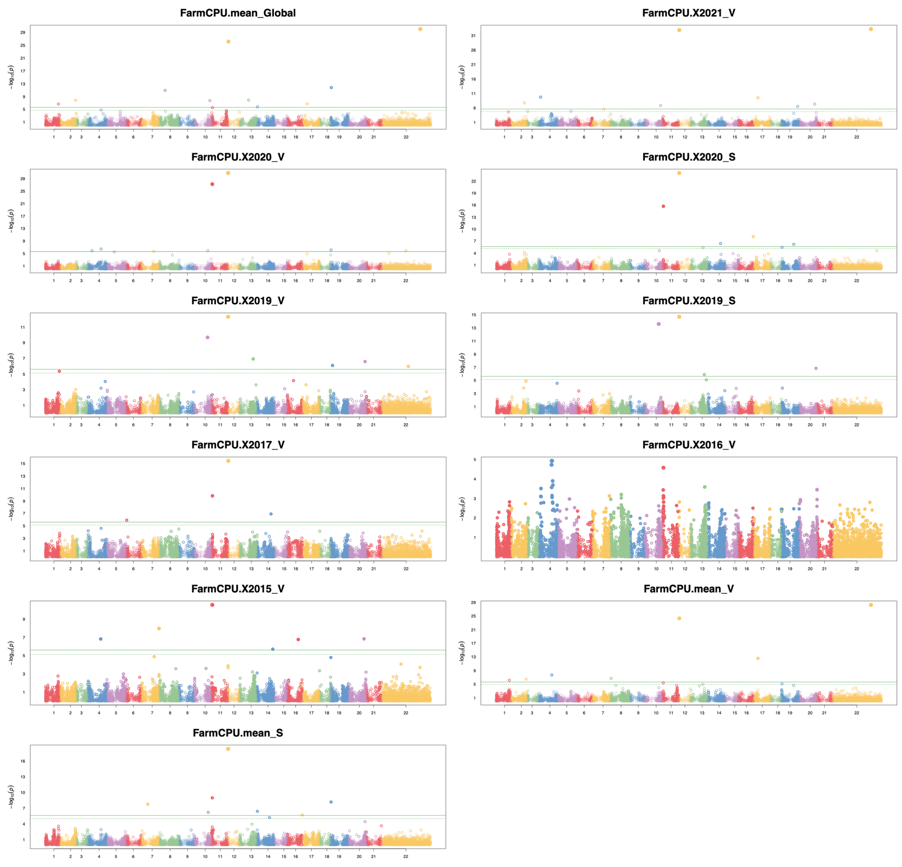
Figure S23 Manhattan plots for GWAS analysis of plant height for the main panel (all lines). Phenotypes named according to the scheme: FarmCPU.season_location. Location: V – Vollebekk, S – Staur

Table S6 Significant markers belonging to the discovered QTL regions for days to heading (DH), days to maturity (DM), grain yield (GY), and plant height (PH). Pos – SNP position in Mbp, E – effect (without correcting for population structure) in the full dataset, %PVE – percentage of variance explained in the full dataset, without correcting for population structure, MAF – minor allele frequency
Trait | QTL | Span | Marker | Pos | -logP | Dataset | Method | E | %PVE | MAF
DH | QHd.nmbu-1B | 1-2 | BS00022180_51 | 1 | 12.95 | Full | FarmCPU, MLM | 1.02 | 14.0 | 0.08
 |  |  | BS00071161_51 | 2 | 3.65 | Full/Adapted | MLM | 0.95 | 13.3 | 0.08
 | QHd.nmbu-7B | 606 | BobWhite_c3541_152 | 606 | 10.06 | Adapted | FarmCPU, MLM | 0.91 | 11.4 | 0.06
DM | QMat.nmbu-6B | 132-136 | wsnp_Ex_rep_c102159_87386822 | 131 | 4.22 | Full/Adapted | MLM | 0.63 | 3.51 | 0.21
 |  |  | Kukri_rep_c71420_511 | 132 | 11.34 | Adapted | FarmCPU, MLM | 1.36 | 14.2 | 0.14
 |  |  | Tdurum_contig14559_741 | 132 | 5.73 | Full/Adapted | MLM | 0.61 | 4.12 | 0.28
 |  |  | Tdurum_contig14559_78 | 132 | 4.78 | Full/Adapted | MLM | 0.60 | 4.05 | 0.28
 |  |  | wsnp_Ex_c12577_20022294 | 132 | 3.16 | Full/Adapted | MLM | 0.28 | 0.92 | 0.32
 |  |  | GENE-3171_203 | 135 | 3.69 | Adapted | MLM | 0.97 | 9.74 | 0.21
 |  |  | GENE-4074_537 | 135 | 4.22 | Full/Adapted | MLM | 0.67 | 3.57 | 0.17
 |  |  | AX-158529874 | 136 | 3.11 | Adapted | MLM | 0.89 | 8.55 | 0.21
 |  |  | AX-158552731 | 136 | 3.50 | Adapted | MLM | 1.06 | 10.4 | 0.18
 |  |  | Tdurum_contig11700_1247 | 136 | 3.11 | Adapted | MLM | 0.89 | 8.55 | 0.21
 | QMat.nmbu-6D | 6 | BS00022523_51 | 6 | 6.28 | Full | FarmCPU, MLM | 0.82 | 8.80 | 0.41
GY | QYld.nmbu-3A | 267 | BS00110129_51 | 267 | 7.16 | Full | FarmCPU, MLM | 38.1 | 22.0 | 0.42
 | QYld.nmbu-5A | 683-708 | AX-158558760 | 685 | 3.50 | Full | MLM | 37.5 | 17.5 | 0.27
 |  |  | AX-94387378 | 686 | 3.17 | Full | MLM | 42.2 | 24.0 | 0.31
 |  |  | AX-95097524 | 694 | 3.82 | Full | MLM | 52.6 | 34.6 | 0.28
 |  |  | BobWhite_c8266_227 | 699 | 36.78 | Full | FarmCPU, MLM | 79.4 | 61.5 | 0.20
 |  |  | AX-158550750 | 708 | 3.55 | Full | MLM | 59.2 | 41.3 | 0.25
 |  |  | wsnp_Ex_c2171_4072774 | 708 | 3.47 | Full | MLM | 59.3 | 41.3 | 0.25
 |  |  | wsnp_Ex_c2171_4072995 | 708 | 3.47 | Full | MLM | 59.3 | 41.3 | 0.25
 |  |  | wsnp_Ex_c2171_4073721 | 708 | 3.47 | Full | MLM | 59.3 | 41.3 | 0.25
 | QYld.nmbu-7B | 701-703 | BS00083578_51 | 701 | 9.85 | Full/Adapted | FarmCPU, MLM | 48.3 | 12.8 | 0.10
 |  |  | BobWhite_c12048_145 | 701 | 3.53 | Full/Adapted | MLM | 26.8 | 10.7 | 0.37
 |  |  | BS00022522_51 | 701 | 5.24 | Full/Adapted | MLM | 46.1 | 11.8 | 0.10
 |  |  | Excalibur_c50612_146 | 701 | 3.08 | Adapted | MLM | 31.5 | 21.6 | 0.11
PH | QHt.nmbu-2A | 524-543 | AX-110920715 | 524 | 3.47 | Full | MLM | 3.73 | 9.56 | 0.09
 |  |  | AX-95095516 | 528 | 3.02 | Adapted | FarmCPU, MLM | 4.01 | 12.6 | 0.08
 |  |  | AX-158561839 | 528 | 2.96 | Full/Adapted | MLM | 4.09 | 10.7 | 0.08
 |  |  | AX-110399256 | 543 | 4.78 | Full | FarmCPU, MLM | 1.81 | 11.6 | 0.08
 |  |  | AX-158540522 | 543 | 2.99 | Adapted | MLM | 4.00 | 12.6 | 0.08
 | QHt.nmbu-4A | 570-603 | CAP11_c3631_75 | 570 | 7.52 | Adapted | FarmCPU, MLM | 1.98 | 6.97 | 0.22
 |  |  | RAC875_c19303_228 | 578 | 5.73 | Full/Adapted | MLM | 2.02 | 7.70 | 0.33
 |  |  | AX-95086844 | 603 | 3.14 | Full | FarmCPU | 0.89 | 0.38 | 0.33
 | QHt.nmbu-4B | 13-59 | AX-158583339 | 13 | 3.43 | Full | MLM | 4.09 | 10.7 | 0.24
 |  |  | BS00037094_51 | 13 | 3.25 | Full | MLM | 1.83 | 5.15 | 0.24
 |  |  | Tdurum_contig93710_409 | 13 | 3.56 | Full | MLM | 1.79 | 4.70 | 0.23
 |  |  | AX-110588223 | 23 | 3.96 | Full/Adapted | MLM | 1.84 | 7.08 | 0.44
 |  |  | wsnp_Ex_c7362_12622736 | 23 | 3.40 | Adapted | MLM | 1.86 | 8.01 | 0.34
 |  |  | TG0010a; TG0010b | 31 | 5.50 | Full/Adapted | FarmCPU | 2.87 | 14.6 | 0.28
 |  |  | AX-94685504 | 31 | 5.65 | Full/Adapted | MLM | 2.66 | 15.1 | 0.49
 |  |  | AX-89380014 | 32 | 3.84 | Full/Adapted | MLM | 2.29 | 10.7 | 0.39
 |  |  | AX-111081978 | 36 | 5.82 | Full/Adapted | MLM | 2.61 | 12.2 | 0.30
 |  |  | AX-158564543 | 37 | 6.10 | Full/Adapted | MLM | 2.60 | 12.0 | 0.29
 |  |  | AX-158564633 | 37 | 4.34 | Full/Adapted | MLM | 1.82 | 6.86 | 0.42
 |  |  | AX-158537142 | 38 | 6.42 | Full/Adapted | MLM | 2.63 | 12.2 | 0.29
 |  |  | AX-158564542 | 38 | 5.55 | Full/Adapted | MLM | 2.02 | 7.68 | 0.33
 |  |  | Tdurum_contig33737_157 | 38 | 6.04 | Full/Adapted | MLM | 2.53 | 11.2 | 0.29
 |  |  | IAAV971 | 41 | 7.00 | Full/Adapted | MLM | 2.76 | 12.5 | 0.26
 |  |  | AX-158618805 | 52 | 6.12 | Full/Adapted | MLM | 2.23 | 8.02 | 0.25
 |  |  | Excalibur_c56787_95 | 59 | 6.61 | Full/Adapted | MLM | 2.71 | 11.4 | 0.24
 | QHt.nmbu-4D | 19-26 | TG0011b | 19 | 25.89 | Full (MLM) Adapted | FarmCPU, MLM | 3.45 | 22.0 | 0.25
 |  |  | TG0011a | 19 | 10.53 | Full/Adapted | MLM | 2.53 | 8.97 | 0.22
 |  |  | BobWhite_s64797_152 | 26 | 26.06 | Full, Adapted (MLM) | FarmCPU, MLM | 3.18 | 11.7 | 0.29
 | QHt.nmbu-6B | 202 | Ra_c10469_616 | 202 | 6.68 | Full | FarmCPU | 2.00 | 5.21 | 0.19

Table S7 Validation of associated markers using sets of independent lines in four seasons in two locations. V – Vollebekk, S – Staur, for instance 2019_S indicates field season 2019 in Staur. Validation results coded as follows: “-“ – phenotype data not available, Mono – marker monomorphic (validation not possible), Rare - minor allele frequency < 0.05, validation not reliable, Rare* - marker with minor allele frequency < 0.05, but visible signs of possible association, Ns – marker polymorphic in the population (minor allele frequency > 0.05), but no significant effect (p <= 0.05), number and unit - marker polymorphic in the population (minor allele frequency > 0.05) and visible significant effect (p <= 0.05)
QTL | Span | Marker | Pos | Alleles  Pos/Neg | Dominant  allele | Validation results
 |  |  |  |  |  | 2019_S | 2019_V | 2020_S | 2020_V | 2021_V | 2022_V
QHd.nmbu-1B | 1-2 | BS00022180_51 | 1 | T/C | C | Rare | Rare | - | Ns | Rare* | Rare
 |  | BS00071161_51 | 2 | - | T | Rare | Rare | - | Rare | Rare | Rare
QHd.nmbu-7B | 606 | BobWhite_c3541_152 | 606 | G/A | G | Rare | Rare | - | Rare* | Rare | Rare*
QMat.nmbu-6B | 132-136 | wsnp_Ex_rep_c102159_87386822 | 131 | G/A | G | - | 1.29dss | - | 2.23dss | 2.19dss | 0.94dss
 |  | Kukri_rep_c71420_511 | 132 | A/G | A | - | 1.19dss | - | 2.33dss | 2.32dss | 0.89dss
 |  | Tdurum_contig14559_741 | 132 | G/A | G | - | 0.72dss | - | 1.27dss | 1.92dss | 0.95dss
 |  | Tdurum_contig14559_78 | 132 | G/A | A | - | 0.74dss | - | 1.27dss | 1.89dss | 0.95dss
 |  | wsnp_Ex_c12577_20022294 | 132 | - | C | - | Ns | - | Ns | Ns | Ns
 |  | GENE-3171_203 | 135 | C/T | C | - | Ns | - | 1.83dss | 2.38dss | 1.72dss
 |  | GENE-4074_537 | 135 | G/A | G | - | Ns | - | 1.52dss | Rare | Rare
 |  | AX-158529874 | 136 | G/A | G | - | Ns | - | 1.11dss | 1.85dss | 0.78dss
 |  | AX-158552731 | 136 | G/A | G | - | Ns | - | 1.70dss | 2.38dss | 1.72dss
 |  | Tdurum_contig11700_1247 | 136 | T/C | T | - | Ns | - | 1.10dss | 1.83dss | 0.92dss
QMat.nmbu-6D | 6 | BS00022523_51 | 6 | A/G | A | - | Ns | - | - | - | 1.61dss
QYld.nmbu-3A | 267 | BS00110129_51 | 267 | A/G | A | Ns | Ns | 35.41g | - | - | 27.71g
QYld.nmbu-5A | 683-708 | AX-158558760 | 685 | A/G | G | Ns | Ns | Ns | - | - | 18.50g
 |  | AX-94387378 | 686 | A/G | G | Ns | Ns | Ns | - | - | 18.52g
 |  | AX-95097524 | 694 | G/A | G | 47.63g | Ns | Ns | - | - | Rare
 |  | BobWhite_c8266_227 | 699 | - | - | Mono | Mono | Mono | - | - | Mono
 |  | AX-158550750 | 708 | - | A | Ns | Rare | Rare | - | - | Ns
 |  | wsnp_Ex_c2171_4072774 | 708 | - | C | Rare | Rare | Rare | - | - | Ns
 |  | wsnp_Ex_c2171_4072995 | 708 | - | A | Ns | Ns | Rare | - | - | Ns
 |  | wsnp_Ex_c2171_4073721 | 708 | - | T | Rare | Rare | Rare | - | - | Ns
QYld.nmbu-7B | 701-703 | BS00083578_51 | 701 | T/C | T | Rare* | Rare | Rare* | - | - | Mono
 |  | BobWhite_c12048_145 | 701 | A/C | A | Ns | Ns | 21.56g | - | - | 23.62g
 |  | BS00022522_51 | 701 | C/T | C | Rare | Rare | Rare* | - | - | Rare
 |  | Excalibur_c50612_146 | 701 | C/T | C | Rare | Rare | 33.81g | - | - | Rare*
QHt.nmbu-2A | 524-543 | AX-110920715 | 524 | G/A | A | Mono | Rare | Rare | Rare | Rare | Rare*
 |  | AX-95095516 | 528 | A/C | A | Mono | Rare | Rare | Rare | Rare | Rare*
 |  | AX-158561839 | 528 | - | C | Mono | Rare | Rare | Rare | - | Rare
 |  | AX-110399256 | 543 | - | C | Mono | Rare | Rare | Rare | Rare | Rare
 |  | AX-158540522 | 543 | - | C | Mono | Rare | Rare | Rare | Rare | Rare
QHt.nmbu-4A | 570-603 | CAP11_c3631_75 | 570 | T/C | T | 7.23cm | 6.41cm | 3.87cm | 4.81cm | 6.53cm | 7.07cm
 |  | RAC875_c19303_228 | 578 | A/G | A | 7.24cm | 6.98cm | 3.89cm | 5.53cm | 6.77cm | 8.02cm
 |  | AX-95086844 | 603 | C/T | T | Ns | 1.89cm | Ns | Ns | Ns | Ns
QHt.nmbu-4B | 13-59 | AX-158583339 | 13 | G/A | G | 7.49cm | 4.65cm | 2.94cm | 4.14cm | 5.74cm | 5.48cm
 |  | BS00037094_51 | 13 | A/G | A | 7.04cm | 4.42cm | 2.95cm | 3.75cm | 5.57cm | 5.55cm
 |  | Tdurum_contig93710_409 | 13 | A/G | A | 7.49cm | 4.38cm | 3.01cm | 3.84cm | 5.66cm | 5.93cm
 |  | AX-110588223 | 23 | G/T | G | Ns | 1.98cm | 2.30cm | 2.15cm | 1.96cm | 3.89cm
 |  | wsnp_Ex_c7362_12622736 | 23 | T/G | T | Ns | 2.07cm | 2.21cm | 1.97cm | 1.82cm | 3.26cm
 |  | TG0010a; TG0010b | 31 | C/T | C | 9.36cm | 7.89cm | 4.21cm | 5.73cm | 6.99cm | 8.05cm
 |  | AX-94685504 | 31 | G/A | Unclear | Ns | 5.70cm | 4.23cm | 4.68cm | 5.60cm | 6.80cm
 |  | AX-89380014 | 32 | G/A | Unclear | 6.25cm | 6.04cm | 4.01cm | 4.01cm | 5.06cm | 5.69cm
 |  | AX-111081978 | 36 | C/T | C | 6.43cm | 6.89cm | 4.08cm | 5.44cm | 6.80cm | 7.84cm
 |  | AX-158564543 | 37 | A/G | A | 7.24cm | 7.04cm | 4.02cm | 5.48cm | 6.72cm | 8.02cm
 |  | AX-158564633 | 37 | A/G | G | 6.65cm | 4.33cm | 2.22cm | 3.63cm | 1.50cm | 2.43cm
 |  | AX-158537142 | 38 | C/T | C | 7.24cm | 7.01cm | 3.88cm | 5.40cm | 6.73cm | 7.99cm
 |  | AX-158564542 | 38 | A/C | A | 7.24cm | 7.01cm | 3.86cm | 5.51cm | 6.67cm | 8.02cm
 |  | Tdurum_contig33737_157 | 38 | A/G | A | 7.24cm | 6.98cm | 3.95cm | 5.54cm | 6.74cm | 8.02cm
 |  | IAAV971 | 41 | C/T | C | 7.24cm | 6.97cm | 4.07cm | 5.38cm | 6.60cm | 7.96cm
 |  | AX-158618805 | 52 | C/T | C | 7.24cm | 6.56cm | 3.99cm | 4.88cm | 6.50cm | 6.69cm
 |  | Excalibur_c56787_95 | 59 | G/T | G | 7.24cm | 6.74cm | 4.11cm | 5.18cm | 6.70cm | 6.72cm
QHt.nmbu-4D | 19-26 | TG0011b | 19 | G/T | G | Mono | 5.59cm | Ns | 4.76cm | 6.14cm | 10.44cm
 |  | TG0011a | 19 | G/T | G | Mono | 4.76cm | 3.29cm | 5.66cm | 7.46cm | 10.40cm
 |  | BobWhite_s64797_152 | 26 | A/C | A | 7.24cm | 7.01cm | 3.85cm | 5.50cm | 6.72cm | 8.03cm
QHt.nmbu-6B | 202 | Ra_c10469_616 | 202 | G/A | A | Rare | Rare | 2.39cm | 2.24cm | Ns | 4.32cm

Figure S24 Locus associated with adaptation to the Norwegian growing conditions: QYld.nmbu-5A. Allele frequencies in the full panel and adapted and exotic parts (a), haplotype analysis of the loci (b) on days to heading (DH)). Comparison among the alleles was performed using Tukey’s HSD test. Alleles with the same letter are not significantly different (α = 0.05). Alleles with low frequencies (in less than ten lines) were gathered into the “Other” bin

