Supplementary Material
Identification of growth-regulating factor family involved in leaf growth regulation in lettuce (Lactuca sativa L.)
Bin Zhang, Tongbing Su, Peirong Li, Xiaoyun Xin, Yunyun Cao, Weihong Wang, Xiuyun Zhao, Deshuang Zhang, Yangjun Yu, Dayong Li, Shuancang Yu*, Fenglan Zhang*
* Correspondence: Shuancang Yu, yushuancang@nercv.org, Fenglan Zhang, zhangfenglan@nercv.org

Supplementary Figures and Tables

Supplementary Figures
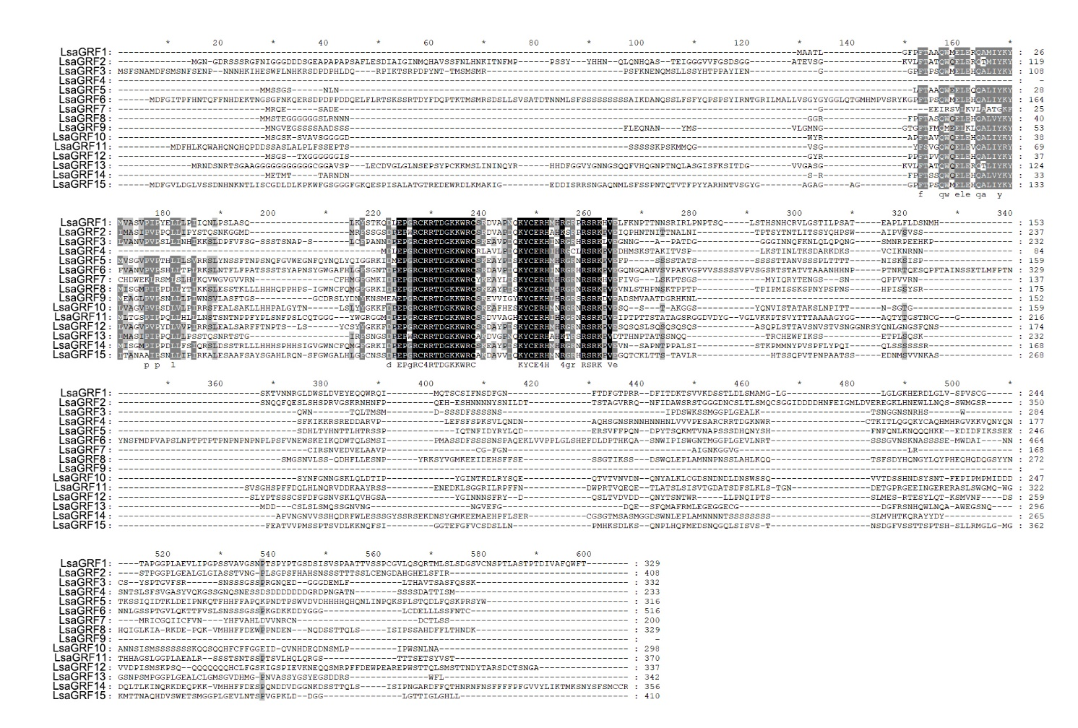
Supplementary Figure 1. The amino acid sequences alignment of LsaGRF genes.

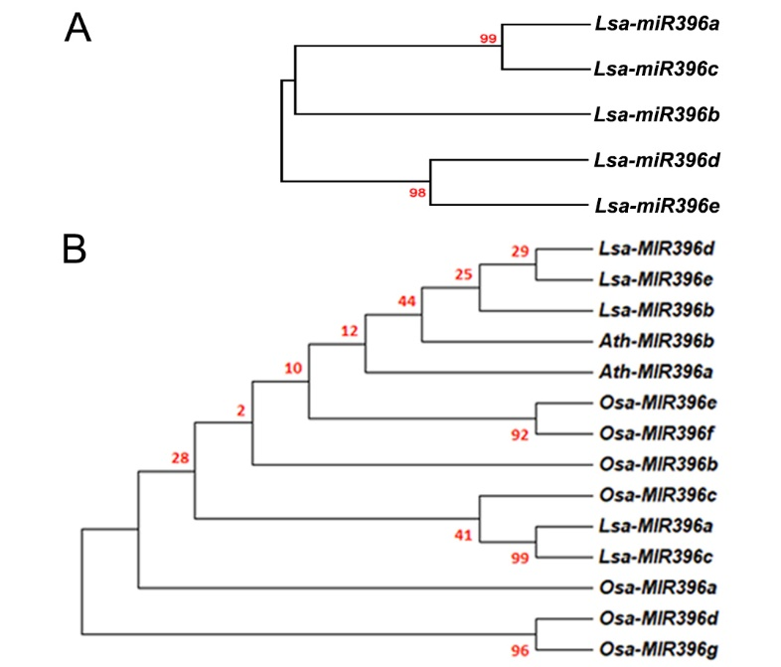
Supplementary Figure 2. Phylogenetic analysis of Lsa-miR396s.
A. Phylogenetic analysis of miR396s in lettuce. B. Phylogenetic relationship of miR396s in Arabidopsis, rice and lettuce.
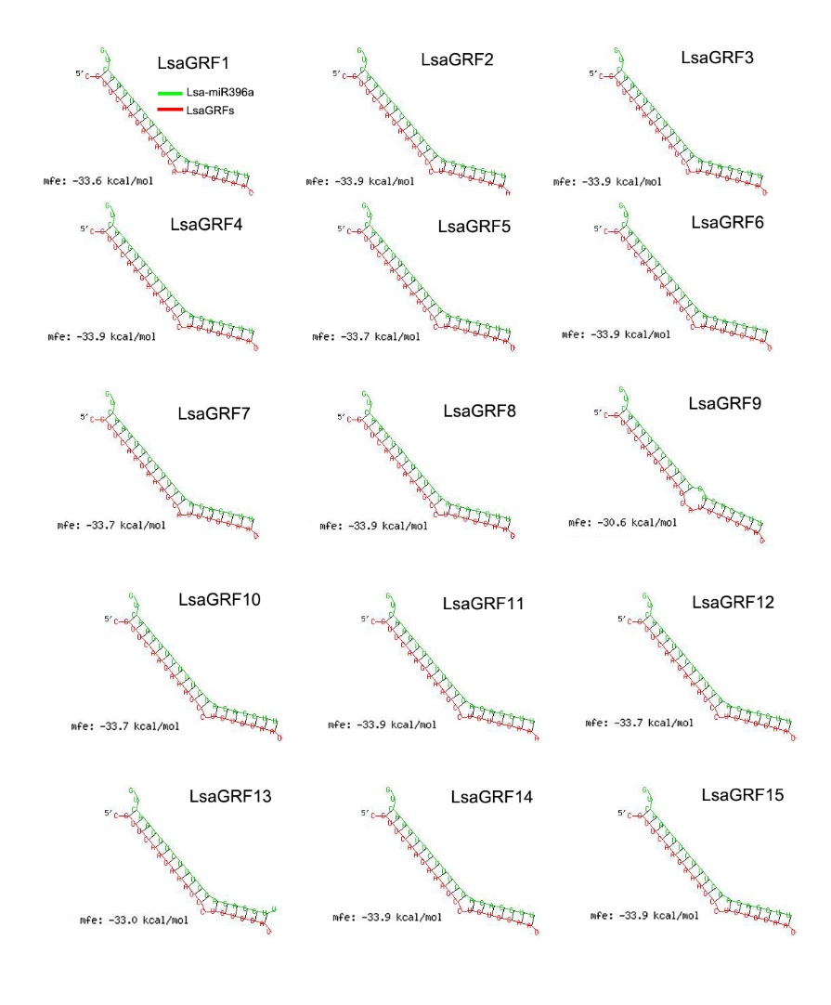
Supplementary Figure 3. The degree of Lsa-miR396a complementarity to all LsaGRFs. Free energies of duplex structures were calculated using RNAhybrid software (http://bibiserv.techfak.uni-bielefeld.de/rnahybrid).
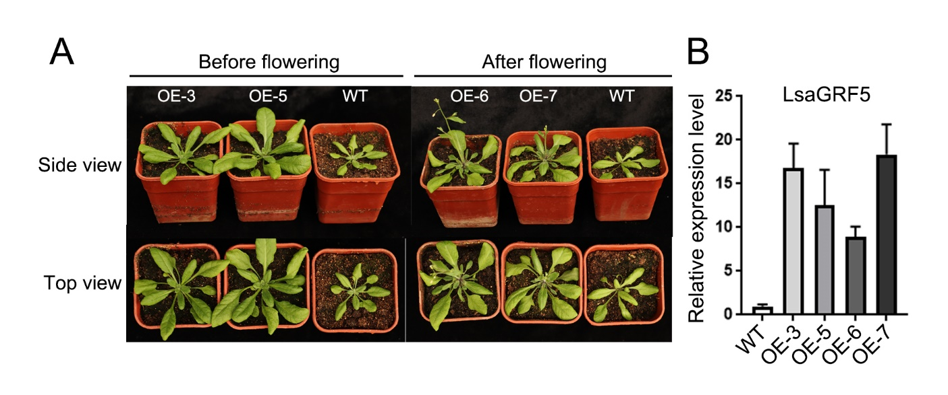
Supplementary Figure 4. The phenotypes of overexpression lines of LsaGRF5 in Arabidopsis. A. The Arabidopsis overexpression lines of LsaGRF5 showed bigger leaves and early flowering phenotypes. B. The expression level of LsaGRF5 in Arabidopsis overexpression lines of LsaGRF5.

1.1 Supplementary Tables
The Supplementary Tables for this article can be found in the attached file with excel format.

