A Systems-thinking Approach to Assess the Efficacy of Local Fisheries Management towards Sustainability

List of figures:
https://docs.google.com/document/d/1JCnNiRa81r5AaP5fSYSFdGDQjmqZztb5/edit

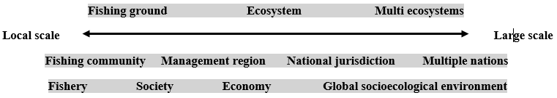
Figure S1. A simplified spatial scale chart (from local scale to large scale) of a fishery system. The natural world is represented above the axis, whereas the human and management systems are represented below the axis. The fishing community may have multiple systems and may operate within various nations. At the bottom, we show a nest within which a fishery system operates, (termed nested systems), which includes the fishery system, society, economy and the global ecological environment. Source: Authors

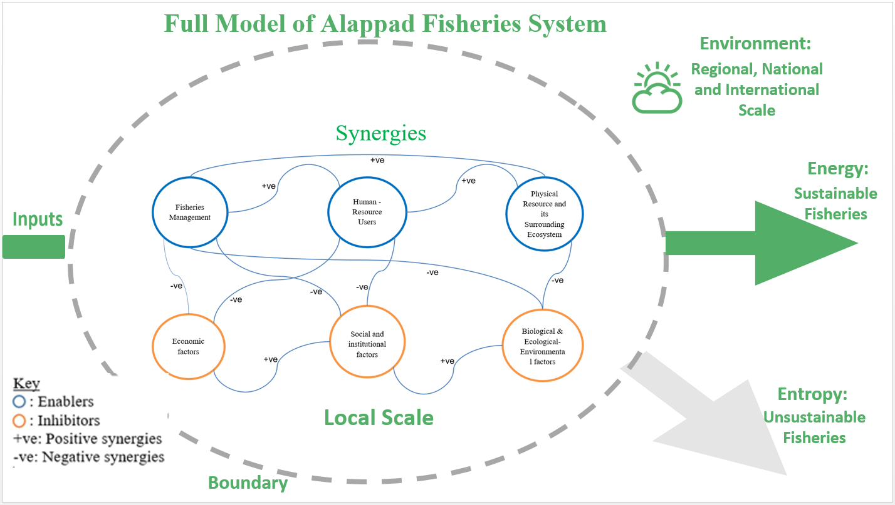
Figure S2. A summary of the abstract full fisheries system model canvas. Source: Authors.

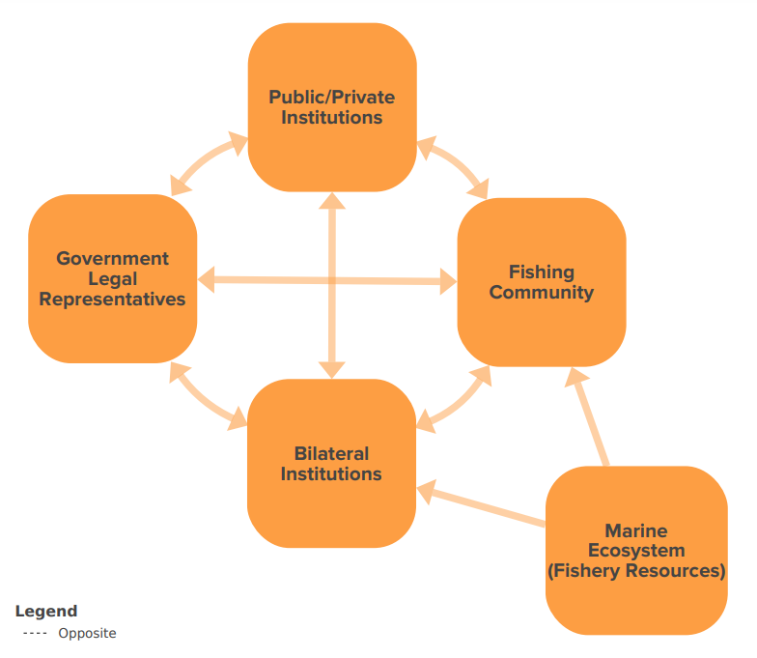

Figure S3. A schematic diagram of composition of various stakeholders in hybrid organisations/institutions and the fishery marine system. Arrows denote the direction of information flow. Kumu link: https://embed.kumu.io/4337901205a3b5de839627b17eca9730 Source: Authors.

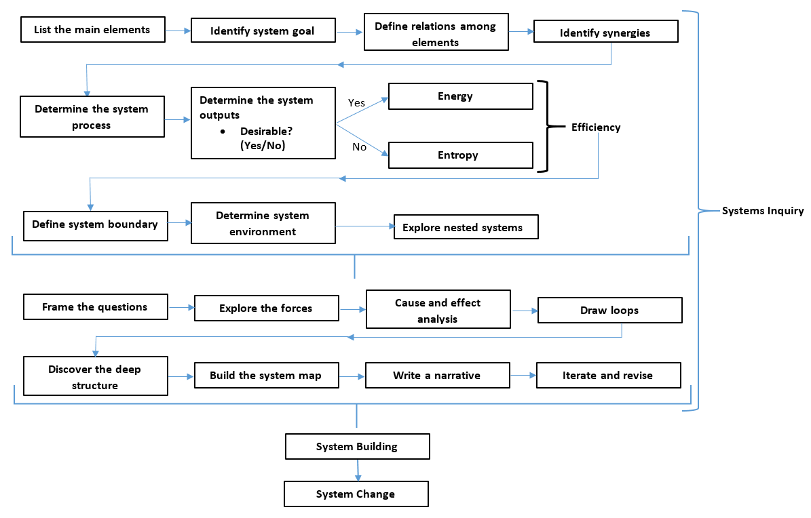
Figure S4. A systems-thinking framework showing systems mapping inquiry process. Source: Authors.

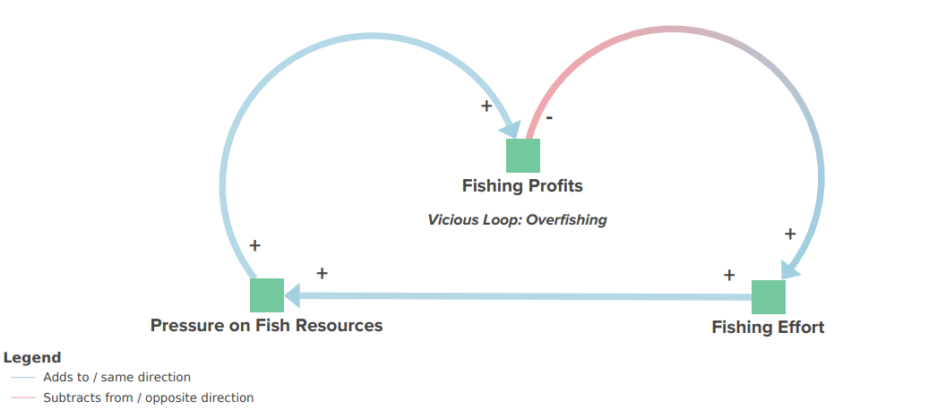
Legend
[++] signs for the increase in synergies
[- -] signs for the decrease in synergies
[+-, -+] signs for opposite synergies
Figure S5. Vicious forces influencing the fishery system through economic elements subsystem. Source: Authors. The systems map can be accessed via the Kumu link: https://embed.kumu.io/084c5ab3c0f8aac794a1f3c002a257b0

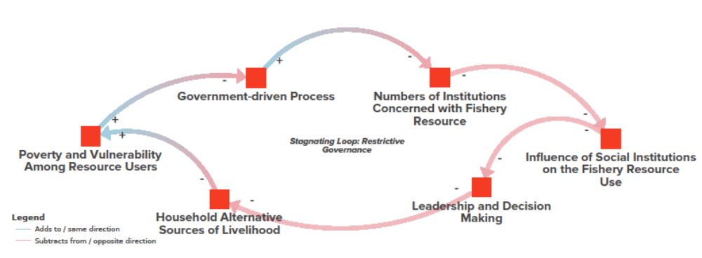
Legend
[++] signs for the increase in synergies
[- -] signs for the decrease in synergies
[+-, -+] signs for opposite synergies
Figure S6. Stagnating forces influencing the fishery system through social elements subsystem. Source: Authors. The systems map can be accessed via the Kumu link:
https://embed.kumu.io/5245867048448baea192a18e92cc8829

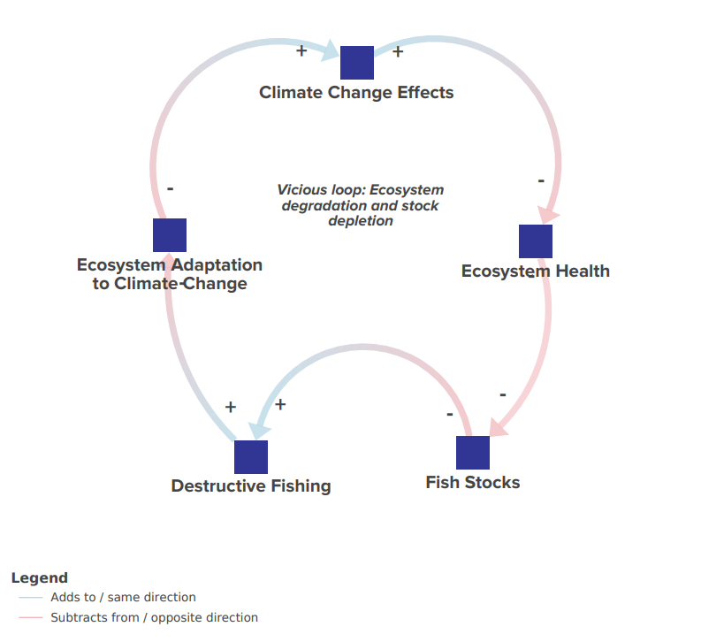
Legend
[++] signs for the increase in synergies
[- -] signs for the decrease in synergies
[+-, -+] signs for opposite synergies

Figure S7. Vicious forces influencing the fishery system map through the environmental elements subsystem. Source: Authors. The systems map can be accessed via the Kumu link: https://embed.kumu.io/f958695507fa78eb52d11672ab7b0b1a

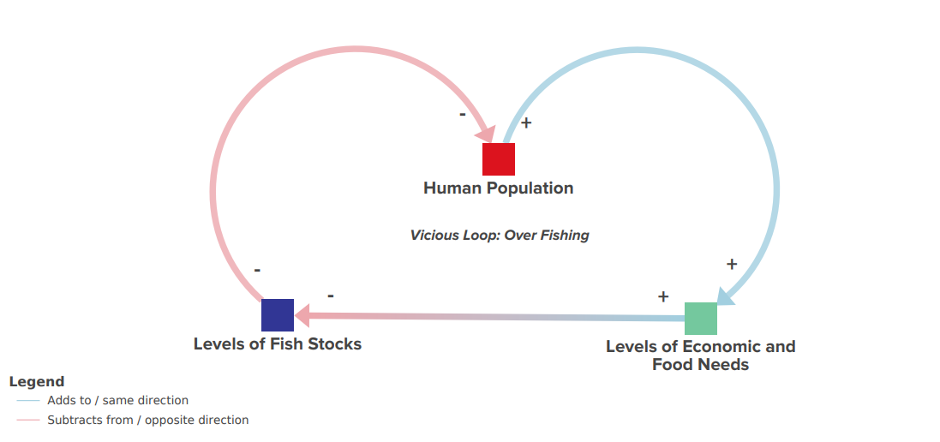

Legend
[++] signs for the increase in synergies
[- -] signs for the decrease in synergies
[+-, -+] signs for opposite synergies
Figure S8. Vicious forces influencing the fishery system through an overlap of economic, environmental and social forces. Source: Authors.

